WISHLIST APPLICATION



WEB APPLICATION USER GUIDE

# Table of Contents

Table of Contents 2

Introduction 3

WishList App LogIn Page 4

Create an account Page 5

Home Page 6

WishList Page 7

Add item (Your WishList) 8

Restore Item (Your WishList) 9

Fulfilled Items (Your WishList) 9

Export (Your WishList) 10

Categories (Category list) 11

Balance History (Your Balance) 12

Balance settings (Your Balance) 13

Export (Your Balance) 13

Profile settings 14

Administrator settings 15

Users (Admin panel) 16

Category list (Admin panel) 16

# Introduction

Nowadays online shopping is becoming more and more popular, this helps you to easily buy a wide variety of clothes, books, accessories and other gadgets, including gifts, for you or your family members directly from your home.

With our WishList App you can create personalized collections of products that you want to buy and you can save them in your user account for future reference, without an immediate intent to purchase them.

You will find easy to locate your item’s website, categorize and prioritize your products on WishList, manage your account’s balance and much more at <https://ozowlt.herokuapp.com/login>.

# WishList App LogIn Page

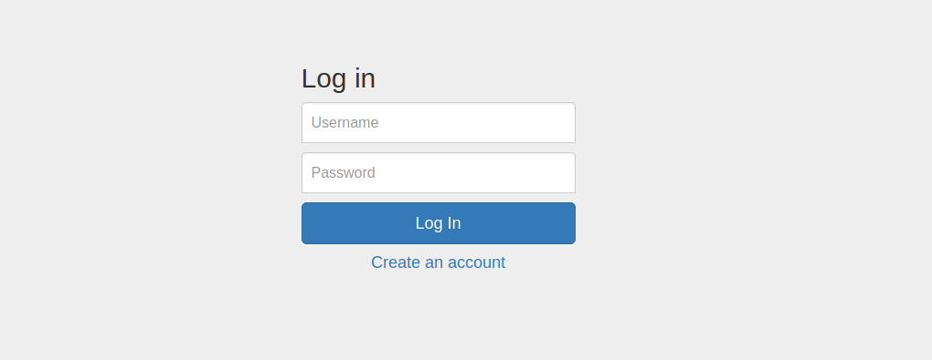

**Log in**

Users who have previously registered for the WishList App must login by:

Entering their **Username**.

Entering their **Password**.

Selecting **Log In** to advance to the next screen and begin using the application.

**Create an account**

Users who have not previously registered for the WishList App must select “Create an account” to use the site.

# Create an account Page

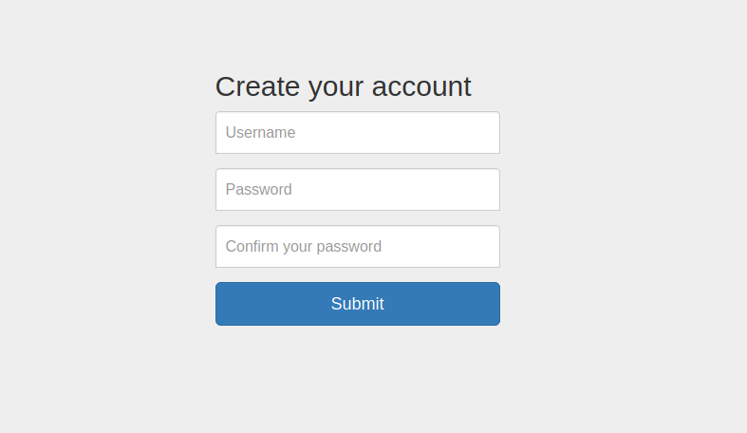

**Username**

Enter the user’s username.

**Password**

Passwords must be at least eight characters long and contain at least one letter character and one numeric character.

**Confirm your password**

As a security check, users will be asked to retype their password.

**Submit**

Press **Submit** to submit the registration information and continue to the next screen.

# Home Page

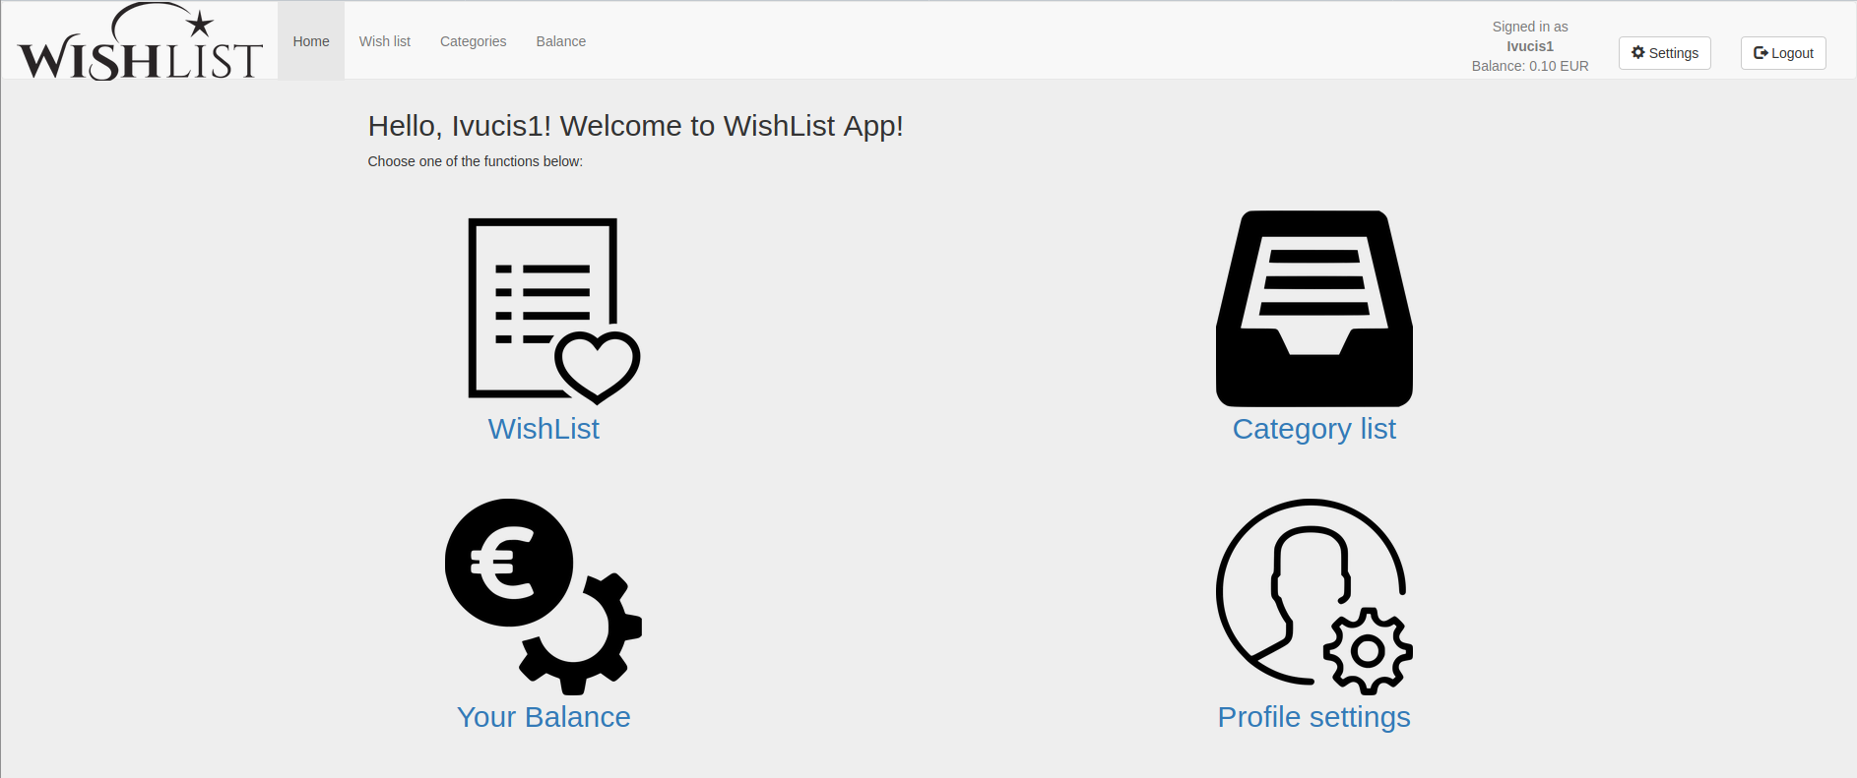

After logging into the WishList App, the user will advance to the Welcome Page. Select the icons on this page to do the following:

**WishList**

Here you can see, edit and delete items from your WishList.

**Category List**

Here you can see your items categorized from your WishList.

**Your balance**

Here you can edit balance of savings to your account.

**Profile settings**

Here you can see WishList statistics of your profile and edit password information.

**Logout**

Press **Logout** button to exit your current session.

# WishList Page

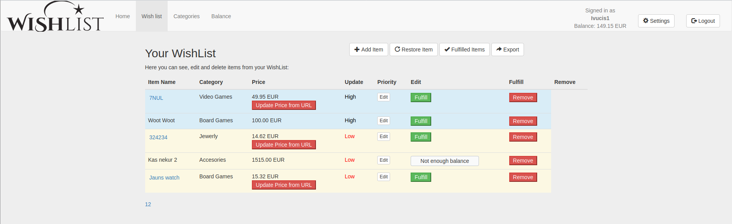

Here you can see, edit and delete items from your WishList.

**Item Name**

Your assigned identification to your item.

**Category**

Division by category.

**Price**

Price of the product. If your item is linked to URL of original product, you can press button ‘Update price from URL’ in order to refresh information.

**Priority**

Sort items by putting level of priority to them.

**Edit**

Press **Edit** button to update details about your WishList item.

**Fulfill**

By pressing **Fulfill** button, you will buy the product from your WishList. The balance of your account will be updated and item moved to **Fulfilled** **Items** list.

**Remove**

By pressing **Remove** button, you will remove product from your WishList and item will be moved to **Restore** **Item** list.

# Add item (Your WishList)

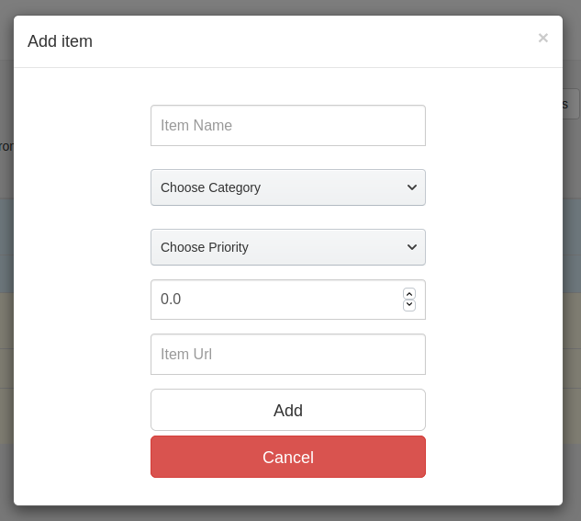

Add item options. The meaning and functionality is the same as for **Edit** button.

**Item Name**

Your assigned identification to your item.

**Choose Category**

Division by category.

**Choose Priority**

Sort items by putting level of priority to them.

**Price**

Enter price of your product.

**Item** **Url**

Add original URL of your product for future reference.

**Add**

Press Add button to create new item on your WishList.

**Cancel**

Press **Cancel** button to disregard any changes made to this screen.

# Restore Item (Your WishList)

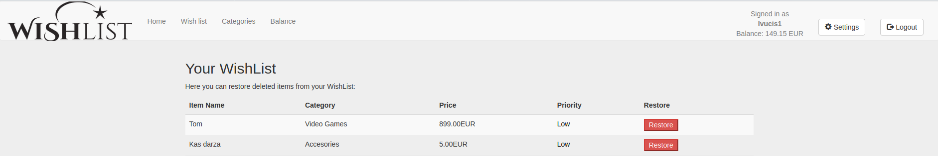

Here you can restore deleted items from your WishList.

**Restore**

Press **Restore** button to add item back to your WishList. Restored items will disappear from this item queue.

# Fulfilled Items (Your WishList)

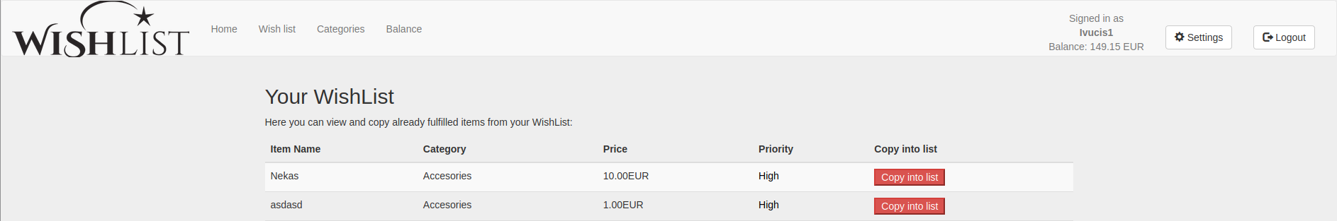

Here you can view and copy already fulfilled items from your WishList. All successfully completed items will be stored in this queue.

**Copy into list**

Press **Copy into list** button to create a re-newed entry of this item in your active WishList.

# Export (Your WishList)

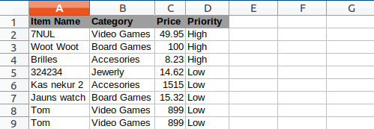

Press **Export** button in order to generate Excel sheet for all of your current items in your WishList for general overview and possibilities to add your own extra comments and calculations.

# Categories (Category list)

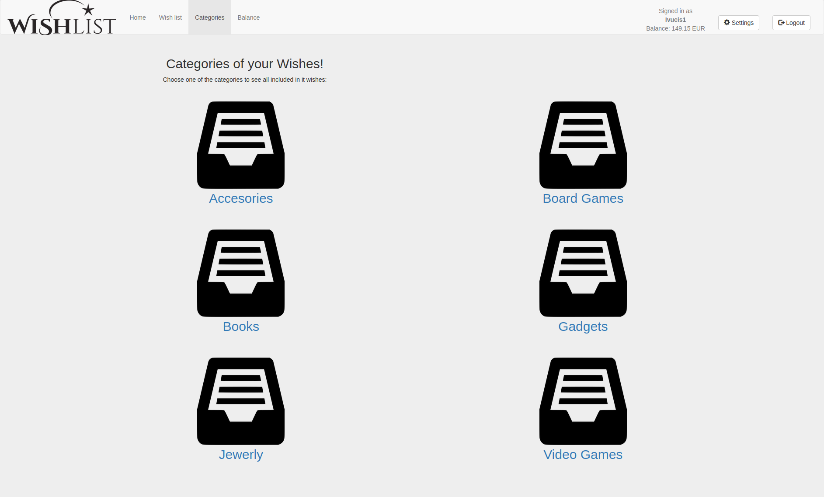

Choose one of the categories to see all included in WishList: Accessories, Board Games, Books, Gadgets, Jewelry and Video Games. This provides fast and easy access to your items mentioned only in this category.

# Balance History (Your Balance)

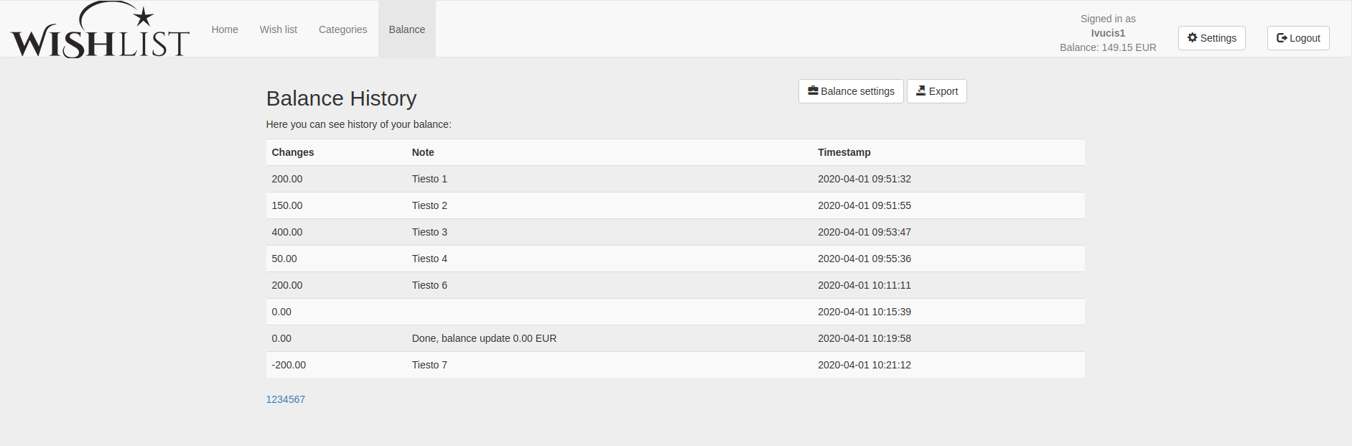

Here you have an overview of all your past item purchases and account balance updates.

**Changes**

Changes of account balance affected by purchase

**Note**

Your personal notes about each particular entry (optional).

**Timestamp**

Timestamp recording changes on your account.

# Balance settings (Your Balance)

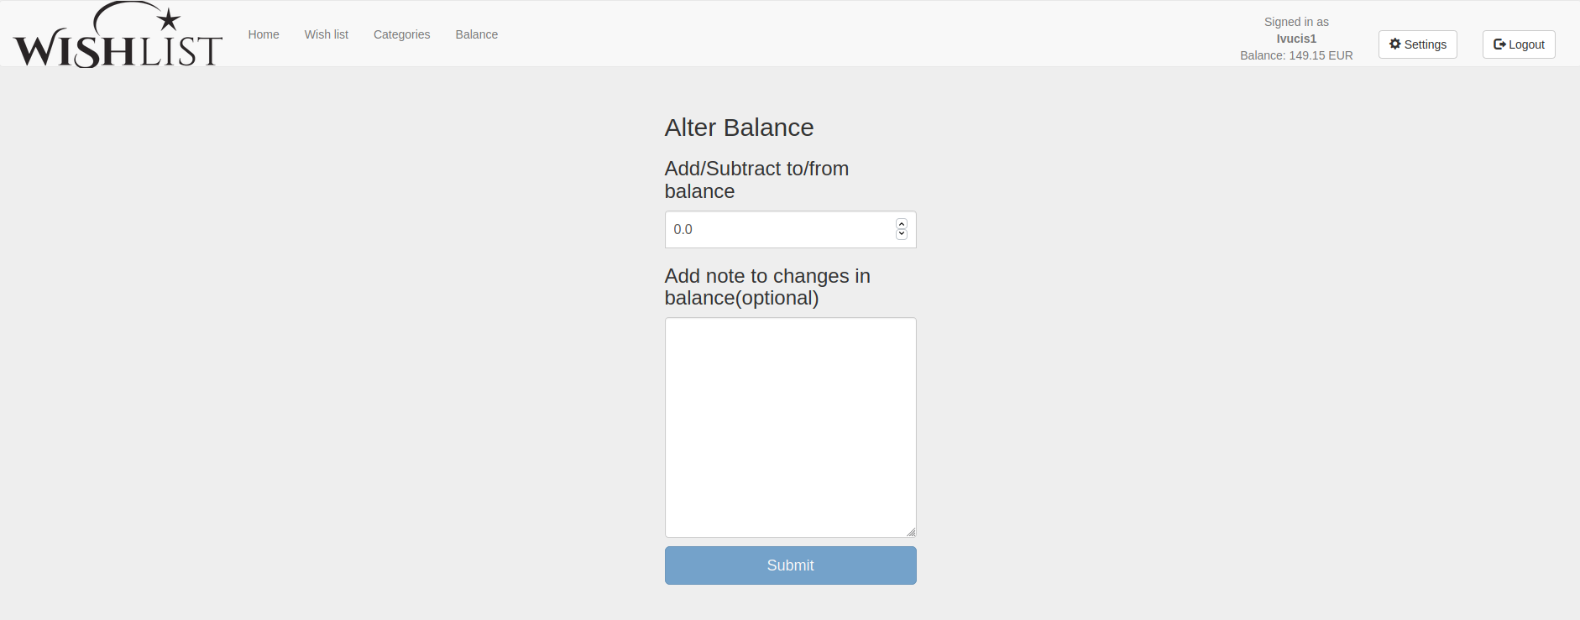

Press **Balance** **settings** button to enter ‘**Alter** **Balance**’ page, where you can update funding on your account and add comments of each particular entry. All changes will be recorded in Balance Hostory.

# Export (Your Balance)

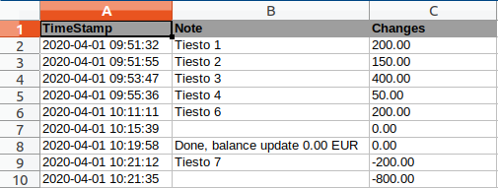

Press **Export** button in order to generate Excel sheet summary for all of your past transaction on your WishList App account.

# Profile settings

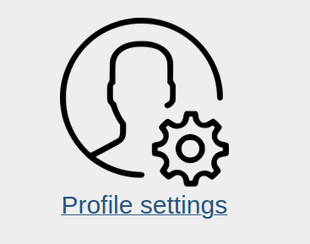

Here you can see WishList statistics of your profile and edit password information.

# Administrator settings

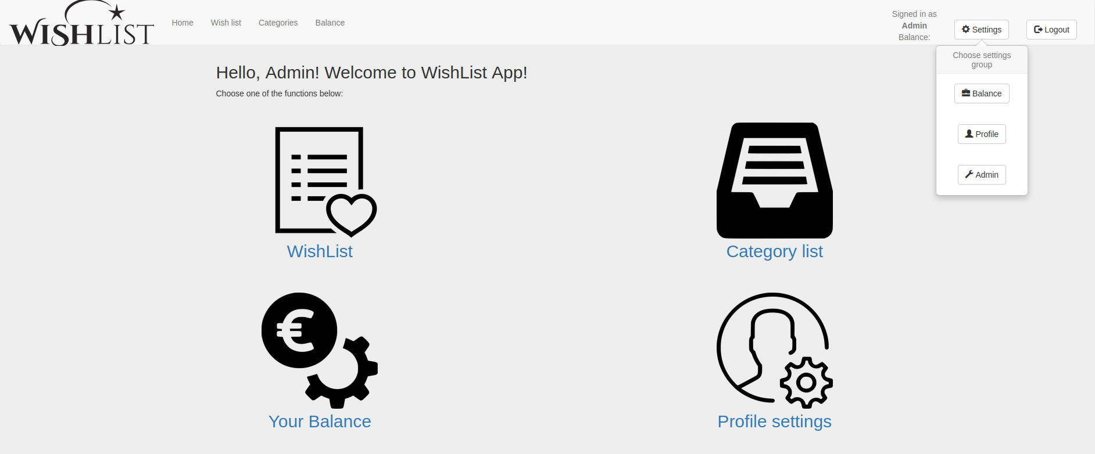

Under **Settings** button is displayed **Admin** button, that grants extra access to features in WishList App in order to modify site global details, like **Users** and **Categories** **list**.

This option is not accessible for normal users of the site.

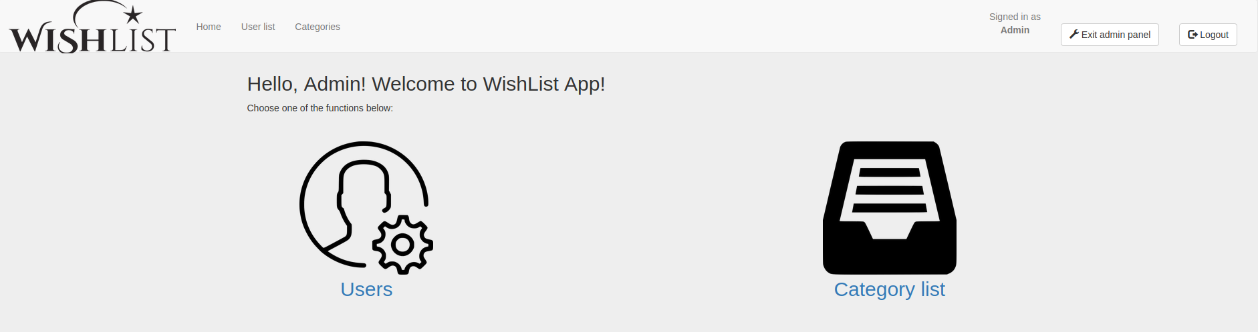

**Users**

Here are displayed all current users of the WishList App site.

**Category** **list**

Here you can update list categories displayed on WishList site.

**Exit** **admin** **panel**

Press **Exit** **admin** **panel** to terminate current session.

# Users (Admin panel)

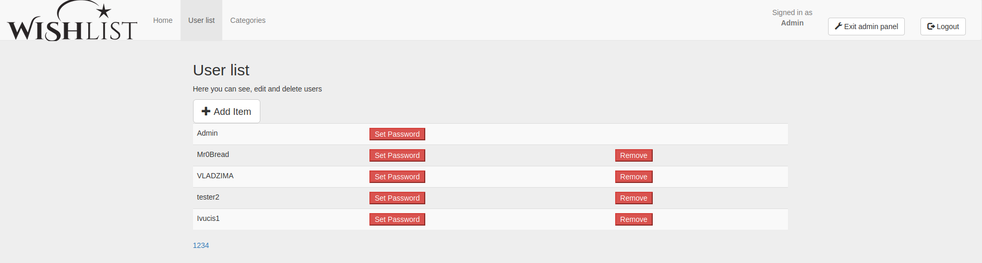

Here are displayed all current users of the WishList App site.

**Set** **Password**

Press **Set** **Password** button to edit new password for the client’s account.

**Remove**

Press **Remove** button to delete user from.

# Category list (Admin panel)

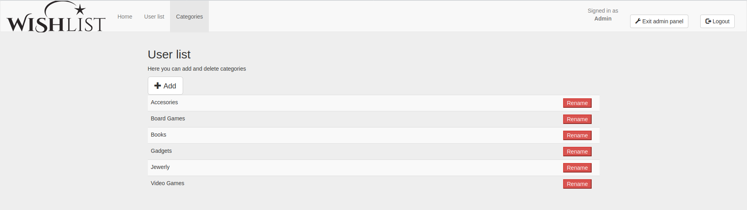

Here you can update list categories displayed on WishList site.

**Rename**

Press **Rename** button to change category name.

**Add**

Press **Add** button to enter new category to the existing list.

**Thank You!**