LEAFLET BASIC TUTORIALS

Date : 21/06/2018
Thursday

so today we are going to learn to drap the google map using leaflet.js framework
so first neet to create the project folder and then follow my instruction-

download some data of shape file from this website -
“https://www.naturalearthdata.com/downloads/110m-cultural-vectors/”

now open the qgis software and do some process.

# select new project in qgis software
# add the vector layer by pressing the ctrl+shift+v
# now you need to add the shape file which you have downloaded after finishing it you are able to show the map in your qgis environment.

# so now just right click on ther vector layer shapefile which you have added earlier and save it in new format (jeojson)

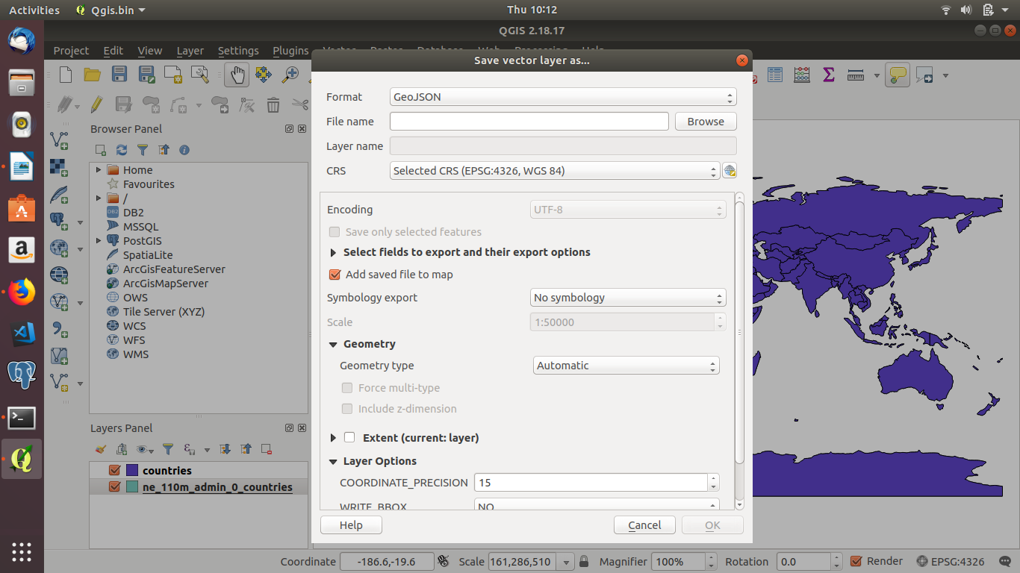
and save it in your desire location-

now you have got the geojson data format ot the shape file so now you are ready to work with map.

# download the leaflet library file from the officail website-

“https://leafletjs.com/”

now create on index.html file and link the required file which is described as below-

<!DOCTYPE html>
<html lang="en">
<head>
<meta charset="UTF-8">
<meta name="viewport" content="width=device-width, initial-scale=1.0">
<meta http-equiv="X-UA-Compatible" content="ie=edge">
<title> Leaflet Map Practice </title>
<!-- include leaflet css folder -->
<link rel="stylesheet" href="lib/leaflet/leaflet.css">
<!-- include leaflet javasript file -->
<script src="lib/leaflet/leaflet.js"></script>
<!-- include the mapdata or shape file -->
<script src="data/countries.geojson"></script>
<!-- define the style -->
<style>
#map{
height: 500px;
width: 100%;
}
</style>

</head>
<body>
<h1>Leaflet Map</h1>
<div id ="map"></div>
<script>
var mymap = L.map('map').setView([20.5937, 78.9629], 5);
var countriesLayer = L.geoJson(countries).addTo(mymap)
</script>
</body>
</html>

Now run the index.html file you will get the map according to your data which you have provided.

