Integrated neural control for AMOSII

Contents:
1) Introduction
2) How to use the integrated controller
3) How to configure the controller
4) How to configure the experiment
5) List of modules & submodules

1) Introduction

The integrated neural controller consists of several control modules (as C++ classes) for generating complex behaviors. These are

- NeuralPreprocessingLearning for sensory preprocessing, and adaptive obstacle avoidance and obstacle negotiation,
- NeuralNavigationControl for generating navigational behaviors (homing, goal-directed and route navigation) through a scalar steering output,
- NeuralLocomotionControl for producing versatile and robust locomotion, including omnidirectional walking, insect-like gaits, and leg adaptation based on forward models.

Each of these module classes contain submodules, which are located in respective subfolders (preprocessing_modules, navigation_modules, locomotion_modules). The central idea of the integrated control structure (Fig. 1) is to allow the user to define which submodules and parameters are used in the experiment.
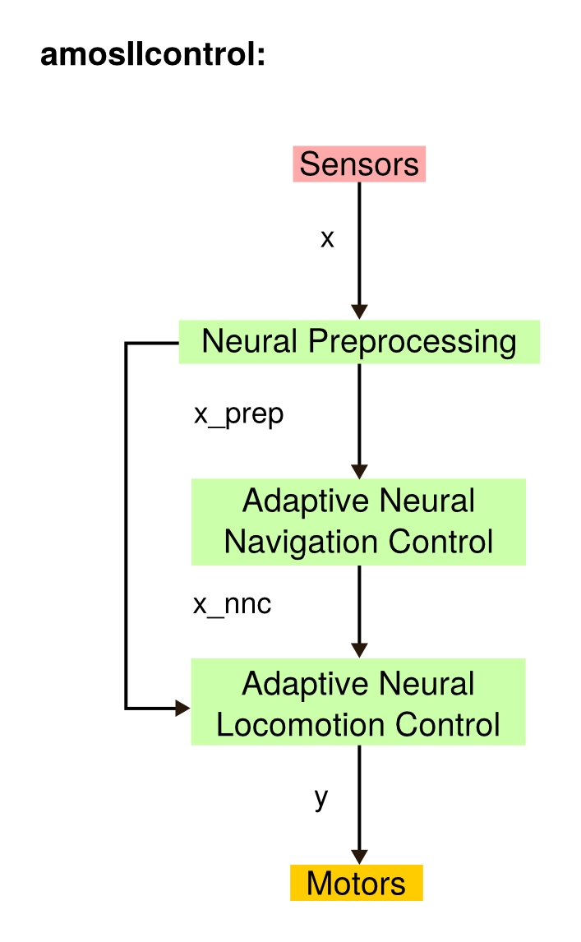

Fig. 1: Scheme of integrated neural control in amosIIcontrol.cpp.

These are set in the project files (i.e., main.cpp).

2) How to use the integrated controller:

To use the integrated controller, you need to modify some of your files first:

i) makefile.conf:
Here you simply need to change the control folder from “modular_neural_control” to “integrated_neural_control”. Further you can define the variables for submodules folders. It should look like this:

# Configuration for simulation makefile # Please add all cpp files you want to compile for this simulation # to the FILES variable # You can also tell where you haved lpzrobots installed

ODEROBOTSSRCPREFIX=$(shell ode_robots-config $(CFGOPTS) –srcprefix) #ode_robots directory
SELFORGSRCPREFIX=$(shell selforg-config $(CFGOPTS) --srcprefix) #selforg directory

GOROBOTS = ../../../..
LPZROBOTS = $(ODEROBOTSSRCPREFIX)/..
AMOSIICONT = $GOROBOTS)/controllers/amosii/integrated_neural_control
PREPROCESSING = $(AMOSIICONT)/preprocessing_modules
LOCOMOTION = $(AMOSIICONT)/locomotion_modules
NAVIGATION = $(AMOSIICONT)/navigation_modules
AMOSIIUTIL = $(GOROBOTS)/utils

Add all the required files to the files variable:

FILES += main \
$(AMOSIICONT)/amosIIcontrol \
$(AMOSIICONT)/NeuralPreprocessingLearning \
$(AMOSIICONT)/NeuralLocomotionControl \
$(AMOSIICONT)/NeuralNavigationControl \
$(AMOSIICONT)/MuscleModel \
$(PREPROCESSING)/FSM \
$(PREPROCESSING)/IRM \
$(PREPROCESSING)/US_OA \
$(PREPROCESSING)/US_ON \
$(NAVIGATION)/PathIntegrationMechanism \
$(LOCOMOTION)/ModularNeuralNetwork \
$(LOCOMOTION)/BackboneJointControl \
$(LOCOMOTION)/forwardmodel \
$(LOCOMOTION)/motormapping \
$(AMOSIIUTIL)/ann-framework/ann \
$(AMOSIIUTIL)/ann-framework/circann \
$(AMOSIIUTIL)/ann-framework/neuron \
$(AMOSIIUTIL)/ann-framework/synapse \
$(AMOSIIUTIL)/ann-library/so2cpg \
$(AMOSIIUTIL)/ann-library/pcpg \
$(AMOSIIUTIL)/ann-library/psn \
$(AMOSIIUTIL)/ann-library/vrn \
$(AMOSIIUTIL)/ann-library/pmn \
$(AMOSIIUTIL)/ann-library/extendedso2cpg \
$(AMOSIIUTIL)/ann-library/adaptiveso2cpgsynplas \
$(AMOSIIUTIL)/ico-framework/ico \
$(AMOSIIUTIL)/interpolator2d \
$(AMOSIIUTIL)/delayline

ii) main.cpp:
The main file must include the corrected controller header file:

#include "controllers/amosii/integrated_neural_control/amosIIcontrol.h"

Then you need to ensure that you pass the correct data types to the constructor, which are (int, bool, bool, bool):

controller = new AmosIIControl(use_amosii_v, use_mCPG, use_muscles, use_navi);
iii) make & start simulation:
Type “make” (use “make clean”, if it does not work first) in console to compile your code. Execute “./start” to start the simulation.

3) How to configure the controller:

i) Constructor options:

(int) aAMOStype define which version of AMOSII is used (default: 2)
(bool) mMCPGs define if multiple CPGs are used (default: false)
(bool) mMuscleModelisEnabled define if muscle model is used (default: false)
(bool) mNNC define if navigation control is used (default: false)

ii) Additional functions for switching controller options:

void flipBJCbool(); flips backbone joint control option (default: true)
void flipOAbool(); flips obstacle avoidance control option (default: false)
Note: The options for backbone joint control and obstacle avoidance are XOR-linked. Thus, any flipping changes both options.

void flipReflexesbool(); flips local leg reflexes (default: true)

4) How to configure the simulation

Have a look at “/projects/amosii/module_integration.cpp” for a smart and intuitive way to configure your simulation. Use generative functions to add objects, such as obstacles or goals to your environment.

5) List of modules & submodules classes

i) Main modules:

AmosIIControl main control class of integrated controller
MuscleModel muscle model class based on VAAMs
NeuralNavigationControl generates steering signal for navigation
NeuralLocomotionControl generates motor signals for locomotion
NeuralPreprocessingLearning generates preprocessed signals from sensors and learning

ii) Preprocessing modules:

FSM ANN module for foot contact sensor preprocessing
IRN ANN module for infrared sensor preprocessing
US_OA ANN module for obstacle avoidance learning
US_ON ANN module for obstacle negotiation learning

iii) Navigation modules:

PathIntegrationMechanism Circular ANN module for path integration

iv) Locomotion modules:

BackboneJointControl ANN module for Backbone Joint Control
ModularNeuralNetwork ANN module for locomotion networks (CPGs, VRNs, PSNs)
ForwardModel ANN module for forward models
MotorMapping Handles mapping from signals to motor joint angles

