Bahria University,

Karachi Campus



LAB EXPERIMENT NO.

02

LIST OF TASKS

|  |  |
| --- | --- |
| TASK NO | OBJECTIVE |
| 1 | Print triangle using python use iterations. |
| 2 | Print Fibonacci Series using python |
|  |  |
|  |  |
|  |  |
|  |  |
|  |  |
|  |  |
|  |  |

Submitted On:

____________

**Task No. 1:** Print triangle using python use iterations.

**Solution:**

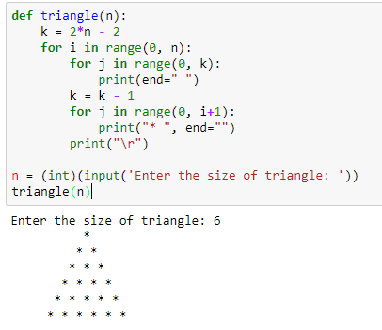

**Task No. 2:** Print Fibonacci Series using python.

**Solution:**

