Bahria University,

Karachi Campus



LAB EXPERIMENT NO.

_______

LIST OF TASKS

|  |  |
| --- | --- |
| TASK NO | OBJECTIVE |
|  |  |
|  |  |
|  |  |
|  |  |
|  |  |
|  |  |
|  |  |
|  |  |
|  |  |

Submitted On:

____________

**Task No. 1:** Implement Breadth First Search in python.

**Solution:**

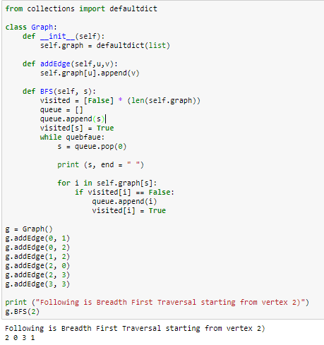

**Task No. 2:** Find shortest path between two nodes using BFS algorithm.

**Solution:**

