Bahria University,

Karachi Campus



LAB EXPERIMENT NO.

_______

LIST OF TASKS

|  |  |
| --- | --- |
| TASK NO | OBJECTIVE |
| 1 | Apply DFS search on the graph given below. |
| 2 | Implement DFS search algorithm while using recursion. |
|  |  |
|  |  |
|  |  |
|  |  |
|  |  |
|  |  |
|  |  |

Submitted On:

____________

(Date: DD/MM/YY

**Task No. 1:** Apply DFS search on the graph given below.

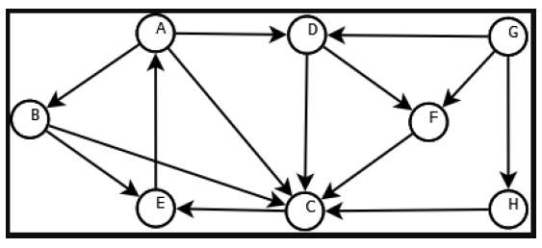

**Solution:**

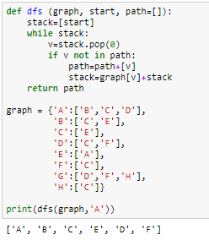

**Task No. 2:** Implement DFS search algorithm while using recursion.

**Solution:**

