**TASK # 01**

Create Calculator application and persist result in shared preferences.

**CODE:**

**JAVA**

package com.example.lab12;  
import android.content.SharedPreferences;  
import android.support.v7.app.AppCompatActivity;  
import android.os.Bundle;  
import android.util.Log;  
import android.view.Gravity;  
import android.view.View;  
import android.widget.Button;  
import android.widget.TextView;  
import android.widget.Toast;  
public class MainActivity extends AppCompatActivity {  
 public static final String SHARED_PREFS = "sharedPrefs";  
 public static final String TEXT = "text";  
 TextView textView;  
 private String text;  
 @Override  
 protected void onCreate(Bundle savedInstanceState) {  
 super.onCreate(savedInstanceState);  
 setContentView(R.layout.activity_main);  
 textView = (TextView)findViewById(R.id.result_text_view);  
 loadData();  
 updateViews(); }  
 public void applyToast(View v){  
 Toast t = Toast.makeText(this,"this is text",Toast.LENGTH_SHORT);  
 t.setGravity(Gravity.CENTER_HORIZONTAL,0,0);  
 t.show(); }  
 public void buttonClear(View v){  
 TextView text = (TextView)findViewById(R.id.result_text_view);  
 text.setText("0"); }  
 public void addValueInView(View v){  
 Button btn = (Button) v;  
 String text = btn.getText().toString();  
  
 TextView view = (TextView)findViewById(R.id.result_text_view);  
 if(view.getText().toString().equals("0")){  
 view.setText("");  
 view.append(text); }  
 else{  
 view.append(text); } }  
 public void buttonDivide(View v){  
 v = (TextView)findViewById(R.id.result_text_view);  
 ((TextView)v).append("/"); }  
 public void buttonMultiply(View v){  
 v = (TextView)findViewById(R.id.result_text_view);  
 ((TextView)v).append("*"); }  
 public void buttonSubtract(View v){  
 v = (TextView)findViewById(R.id.result_text_view);  
 ((TextView)v).append("-"); }  
 public void buttonAdd(View v){  
 v = (TextView)findViewById(R.id.result_text_view);  
  
 ((TextView)v).append("+"); }  
 public void buttonEqual(View v){  
 v = (TextView)findViewById(R.id.result_text_view);  
 try {  
 if (((TextView) v).getText().toString().contains("/")) {  
 int index = ((TextView) v).getText().toString().indexOf('/');  
 String stringNum1 = ((TextView) v).getText().toString().substring(0, index);  
 String stringNum2 = ((TextView) v).getText().toString().substring(index+1);  
 double num1 = Double.valueOf(stringNum1);  
 double num2 = Double.valueOf(stringNum2);  
 double ans = num1 / num2;  
 ((TextView) v).setText(String.valueOf(ans)); }  
 else if (((TextView) v).getText().toString().contains("+")) {  
 int index = ((TextView) v).getText().toString().indexOf('+');  
 String stringNum1 = ((TextView) v).getText().toString().substring(0, index);  
 String stringNum2 = ((TextView) v).getText().toString().substring(index+1);  
 double num1 = Double.valueOf(stringNum1);  
 double num2 = Double.valueOf(stringNum2);  
 double ans = num1 + num2;  
 ((TextView) v).setText(String.valueOf(ans)); }  
 else if (((TextView) v).getText().toString().contains("*")) {  
 int index = ((TextView) v).getText().toString().indexOf('*');  
 String stringNum1 = ((TextView) v).getText().toString().substring(0, index);  
 String stringNum2 = ((TextView) v).getText().toString().substring(index+1);  
 double num1 = Double.valueOf(stringNum1);  
 double num2 = Double.valueOf(stringNum2);  
 double ans = num1*num2;  
 ((TextView) v).setText(String.valueOf(ans)); }  
 else if (((TextView) v).getText().toString().contains("-")) {  
 int index = ((TextView) v).getText().toString().indexOf('-');  
 String stringNum1 = ((TextView) v).getText().toString().substring(0, index);  
 String stringNum2 = ((TextView) v).getText().toString().substring(index+1);  
 double num1 = Double.valueOf(stringNum1);  
 double num2 = Double.valueOf(stringNum2);  
 double ans = num1-num2;  
 ((TextView) v).setText(String.valueOf(ans)); }  
 }catch (Exception e){  
 Log.e("error","Exception: "+e); }  
 finally {  
 saveData(); }  
 Toast t = Toast.makeText(this,"this is text",Toast.LENGTH_SHORT);  
 t.setGravity(Gravity.CENTER_HORIZONTAL,0,0);  
 t.show(); }  
 public void saveData() {  
 SharedPreferences sharedPreferences = getSharedPreferences(SHARED_PREFS, MODE_PRIVATE);  
 SharedPreferences.Editor editor = sharedPreferences.edit();  
 editor.putString(TEXT, textView.getText().toString());  
 editor.apply();  
 Toast.makeText(this, "Data saved", Toast.LENGTH_SHORT).show(); }  
 public void loadData() {  
 SharedPreferences sharedPreferences = getSharedPreferences(SHARED_PREFS, MODE_PRIVATE);  
 text = sharedPreferences.getString(TEXT, ""); }  
 public void updateViews() {  
 textView.setText(text); }}

**XML**

activity main.xml

<?xml version="1.0" encoding="utf-8"?>

<LinearLayout xmlns:android="http://schemas.android.com/apk/res/android"

xmlns:app="http://schemas.android.com/apk/res-auto"

xmlns:tools="http://schemas.android.com/tools"

android:layout_width="match_parent"

android:layout_height="match_parent"

android:orientation="vertical"

tools:context=".MainActivity">

<LinearLayout

android:layout_width="match_parent"

android:layout_height="0dp"

android:layout_weight="2"

android:orientation="horizontal"

android:background="#3183C9">

<TextView

android:id="@+id/result_text_view"

android:layout_width="match_parent"

android:layout_height="match_parent"

android:text="0"

android:gravity="center_vertical"

android:paddingRight="30dp"

android:textColor="#FFF"

android:textSize="40sp" />  
 </LinearLayout>

<LinearLayout

android:layout_width="match_parent"

android:layout_height="0dp"

android:layout_weight="1"

android:orientation="horizontal">

<Button

android:layout_width="0dp"

android:layout_height="match_parent"

android:layout_weight="1"

android:text="@string/_7"

android:onClick="addValueInView"/>

<Button

android:layout_width="0dp"

android:layout_height="match_parent"

android:layout_weight="1"

android:text="@string/_8"

android:onClick="addValueInView"/>

<Button

android:layout_width="0dp"

android:layout_height="match_parent"

android:layout_weight="1"

android:text="@string/_9"

android:onClick="addValueInView"/>

<Button

android:layout_width="0dp"

android:layout_height="match_parent"

android:layout_weight="1"

android:text="@string/divide"

android:onClick="buttonDivide"/>

</LinearLayout>

<LinearLayout

android:layout_width="match_parent"

android:layout_height="0dp"

android:layout_weight="1"

android:orientation="horizontal">

<Button

android:layout_width="0dp"

android:layout_height="match_parent"

android:layout_weight="1"

android:text="@string/_6"

android:onClick="addValueInView"/>

<Button

android:layout_width="0dp"

android:layout_height="match_parent"

android:layout_weight="1"  
 android:text="@string/_5"

android:onClick="addValueInView"/>

<Button

android:layout_width="0dp"

android:layout_height="match_parent"

android:layout_weight="1"

android:text="@string/_4"

android:onClick="addValueInView"/>

<Button

android:layout_width="0dp"

android:layout_height="match_parent"

android:layout_weight="1"

android:text="@string/multiply"

android:onClick="buttonMultiply"/>

</LinearLayout>  
 <LinearLayout

android:layout_width="match_parent"

android:layout_height="0dp"

android:layout_weight="1"

android:orientation="horizontal">

<Button

android:layout_width="0dp"

android:layout_height="match_parent"

android:layout_weight="1"

android:text="@string/_3"

android:onClick="addValueInView"/>

<Button

android:layout_width="0dp"

android:layout_height="match_parent"

android:layout_weight="1"

android:text="@string/_2"

android:onClick="addValueInView"/>

<Button

android:layout_width="0dp"

android:layout_height="match_parent"

android:layout_weight="1"

android:text="@string/_1"

android:onClick="addValueInView"/>

<Button

android:layout_width="0dp"

android:layout_height="match_parent"

android:layout_weight="1"

android:text="@string/minus"

android:onClick="buttonSubtract"/>

</LinearLayout>

<LinearLayout

android:layout_width="match_parent"

android:layout_height="0dp"

android:layout_weight="1"

android:orientation="horizontal">

<Button

android:layout_width="0dp"

android:layout_height="match_parent"

android:layout_weight="1

android:text="@string/c"

android:onClick="buttonClear"/>

<Button

android:layout_width="0dp"

android:layout_height="match_parent"

android:layout_weight="1"

android:text="@string/_0"

android:onClick="addValueInView"/>

<Button

android:layout_width="0dp"

android:layout_height="match_parent"

android:layout_weight="1"

android:text="@string/equal"

android:onClick="buttonEqual"/>

<Button

android:layout_width="0dp"

android:layout_height="match_parent"

android:layout_weight="1"

android:text="@string/plus"

android:onClick="buttonAdd"/>

</LinearLayout>

</LinearLayout>

Strings.xml:

<resources>

<string name="app_name">Lab12</string>  
<string name="_7">7</string>

<string name="_8">8</string>

<string name="_9">9</string>

<string name="_6">6</string>

<string name="_5">5</string>

<string name="_4">4</string>

<string name="_3">3</string>

<string name="_2">2</string>

<string name="_1">1</string>

<string name="c">c</string>

<string name="_0">0</string>

<string name="plus">+</string>

<string name="minus">-</string>

<string name="multiply">*</string>

<string name="divide">/</string>

<string name="equal">=</string>

</resources>

**OUTPUT**

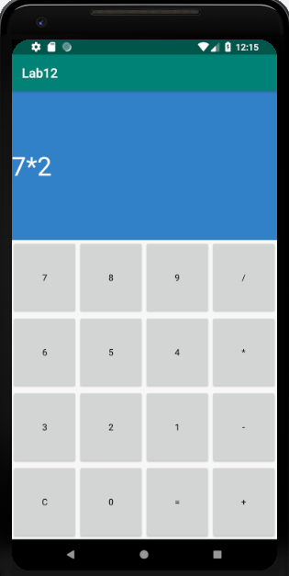 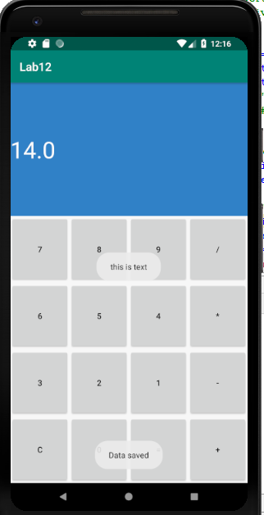

Go Back and again start application saved data will appear in text box.

