Bahria University,

Karachi Campus



LAB EXPERIMENT NO.

03

**LIST OF TASKS**

|  |  |
| --- | --- |
| TASK NO | OBJECTIVE |
| 1 | **Group Task: Each group in a cluster must have to play its part in**  **making the assigned project ERD’s Class Diagrams and Use Cases**  **using Rational Rose software** |

**Submitted On:**

**____________**

**(Date: DD/MM/YY)**

**Task No. 1:**

**Group Task: Each group in a cluster must have to play its part in making the assigned project ERD’s Class Diagrams and Use Cases using Rational Rose software**

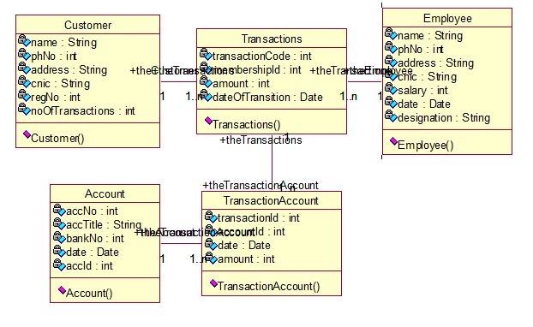

**Use case Diagram:**

