Bahria University,

Karachi Campus



LAB EXPERIMENT NO.

04

LIST OF TASKS

|  |  |
| --- | --- |
| TASK NO | OBJECTIVE |
| 1 | **Forward Engineering: Generate Code using Rational Rose using**  **the previous class diagram design individually.** |
| 2 | **Make changes in the code and apply Reverse Engineering to make**  **Diagram from code.** |

Submitted On:

____________

(Date: DD/MM/YY)

**Task No. 1:**

Forward Engineering: Generate Code using Rational Rose using the previous class diagram design individually.

**Diagram:**

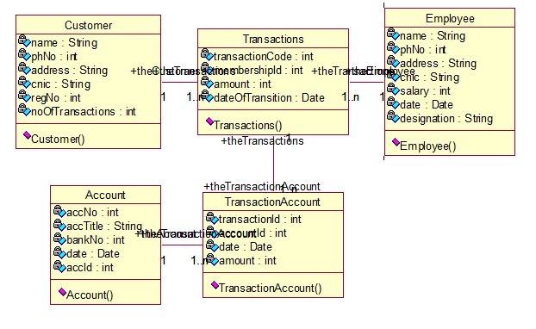

**Code**

import java.sql.Date;

protected class Employee

{

private String name;

private int phNo;

private String address;

private String cnic;

private int salary;

private Date date;

private String designation;

public Transactions theTransactions[];

/**

@roseuid 5CBB8D5A0307

*/

public Employee()

{

}

}

protected class Customer

{

private String name;

private int phNo;

private String address;

private String cnic;

private int regNo;

private int noOfTransactions;

public Transactions theTransactions[];

/**

@roseuid 5CBB8D5A02CC

*/

public Customer()

{

}

}

protected class Account

{

private int accNo;

private String accTitle;

private int bankNo;

private Date date;

private int accId;

public TransactionAccount theTransactionAccount[];

/**

@roseuid 5CBB8D5A028F

*/

public Account()

{

}

}

protected class TransactionAccount

{

private int transactionId;

private int accountId;

private Date date;

private int amount;

public Transactions theTransactions;

public Account theAccount;

/**

@roseuid 5CBB8D5A033C

*/

public TransactionAccount()

{

}

}

protected class Transactions

{

private int transactionCode;

private int membershipId;

private int amount;

private Date dateOfTransition;

public Customer theCustomer;

public Employee theEmployee;

public TransactionAccount theTransactionAccount[];

/**

@roseuid 5CBB8D5A037F

*/

public Transactions()

{

}

}

**Task 02:**

Make changes in the code and apply Reverse Engineering to make Diagram **from code.**

**Code:**

import java.sql.Date;

protected class Employee

{

private String name;

private int phNo;

private String email;

private String address;

private String cnic;

private Date dateOfBirth;

private int salary;

private Date date;

private String designation;

public Transactions theTransactions[];

/**

@roseuid 5CBB8D5A0307

*/

public Employee()

{

}

public void addEmployee(){

}

public void viewEmployee(){

}

public void deleteEmployee(){

}

}

protected class Customer

{

private String name;

private int phNo;

private String email;

private String address;

private String cnic;

private Date dateOfBirth;

private int regNo;

private int noOfTransactions;

public Transactions theTransactions[];

/**

@roseuid 5CBB8D5A02CC

*/

public Customer()

{

}

public void addCustomer(){

}

public void viewCustomer(){

}

public void deleteCustomer(){

}

}

protected class Account

{

private int accNo;

private String accTitle;

private int bankNo;

private String bankName;

private Date date;

private int accId;

public TransactionAccount theTransactionAccount[];

/**

@roseuid 5CBB8D5A028F

*/

public Account()

{

}

public void addAccount(){

}

public void viewAccount(){

}

public void deleteAccount(){

}

}

protected class TransactionAccount

{

private int transactionId;

private int accountId;

private String accType;

private Date date;

private int amount;

public Transactions theTransactions;

public Account theAccount;

/**

@roseuid 5CBB8D5A033C

*/

public TransactionAccount()

{

}

public void addTransactionAccount(){

}

public void viewTransactionAccount(){

}

}

protected class Transactions

{

private int transactionCode;

private int membershipId;

private int amount;

private Date dateOfTransition;

public Customer theCustomer;

public Employee theEmployee;

public TransactionAccount theTransactionAccount[];

/**

@roseuid 5CBB8D5A037F

*/

public Transactions()

{

}

public void addTransaction(){

}

public void viewTransaction(){

}

}

**Diagram:**

