1 ) client :

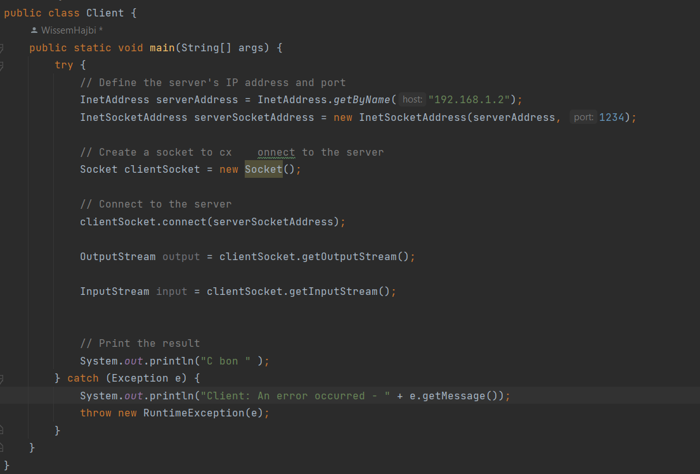

2 ) server :

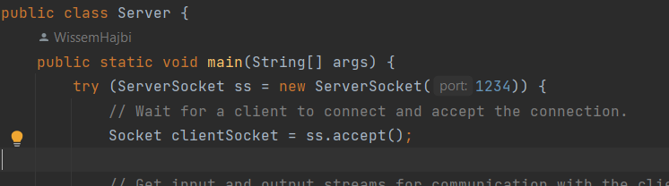

https://github.com/WissemHajbi/APP_REP/tree/master/TP1/Wissem_Hajbi_TP1/src