**Service -**

**IConversionRemote -**

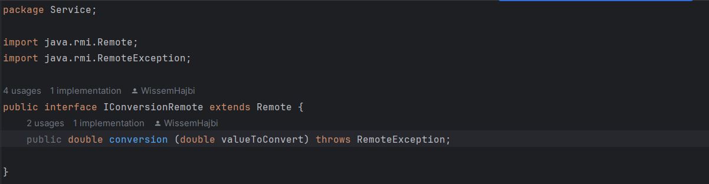

**IConversionImpl-**

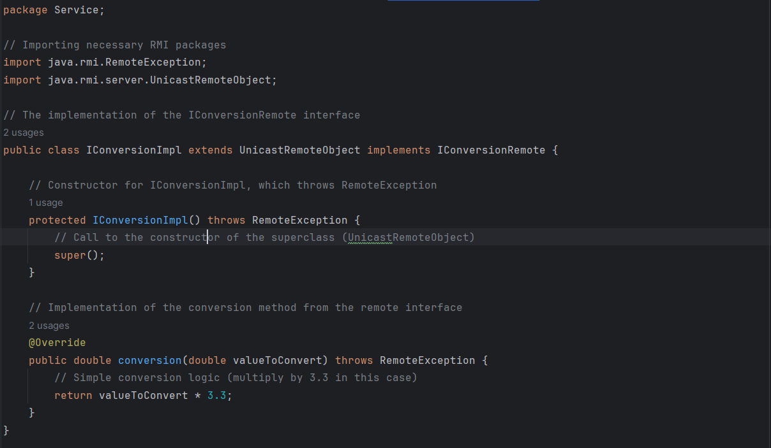

**RMIserver -**

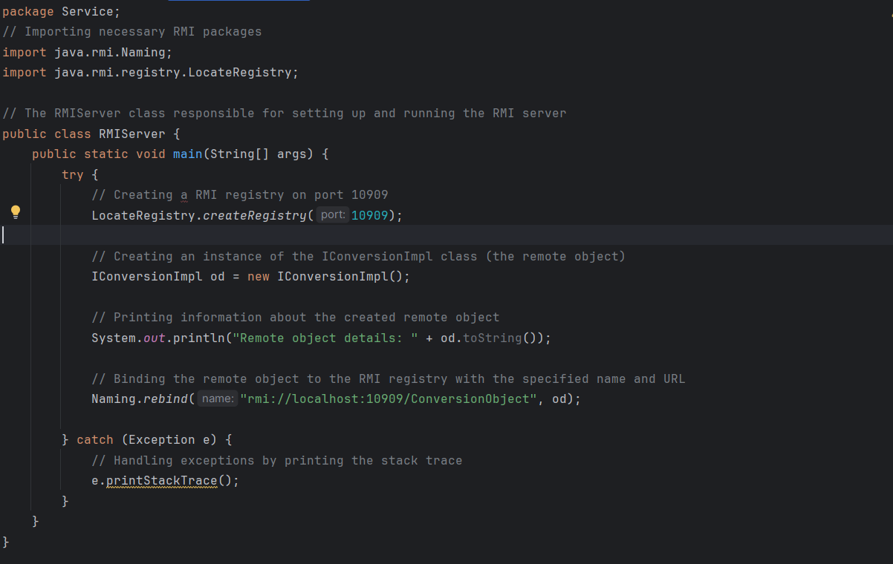

**Client -**

**RMIclient -**

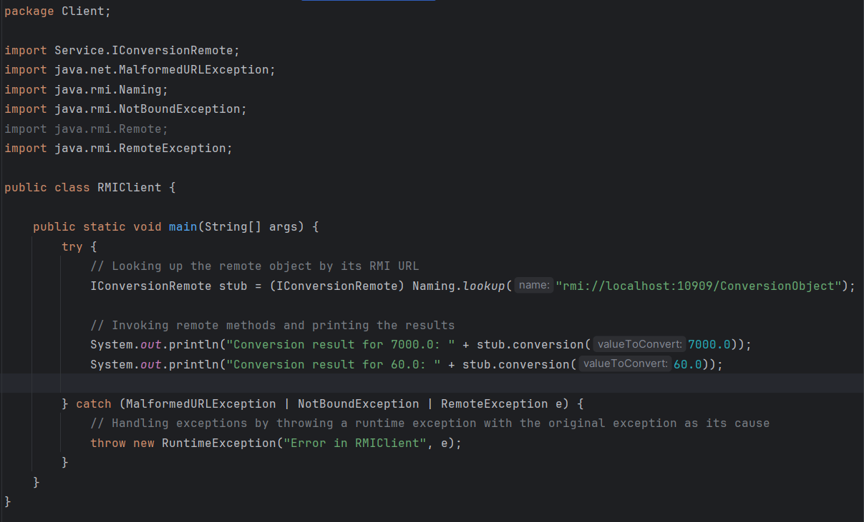

**IConversionRemote -**

**We need this interface from the service package.**



**https://github.com/WissemHajbi/rep**