SATELLITE REMOTE SENSING OF ICE MOTION

W.J. Emery, C.W. Fowler and J. Maslanik
CCAR Box 431
Univ. of Colorado
Boulder,Co., 80309

July 1993

A. INTRODUCTION
Displacement of sea ice over time is perhaps the most distinctive
feature in satellite images of the polar ice cover. Whereas in the past,
the only means of determining ice motion was by direct observation from
camps on the ice or from ice-bound ships and more recently, using
satellite-tracked buoys [1], satellite remote sensing now permits
operational tracking of ice movement over the entire Arctic and Antarctic
oceans, with a spatial coverage and detail not possible using field
observations.
Accurate tracking of sea ice motion on these spatial and temporal
scales can play important roles in applications ranging from climate
studies to ship operations. Since ice movement is an integral part of ice-
ocean-atmosphere interactions in the polar regions, ice displacement is a
key parameter in numerical models of polar processes and climate.
Remotely-sensed ice motions are a useful tool for verifying model
performance. In turn, combinations of satellite data with model output
improve prediction of ice movement that can assist in planning for
shipping and off-shore oil drilling operations in the polar regions.
Since sea ice moves relatively quickly (typically 10's of kilometers per
day in some areas), the key requirement of a remote sensing instrument
for ice-motion mapping is frequent repeat coverage. The extensive cloud
cover and low sun angles in polar regions place further limitations on
remote sensing. Within these general requirements, the types of satellite
instruments available offer a unique combination of advantages and
limitations. Visible-band and infrared sensors onboard meteorological
satellites, such as the Advanced Very High Resolution Radiometer (AVHRR)
on the Tiros platforms, cover the polar regions several times per day with
fields-of-view of approximately 1.1 km at nadir and 3.5 km at the swath
edge. Spatial coverage of the polar regions with AVHRR is excellent, with
the overlap of the passes at polar latitudes.
The main limitation of such visible and thermal-band sensors for ice-
motion mapping is cloud cover. In polar regions where cloud cover is
extensive and persistent, a cloud-free pair of images may not be available
for a particular area for weeks at a time. Visible-wavelength channels
are of course only useable during sunlit times from spring to fall. While
the thermal channels record brightness temperatures year round, they may
not be useful during parts of the summer when the open-ocean and sea-ice
surface temperatures are similar. In general then, only thermal images
are suitable for winter mapping, while visible-band images can be used
during the summer, and possibly both during parts of spring and fall
months.
Active microwave instruments such as synthetic aperture radar (SAR)
carried onboard ERS-1 and JERS-1 and planned for Radarsat provide much
higher spatial resolution (10's of meters) and can sense the surface in
virtually any type of weather. Given the relatively high spatial resolution
of the instrument, SAR data are particularly applicable to the study of
small scale ice movement in areas such as the marginal ice zones and
deforming ice. However, due to the large data volume and the associated
processing requirements, SAR imagers typically collect data along a fairly
narrow swath (hundreds of kilometers versus thousands of kilometers for
the AVHRR). The frequency of sampling individual locations is therefore
less, although the increase in overlap among orbits approaching the pole,
as well as variations in orbit configurations, can provide relatively
frequent coverage, such as the 3-day repeat cycle of ERS-1 [2].
Like radar, passive microwave sensors such as the Special Sensor
Microwave/Imager (SSM/I) onboard the Defense Meteorological Satellite
Program (DMSP) satellites offer the advantage of year-round operation
under all atmospheric conditions. However, passive microwave images
from satellites typically have spatial resolutions of 10's of kilometers -
insufficient to resolve the individual leads and floes needed to track the
motion of specific ice features. Large masses of ice with unique
emissivity properties can potentially be tracked over time, aided by the
frequent temporal sampling and multispectral capabilities of such
sensors.
With this introduction in mind, the following sections describe some of
the basic considerations involved in determining ice motion from satellite
data, and introduce some of the different techniques used to calculate ice
velocities.

B. TECHNIQUES
Image Registration:
Assuming that a pair of images has been assembled that cover
approximately the same area over a span of a few days, the first
processing issue that must be addressed to extract sea-ice motion is
image registration or geo-location. All satellite imagery has some
positioning error associated with the earth location of each pixel in the
imagery. This error arises from uncertainty in orbital modeling, the
precise time the data was collected by the satellite, modeling of the
shape of the earth, and knowledge of the pointing accuracy of the
instruments on the satellite. In the first stage of the geolocation
process, satellite time-and-position (ephemeris) data typically obtained
from government tracking sources are supplied to an orbit model to
calculate the earth location of pixels in the imagery. Error is introduced
by approximations within the orbital model, inaccuracies within the
original ephemeris, and unmodeled changes in the satellite positioning
between image acquisition time and the time the ephemeris was obtained.
As this time gap between ephemeris and image acquisition increases, the
error introduced by the model also increases and can become substantial.
Some satellites such as the TIROS platforms use an on-board clock that is
subject to drift and is corrected at intermittent intervals. Since this
clock-supplied time from the satellite may be wrong, the prediction of the
satellite position then will be incorrect. In addition, the pointing angles
of the instrument (e.g., roll, pitch, and yaw) may not be completely known.
The shape of the earth is modeled typically as an oblate spheroid, when
satellite data are projected to an approximation of the earth's surface.
Since the shape of the earth does not exactly fit the oblate spheriod
model, and map projections are local approximations of a spherical earth,
additional errors are introduced in this process.
The residual error from this initial orbit-modeling geolocation can be
reduced further by shifting or warping images based on specific
unchanging surface features such as coastlines or islands identifiable on
each image. Using these "control points," registration error can typically
be reduced to less than one pixel width. Even for sea ice images over open
ocean, the lack of immediate control points can be compensated for, by
using control points elsewhere in the orbit to compute the spacecraft
attitude. These attitude parameters can then be propagated in time to
produce one pixel accuracy in images without nearby control points.
A final consideration in the geolocation process is that the images
should be projected to a map grid that is close to equidistant. Then, by
knowing the pixel resolution, any displacement of the ice in pixel values
can be simply converted into velocities over the entire image. The most
common projection is the modified polar stereographic projection that,
while not a true equidistant projection, is suitable for most polar
applications.

Considerations of Error and Application on Choices of Imagery:
The desired application of ice-displacement products determines the
types of imagery used for ice-motion mapping. The choice of imagery is
driven by the required precision of the ice motions, as well as the
prevailing lighting and cloud cover conditions during the period of
interest.
Since ice motion computed from satellite imagery represents the
displacement between the acquisition times of the two images, these
motions do not represent instantaneous velocities. Changes in the speed
and direction of the ice can occur between the times the two images are
acquired, especially when the length of time between images becomes
greater. In turn, the spatial resolution of the imagery and the geolocation
accuracy control the precision with which ice displacements can be
mapped. Figure 1 describes this relationship between spatial resolution
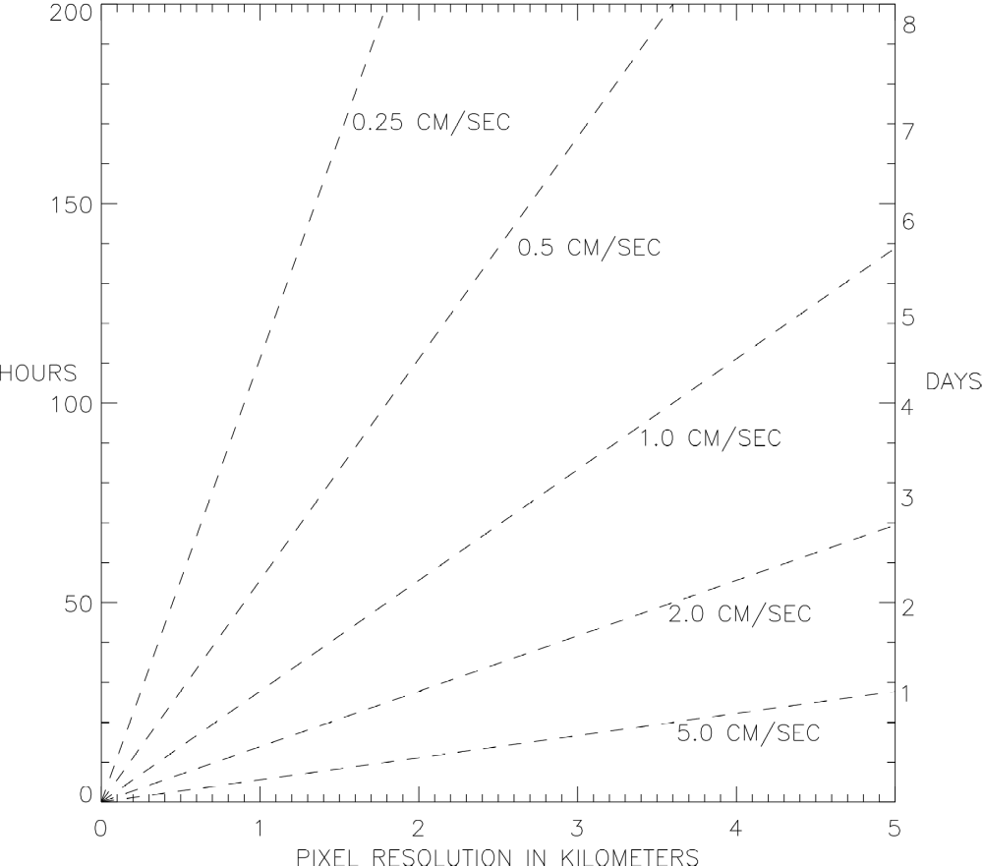
Fig. 1 Graph showing the relationship of image resolution,time
difference between images, and calculated velocity resolution.

and temporal sampling. For example, for AVHRR data at 1.1 km nadir
resolution and one day between image pairs, a velocity resolution of about
one cm/sec is possible. The four-km resolution Global Area Coverage
(GAC) AVHRR data allow velocity resolutions of slightly better than five
cm/sec for images separated by one day. SAR data at 100m resolution
with three days between image pairs would give very fine velocity
resolution better than 0.25 cm/sec. As can be seen, a trade-off exists
between resolution constraints and time difference between images.
Figure 1 also describes the effects of registration error. For example,
using the case of AVHRR data with a four-km resolution and assuming a
co-registration error of 1/2 pixel and 50 hours between images, an error
of +/- one cm/sec is possible for calculated vectors.
In addition to these considerations relating to required precision and
temporal sampling, the initial conversion of satellite radiances or
backscatter to representations of surface albedo, temperature, roughness,
or emissivity properties affects the suitability of specific sensors for
the desired application. Fortunately, these image calibration and post-
processing issues affect ice-motion mapping only in terms of the ability
to detect sea ice features. The only processing that may be needed is to
correct for sun angle, which in turn is only necessary for visible-band
data acquired at different times of day. Since the radiometric
relationships between spectral channels and between radiances and
geophysical features are not important, image enhancement routines can
be applied to assist in identifying ice leads and floes.

Spatial Correlation Methods:
While manual methods are suitable for some applications and for a
first-look at ice-atmosphere interactions, automated methods are clearly
desirable. An effective method for tracking displacements is the use of
correlations between sets of pixels between image pairs. A small target
area in one image is correlated with many areas of the same size in a
search region of the second image. The displacement of the ice is then
defined by the location in the second image where the correlation
coefficient is the highest. Although this process can be automated quite
easily, it makes the basic assumption that the sea-ice cover can be
treated as a solid, with the ice movement only a translation of this solid
plane (e.g., ignoring deformation and rotation of the ice). This assumption
is generally valid over short distances away from ice edges such as the
marginal ice zone where the ice is less constrained.
The selection of the sizes of the target and search windows in the
images depends upon several factors. The size of the target window
cannot be so large as to negate this solid-plane assumption, but the
window size must be large enough so that the correlation still has some
statistical significance. The size of the search window is dependent on
the expected displacement of the ice (fig. 2). The inside box is the target
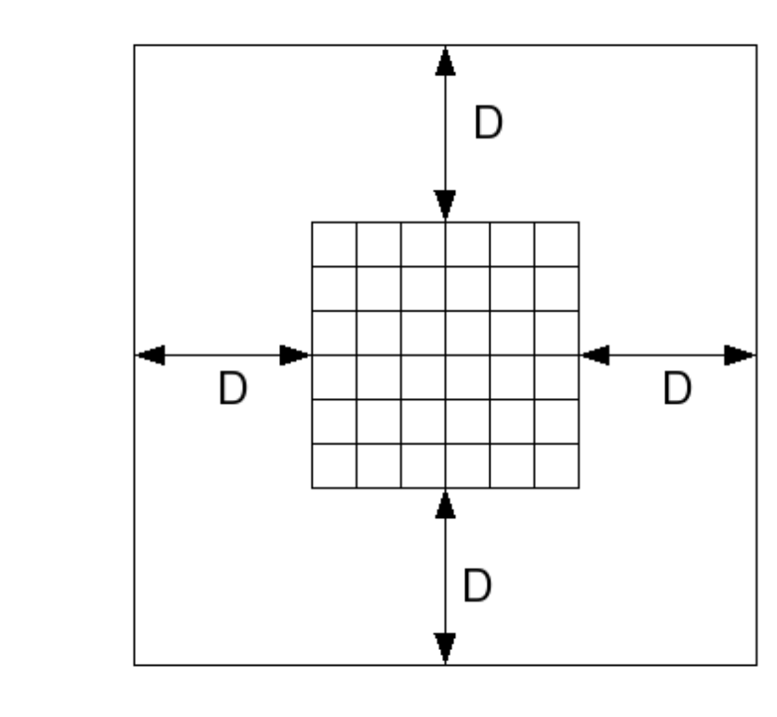
Fig. 2 Figure showing the search and target areas for correlation.

window and 'd' is the maximum distance in pixels that the ice is expected
to move. Cross-correlations are then computed at each possible location
within the search window. An example of the cross-correlation values for
a typical case (Fig. 3) show a peak where the maximum correlation
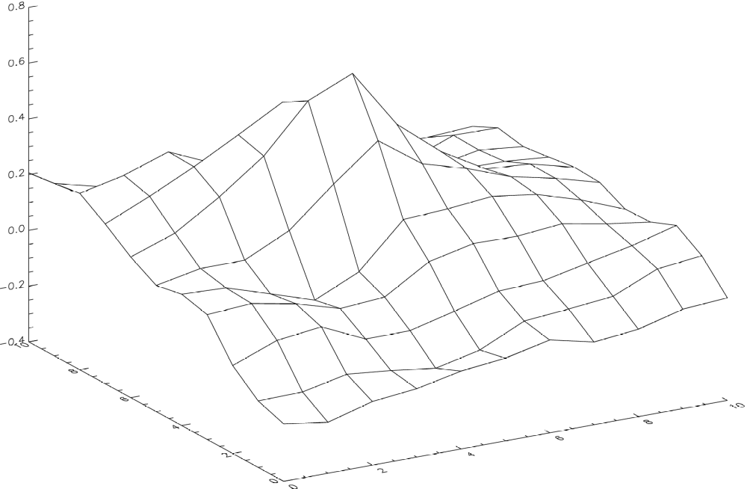
Fig. 3 Plot of correlation values from typical cross-correlation
calculations of search and target windows.

coefficient denotes the location of the ice movement. This method,
typically referred to as a Maximum Cross-Correlation (MCC) procedure, is
widely used [4][5], including applications to both AVHRR and SAR data
[6][7][8].
Since the number of correlations done in the MCC process is (2d+1)2,
computation time increases exponentially as the value for d (the maximum
ice movement distance) increases. If ice displacement is on the order of
tens of pixels, computation time can run into several hours or days using
typical workstation computers. One approach to speed the calculations is
through fast Fourier transforms (FFT). The FFT of the target window is
multiplied by the complex conjugate of the FFT of the search window. The
inverse FFT of the product will then show the lag or the amount of
displacement of the ice. For maximum efficiency, the windows should be
powers of two in size and the target window must be padded to the same
size as the search window. The padding and aliasing that occur with the
use of FFT's can introduce some error, but are not usually significant.
However, if any masking is done, such as of land masses or clouds, FFT's
may not be appropriate because all values in the image are used, and the
masked portions may force the ice velocity vector to a wrong value. The
direct method of calculating the correlation coefficient is preferable in
these cases.
A second approach to reducing computation time is by applying some
prior knowledge about likely ice conditions and motion. With this
knowledge in hand, the search window can be reduced in size. If such
knowledge is not available initially, reduced-resolution images can be
used to supply an low-resolution estimate of ice velocities that can then
be used as starting values, or seed points, in the full-resolution images.
In this "nested correlation" approach ([9],[10]), very small search windows
can be used.
Another method of speeding up the process is to calculate cross-
correlations at a reduced number of locations in the search window
through an iterative process in which the maximum correlation
coefficient is found and the size of the search window reduced at each
step. Looking again at fig. 3, the peak could be converged upon in just a
few steps. However, since multiple peaks may be present, care must be
taken to insure the method converges at the correct peak. Initial
knowledge about likely ice displacement is also available from wind
fields, which can explain as much as 70% of the variability in the ice
movement [11]. Gridded wind fields supplied by forecast models such as
the National Meteorological Center (NMC) and European Center for Medium-
range Weather Forecasts (ECMWF) can be used to estimate ice
displacement as a seed value to reduce the search window size as
described above.

An Example - AVHRR-Derived Ice Motions in the Beaufort Sea
To illustrate some of the basic processing steps needed in operational
ice-motion detection, we consider the problem of estimating ice
velocities from meteorological satellite imagery. Figs. 5 and 6 are AVHRR
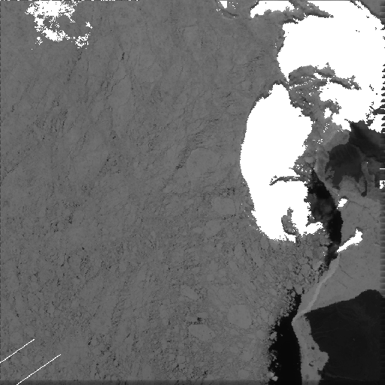
Fig. 5 AVHRR visible-image showing portion of Beaufort Sea on July 10, 1992. Image covers area of about 500 km by 500km
centered at 76N and -130W.

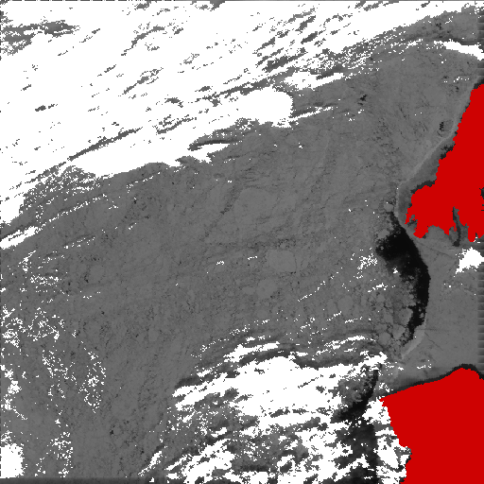
Fig. 6 Same as figure 5, except on July 11, 1992.

thermal-channel images in the Beaufort Sea acquired three days apart in
late fall (images are about 500 kilometers square and centered at 76 deg.
north latitude and -130 deg. west longitude, with a pixel spacing of one
km). Since cloud motion must somehow be distinguished from sea-ice
motion, a maximum likelihood classification is first used to detect and
mask out cloud-covered areas along with land areas. Unlike applications
such as sea-surface temperature calculations where pure clear-sky pixels
are desired, cloud-contaminated pixels can be used in the ice-motion
calculations as long as some surface features are visible.
The importance of cloud screening is demonstrated by applying the
direct method of calculating the ice displacements (target window of 10
by 10 and a maximum displacement of 5 pixels) from the images prior to
cloud detection. A fairly smooth field of ice velocities can be seen in the
middle of the resulting motion-vector plot (fig. 7), among other more
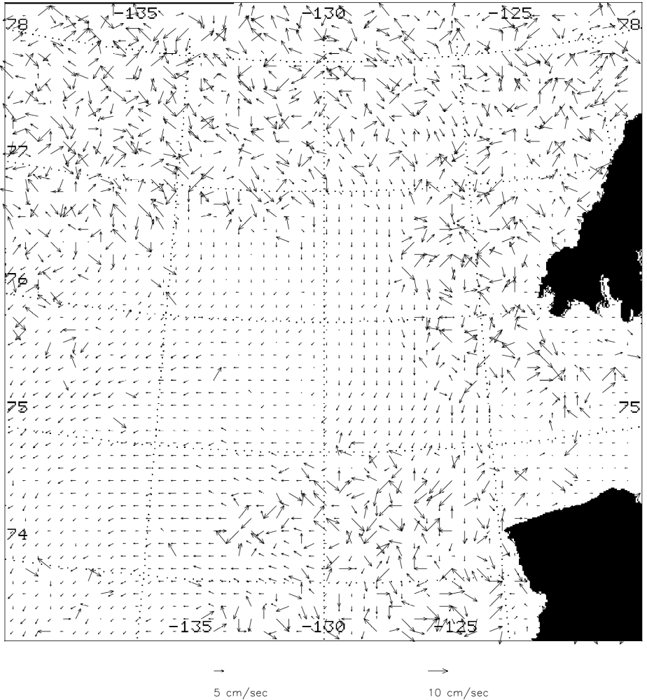

Fig. 7 Plot of all calculated vectors from the July 10 and 11
AVHRRimages.

chaotic vectors representing changes in cloud cover. Using the land and
cloud masked images, the "signal/noise" ratio is improved, although many
spurious vectors still remain along cloud edges. A spatial coherence
filter [5] and thresholding of the correlation coefficients can also be
applied to distinguish realistic ice motion vectors from cloud changes
(fig. 8). This filter assumes that the ice velocity field is fairly coherent
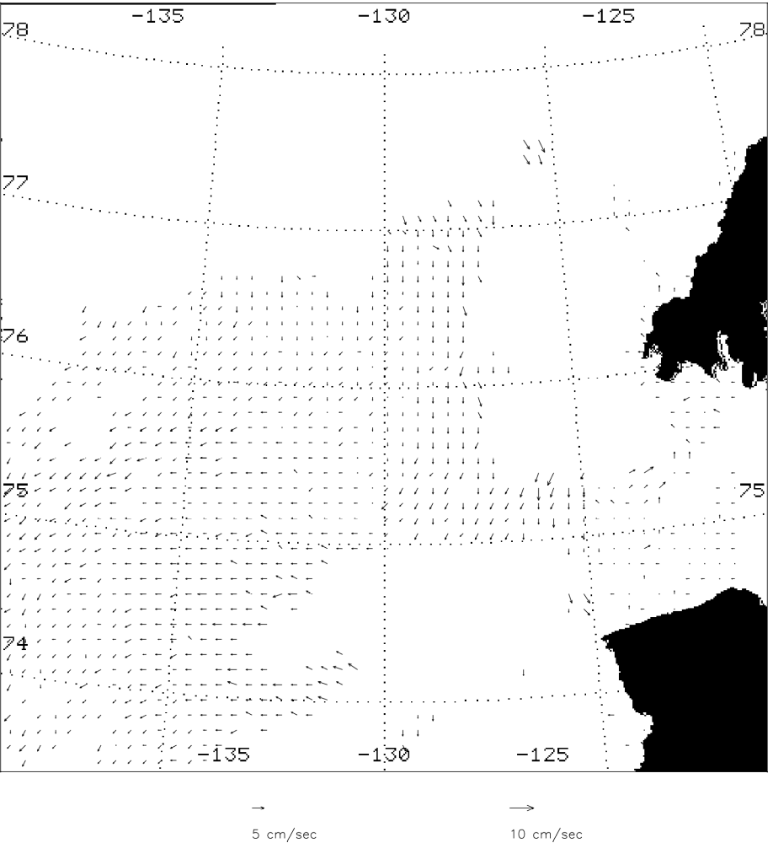
Fig. 8 Plot of vectors after using two filtering techniques: first, a
cutoff value was assigned to the correlation coefficients: and
second, a nearst neighbor filter was used.

locally. The filter compares neighboring vectors, and if displacement
differences between the center vector and the eight surrounding vectors
are less than two pixels, then the center vector is accepted as a "good"
vector. The filter parameters are changed depending upon the ice
conditions and location. While the spatial coherence filter alone could
potentially be used to remove cloud-related vectors (or alternatively, be
used as a cloud-detection procedure), a prior screening of the images to
mask out cloudy areas generally improves the resulting product.

