16 January, 2009 - Published 13:14 GMT

US banks bailout

The United States Treasury says it's agreed to provide Bank of America with $20bn in fresh government support. This cash injection comes on top of $25bn the bank has already received in aid. Here's our business reporter Mark Gregory:
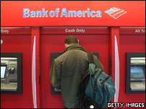
Listen to the story
This is the second massive injection of government cash for America's largest bank. It signifies that the crisis facing the world's leading financial institutions is far from over.
Bank of America needs the extra money to deal with unexpectedly severe debt problems at the investment group Merrill Lynch which it bought last September.
Meanwhile, in a further sign of the times, Citigroup, another US banking giant, has reported a thumping $8bn loss - worse than expected - for the final part of last year.
Mark Gregory, BBC
Listen to the words
massive injection
provision of a very large sum of money
signifies
means
facing
experienced by
far from over
very unlikely to be resolved soon
extra
more, additional
severe debt problems
the inability to pay back the money owed which has turned out to be very serious and even dangerous
in a further sign of the times
as another confirmation that current problems exist
banking giant
a very large bank
thumping
extremely large, huge

