OOPS
1.OOPS Basics:
I'm tying everything to a cozy cafe example (like one with a library corner, fresh pastries, and occasional live music events) because it feels relatable and fun. Makes the concepts stick better for me.

What Is Object-Oriented Programming?
OOP is a programming paradigm (way of thinking about code) that organizes software design around objects rather than functions or logic alone.
- Core idea: Everything is modeled as objects (instances of classes) that have data (attributes/properties) and behavior (methods/functions).
- Classes act like blueprints/templates.
- Objects are real instances created from those blueprints.
Quick mental note: It's like shifting from "what the program does step-by-step" to "what things exist and how they interact."
In our cafe example: Think of the cafe as a system full of objects – a Coffee object (with properties like type, temperature, price) that can brew() or serve(), a Customer object that can order() or readBook(), a Musician object that can perform().

Object-Oriented Programming Relation with the Real World & How It Solves Real-World Problems
OOP mirrors the real world super well – that's why it's powerful.
- Real world = full of entities (things) that have properties and actions.
- OOP lets us model these directly:
  - Entity - Class
  - Specific thing - Object
  - Properties - Fields/Attributes
  - Actions - Methods
This makes code intuitive and easier to understand/maintain.
Solving real-world problems: Complex systems (like managing a cafe) have many interacting parts. OOP breaks them into manageable objects that communicate (via method calls).
Cafe example:
- A busy evening with live music: Customers ordering pastries, musicians setting up, baristas making drinks.
- Without OOP: One giant list of steps (procedural mess).
- With OOP: Separate objects interact naturally – Customer calls order() on Menu, Barista handles prepareDrink(), EventManager schedules perform() for Musician.
It solves scalability: Add a new pastry type? Just create a new object subclass. Real-world changes map directly to code changes.

Why Study OOP & Why Is It Important?
- Most modern languages support OOP (Java, C++, TypeScript, Python, C#, etc.). Even multi-paradigm ones encourage it for larger projects.
- Makes code reusable, maintainable, scalable.
- Industry standard for big software (apps, games, web backends, enterprise systems).
- Helps think in abstractions – crucial for solving complex problems.
Personal note: For my internship, knowing OOP well shows I can handle real codebases, not just scripts. Managers love it because it reduces bugs in team projects.
In cafe context: Imagine scaling to a chain of cafes – OOP lets you reuse code for inventory, events, etc., across locations.

Advantages & Limitations of OOP
Advantages:
- Modularity - Easy to divide work in teams.
- Reusability - Inheritance, polymorphism.
- Maintainability - Change one class, affects objects predictably.
- Security - Encapsulation hides data.
- Real-world modeling - Intuitive (as above).
- Handles complexity better for large systems.
Limitations:
- Steeper learning curve than procedural.
- Overhead - More memory/runtime (objects, virtual tables).
- Over-engineering risk - Beginners force OOP everywhere, making simple things complex.
- Not always best for small scripts or performance-critical code (e.g., embedded systems).
- Can lead to deep inheritance hierarchies (hard to debug).
Note: For our small cafe sim, advantages outweigh – but for a tiny calculator, procedural might be simpler.

Difference Between Procedural and Object-Oriented Programming
Procedural (POP): Focus on procedures/functions. Data and functions are separate.
- Top-down approach.
- Functions call other functions.
- Global data accessible everywhere (risky).
OOP: Focus on objects. Data and functions bundled together.
- Bottom-up approach.
- Objects interact via messages (method calls).
- Data hidden inside objects.
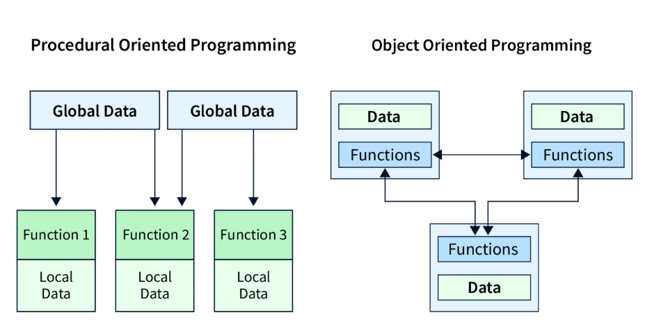

2. Classes and Objects:

What is a Class
A class is basically a blueprint.
Not a real thing yet, just a definition of what something should have and can do.
It defines:
- what data an object will store
- what actions it can perform
Important thing I noted:
A class doesn’t take memory on its own. Until you create an object, nothing really exists.
I kept comparing it to:
- a recipe (instructions, not the food)
- an architectural plan (design, not building)
Cafe analogy helped again.
The class is like the design plan for our cafe — layout idea, menu structure, rules for events.
But no customers, no coffee smell yet.

What is an Object
An object is the real thing created from a class.
Once object is created, memory is allocated and values are real.
So:
- class = idea
- object = actual instance
Multiple objects can come from same class, but each one can have different state.
This part confused me early, but example helped.
Cafe version:
- Class → Cafe blueprint
- Object → actual cafe running right now
  - tables placed
  - pastries baking
  - someone reading book, music playing
Objects interacting is what makes program do something.
Without objects, class just sits there.
Personal note: Class = plan (reusable), Object = what customers experience (unique each time).

Use of Classes and Objects Inside and Outside of Main Class
- Inside the main class: Often for testing/demo – create objects in main() method to show how things work.
- Outside: Real-world – classes in separate files/packages, objects created wherever needed (other classes, modules).
In big projects, classes are spread across files, objects passed around.

Can Class and Object Exist or Use Individually?
- Class: Yes, can exist without objects (e.g., abstract class, or just defined but never instantiated).
- Object: No – cannot exist without a class. Every object needs a class as its template.
Extra: Static members (like class variables/methods) can be used without creating objects – e.g., a cafe chain's shared loyalty program rules.
3. Keywords:
These keywords are the "special words" that give OOP its power – controlling behavior, inheritance, memory, etc. They're not in every language the same way

1. Static Keyword
Definition: Belongs to the class itself, not instances/objects. Shared across all objects.
Uses: Class-level variables/methods (e.g., counters, utility functions).
Pros: Memory efficient (one copy), easy access without object. Cons: No access to instance data, can lead to global-like state (hard to test/debug).
Why important: For shared data/behavior, like tracking total customers in the cafe.
Cafe example: A static totalSales in Cafe class – shared across all cafe branches.

