Use case level 0

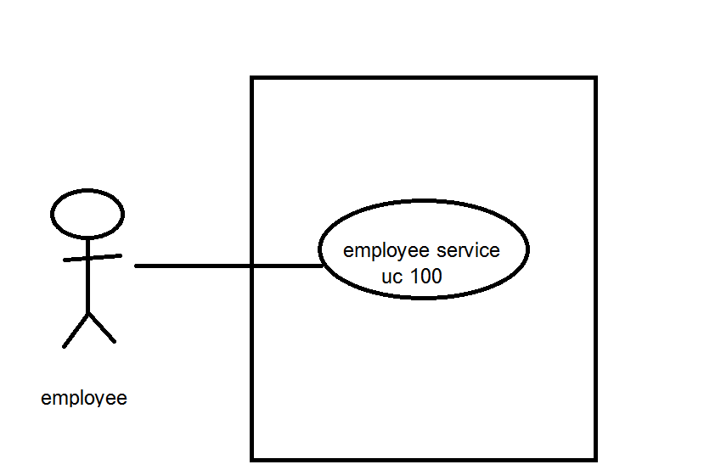

Use case level 1

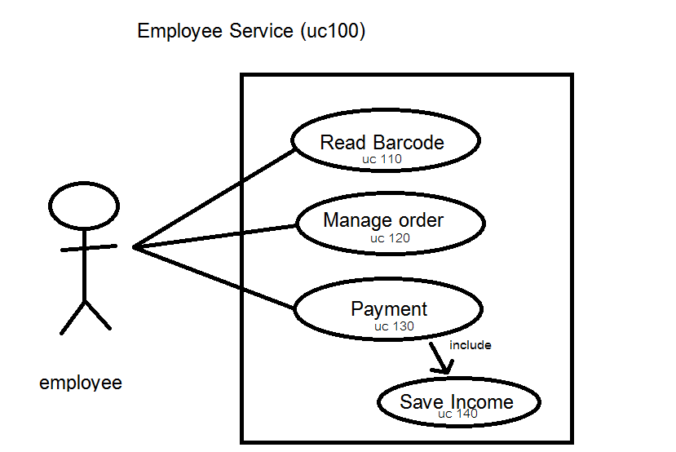

UC 110:Read Barcode



UC120:Manage order



UC130 : Payment

UC140 : Save income

Sequence Daigram

UC110:Read Barcode



UC120:Manage Order

UC130: Payment

UC140:save income