**ระบบลูกหนี้**

**1.USE CASE**

**ระบบลูกหนี้ UC100**

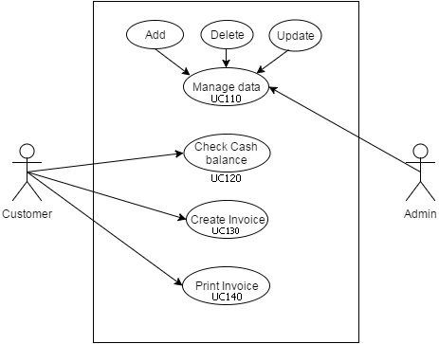

**2.MVC Model**

2.1 Manage data UC110

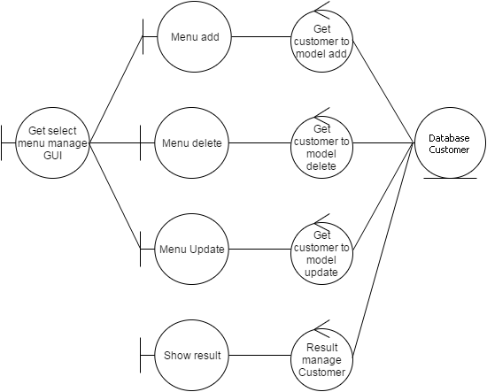

2.2 Check Cash balance UC120

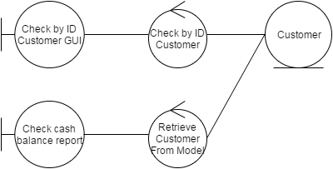

2.3 Create Invoice UC130

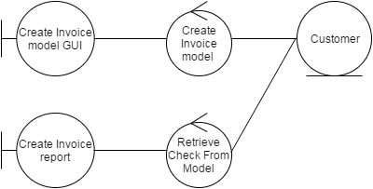

2.4 Print Invoice UC140

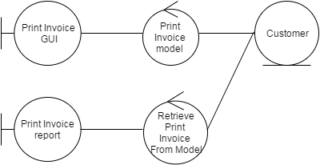

**3. Sequence Diagram**

3.1 Manage data UC110



3.2 Check Cash balance UC120



3.3 Create Invoice UC130



3.4 Print Invoice UC140

