Class06 github

Zhuohang Wu

January 24, 2019

### Class06

## Section 1 : reading files again

HahHahaHahahAhHAhahahahahahAhaahaHaHahaahaHaAhAH!!!!!!!!!!

plot(1:50)

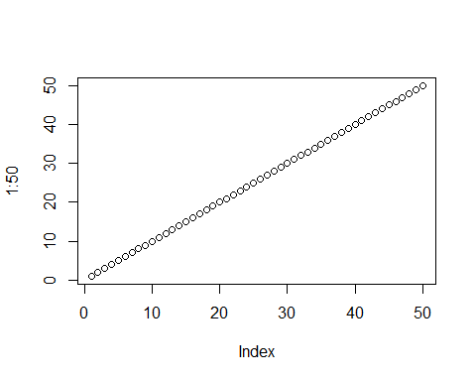

HehehHehheHEHeHehehehHeheheHhEhEhehehEHhEh!!!!!!!

read.table("https://bioboot.github.io/bimm143_W19/class-material/test1.txt", header= TRUE, sep=",")

## Col1 Col2 Col3  
## 1 1 2 3  
## 2 4 5 6  
## 3 7 8 9  
## 4 a b c

read.table("https://bioboot.github.io/bimm143_W19/class-material/test2.txt", header=TRUE, sep="$")

## Col1 Col2 Col3  
## 1 1 2 3  
## 2 4 5 6  
## 3 7 8 9  
## 4 a b c

read.table("https://bioboot.github.io/bimm143_W19/class-material/test3.txt", col.names = c("A","B","C"), row.names = c("!","@","#","$","%"), sep="")

## A B C  
## ! 1 6 a  
## @ 2 7 b  
## # 3 8 c  
## $ 4 9 d  
## % 5 10 e

data1 <- read.csv("https://bioboot.github.io/bimm143_W19/class-material/test1.txt")  
data1

## Col1 Col2 Col3  
## 1 1 2 3  
## 2 4 5 6  
## 3 7 8 9  
## 4 a b c

data2 <- read.csv("https://bioboot.github.io/bimm143_W19/class-material/test2.txt")  
data2

## Col1.Col2.Col3  
## 1 1$2$3  
## 2 4$5$6  
## 3 7$8$9  
## 4 a$b$c

data3 <- read.csv("https://bioboot.github.io/bimm143_W19/class-material/test3.txt")  
data3

## X1...6...a  
## 1 2 7 b  
## 2 3 8 c   
## 3 4 9 d  
## 4 5 10 e

A_Math_Problem <- function(x)  
{  
 y <- (x^4)   
 z <-( y+9)  
 print(y)  
 print(z)  
}  
  
A_Math_Problem(2)

## [1] 16  
## [1] 25

A_Math_Problem(56)

## [1] 9834496  
## [1] 9834505

library(bio3d)  
Kinase <- function(s){  
 s1 <- read.pdb("4AKE") # kinase with drug  
 s2 <- read.pdb("1AKE") # kinase no drug  
 s3 <- read.pdb("1E4Y") # kinase with drug  
 if(s == 1){  
 s1.chainA <- trim.pdb(s1, chain="A", elety="CA")  
 s1.b <- s1.chainA$atom$b  
 plotb3(s1.b, sse=s1.chainA, typ="l", ylab="Bfactor")  
 return()  
 }  
 if(s <- 2){  
 s2.chainA <- trim.pdb(s2, chain="A", elety="CA")  
 s2.b <- s2.chainA$atom$b  
 plotb3(s2.b, sse=s1.chainA, typ="l", ylab="Bfactor")  
 return  
 }  
 if(s <- 3){  
 s3.chainA <- trim.pdb(s1, chain="A", elety="CA")  
 s3.b <- s3.chainA$atom$b  
 plotb3(s3.b, sse=s1.chainA, typ="l", ylab="Bfactor")  
 return  
 }  
}

Kinase(1)

## Note: Accessing on-line PDB file  
## Note: Accessing on-line PDB file  
## PDB has ALT records, taking A only, rm.alt=TRUE  
## Note: Accessing on-line PDB file

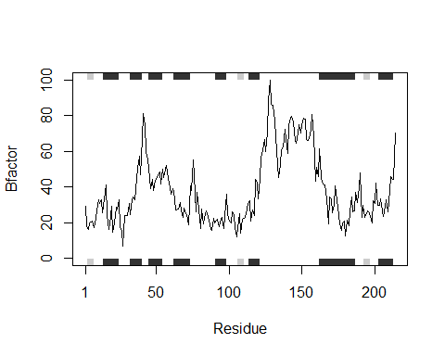

## NULL