class09

Zhuohang Wu

February 7, 2019

wisc.df <- read.csv("WisconsinCancer.csv")  
  
wisc.data <- as.matrix(wisc.df[,3:32])  
row.names(wisc.data) <- wisc.df$id  
diagnosis <- as.numeric(wisc.df$diagnosis)  
table(wisc.df$diagnosis)

##   
## B M   
## 357 212

View(diagnosis)

tmp <- rep(0,nrow(wisc.df))  
as.numeric(wisc.df$diagnosis=="M")

## [1] 1 1 1 1 1 1 1 1 1 1 1 1 1 1 1 1 1 1 1 0 0 0 1 1 1 1 1 1 1 1 1 1 1 1 1  
## [36] 1 1 0 1 1 1 1 1 1 1 1 0 1 0 0 0 0 0 1 1 0 1 1 0 0 0 0 1 0 1 1 0 0 0 0  
## [71] 1 0 1 1 0 1 0 1 1 0 0 0 1 1 0 1 1 1 0 0 0 1 0 0 1 1 0 0 0 1 1 0 0 0 0  
## [106] 1 0 0 1 0 0 0 0 0 0 0 0 1 1 1 0 1 1 0 0 0 1 1 0 1 0 1 1 0 1 1 0 0 1 0  
## [141] 0 1 0 0 0 0 1 0 0 0 0 0 0 0 0 0 1 0 0 0 0 1 1 0 1 0 0 1 1 0 0 1 1 0 0  
## [176] 0 0 1 0 0 1 1 1 0 1 0 1 0 0 0 1 0 0 1 1 0 1 1 1 1 0 1 1 1 0 1 0 1 0 0  
## [211] 1 0 1 1 1 1 0 0 1 1 0 0 0 1 0 0 0 0 0 1 1 0 0 1 0 0 1 1 0 1 0 0 0 0 1  
## [246] 0 0 0 0 0 1 0 1 1 1 1 1 1 1 1 1 1 1 1 1 1 0 0 0 0 0 0 1 0 1 0 0 1 0 0  
## [281] 1 0 1 1 0 0 0 0 0 0 0 0 0 0 0 0 0 1 0 0 1 0 1 0 0 0 0 0 0 0 0 0 0 0 0  
## [316] 0 0 1 0 0 0 1 0 1 0 0 0 0 1 1 1 0 0 0 0 1 0 1 0 1 0 0 0 1 0 0 0 0 0 0  
## [351] 0 1 1 1 0 0 0 0 0 0 0 0 0 0 0 1 1 0 1 1 1 0 1 1 0 0 0 0 0 1 0 0 0 0 0  
## [386] 1 0 0 0 1 0 0 1 1 0 0 0 0 0 0 1 0 0 0 0 0 0 0 1 0 0 0 0 0 1 0 0 1 0 0  
## [421] 0 0 0 0 0 0 0 0 0 0 1 0 1 1 0 1 0 0 0 0 0 1 0 0 1 0 1 0 0 1 0 1 0 0 0  
## [456] 0 0 0 0 0 1 1 0 0 0 0 0 0 1 0 0 0 0 0 0 0 0 0 0 1 0 0 0 0 0 0 0 1 0 1  
## [491] 0 0 1 0 0 0 0 0 1 1 0 1 0 1 0 0 0 0 0 1 0 0 1 0 1 0 1 1 0 0 0 1 0 0 0  
## [526] 0 0 0 0 0 0 0 0 1 0 1 1 0 0 0 0 0 0 0 0 0 0 0 0 0 0 0 0 0 0 0 0 0 0 0  
## [561] 0 0 1 1 1 1 1 1 0

cbind(diagnosis,wisc.df$diagnosis)

## diagnosis   
## [1,] 2 2  
## [2,] 2 2  
## [3,] 2 2  
## [4,] 2 2  
## [5,] 2 2  
## [6,] 2 2  
## [7,] 2 2  
## [8,] 2 2  
## [9,] 2 2  
## [10,] 2 2  
## [11,] 2 2  
## [12,] 2 2  
## [13,] 2 2  
## [14,] 2 2  
## [15,] 2 2  
## [16,] 2 2  
## [17,] 2 2  
## [18,] 2 2  
## [19,] 2 2  
## [20,] 1 1  
## [21,] 1 1  
## [22,] 1 1  
## [23,] 2 2  
## [24,] 2 2  
## [25,] 2 2  
## [26,] 2 2  
## [27,] 2 2  
## [28,] 2 2  
## [29,] 2 2  
## [30,] 2 2  
## [31,] 2 2  
## [32,] 2 2  
## [33,] 2 2  
## [34,] 2 2  
## [35,] 2 2  
## [36,] 2 2  
## [37,] 2 2  
## [38,] 1 1  
## [39,] 2 2  
## [40,] 2 2  
## [41,] 2 2  
## [42,] 2 2  
## [43,] 2 2  
## [44,] 2 2  
## [45,] 2 2  
## [46,] 2 2  
## [47,] 1 1  
## [48,] 2 2  
## [49,] 1 1  
## [50,] 1 1  
## [51,] 1 1  
## [52,] 1 1  
## [53,] 1 1  
## [54,] 2 2  
## [55,] 2 2  
## [56,] 1 1  
## [57,] 2 2  
## [58,] 2 2  
## [59,] 1 1  
## [60,] 1 1  
## [61,] 1 1  
## [62,] 1 1  
## [63,] 2 2  
## [64,] 1 1  
## [65,] 2 2  
## [66,] 2 2  
## [67,] 1 1  
## [68,] 1 1  
## [69,] 1 1  
## [70,] 1 1  
## [71,] 2 2  
## [72,] 1 1  
## [73,] 2 2  
## [74,] 2 2  
## [75,] 1 1  
## [76,] 2 2  
## [77,] 1 1  
## [78,] 2 2  
## [79,] 2 2  
## [80,] 1 1  
## [81,] 1 1  
## [82,] 1 1  
## [83,] 2 2  
## [84,] 2 2  
## [85,] 1 1  
## [86,] 2 2  
## [87,] 2 2  
## [88,] 2 2  
## [89,] 1 1  
## [90,] 1 1  
## [91,] 1 1  
## [92,] 2 2  
## [93,] 1 1  
## [94,] 1 1  
## [95,] 2 2  
## [96,] 2 2  
## [97,] 1 1  
## [98,] 1 1  
## [99,] 1 1  
## [100,] 2 2  
## [101,] 2 2  
## [102,] 1 1  
## [103,] 1 1  
## [104,] 1 1  
## [105,] 1 1  
## [106,] 2 2  
## [107,] 1 1  
## [108,] 1 1  
## [109,] 2 2  
## [110,] 1 1  
## [111,] 1 1  
## [112,] 1 1  
## [113,] 1 1  
## [114,] 1 1  
## [115,] 1 1  
## [116,] 1 1  
## [117,] 1 1  
## [118,] 2 2  
## [119,] 2 2  
## [120,] 2 2  
## [121,] 1 1  
## [122,] 2 2  
## [123,] 2 2  
## [124,] 1 1  
## [125,] 1 1  
## [126,] 1 1  
## [127,] 2 2  
## [128,] 2 2  
## [129,] 1 1  
## [130,] 2 2  
## [131,] 1 1  
## [132,] 2 2  
## [133,] 2 2  
## [134,] 1 1  
## [135,] 2 2  
## [136,] 2 2  
## [137,] 1 1  
## [138,] 1 1  
## [139,] 2 2  
## [140,] 1 1  
## [141,] 1 1  
## [142,] 2 2  
## [143,] 1 1  
## [144,] 1 1  
## [145,] 1 1  
## [146,] 1 1  
## [147,] 2 2  
## [148,] 1 1  
## [149,] 1 1  
## [150,] 1 1  
## [151,] 1 1  
## [152,] 1 1  
## [153,] 1 1  
## [154,] 1 1  
## [155,] 1 1  
## [156,] 1 1  
## [157,] 2 2  
## [158,] 1 1  
## [159,] 1 1  
## [160,] 1 1  
## [161,] 1 1  
## [162,] 2 2  
## [163,] 2 2  
## [164,] 1 1  
## [165,] 2 2  
## [166,] 1 1  
## [167,] 1 1  
## [168,] 2 2  
## [169,] 2 2  
## [170,] 1 1  
## [171,] 1 1  
## [172,] 2 2  
## [173,] 2 2  
## [174,] 1 1  
## [175,] 1 1  
## [176,] 1 1  
## [177,] 1 1  
## [178,] 2 2  
## [179,] 1 1  
## [180,] 1 1  
## [181,] 2 2  
## [182,] 2 2  
## [183,] 2 2  
## [184,] 1 1  
## [185,] 2 2  
## [186,] 1 1  
## [187,] 2 2  
## [188,] 1 1  
## [189,] 1 1  
## [190,] 1 1  
## [191,] 2 2  
## [192,] 1 1  
## [193,] 1 1  
## [194,] 2 2  
## [195,] 2 2  
## [196,] 1 1  
## [197,] 2 2  
## [198,] 2 2  
## [199,] 2 2  
## [200,] 2 2  
## [201,] 1 1  
## [202,] 2 2  
## [203,] 2 2  
## [204,] 2 2  
## [205,] 1 1  
## [206,] 2 2  
## [207,] 1 1  
## [208,] 2 2  
## [209,] 1 1  
## [210,] 1 1  
## [211,] 2 2  
## [212,] 1 1  
## [213,] 2 2  
## [214,] 2 2  
## [215,] 2 2  
## [216,] 2 2  
## [217,] 1 1  
## [218,] 1 1  
## [219,] 2 2  
## [220,] 2 2  
## [221,] 1 1  
## [222,] 1 1  
## [223,] 1 1  
## [224,] 2 2  
## [225,] 1 1  
## [226,] 1 1  
## [227,] 1 1  
## [228,] 1 1  
## [229,] 1 1  
## [230,] 2 2  
## [231,] 2 2  
## [232,] 1 1  
## [233,] 1 1  
## [234,] 2 2  
## [235,] 1 1  
## [236,] 1 1  
## [237,] 2 2  
## [238,] 2 2  
## [239,] 1 1  
## [240,] 2 2  
## [241,] 1 1  
## [242,] 1 1  
## [243,] 1 1  
## [244,] 1 1  
## [245,] 2 2  
## [246,] 1 1  
## [247,] 1 1  
## [248,] 1 1  
## [249,] 1 1  
## [250,] 1 1  
## [251,] 2 2  
## [252,] 1 1  
## [253,] 2 2  
## [254,] 2 2  
## [255,] 2 2  
## [256,] 2 2  
## [257,] 2 2  
## [258,] 2 2  
## [259,] 2 2  
## [260,] 2 2  
## [261,] 2 2  
## [262,] 2 2  
## [263,] 2 2  
## [264,] 2 2  
## [265,] 2 2  
## [266,] 2 2  
## [267,] 1 1  
## [268,] 1 1  
## [269,] 1 1  
## [270,] 1 1  
## [271,] 1 1  
## [272,] 1 1  
## [273,] 2 2  
## [274,] 1 1  
## [275,] 2 2  
## [276,] 1 1  
## [277,] 1 1  
## [278,] 2 2  
## [279,] 1 1  
## [280,] 1 1  
## [281,] 2 2  
## [282,] 1 1  
## [283,] 2 2  
## [284,] 2 2  
## [285,] 1 1  
## [286,] 1 1  
## [287,] 1 1  
## [288,] 1 1  
## [289,] 1 1  
## [290,] 1 1  
## [291,] 1 1  
## [292,] 1 1  
## [293,] 1 1  
## [294,] 1 1  
## [295,] 1 1  
## [296,] 1 1  
## [297,] 1 1  
## [298,] 2 2  
## [299,] 1 1  
## [300,] 1 1  
## [301,] 2 2  
## [302,] 1 1  
## [303,] 2 2  
## [304,] 1 1  
## [305,] 1 1  
## [306,] 1 1  
## [307,] 1 1  
## [308,] 1 1  
## [309,] 1 1  
## [310,] 1 1  
## [311,] 1 1  
## [312,] 1 1  
## [313,] 1 1  
## [314,] 1 1  
## [315,] 1 1  
## [316,] 1 1  
## [317,] 1 1  
## [318,] 2 2  
## [319,] 1 1  
## [320,] 1 1  
## [321,] 1 1  
## [322,] 2 2  
## [323,] 1 1  
## [324,] 2 2  
## [325,] 1 1  
## [326,] 1 1  
## [327,] 1 1  
## [328,] 1 1  
## [329,] 2 2  
## [330,] 2 2  
## [331,] 2 2  
## [332,] 1 1  
## [333,] 1 1  
## [334,] 1 1  
## [335,] 1 1  
## [336,] 2 2  
## [337,] 1 1  
## [338,] 2 2  
## [339,] 1 1  
## [340,] 2 2  
## [341,] 1 1  
## [342,] 1 1  
## [343,] 1 1  
## [344,] 2 2  
## [345,] 1 1  
## [346,] 1 1  
## [347,] 1 1  
## [348,] 1 1  
## [349,] 1 1  
## [350,] 1 1  
## [351,] 1 1  
## [352,] 2 2  
## [353,] 2 2  
## [354,] 2 2  
## [355,] 1 1  
## [356,] 1 1  
## [357,] 1 1  
## [358,] 1 1  
## [359,] 1 1  
## [360,] 1 1  
## [361,] 1 1  
## [362,] 1 1  
## [363,] 1 1  
## [364,] 1 1  
## [365,] 1 1  
## [366,] 2 2  
## [367,] 2 2  
## [368,] 1 1  
## [369,] 2 2  
## [370,] 2 2  
## [371,] 2 2  
## [372,] 1 1  
## [373,] 2 2  
## [374,] 2 2  
## [375,] 1 1  
## [376,] 1 1  
## [377,] 1 1  
## [378,] 1 1  
## [379,] 1 1  
## [380,] 2 2  
## [381,] 1 1  
## [382,] 1 1  
## [383,] 1 1  
## [384,] 1 1  
## [385,] 1 1  
## [386,] 2 2  
## [387,] 1 1  
## [388,] 1 1  
## [389,] 1 1  
## [390,] 2 2  
## [391,] 1 1  
## [392,] 1 1  
## [393,] 2 2  
## [394,] 2 2  
## [395,] 1 1  
## [396,] 1 1  
## [397,] 1 1  
## [398,] 1 1  
## [399,] 1 1  
## [400,] 1 1  
## [401,] 2 2  
## [402,] 1 1  
## [403,] 1 1  
## [404,] 1 1  
## [405,] 1 1  
## [406,] 1 1  
## [407,] 1 1  
## [408,] 1 1  
## [409,] 2 2  
## [410,] 1 1  
## [411,] 1 1  
## [412,] 1 1  
## [413,] 1 1  
## [414,] 1 1  
## [415,] 2 2  
## [416,] 1 1  
## [417,] 1 1  
## [418,] 2 2  
## [419,] 1 1  
## [420,] 1 1  
## [421,] 1 1  
## [422,] 1 1  
## [423,] 1 1  
## [424,] 1 1  
## [425,] 1 1  
## [426,] 1 1  
## [427,] 1 1  
## [428,] 1 1  
## [429,] 1 1  
## [430,] 1 1  
## [431,] 2 2  
## [432,] 1 1  
## [433,] 2 2  
## [434,] 2 2  
## [435,] 1 1  
## [436,] 2 2  
## [437,] 1 1  
## [438,] 1 1  
## [439,] 1 1  
## [440,] 1 1  
## [441,] 1 1  
## [442,] 2 2  
## [443,] 1 1  
## [444,] 1 1  
## [445,] 2 2  
## [446,] 1 1  
## [447,] 2 2  
## [448,] 1 1  
## [449,] 1 1  
## [450,] 2 2  
## [451,] 1 1  
## [452,] 2 2  
## [453,] 1 1  
## [454,] 1 1  
## [455,] 1 1  
## [456,] 1 1  
## [457,] 1 1  
## [458,] 1 1  
## [459,] 1 1  
## [460,] 1 1  
## [461,] 2 2  
## [462,] 2 2  
## [463,] 1 1  
## [464,] 1 1  
## [465,] 1 1  
## [466,] 1 1  
## [467,] 1 1  
## [468,] 1 1  
## [469,] 2 2  
## [470,] 1 1  
## [471,] 1 1  
## [472,] 1 1  
## [473,] 1 1  
## [474,] 1 1  
## [475,] 1 1  
## [476,] 1 1  
## [477,] 1 1  
## [478,] 1 1  
## [479,] 1 1  
## [480,] 2 2  
## [481,] 1 1  
## [482,] 1 1  
## [483,] 1 1  
## [484,] 1 1  
## [485,] 1 1  
## [486,] 1 1  
## [487,] 1 1  
## [488,] 2 2  
## [489,] 1 1  
## [490,] 2 2  
## [491,] 1 1  
## [492,] 1 1  
## [493,] 2 2  
## [494,] 1 1  
## [495,] 1 1  
## [496,] 1 1  
## [497,] 1 1  
## [498,] 1 1  
## [499,] 2 2  
## [500,] 2 2  
## [501,] 1 1  
## [502,] 2 2  
## [503,] 1 1  
## [504,] 2 2  
## [505,] 1 1  
## [506,] 1 1  
## [507,] 1 1  
## [508,] 1 1  
## [509,] 1 1  
## [510,] 2 2  
## [511,] 1 1  
## [512,] 1 1  
## [513,] 2 2  
## [514,] 1 1  
## [515,] 2 2  
## [516,] 1 1  
## [517,] 2 2  
## [518,] 2 2  
## [519,] 1 1  
## [520,] 1 1  
## [521,] 1 1  
## [522,] 2 2  
## [523,] 1 1  
## [524,] 1 1  
## [525,] 1 1  
## [526,] 1 1  
## [527,] 1 1  
## [528,] 1 1  
## [529,] 1 1  
## [530,] 1 1  
## [531,] 1 1  
## [532,] 1 1  
## [533,] 1 1  
## [534,] 2 2  
## [535,] 1 1  
## [536,] 2 2  
## [537,] 2 2  
## [538,] 1 1  
## [539,] 1 1  
## [540,] 1 1  
## [541,] 1 1  
## [542,] 1 1  
## [543,] 1 1  
## [544,] 1 1  
## [545,] 1 1  
## [546,] 1 1  
## [547,] 1 1  
## [548,] 1 1  
## [549,] 1 1  
## [550,] 1 1  
## [551,] 1 1  
## [552,] 1 1  
## [553,] 1 1  
## [554,] 1 1  
## [555,] 1 1  
## [556,] 1 1  
## [557,] 1 1  
## [558,] 1 1  
## [559,] 1 1  
## [560,] 1 1  
## [561,] 1 1  
## [562,] 1 1  
## [563,] 2 2  
## [564,] 2 2  
## [565,] 2 2  
## [566,] 2 2  
## [567,] 2 2  
## [568,] 2 2  
## [569,] 1 1

colMeans(wisc.data)

## radius_mean texture_mean perimeter_mean   
## 1.412729e+01 1.928965e+01 9.196903e+01   
## area_mean smoothness_mean compactness_mean   
## 6.548891e+02 9.636028e-02 1.043410e-01   
## concavity_mean concave.points_mean symmetry_mean   
## 8.879932e-02 4.891915e-02 1.811619e-01   
## fractal_dimension_mean radius_se texture_se   
## 6.279761e-02 4.051721e-01 1.216853e+00   
## perimeter_se area_se smoothness_se   
## 2.866059e+00 4.033708e+01 7.040979e-03   
## compactness_se concavity_se concave.points_se   
## 2.547814e-02 3.189372e-02 1.179614e-02   
## symmetry_se fractal_dimension_se radius_worst   
## 2.054230e-02 3.794904e-03 1.626919e+01   
## texture_worst perimeter_worst area_worst   
## 2.567722e+01 1.072612e+02 8.805831e+02   
## smoothness_worst compactness_worst concavity_worst   
## 1.323686e-01 2.542650e-01 2.721885e-01   
## concave.points_worst symmetry_worst fractal_dimension_worst   
## 1.146062e-01 2.900756e-01 8.394582e-02

apply(wisc.data,2,sd)

## radius_mean texture_mean perimeter_mean   
## 3.524049e+00 4.301036e+00 2.429898e+01   
## area_mean smoothness_mean compactness_mean   
## 3.519141e+02 1.406413e-02 5.281276e-02   
## concavity_mean concave.points_mean symmetry_mean   
## 7.971981e-02 3.880284e-02 2.741428e-02   
## fractal_dimension_mean radius_se texture_se   
## 7.060363e-03 2.773127e-01 5.516484e-01   
## perimeter_se area_se smoothness_se   
## 2.021855e+00 4.549101e+01 3.002518e-03   
## compactness_se concavity_se concave.points_se   
## 1.790818e-02 3.018606e-02 6.170285e-03   
## symmetry_se fractal_dimension_se radius_worst   
## 8.266372e-03 2.646071e-03 4.833242e+00   
## texture_worst perimeter_worst area_worst   
## 6.146258e+00 3.360254e+01 5.693570e+02   
## smoothness_worst compactness_worst concavity_worst   
## 2.283243e-02 1.573365e-01 2.086243e-01   
## concave.points_worst symmetry_worst fractal_dimension_worst   
## 6.573234e-02 6.186747e-02 1.806127e-02

wisc.pr <- prcomp(wisc.data, scale=TRUE)  
summary(wisc.pr)

## Importance of components:  
## PC1 PC2 PC3 PC4 PC5 PC6  
## Standard deviation 3.6444 2.3857 1.67867 1.40735 1.28403 1.09880  
## Proportion of Variance 0.4427 0.1897 0.09393 0.06602 0.05496 0.04025  
## Cumulative Proportion 0.4427 0.6324 0.72636 0.79239 0.84734 0.88759  
## PC7 PC8 PC9 PC10 PC11 PC12  
## Standard deviation 0.82172 0.69037 0.6457 0.59219 0.5421 0.51104  
## Proportion of Variance 0.02251 0.01589 0.0139 0.01169 0.0098 0.00871  
## Cumulative Proportion 0.91010 0.92598 0.9399 0.95157 0.9614 0.97007  
## PC13 PC14 PC15 PC16 PC17 PC18  
## Standard deviation 0.49128 0.39624 0.30681 0.28260 0.24372 0.22939  
## Proportion of Variance 0.00805 0.00523 0.00314 0.00266 0.00198 0.00175  
## Cumulative Proportion 0.97812 0.98335 0.98649 0.98915 0.99113 0.99288  
## PC19 PC20 PC21 PC22 PC23 PC24  
## Standard deviation 0.22244 0.17652 0.1731 0.16565 0.15602 0.1344  
## Proportion of Variance 0.00165 0.00104 0.0010 0.00091 0.00081 0.0006  
## Cumulative Proportion 0.99453 0.99557 0.9966 0.99749 0.99830 0.9989  
## PC25 PC26 PC27 PC28 PC29 PC30  
## Standard deviation 0.12442 0.09043 0.08307 0.03987 0.02736 0.01153  
## Proportion of Variance 0.00052 0.00027 0.00023 0.00005 0.00002 0.00000  
## Cumulative Proportion 0.99942 0.99969 0.99992 0.99997 1.00000 1.00000

biplot(wisc.pr)

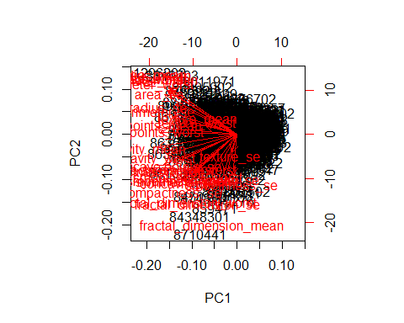

plot(wisc.pr$x[,1],wisc.pr$x[,2],col=diagnosis+1, xlab = "PC1",ylab = "PC2")

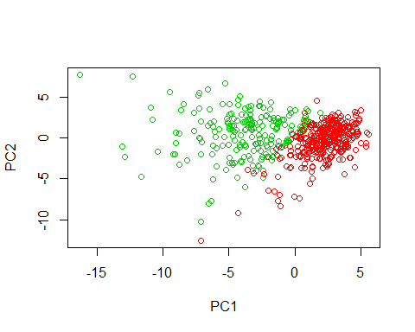

varance <- wisc.pr$sdev^2  
pve <- varance/sum(varance)*100  
head(varance)

## [1] 13.281608 5.691355 2.817949 1.980640 1.648731 1.207357

barplot(pve, ylab = "Precent of Variance Explained",  
 names.arg=paste0("PC",1:length(pve)), las=2, axes = FALSE)  
axis(2, at=pve, labels=round(pve,2)*100 )

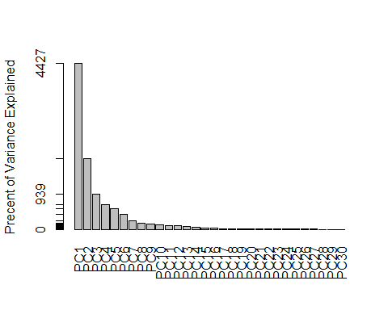

data.scaled <- scale(wisc.data)  
data.dist <- dist(data.scaled)  
wisc.hclust <- hclust(data.dist, method = "complete")  
plot(wisc.hclust)  
abline(h=19.4, col="red", lty=2)

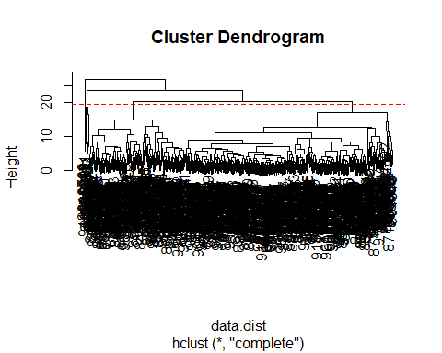

plot(wisc.pr$x[,1],wisc.pr$x[,2], col=diagnosis+1)

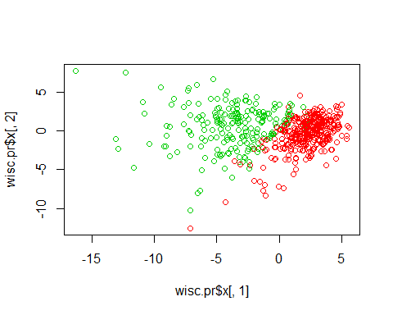

pc.dist <- dist(wisc.pr$x[,1:3])  
pc.hclust <- hclust(pc.dist, method="ward.D2")  
plot(pc.hclust)

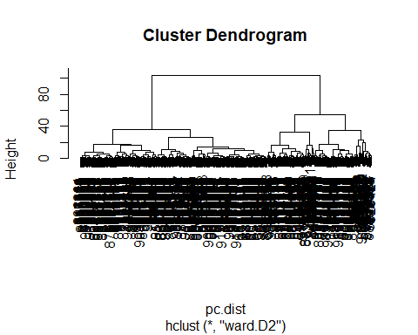

grps <- cutree(pc.hclust, k=2)  
table(grps,diagnosis)

## diagnosis  
## grps 1 2  
## 1 24 179  
## 2 333 33

plot(wisc.pr$x[,1:2], col=grps)

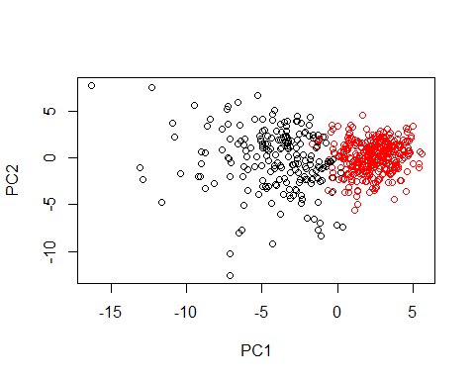

new <- read.csv("new_samples.csv")  
npc <- predict(wisc.pr, newdata=new)  
npc

## PC1 PC2 PC3 PC4 PC5 PC6  
## [1,] 2.576616 -3.135913 1.3990492 -0.7631950 2.781648 -0.8150185  
## [2,] -4.754928 -3.009033 -0.1660946 -0.6052952 -1.140698 -1.2189945  
## PC7 PC8 PC9 PC10 PC11 PC12  
## [1,] -0.3959098 -0.2307350 0.1029569 -0.9272861 0.3411457 0.375921  
## [2,] 0.8193031 -0.3307423 0.5281896 -0.4855301 0.7173233 -1.185917  
## PC13 PC14 PC15 PC16 PC17 PC18  
## [1,] 0.1610764 1.187882 0.3216974 -0.1743616 -0.07875393 -0.11207028  
## [2,] 0.5893856 0.303029 0.1299153 0.1448061 -0.40509706 0.06565549  
## PC19 PC20 PC21 PC22 PC23 PC24  
## [1,] -0.08802955 -0.2495216 0.1228233 0.09358453 0.08347651 0.1223396  
## [2,] 0.25591230 -0.4289500 -0.1224776 0.01732146 0.06316631 -0.2338618  
## PC25 PC26 PC27 PC28 PC29  
## [1,] 0.02124121 0.078884581 0.220199544 -0.02946023 -0.015620933  
## [2,] -0.20755948 -0.009833238 -0.001134152 0.09638361 0.002795349  
## PC30  
## [1,] 0.005269029  
## [2,] -0.019015820

plot(wisc.pr$x[,1:2], col=grps)  
points(npc[,1], npc[,2], col="blue", pch=16)

