1. Does income affect the number of breweries across the US?

We looked at median income over the past seven years and compared that to the number of breweries opened per year. Based on our findings, we determined that there isn’t a strong correlation between median income and the number of breweries established in a given year or overall.

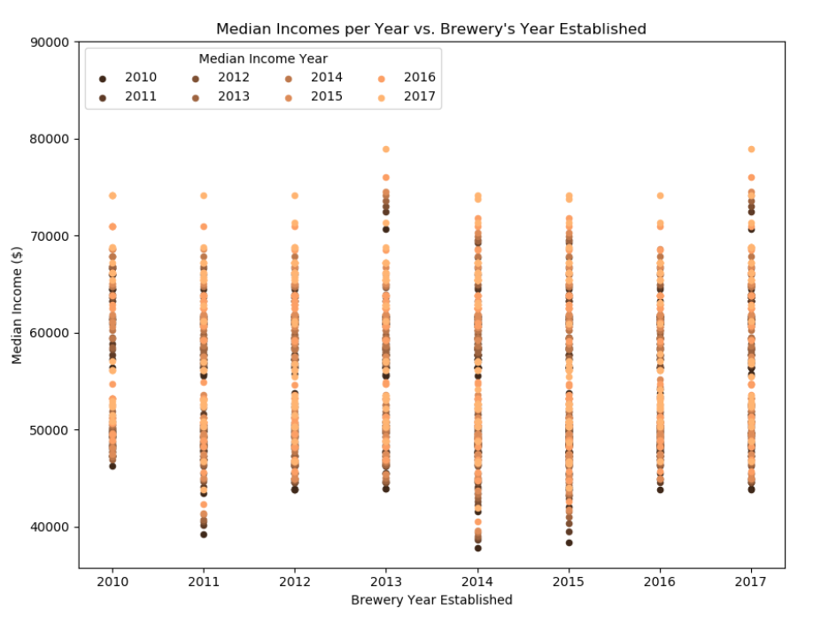

2. Does population size affect the number of breweries across the US?

We looked at population size and compared that to the number of breweries. When looking at population and the number of breweries, we found that there is not a strong correlation in a given year or overall.

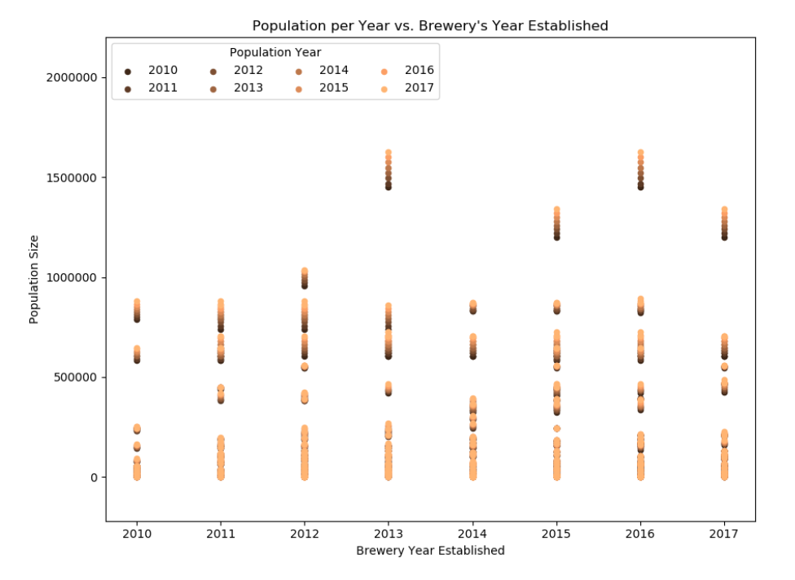

3. Which region has the greatest number of breweries in the US?

Based on our findings, we determined that the midwest (Ohio, Indiana, Michigan, Illinois, Missouri, Wisconsin, Minnesota, Iowa, Kansas, Nebraska, South Dakota, North Dakota) has the greatest number of breweries. With more time, we could have looked into why the midwest has the greatest number of new breweries.

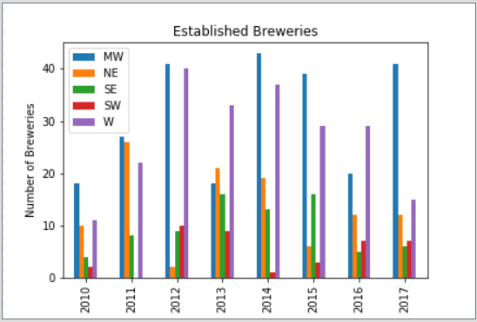

4. How many breweries were created per year?

We looked at the number of breweries per year to figure out if we can see any trends without any additional factors such as population, income, age, etc. We noticed a huge number of breweries opening up in 2014. With more time, we could have looked into possible factors as to why 2014 saw such a growth compared to the other years.

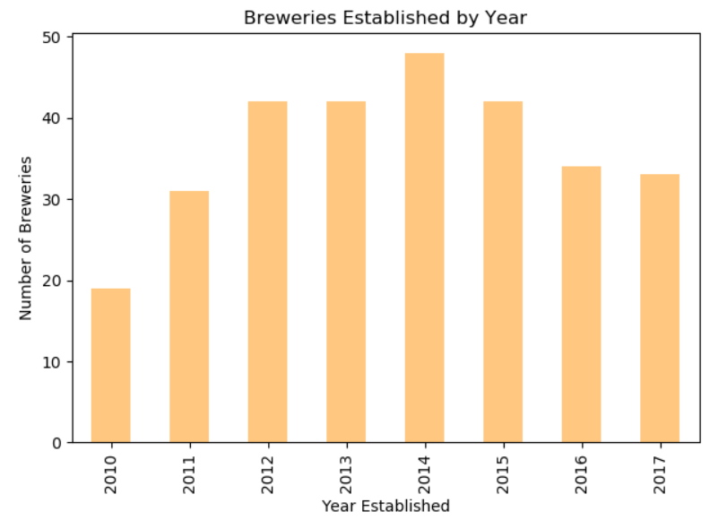

5. How many breweries per year have closed?

We looked at how many breweries closed per year and noticed a spike in closures in 2012 and then another spike in 2014. Without further analysis, we’re unable to determine what exactly caused the spike in closures.

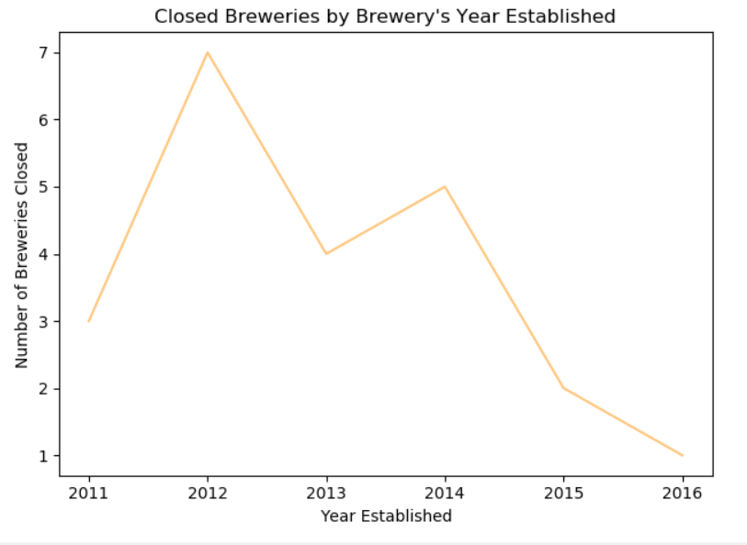

6. Which region has the greatest population?

When comparing the populations per region, we noticed that the Midwest has the largest population. Once we had this graph, we noticed that the Midwest has the largest population and the largest number of breweries. At first we thought this correlation occurred because there are 12 states that make up the Midwest but the Northeast and Southeast also have 12 states. Without more analysis and adding more factors, we’re unable to determine why the Midwest has the largest population and number of breweries.

