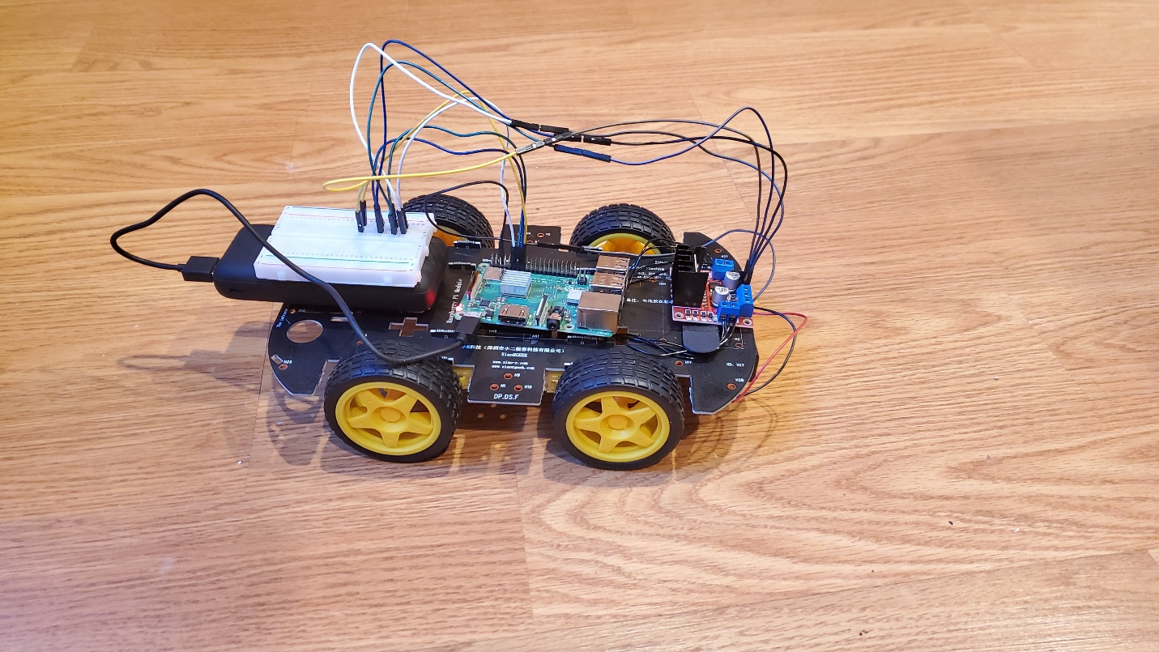

PiCar

A Wi-Fi Controlled Car Using a Raspberry Pi Created By: Alexander Wittman Instructor: David Tarnoff Class: CSCI 4677-901

**Table of Contents**

# System Design:

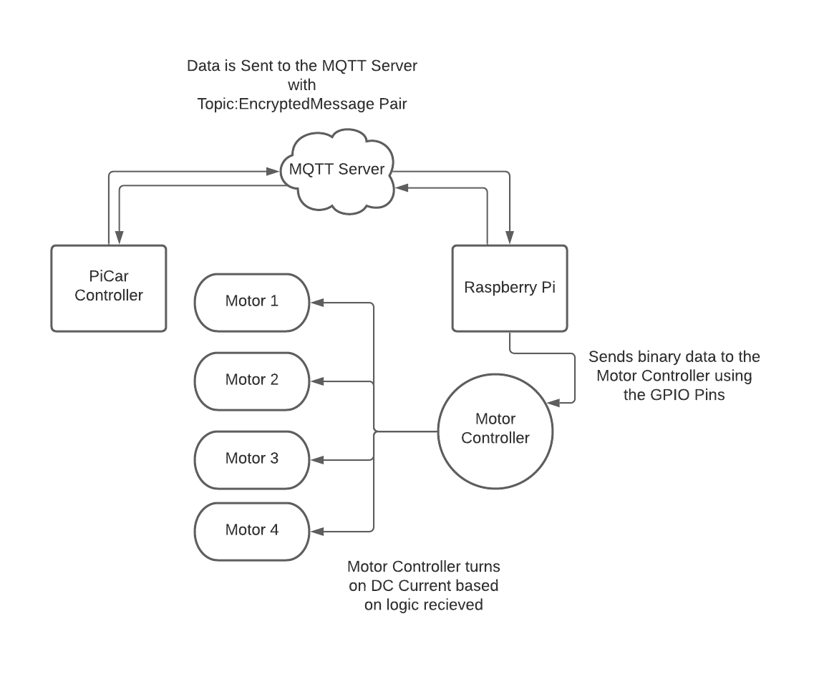

# Electrical Diagram:

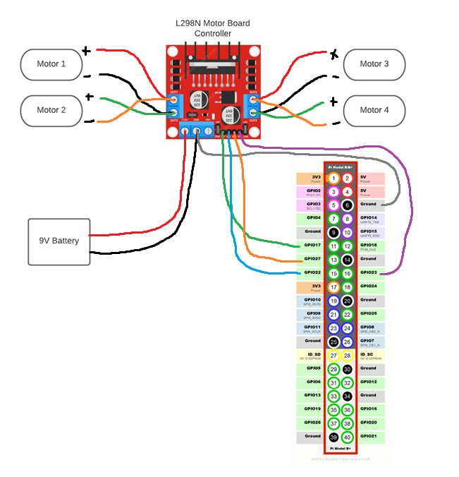

Resources:

<https://stackoverflow.com/questions/59185152/raspberry-pi-node-js-gpio-control>

https://lastminuteengineers.com/l298n-dc-stepper-driver-arduino-tutorial/