**PRE-LAB QUESTIONS OR EXERCISES**

1. How late can you arrive for lab and still be admitted? **Twenty Minutes**

How late can you arrive for lab and still be allowed to take the lab quiz? **Ten Minutes**

1. When are your prelab submissions to Canvas due? **Fifteen Minutes**
2. Can you drop this lab (Lab 0) if ...
   1. you overslept? **Yes**
   2. project is due for other class? **Yes**
3. Can any lab be dropped? **No**
4. What minimum lab average is required in order to be eligible to pass the course? **65%**
5. In electronic assembly, does neatness count? **Yes**
6. If you are very careful, is it okay to do all of the soldering (described below) and then show your finished board to your PI? **No**
7. Should the soldering iron touch the solder while soldering parts in place? **No**
8. Should the long or the short side of the headers get inserted into the breadboard? **Long Side**
9. When soldering each of the two 5-pin headers into J3 on PLD PCB, should the short pins point down or up? These headers are inserted from the top of the board, where the J3 is visible. **Point Down**

**PROBLEMS ENCOUNTERED**

N/A

**REQUIREMENTS NOT MET**

N/A

**FUTURE WORK/APPLICATIONS**

N/A

**PRE-LAB REQUIREMENTS (Design, Schematic, ASM Chart, VHDL, etc.)**

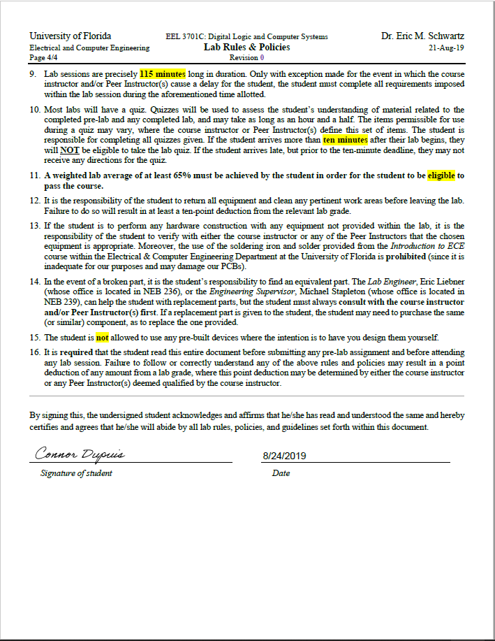

Figure 1: Signed Copy of Labs and Rules

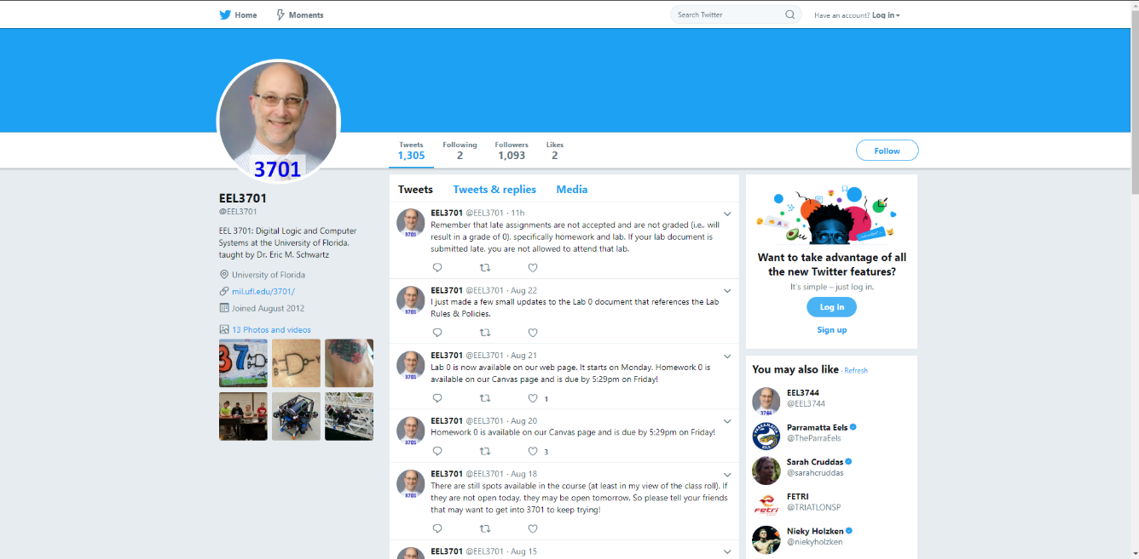

Figure 2: Screenshot of the Twitter page for 3701