**PRE-LAB QUESTIONS OR EXERCISES**

N/A

**PROBLEMS ENCOUNTERED**

N/A

**REQUIREMENTS NOT MET**

N/A

**FUTURE WORK/APPLICATIONS**

This lab gave me a better understanding of how somewhat more complex circuit and logic designs can be made and implemented. In this lad we created a decoder that converted a binary number into HEX of an LED display. This is valuable because it gives insight as to how basic conversion works, even if this is at a really low level.

**PRE-LAB REQUIREMENTS (Design, Schematic, ASM Chart, VHDL, etc.)**

**Part A**

Figure 1: Truth and voltage table for MUX

Figure 2: Logic equations for MUX

Figure 3: Functional Block Diagram for MUX

Figure 4: Circuit design for MUX

Figure 5: Quartus circuit design for MUX

The final output of the MUX.

When being directed to, all the inputs have a 0 and a 1. The arrow is pointing to when S0 and S1 are 00, then D0 is 0 then 1.

S0 and S1 corresponds to which input it is directing to. 00 goes to D0, 01 goes to D1_L, 10 goes to D2, and 11 goes to D3_L.

**Part B**

Figure 6: Truth table for 7-segment LED

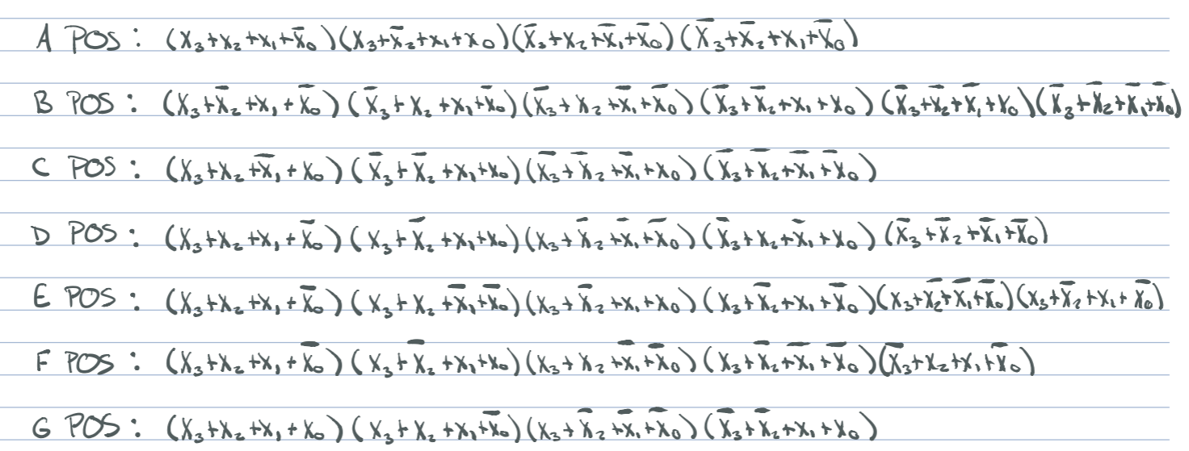

Figure 7: Logic equations for 7-segment LED

Figure 8: Voltage table for 7-segment LED

Figure 9: Functional block diagram for 7-segment LED

Figure 10: Quartus circuit design for 7-segment LED

T is a test input which if it is Low, then all the LED segments should turn on.

The inputs represent a binary number which is then translated into the hex via the LED segments previously described. IE. 1111= 15 = F

The letter determines whether not that respective LED segment is on. High is on and Low is off