Exploratory Data Analysis (EDA)
Agricultural Crop Yield Dataset
Detailed statistical, distributional, relationship, trend, and anomaly analysis

1. Executive Summary
The dataset contains 1,200 rows and 15 columns. The analysis examines data quality, numerical distributions, categorical composition, correlations, relationships, possible trends, and IQR-based anomalies.

2. Dataset Overview and Data Quality
Rows: 1,200
Columns: 15
Duplicate rows detected: 0
Total missing cells: 0
Finding: No missing values were detected, indicating a complete dataset for the available fields.

3. Descriptive Statistics
Variable | Mean | Std. Dev. | Min | Median | Max
Crop_Year | 2008.535 | 7.107 | 1997.000 | 2009.000 | 2020.000
Area | 12965.547 | 12561.410 | 205.310 | 7874.165 | 40465.656
Production | 43357.234 | 50066.182 | 338.454 | 18659.791 | 145774.840
Annual_Rainfall | 1057.557 | 429.636 | 300.000 | 1065.700 | 2310.325
Fertilizer | 1474069.585 | 1477408.418 | 10775.714 | 847650.781 | 4678838.037
Pesticide | 50501.564 | 52522.188 | 356.073 | 28273.970 | 163819.352
Yield | 2.790 | 2.042 | 0.488 | 1.984 | 6.849
Area_Normalized | 0.317 | 0.312 | 0.000 | 0.190 | 1.000
Annual_Rainfall_Normalized | 0.377 | 0.214 | 0.000 | 0.381 | 1.000
Fertilizer_Normalized | 0.313 | 0.316 | 0.000 | 0.179 | 1.000
Pesticide_Normalized | 0.307 | 0.321 | 0.000 | 0.171 | 1.000
Yield_Normalized | 0.362 | 0.321 | 0.000 | 0.235 | 1.000
Interpretation: Mean and median differences can indicate skewness. Large standard deviations relative to the mean suggest substantial variation. Minimum/maximum values were also reviewed for potentially unusual observations.

4. Distribution Analysis

Distribution — Crop_Year
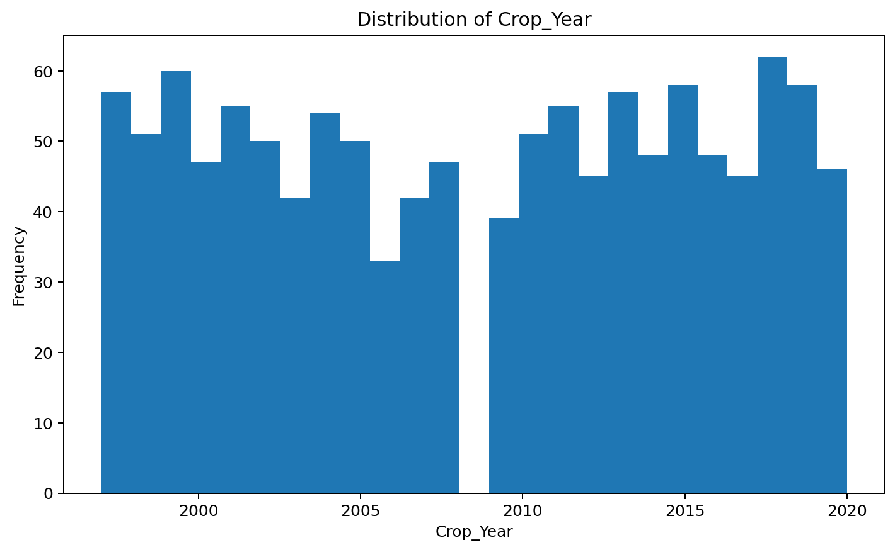
The distribution of Crop_Year is approximately symmetric (skewness ≈ -0.032).

Distribution — Area
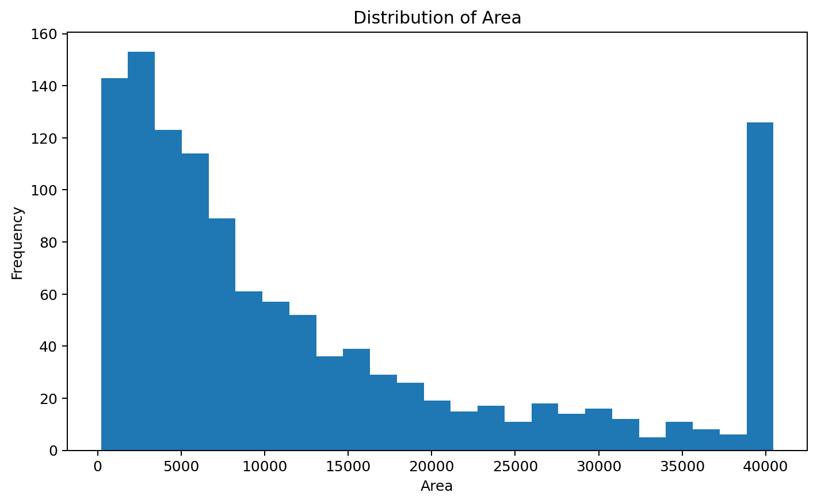
The distribution of Area is right-skewed (skewness ≈ 1.147).

Distribution — Production
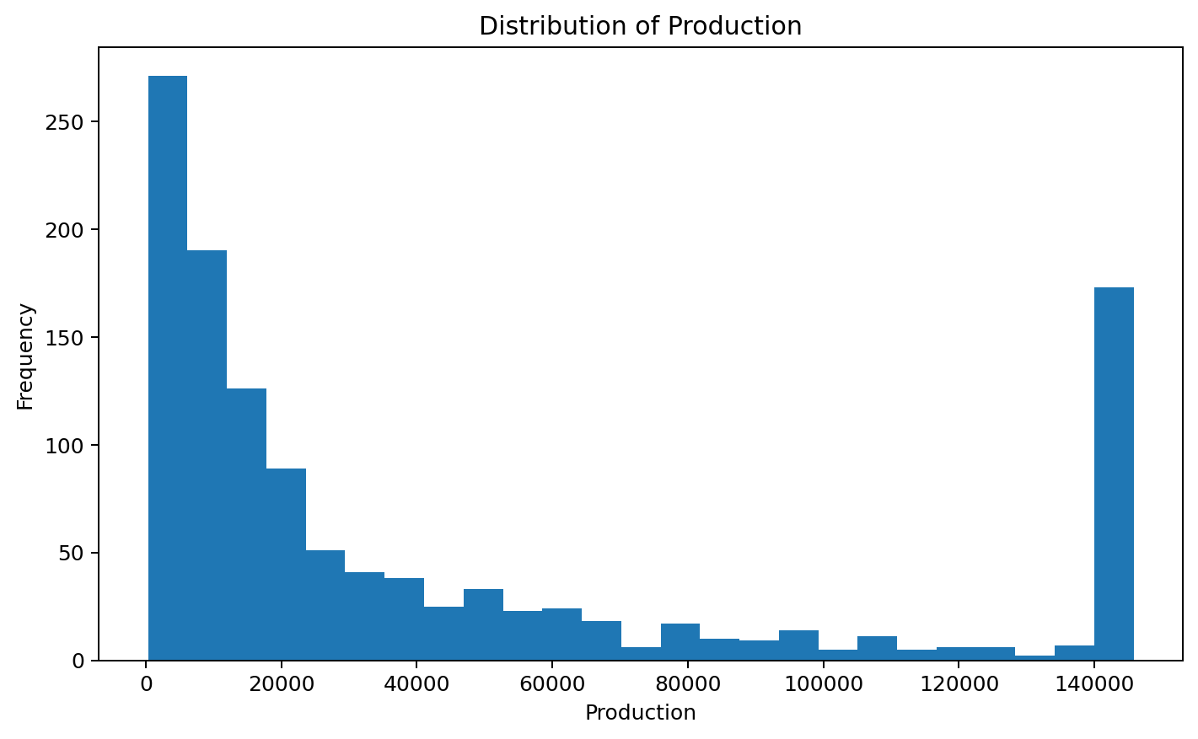
The distribution of Production is right-skewed (skewness ≈ 1.195).

Distribution — Annual_Rainfall
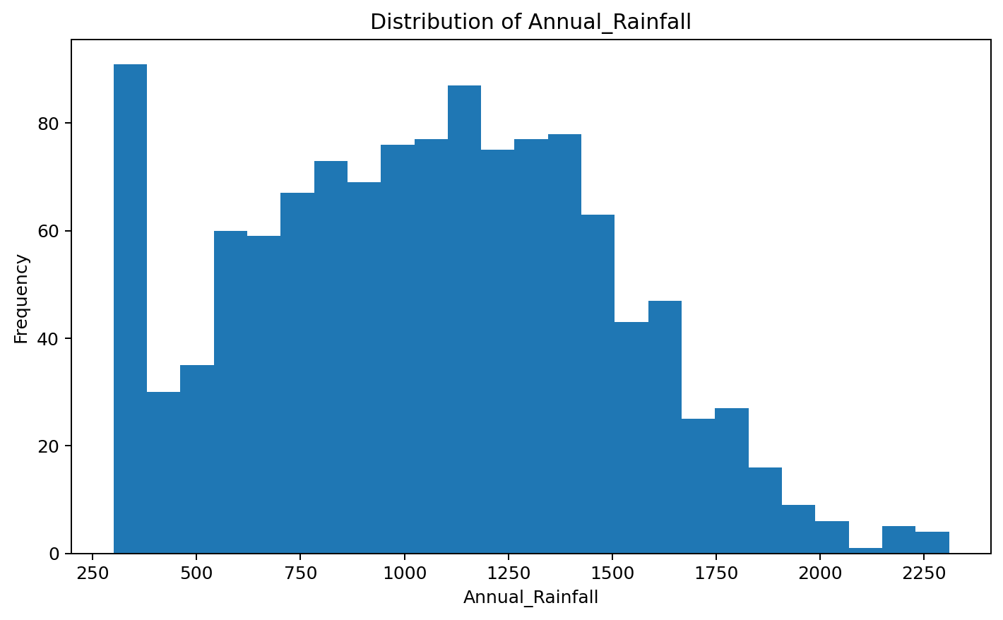
The distribution of Annual_Rainfall is approximately symmetric (skewness ≈ 0.125).

Distribution — Fertilizer
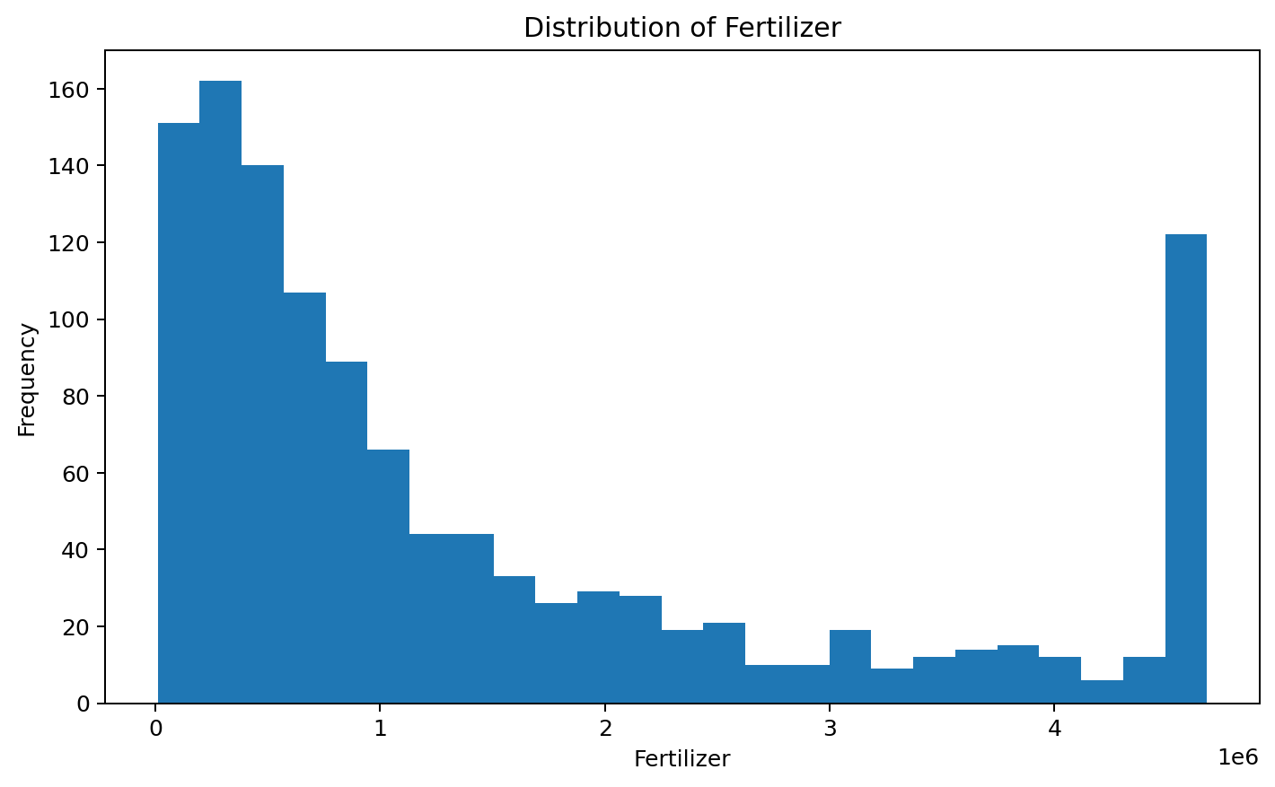
The distribution of Fertilizer is right-skewed (skewness ≈ 1.148).

Distribution — Pesticide
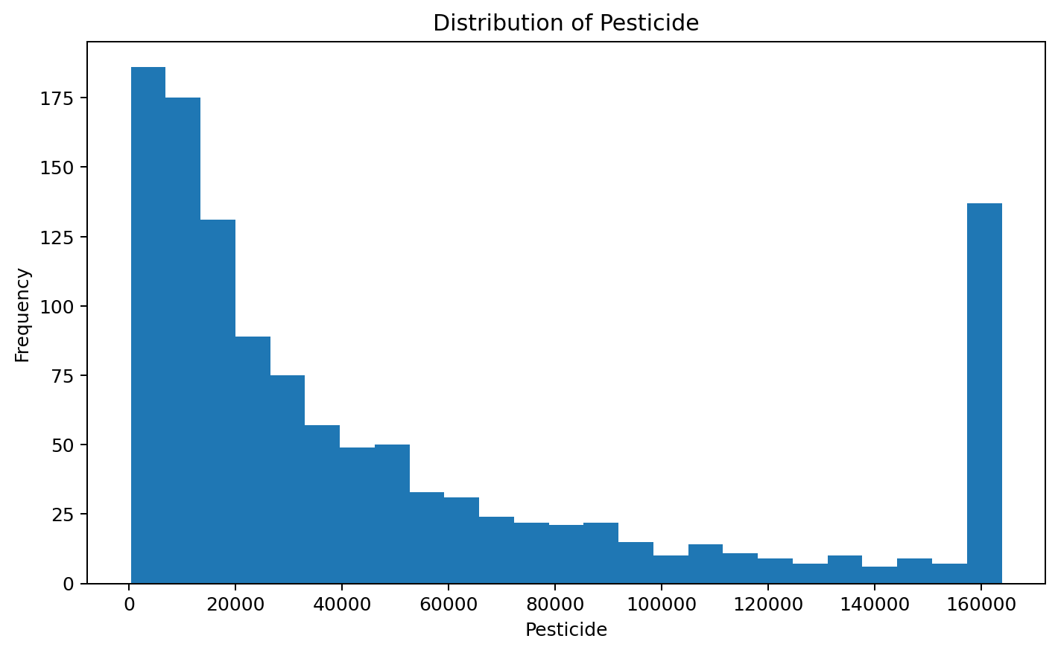
The distribution of Pesticide is right-skewed (skewness ≈ 1.176).

5. Categorical Analysis

Category Frequency — Crop
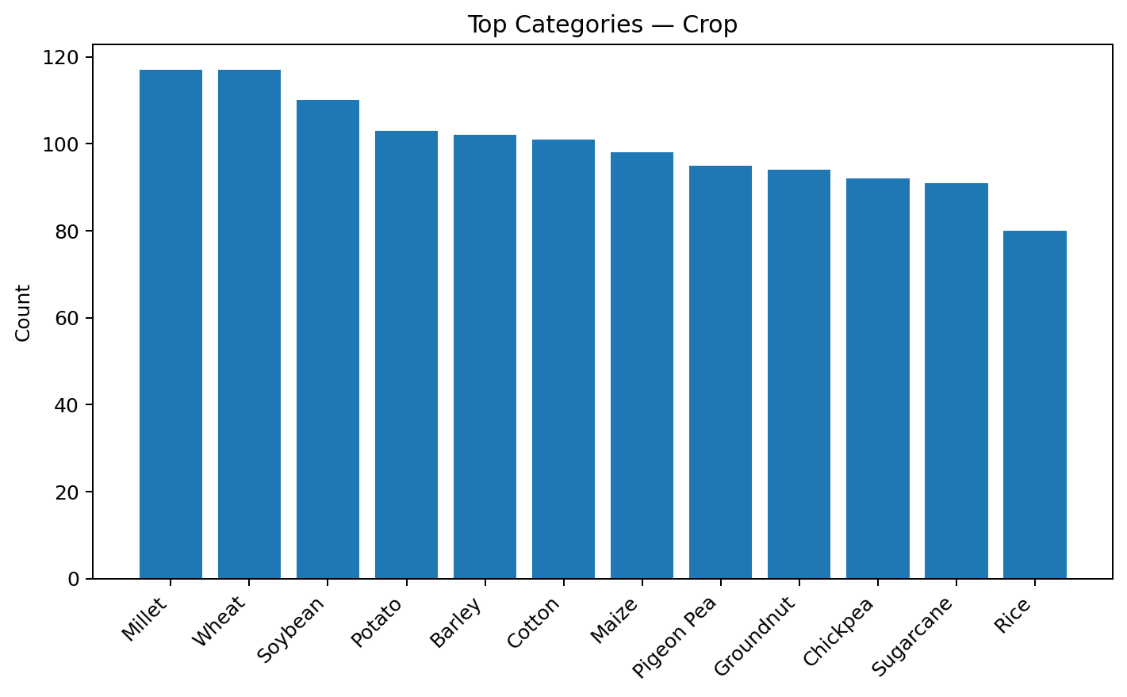

Category Frequency — Season
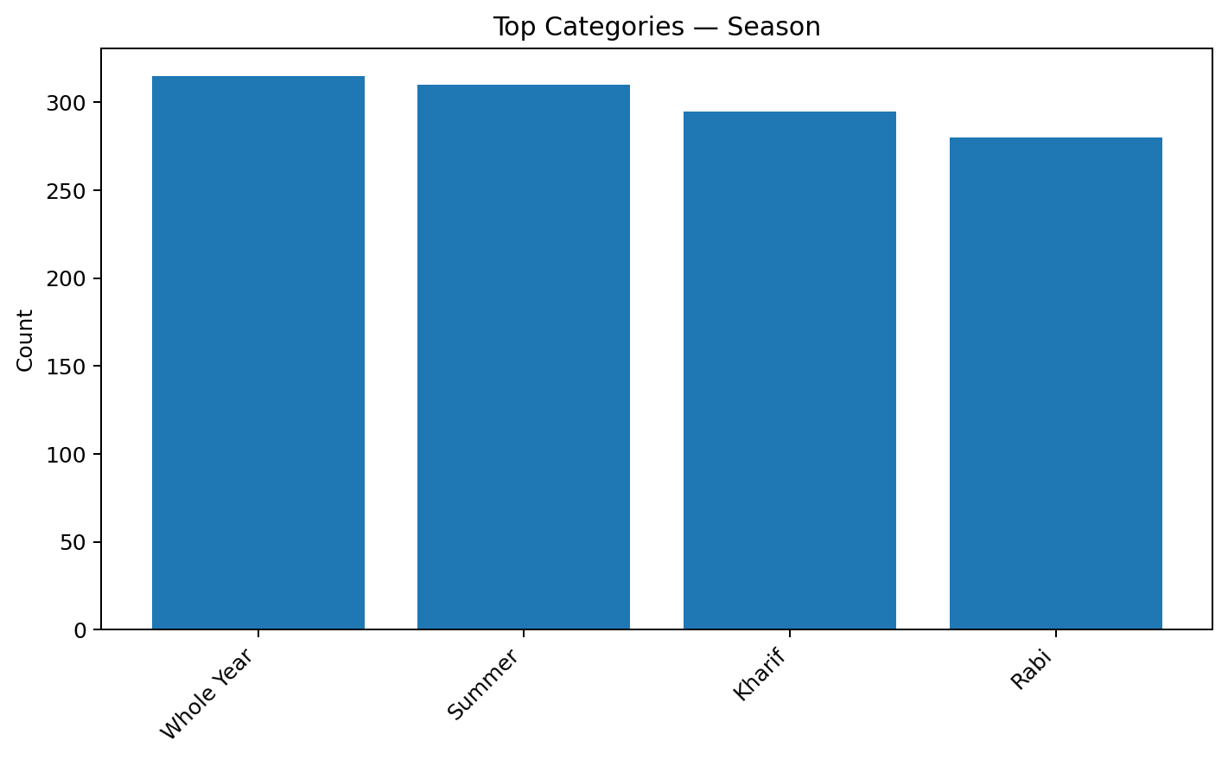

Category Frequency — State
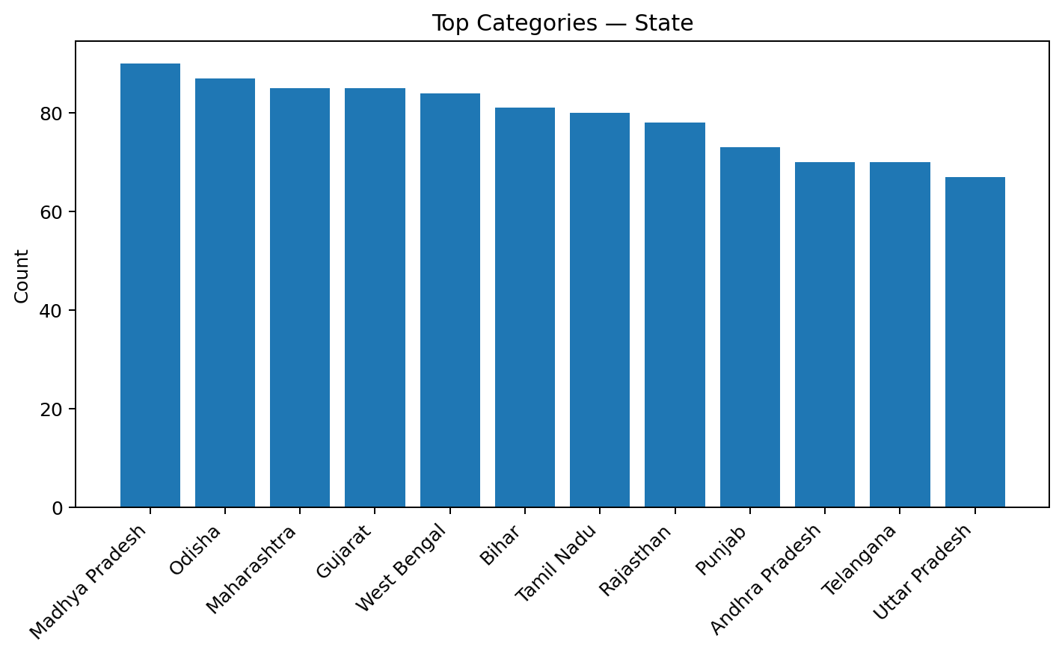

6. Outlier and Anomaly Analysis
- Yield_Normalized: 197 IQR outliers (16.42% of non-missing observations).
- Production: 170 IQR outliers (14.17% of non-missing observations).
- Pesticide_Normalized: 130 IQR outliers (10.83% of non-missing observations).
- Area_Normalized: 120 IQR outliers (10.00% of non-missing observations).
- Crop_Year: 0 IQR outliers (0.00% of non-missing observations).
- Area: 0 IQR outliers (0.00% of non-missing observations).
- Annual_Rainfall: 0 IQR outliers (0.00% of non-missing observations).
- Fertilizer: 0 IQR outliers (0.00% of non-missing observations).
- Pesticide: 0 IQR outliers (0.00% of non-missing observations).
- Yield: 0 IQR outliers (0.00% of non-missing observations).
- Annual_Rainfall_Normalized: 0 IQR outliers (0.00% of non-missing observations).
- Fertilizer_Normalized: 0 IQR outliers (0.00% of non-missing observations).
IQR outliers are statistical flags, not automatic errors. In agricultural data, extreme values can represent genuine differences caused by crop type, weather, soil, irrigation, farm practices, or exceptional seasons. They should therefore be investigated before removal.
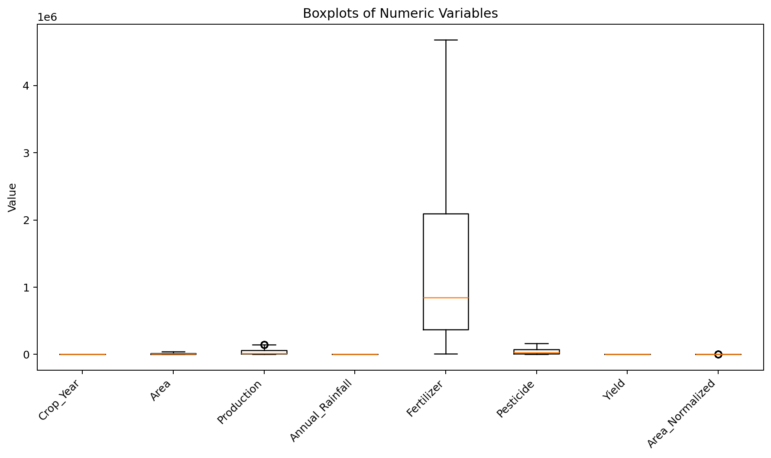

7. Correlation and Relationship Analysis
- Yield and Yield_Normalized: Pearson r = 1.000, indicating a strong positive linear relationship. Correlation describes association and does not establish causation.
- Pesticide and Pesticide_Normalized: Pearson r = 1.000, indicating a strong positive linear relationship. Correlation describes association and does not establish causation.
- Fertilizer and Fertilizer_Normalized: Pearson r = 1.000, indicating a strong positive linear relationship. Correlation describes association and does not establish causation.
- Area and Area_Normalized: Pearson r = 1.000, indicating a strong positive linear relationship. Correlation describes association and does not establish causation.
- Annual_Rainfall and Annual_Rainfall_Normalized: Pearson r = 1.000, indicating a strong positive linear relationship. Correlation describes association and does not establish causation.

Correlation Matrix
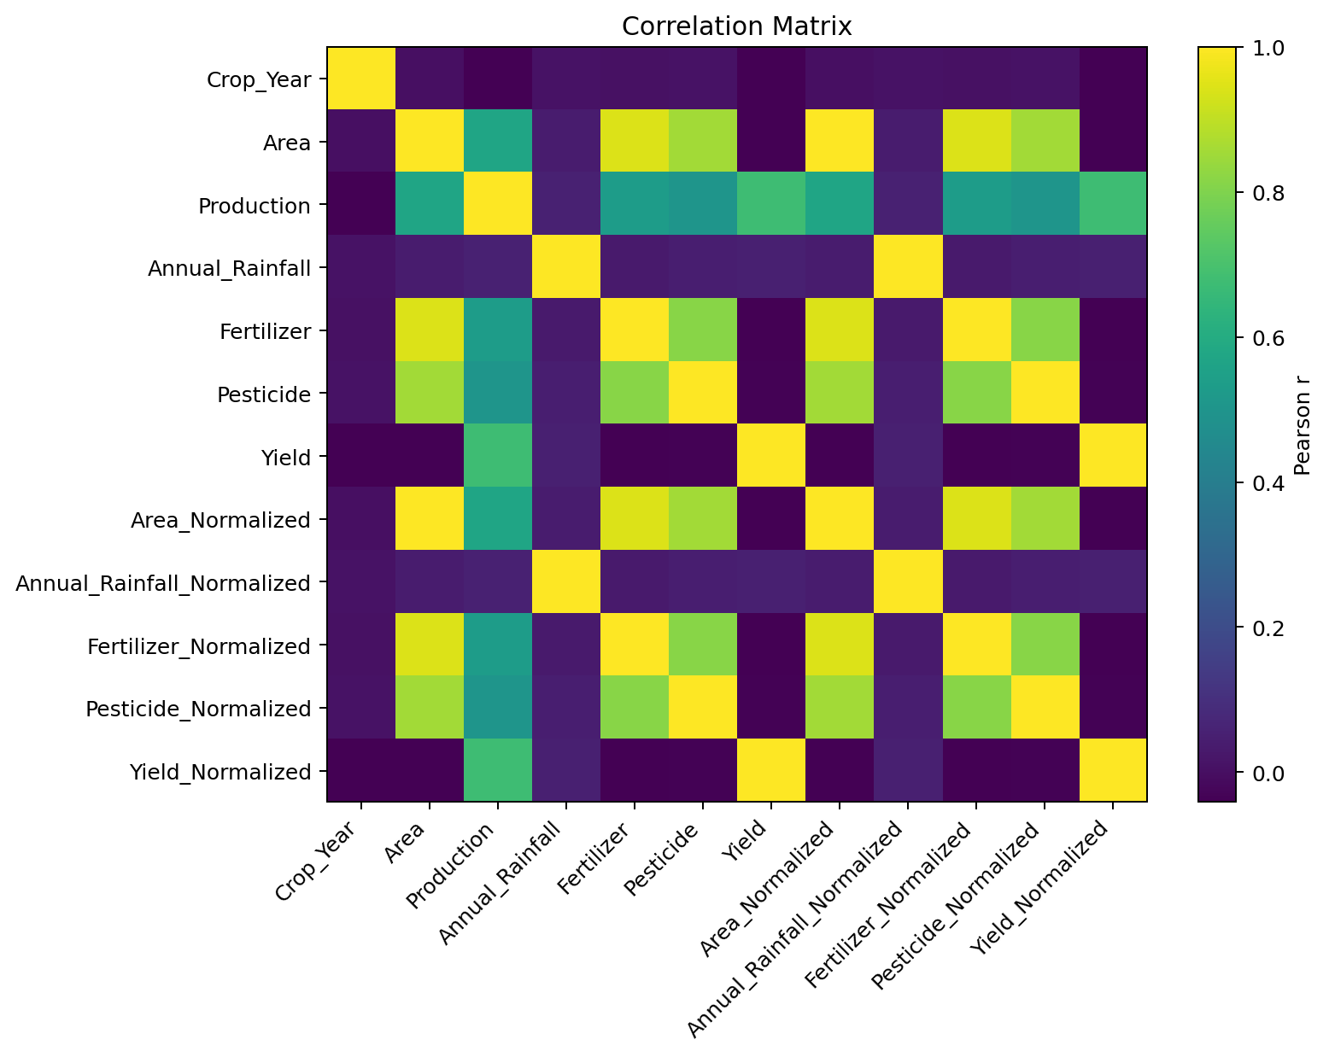

Relationship — Yield vs Yield_Normalized
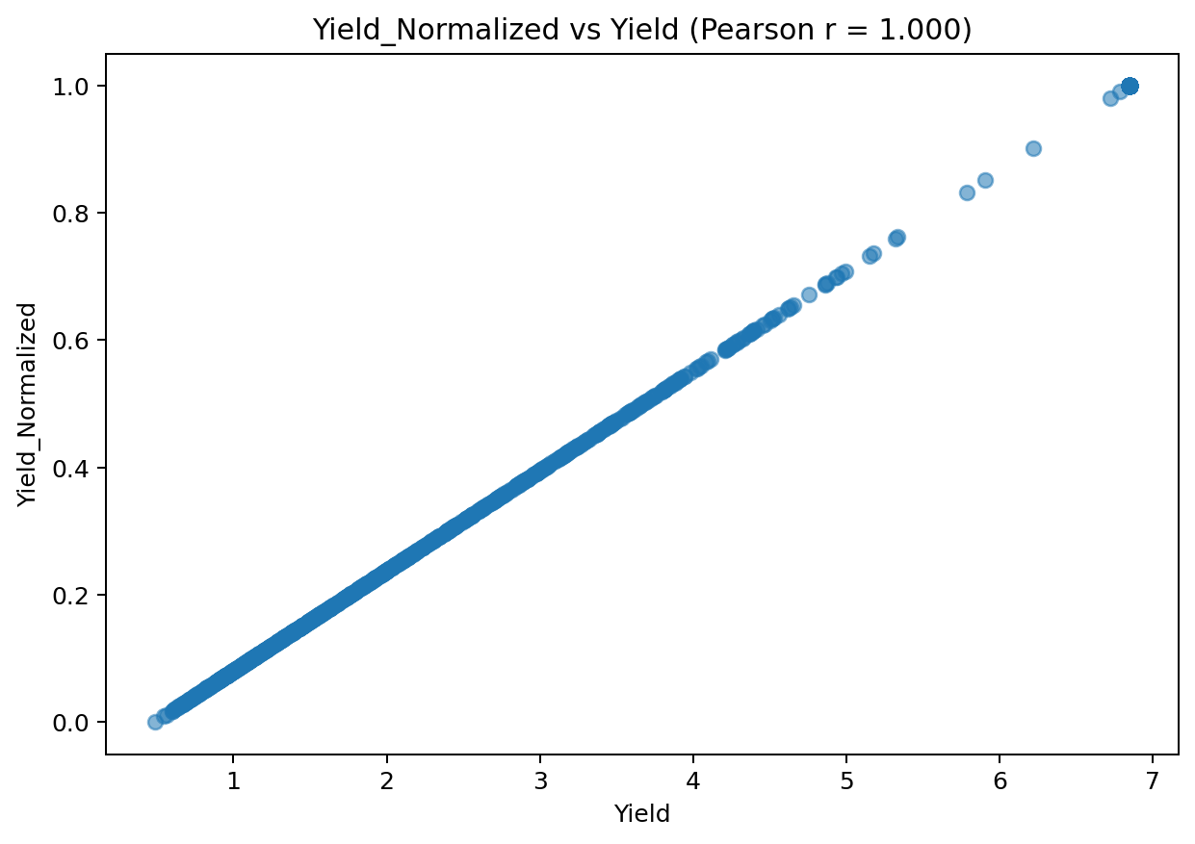

Relationship — Pesticide vs Pesticide_Normalized
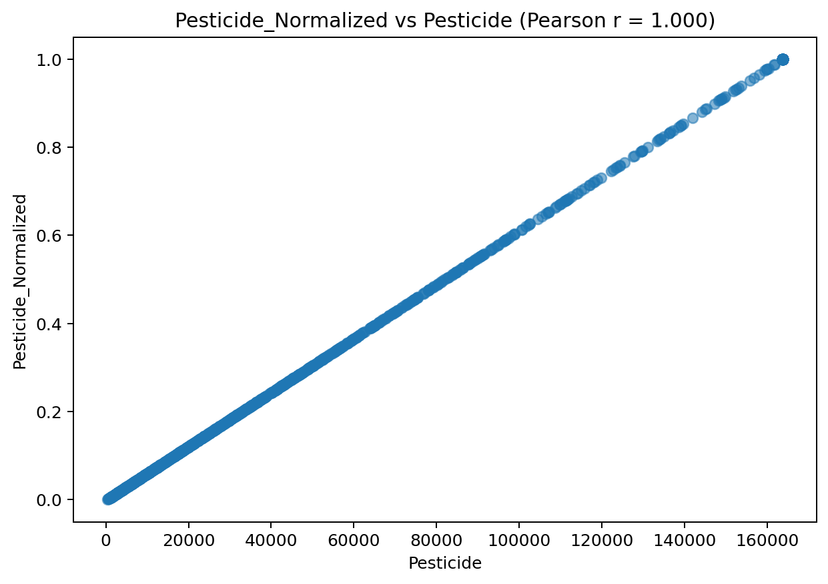

Relationship — Fertilizer vs Fertilizer_Normalized
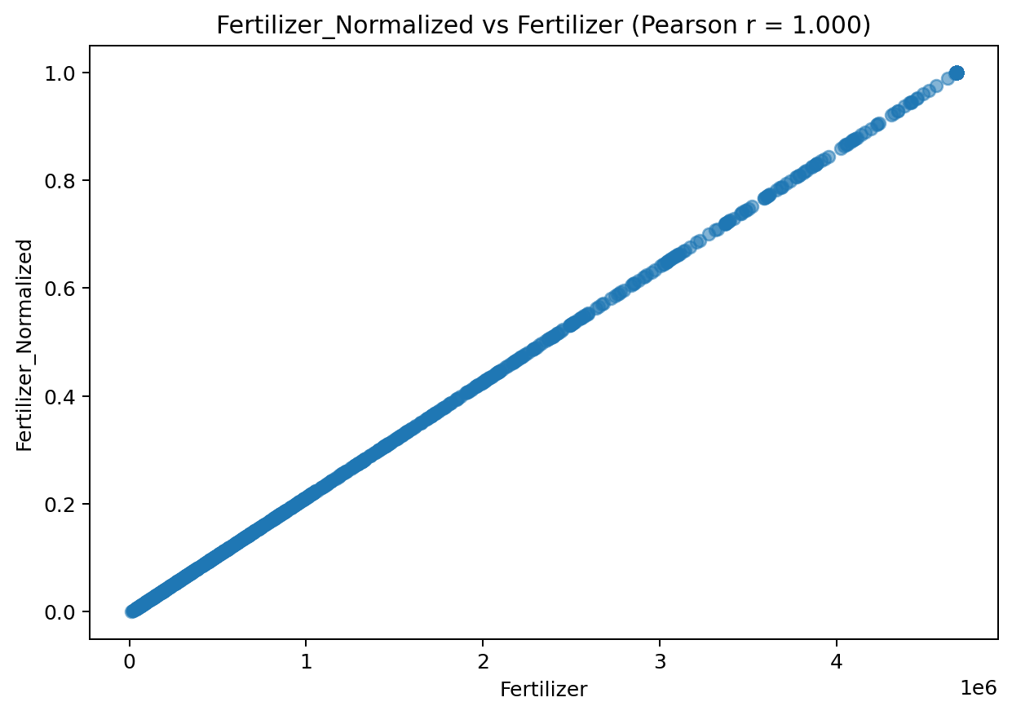

8. Agricultural Yield Insights
The identified yield variable is 'Yield'. Its mean is 2.790, median is 1.984, and standard deviation is 2.042.
Across 'Crop', the highest average yield is associated with 'Sugarcane' (6.849), while the lowest is 'Pigeon Pea' (1.030). This indicates meaningful group-level differences that may warrant further investigation.

9. Trend Analysis
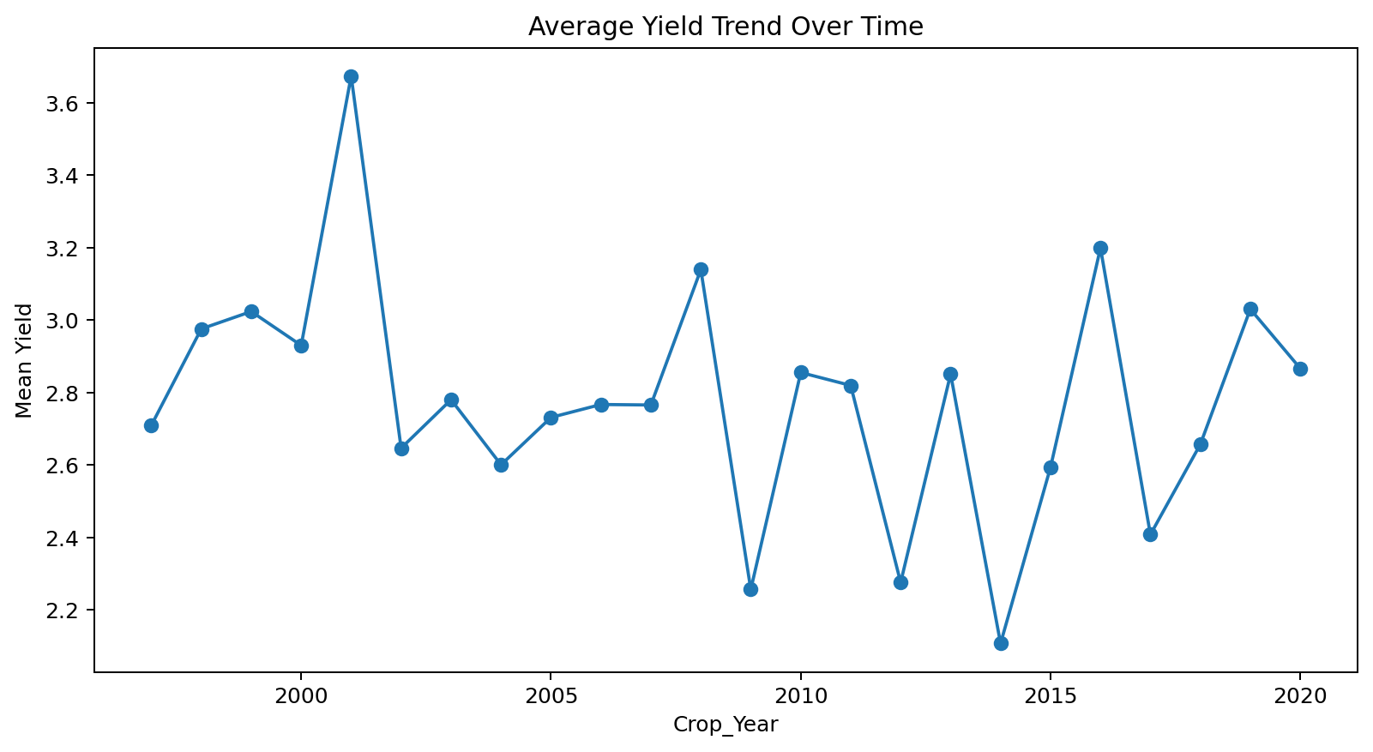
Average yield increased from the first observed period to the last observed period (change ≈ 0.157). The pattern should be interpreted together with weather, crop mix, and management variables before attributing causality.

10. Key Findings and Recommendations
- The dataset provides 1,200 observations across 15 variables.
- Data quality review found 0 duplicate rows and 0 missing cells.
- Distribution analysis highlights the central tendency, variability, skewness, and possible heavy tails of the numeric variables.
- IQR analysis identifies statistical anomalies that should be investigated rather than automatically deleted.
- Correlation analysis identifies the strongest linear associations among numeric variables; these relationships can guide feature selection and further modeling.
- Group-level comparisons can reveal differences in agricultural outcomes across crop, region, soil, season, or other categorical dimensions when those fields are present.
Recommended next steps: investigate extreme observations against original records; compare yield across crop/region/season categories; test statistical significance of important group differences; examine multicollinearity before predictive modeling; and, where time fields exist, evaluate seasonality and year-over-year changes.

11. Conclusion
The EDA provides a structured understanding of the agricultural dataset by combining data-quality checks, descriptive statistics, visual exploration, correlation analysis, outlier detection, and trend/group analysis. The findings can be used as a foundation for feature engineering, predictive modeling, and agribusiness decision-making.

