Welcome to Kongelundsvej :)

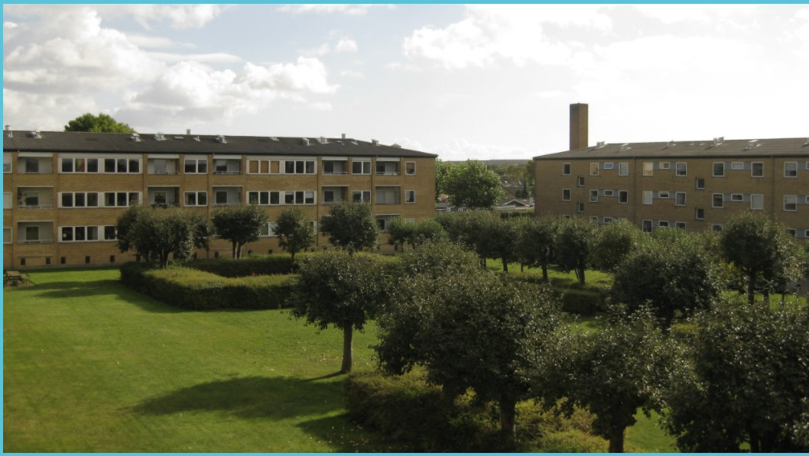
Common areas
The common areas outside the window and behind the building you are free to to use it anytime. You can use the hallway key to get access to the common area. Remember to always lock the common area doors after using them.

If you grill in the common area, don’t put the grill on the benches or the grass.

Where the laundry room is
The laundry room is located in the basement.
You walk to the basement, unlock the door using the hallway key
Then you walk to the right and continue outside
Right before the stairs, you can use the hallway key to unlock the door on your left.
Continue straight for a while, and you will see the laundry room on your right.

Guide for using the laundry room
You can access the laundry room using the Hallway key.
When you get there, you can reserve washes and wash and dry.
When you use it, you take up a slot for a machine. Here are the slots:

Weekdays and Saturdays:
08:00-11:00
11:00-14:00
14:00-17:00
17:00-20:00

Sundays and public holidays:
11:00-14:00
14.00-17.00
17.00-20.00

When you reserve a slot, you have 15 minutes to start a wash – if you come later, there is a chance someone will snap the spot. But otherwise the 3 hours are for you only.
You can reserve up to 3 machine slots at the same time.

To reserve a slot, you hold the white chip to the reservation panel. Then you can reserve a time later, or grab one right away if they are free.

Smoking
Smoking is perhibited in the hallway, in the basement and in the common rooms. If someone is to smoke inside the apartment, please do it in the balcony and use an ashtray or can.

Noise and music
Everyone have to be quiet after 10 pm and until 8 am. Other than that, you are allowed to make noise responsibly. It is not allowed to have loud music in the common areas.
After 7 pm you should avoid using heavy machinery such as drill.
If you want to make an exception, you can put a note on the bullet board in the hallway – that is always okay a few times a year.
Balcony
You can use the balcony anytime for anything, but it is not allowed to grill on it.

Trash
You can access the trash area outside the door and to the left, next to the cars by the fence.
You will have to use the hallway key for the wooden door.
If you find something interesting or useful from the place, you are allowed to take it.

There are the following trash cans there:
- Food waste
- Paper
- Cardboard
- Glass
- Metal
- Plastic

You are encoured to sort the waste, but you don’t have to.
The waste that does not fit into those categories, you can simply put in a bag and put in the vent.
The vent is located right outside the door to the right. To open it, you can use the lever that is next to the electricity box in the apartment entrance.

Bottles can be recycled at LIDL, and you get some money when you recycle bottles, that can then be used in LIDL for buying whatever you want.

Mailbox
You have a mailbox by the apartment entrance. You can access it using the mailbox key.

Fireworks
You are only allowed to fire fireworks on the 31st of december and on the 1st of january.

Cars and parking
You are allowed to have a car here, but it has to be registered. If it is registered it is free to park here.
If any guests want to park here, you can download the e-park app and issue a guest permit to them.

For the parking app, you can use the following login:
Email: fred@wituz.com
Password: yDTra5Qb85!PyOtkrz5s

Light
The light in the living room and the balcony uses Phillips Hue. You can just use the contact on the doorframe, or if you want to change the color of the light you can download the Hue app. If you download the app, you will need to pair the phone with the Hue bridge. The Hue bridge is located behind the radiator in the living room.

Heat and cooling
You can control the heat by the radiators. Sometimes during the summer, it gets very hot in here (but probably nothing compared to what you are used to in India :D). The trick is open the window in the hallway, and keep both doors open. You can put a shoe between the door and doorframe to prevent it from closing.

Bathroom exhaust
The bathroom exhaust is always on – it is just a hole to the roof. I usually just keep the door closed, then the humid will disappear after a while, and the rest of the apartment stays nice and dry. Close the door when you shower - it is important to not have humid in the apartment, as it can grow fungus.

Shopping
You of course have LIDL right next door. There is also a Netto behind LIDL. If you need anything else, there is Fields. You can look it up on Google Maps. There you will for sure find anything you might need, it is huge.

Transportation
Bus 33 is right outside the door. It goes straight to center.
Otherwise, the metro is the key for everywhere you need to go.

Other things
The wifi password is dtn42mjgnl

Once per day or so, the fridge sometimes says a short loud noise, but it is all okay and everything is okay.

Your neighbors and everyone here are mostly very nice and friendly.

You’re welcome to contact me anytime at +4524460302.
Enjoy living here as much as you can – I really enjoyed, and think it is such a nice place to live as one person.

- Frederik :)

