The Application

1. Project Description

1.1. Project plan
Some project plan

2. Functional architecture

2.1. Functional architecture diagram
Some diagram
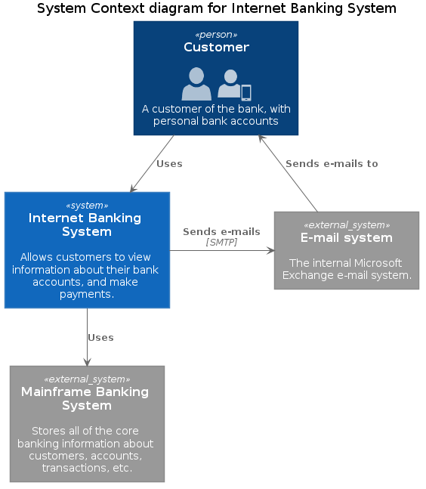
Example tool from PlantUML hitchhiker’s guide.

3. Technical architecture

3.1. Technical architecture diagram
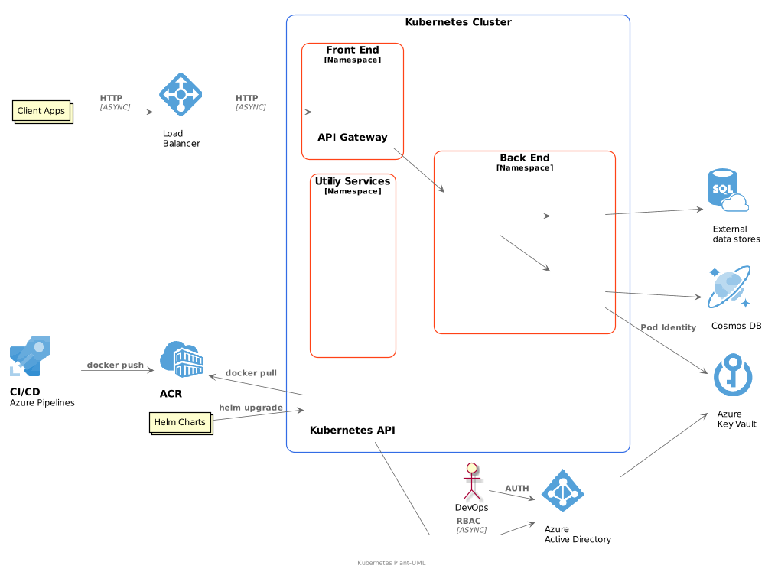

3.2. Technical resources

3.2.1. Network
Environment | Provider | Network name | Subnet name | CIDR | Description
Dev | Some CSP | mynetwork | mysubnet | 10.0.0.0/24 | The network
Prod | Some CSP | mynetwork | mysubnet | 10.0.0.0/24 | The network

3.2.2. Cloud
Environment | Provider | Folder | Resource Type | Name
Dev | Some CSP | myappdev | Container runtime | mycontainerdev
Dev | Some CSP | myappdev | PaaS Database | mydatabasedev
Prod | Come CSP | myappprod | Container runtime | mycontainerprod
Prod | Some CSP | myappprod | PaaS Database | mydatabaseprod
Container runtime settings :
vCPU : 0.5
Mem : 512Mb

4. Security requirements

4.1. Authentication
SSO

Revision history

v0.8.0
- 3230f44 Wivik Sat, 8 Jul 2023 16:45:01 +0200 fix removed info about five last
- a959a7a Wivik Sat, 8 Jul 2023 16:44:27 +0200 feat: change revision generation ## v0.7.0
- a5c5021 Wivik Sat, 8 Jul 2023 16:41:17 +0200 feat: change revision generation
- 7a035db Wivik Sat, 8 Jul 2023 16:40:30 +0200 feat: change revision generation

v0.6.0
- d715470 Wivik Sat, 8 Jul 2023 16:39:06 +0200 feat: change revision generation
- 57ddab0 Wivik Sat, 8 Jul 2023 16:38:49 +0200 feat: change revision generation

v0.5.0
- 3d40a35 Wivik Sat, 8 Jul 2023 16:36:33 +0200 feat: change revision generation

v0.4.0
f5629f1 Wivik Sat, 8 Jul 2023 16:33:58 +0200 feat: change revision generation 66f24c6 Wivik Sat, 8 Jul 2023 12:22:17 +0200 ci: add version on action

