# 2. Scope of Testing

This test suite covers the core functionalities of the Front system, including:

* User register
* User Login
* Forget password,
* ResetPassword
* User homepage

# 3.Testing Environment

* Operating System: Windows 11
* Node.js Version: v20.14.0
* Database: SQLite (in-memory database for testing purposes)
* Testing Framework: JTest

# 4.Test Cases

## 4.1 User register

|  |  |  |  |  |
| --- | --- | --- | --- | --- |
| Test Case ID | Test Case Name | Description | Expected Outcome | Test Result |
| TC_01 | Rendering of Test Registration Form | Check the Full Name, Email, Password, and Re type Password input boxes on the registration page for display | All content displayed correctly | Passed |
| TC_02 | Test password mismatch error message | The password entered twice during registration is inconsistent. Please check the prompt message for the registration result | Tip:Passwords don't match | Passed |
| TC_03 | Call Supabase's registration method when submitting test forms | Enter the correct account, password, and confirmation password to register | successfully registered | Passed |
| TC_04 | Handling registration errors during testing | Simulate errors when inserting user data and check for error message prompts | Tip:Error inserting user data | Passed |
| TC_05 | Test the click event of the 'Already have an account' button | Click on the 'Already have an account' link and check if you have navigated to the login page | Navigate to the login page | Passed |
| TC_06 | Test the situation of missing user ID after registration | Simulate user ID being null after registration, check for error message content | Tip:User ID not available after signup | Passed |
| TC_07 | Prompt and redirect after successful registration testing | Enter the correct information for registration. After successful registration, check if a success prompt is displayed and if it redirects to the login page | Tip:Registration successful! Please check your email to confirm your account.  Redirects to login page | Passed |
| TC_08 | Handling authentication errors during the testing registration process | Simulate authentication errors during registration and check if error messages are displayed | Tip:Authentication failed | Passed |

## 4.2 User Login

|  |  |  |  |  |
| --- | --- | --- | --- | --- |
| Test Case ID | Test Case Name | Description | Expected Outcome | Test Result |
| TC_01 | Test whether the login page is rendered | On the login page, check if the email, password input box, and login button are displayed correctly | All content displayed correctly | Passed |
| TC_02 | Test successful login situation | Enter the successfully registered account and password to log in | Login successful! | Passed |
| TC_03 | Display error message when testing login failure | Enter incorrect account and password to log in | Tip:Invalid credentials | Passed |
| TC_04 | Test navigation to forgot password page | Click the forget password button and check if you have navigated to the forget password page | Navigate to the forgot password page | Passed |
| TC_05 | Test navigation to registration page | Click the button [No account?] and check if you have navigated to the registration page | Navigated to the registration page | Passed |

## 4.3 Forget password

|  |  |  |  |  |
| --- | --- | --- | --- | --- |
| Test Case ID | Test Case Name | Description | Expected Outcome | Test Result |
| TC_01 | Initial rendering of the forgotten password page for testing | Check if there is an email input box and if there is a continue button | All content displayed correctly | Passed |
| TC_02 | Successful submission of password reset request for testing | On the password recovery page, enter a correct email and click Continue | Tip:password reset email sent. please check your inbox. | Passed |
| TC_03 | Test password reset request failure and error handling | On the password recovery page, enter the incorrect email and click Continue | Tip:Email not found | Passed |

## 4.4 ResetPassword

|  |  |  |  |  |
| --- | --- | --- | --- | --- |
| Test Case ID | Test Case Name | Description | Expected Outcome | Test Result |
| TC_01 | Test whether the reset password page is rendered | Check if the new password input box exists, and verify if the new password input box exists | All content displayed correctly | Passed |
| TC_02 | Test successfully reset password | On the reset password page, enter the correct new password and confirm password, and click the reset password button | Tip:Password updated successfully. Redirecting to login... | Passed |
| TC_03 | Display error message when testing password mismatch | On the reset password page, enter the new password and confirm that the password do not match, then click the reset password button | Tip:Passwords don't match | Passed |
| TC_04 | Test handling errors returned by Supabase | Simulated password update failed | Tip:Error updating password | Passed |

## 4.5 User homepage

|  |  |  |  |  |
| --- | --- | --- | --- | --- |
| Test Case ID | Test Case Name | Description | Expected Outcome | Test Result |
| TC_01 | Verify homepage data display | Log in to the homepage page and check the loading of username, role, email, phone_numbers, and location | Data loading is correct | Passed |
| TC_02 | handles click outside while editing | Log in to the homepage page, click on the username to edit, and then click on other areas of the page | Cancel editing status | Passed |
| TC_03 | successfully uploads avatar | Log in to the homepage, click on edit avatar, select an avatar to upload | Avatar uploaded successfully | Passed |
| TC_04 | Turn off avatar editing mode when clicking external | Log in to the homepage page, click on the avatar to edit, and then click on other areas of the page | Cancel editing status | Passed |
| TC_05 | Test username field update | Log in and enter the homepage, click on username to edit, enter username, and click the Save button | Username updated successfully | Passed |
| TC_06 | Test role field update | Log in and enter the homepage, click on role to edit, enter Role, and click the Save button | Role updated successfully | Passed |
| TC_07 | Test Email field update | Log in and enter the homepage, click on Email to edit, enter Email, and click the Save button | Email updated successfully | Passed |
| TC_08 | Test phone field update | Log in and enter the homepage, click on phone to edit, enter phone, and click the Save button | phone updated successfully | Passed |
| TC_09 | Test Location field update | Log in and enter the homepage, click on Location to edit, enter Location, and click the Save button | Location updated successfully | Passed |

# 5.Test Execution Summary

Total Test Cases: 29

Passed: 29

Failed: 0

All core functionalities have been tested, and no major issues were encountered. The systemperforms as expected under both normal and edge cases. Here is a summary of the testcoverage and results for each module:

|  |  |  |  |
| --- | --- | --- | --- |
| Module | Total Test Cases | Passed | Failed |
| User register | 8 | 8 | 0 |
| User Login | 5 | 5 | 0 |
| forget password | 3 | 3 | 0 |
| change password | 4 | 4 | 0 |
| User homepage | 9 | 9 | 0 |

The partial unit testing code is as follows:

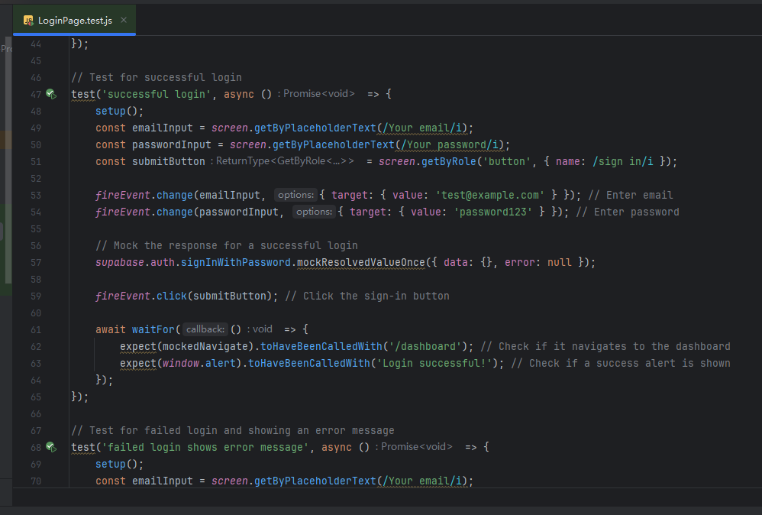

Perform unit testing, all tests have passed:

