|  |
| --- |
| **REPORT OF INDUSTRIAL TRAINING CARRIED OUT AT**  **MASTER GRAIN MILLING LIMITED(BLUE RIBBON)**    **DEPARTMENT: ELECTRICAL ENGINEERING.**  **STUDENT’S NAME: MUHAMMED SIRAAJI**  **INDEX NUMBER: UBT002/2018/T/D/A/250.**  **YEAR OF STUDY: YEAR TWO.**  PERIOD OF TRAINING: 21st Dec-30 Feb.  **INDUSTRIAL TRAINING COLLEGE SUPERVISOR.**  **CORDINATOR.**  **NAME: MR. ODERO REAGAN NAME: MR. MUKWAYA EDWARD**  **SIGNATURE…………………… SIGNATURE……………………….**  **DATE: ……………………………. DATE………………………………...** **APPROVAL** This is to approve that **MUHAMMED SIRAAJI** did and accomplished his internship training at Master grain milling limited under my supervision. This is the true record of the work he did and it is ready for submission to the Uganda Business and Technical Examinations Board as a partial fulfillment for the requirements of a National Diploma in Electrical Engineering.  **HEAD OF ELECTRICAL DEPARTMENT FIELD SUPERVISOR**    **ENG. ISIKO ZAKARIAH ENG.GABULA FRANK**    **SIGNATURE:....................... SIGNATURE:....................**    **DATE:................................ DATE:..............................** |

**DECLARATION.**

I **MUHAMMED SIRAAJI** declare to the best of my knowledge that the information in this report is of my effort and the content in this report has never been presented anywhere to any institution of learning.

I have however referred to some published material and these have been acknowledged in the reference section of this report.

Signature Date

….….……………………. ………………………….

**DEDICATION**

I dedicate this report to my dear mum Rehma Musa and my loved dad Siraaji Sulaiman who have been there for me for the entire struggle.

I also dedicate with special thanks to the entire managing staff of blue ribbon and the team I have been working with they really showed me love that I will never get in any other place.

**ACKNOWLEDGEMENT**.

First, I thank the almighty ALLAH, who enabled me complete my diploma program.

I also extend my sincere thanks to the management of **MASTER GRAIN MILLING LIMITED**

Not forgetting **Eng. Isiko Zakariah and Eng. Gabula frank, Anthony, Jimmy, Medie, Sajad and Amos** among others for the great supervision during the training.

**ABSTRACT**

This report gives an extensive overview of the work done during my training from 21st December 2020 to 21st February 2021 at **MASTER GRAIN MILLING LIMITED.**

It explains a number of activities learnt during the training. This industrial training report is organized into three chapters.

Chapter one gives a brief introduction about the industrial training and a look at the place where the training was carried out and giving a few details about the company **(MASTER GRAIN MILLING LIMITED).**

Chapter two covers a brief explanation of how the grain is turned into flour, and how the power flows into the entire buildings.

Chapter three looks at the practical work done on the company I was posted to and the control cct we used in carrying out our work.

It states the observations noted during training, the conclusions drawn and a brief recommendation to the training.

## LIST OF ACRONYMS

UTC-Uganda Technical College.

Eng.-Engineer.

Mr.-Mister.

Comp.- Compressor

Drier.- Air drier

QMW - Motor control panel

QMW 1- Motor control panel

WDB- Workshop distribution board

WLS- Workshop lights a d sockets

KLS- Kitchen lights and sockets

WSP- Water supply pump

WM- Workshop machines

ODB 1- Old mill distribution board 1

OLS- Office lights and sockets

OMLS- Old mill lights and sockets

ODB 2- Old mill distribution board 2

PM- Packing machines

OPM- Other production machines

NDB- New mill distribution board

NMLS- New mill lights and sockets

WB- Weigh bridge

NWP- New mill water pump

MCC- Motor control centers (new mill

Cct- circuit**TABLE OF CONTENTS**

# CHAPTER PAGE

Approval…………………………………………………………………………………………………………ii

Declaration ………………………………………………………………………………………….……....iii

Dedication ………………………………………………………………………………………………....…iv

Acknowledgment ……………………………………………………………………………………….…..v

Abstract ………………………………………………………………………………………….………….……vi

List of acronyms …………………………………………………………………………………….………..ix

# CHAPTER ONE

1.1Background and introduction ……………………………………………………….……….……1

1.1.1Introduction ……….………………………………………….…………………………………..……1

1.1.2Background of the company ……………….…………..………………………………….……1

1.2Objectives of the real life …………………………..………………………………………….….…2

1.3.1Mission…………………………………………………………………..……………………………....3

1.3.2 Motto………………………………………..………………………………………………………..…..3

1.4.3The real life ………………………..……………………………………………………….………….5

# CHAPTER TWO

2.1The photocells……………………………………………………………………………………………14

2.2 Characteristics of photocells…………………………….…….…………………………………14

2.3 Advantages of photocells………………………………………………………..….………………………………………….14

2.4 Parts of a photocell…………………………………….…..……………………….………………..14

2.5 Construction of a photocell………………….…………………………………….......……......14

2.6 How a photocell functions……………….………………………………………………………….15

2.7 The faults in photocells………………………………………………………………………………………………..….15

2.8 Types of photocells…………………………………………………………….……………………………………………..15

3.0 Construction of a rectifier circuit……………………………………………..………………………………….……16

3.1 Testing for continuity…………………………………………………………………………………………………….16

3.2 Testing the transformer…………………………………………………………………………………………………17

3.3Soldering of the rectifier circuit…………………………………………………………………………………….…17

3.4 Assembling the circuit…………………………………………………………………………………………………….18

3.5 Testing the photocell circuit………………………………………………………………………………………….18

# CHAPTER THREE

4.0Analysis of the real life …………………………………………………………………………………….…..…..…19

4.1Achievements …………………………………………………………………………………………………….……….…19

4.2Challenges ……………………………………………………………………………………………………….…….…….19

4.3Conclusion ………………………………………………………………………………………………………….….….…..19

4.4Recommendations ……………………………………………………………………………………………….………...19

4.5 Appendix ……………………………………………………………………………………………….…………….……….20

4.6 References …………………………………….……………………………………………………………………….………21

**CHAPTER ONE**

# 1.1 BACKGROUND AND INTRODUCTION

**1.1.1 Introduction.**

Industrial training is a training carried out after completion of every year of study. This is carried out to improve on the learners’ experience with regard to the world of work and putting the electrical theoretical work into practicals

1.1.2 **Background of the company.**

Master grain milling limited was started in 2011 with a board of directors. And currently **Mr. Itaaga Swamit** is the manager who took over the management in 2013.

The company started by producing 120 tones per 24 hours producing wheat flour for home baking flour and super bakers flour with a brand name "blue ribbon". Currently its producing 18.7 tones per hour.

**LOCATION.**

Master grain milling limited is located in naruwerere zone 1.5km Njeru-Kayunga road.

## ORGANISATION STRUCTURE

Board of directors

Managing directors

General Manager

Board of directors

Mill manager

Managing directors

General Manager

Production supervisor

Sales manager

Board of directors

Mill manager

Managing directors

General Manager

Production supervisor

**1.1.4 Objectives of the training**

* To widen our opportunities in the electrical field.
* To enable us gain confidence in the world of sensors technology.
* To enable us transform the learnt theory to practical work.
* To equip us with the knowledge about the behaviors of photocells.
* To enable us know the applications of electrical machines like motors.
* To gain awareness, and understand how milling machines operate.
* To develop skills as a future electrical Engineer that is relevant to the discipline of engineering thus being able to practically deal with day-to-day problems that arise in the engineering field.

1.1.5 **THE INDUSTRIAL TRAINING PROGRAMME:**

My training was carried out over a period of two months with the electrical section.

The main activities carried out in this period were;

* Connection of DOL power cct and control cct.
* Connection of star delta power and

Control cct.

* Connection of forward and reverse motors
* Collecting of the electrical daily check report
* Learning how the cleaning, milling and packing process takes place
* Learnt how to connect and arrange cables in the LV panels
* Changing of a sifter motor.

**CHAPTER TWO**

**LITERATURE REVIEW**

# **2.1 CLEANING OF THE GRAIN**

**2.1.1 Intake (offloading bay)**

The harvested wheat grains are brought to the factory by use of trucks, trailers etc. There after the grains are taken to the intake where it’s elevated to the dirty silo.

**2.1.2. 1st cleaning**

The wheat grains in the dirty silo are conveyed to the elevator which elevates the grains to the vibrating separator which separates grains from other unwanted things like husks, big stones, corn cobs, corn leaves, straw strings, papers etc.

From the separator the grains are fed to the gravity grading destoner which serves to remove impurities such as stones, glasses and other high density or low density impurities from grains.

From the destoner the grain is elevated to the dampener, this ensures that the grain is completely dampened. It adjusts the moisture of the grain in the cleaning process to improve the grinding performance and decrease bran toughness.

The out put from the dampener is fed to the silo where it’s kept for 10-12hrs as the moisture of the grain is noted to a desired target.

**2.1.3. 2nd Cleaning**

The grains in the silo are conveyed towards the elevator that elevates the grains via the magnet to the geoto which removes the pericarp from the grain.

From the geoto its elevated to the 2nd dampener then fed to the silo where its kept for 10-12hrs as its moisture is noted for a desired target to be met before milling starts.

**2.2 MILLING PROCESS OF THE GRAIN**

The grain from the silo of the 2nd cleaning is elevated to the scourer which helps to remove the remains of the pericarp.

From the scaurer its fed to the bin, from here its fed to the B1 scales that weighs grains at an interval of 8.2 tones and 10.5 tones per hour for the old mill and new mill respectively.

From the scale its fed to the brake rollers (B1/B2) via the magnet that helps to remove ironic materials from the grains. The grains are then grinded from here.

From the brake rollers its fed to the detachers then to the filter hence fed to the sifter to re-grade from course material and fine materials.

The out put from the sifter is fed to respective machines such as brake rollers (B3/B4), smooth rollers (C1…, C7) and reduction rollers (R3, R4).

The process is continuous until fine flour is extracted and fed from the sifter to the conveyor where its treated using fortificant and improver.

From here its fed to the mono sifter to mix the mixture then fed to the B2 scale that weighs flour hence fed to the flour slip (ready for packaging).

**Summarized flow chart of old mill flour process**

softer

micro dozer

Weigh bridge

Flour magnet

filters

intake

Mono-sifter

detachers

Dirty grain silos

Flour scale

B1 roller

Separator

B1 magnet

dustoner

magnet

Packing machines

B1 scale

First tempering

loading

scourer

magnet

Second tempering

ghetto

**2.3 THE FLOW OF POWER WITHIN THE BUILDINGS**

The company has got two in door transformers where by one transformer powers the old mill machines compressor, drier, packing machines, workshop, security lights etc. as shown in the line diagrams below.

The 2nd transformer was installed to power the new mill machines. It’s only connected to the motors and power factor control machine as shown in the line diagram below.

**2.3.1 A single line diagram for electricity flow for old mill and power supply.**

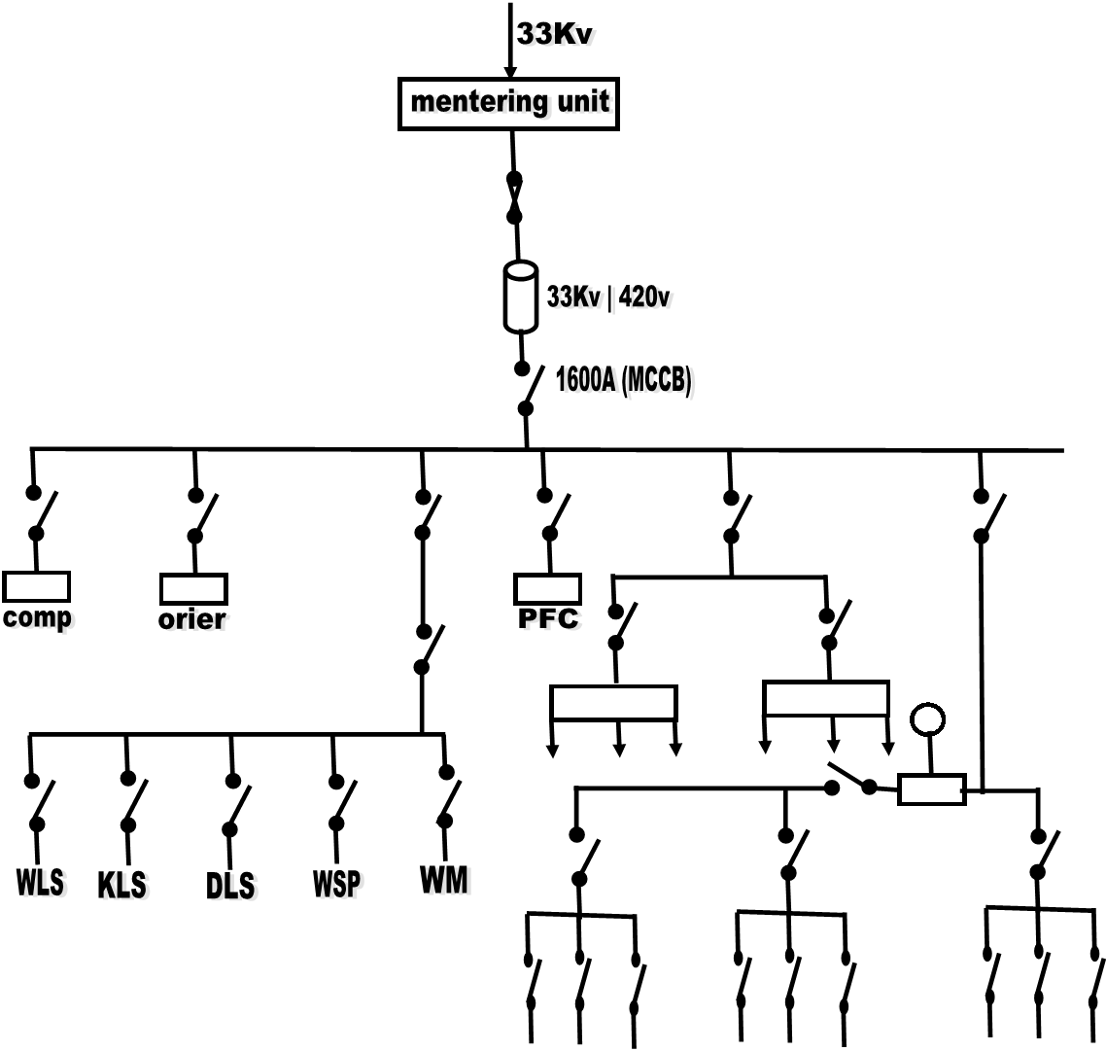

**2.3.1 A single line diagram for electricity flow of the new mill.**

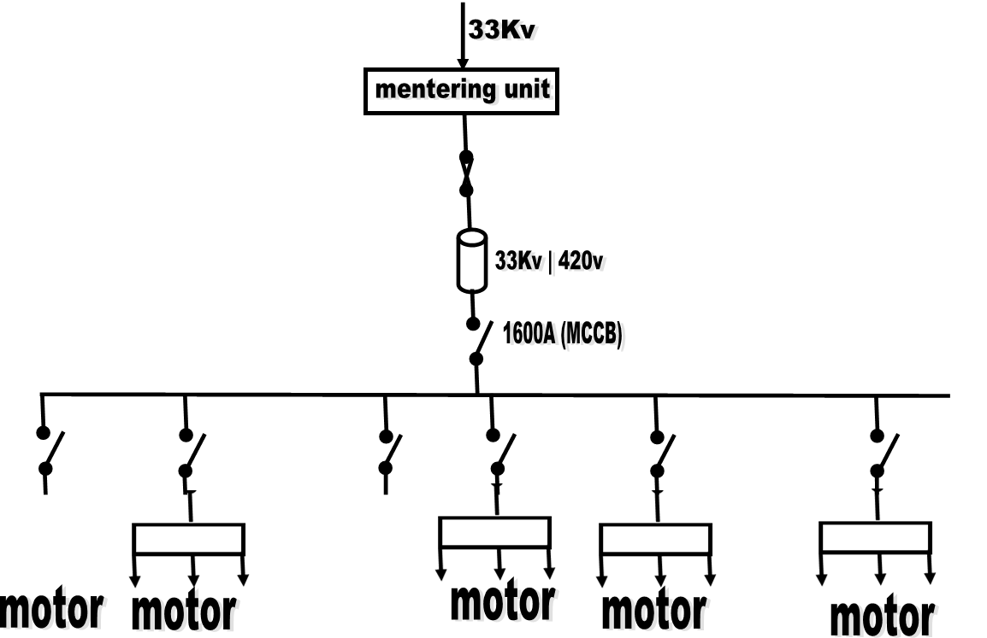

**CHAPTER THREE**

**4.0 ANALYSIS OF THE INTERNSHIP**

The training was carried out on a five weekly days i.e. Monday to Friday from 7:30 am to 6:00 pm.

**4.1 PRACTICAL WORK CARRIED OUT DURING THE TRAINING.**

A motor is an electrical device that turns electrical energy into mechanical energy.

There are four types of motor starters;

* Direct on line motor starter
* Star delta motor starter
* Forward and reverse motor starter
* Soft starters

**4.1.1 D.O.L motor stator connections**

During the training I learnt how to connect the power cct and control circuit of direct online motor stator, as shown in the diagrams bellow.

Tools used;

* Pair of plairs
* Screw drivers

Materials used;

* Connecting wires
* Contactor
* Breaker
* Overload relay
* Auxiliary

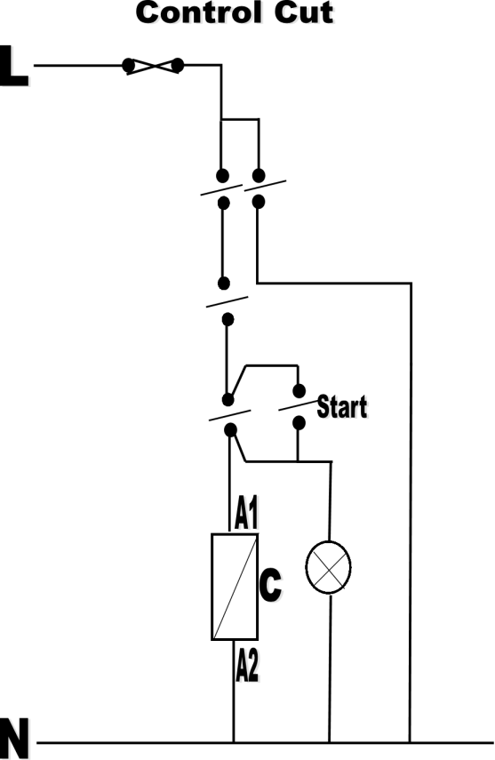

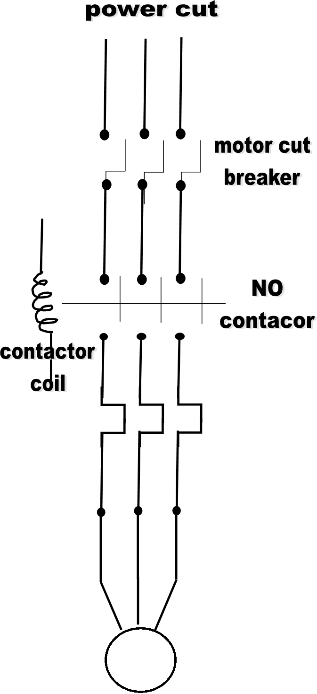

**4.1.2 Star delta motor starter connections**

The diagrams bellow show the connections of star delta connections.

Tools used;

* Screw driver
* Pair of plairs

Materials used;

* Connecting wires
* Breaker
* 2 Contactors
* Overload relay
* Auxiliaries
* Timer

**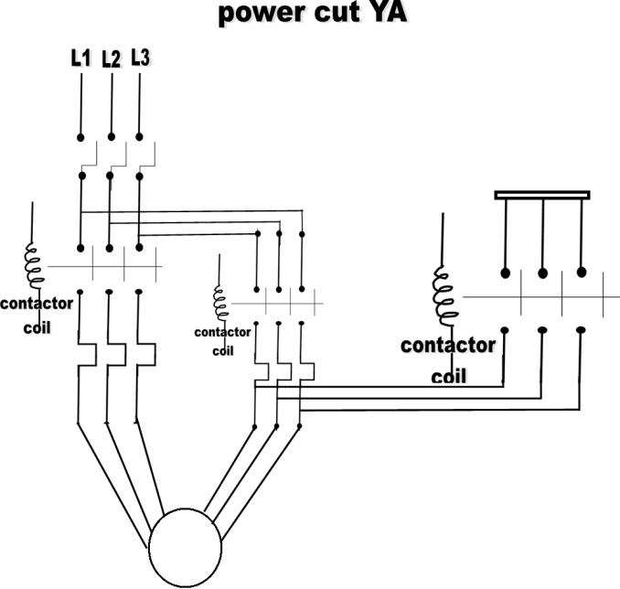**

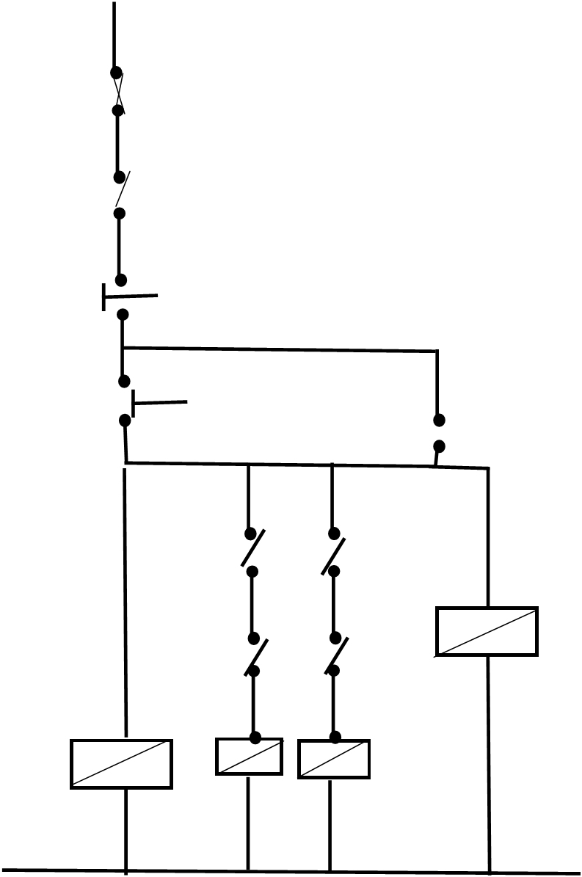

**4.1.3 Forward and reverse motor control connections**

The diagrams bellow show the power and control connections of forward and reverse motor control connections.

**Tools used**

* Pair of plairs
* Screw drivers

**Materials used;**

* Connecting wires
* 2Contactors
* Overload relays
* Timers
* Overload relay
* Motor control Breakers
* Auxiliaries
* **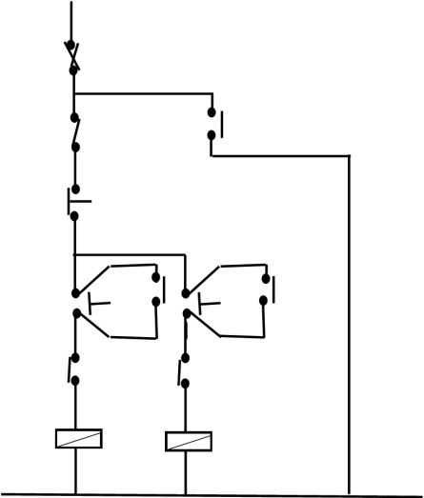**

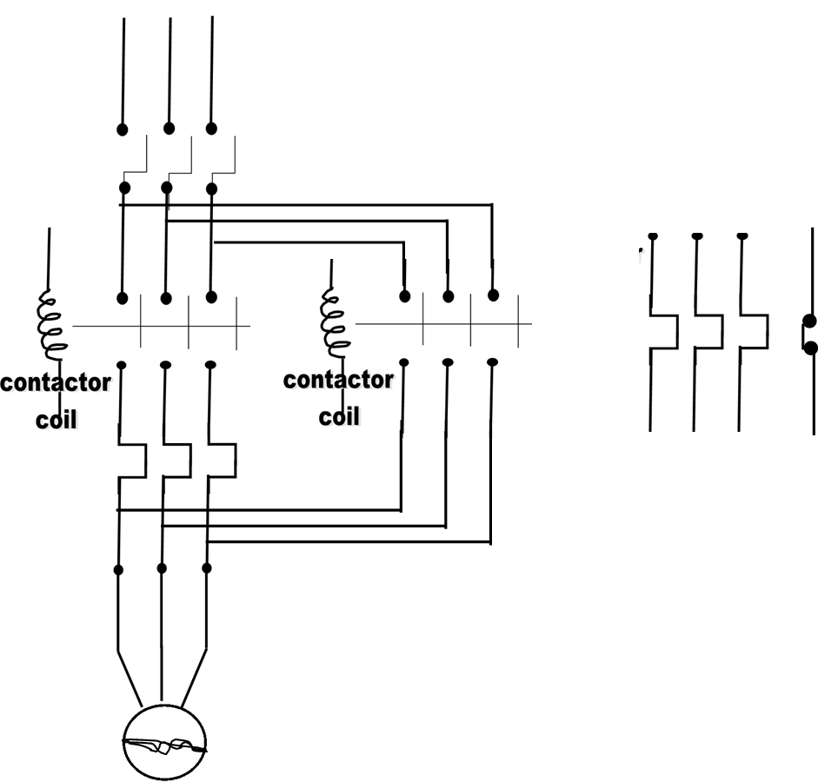

# **4.1 Achievements**

* Am able to work with some of the available tools such as screw drivers, multimeter etc.
* Am able to use the theory learnt in the lecture room to do the practical work because
* I also learned that it’s important to use eyes, nose, and ears before touching something.
* I also learnt how to be neat in whatever you do that’s to say while arranging cables in control panel.

# **4.2 Challenges**

I faced a challenge of long distance moved from the company to the place of residence since it was a new environment.

In the beginning we found challenges of interpreting the control ccts of motors but later this was solved by the help of supervisor who told guided us through the entire session.

I also faced a challenge of noisy machines which wasn’t familiar with but later I got used with the environment.

# **4.3 Conclusion**

The internship exercise was of great importance in the sense that it was able to provide me with the technical skills, an experience of a working environment and its various practicalities, which greatly complements what is covered in class in effort of bringing up a good engineer in future.

However, amidst all the above challenges, we managed to fulfill all our tasks and accomplished the training.

A special thanks goes to supervisor **Mr. EKIFA FRED** and the entire administration of **BLUE RIBBON** for their continued support during the training and I pray that may almighty reward them accordingly.

# **4.4 Recommendations**

I do recommend that the board of UBTEB should be putting there the training period at same time let the administration of companies aware of the training in order to prevent delays in periods when the training should start.

|  |
| --- |
| C:\Users\u\AppData\Local\Microsoft\Windows\INetCache\Content.Word\IMG_20200302_164645_8.jpg |

# **APPENDIX**

**The control circuit of a photocell.**

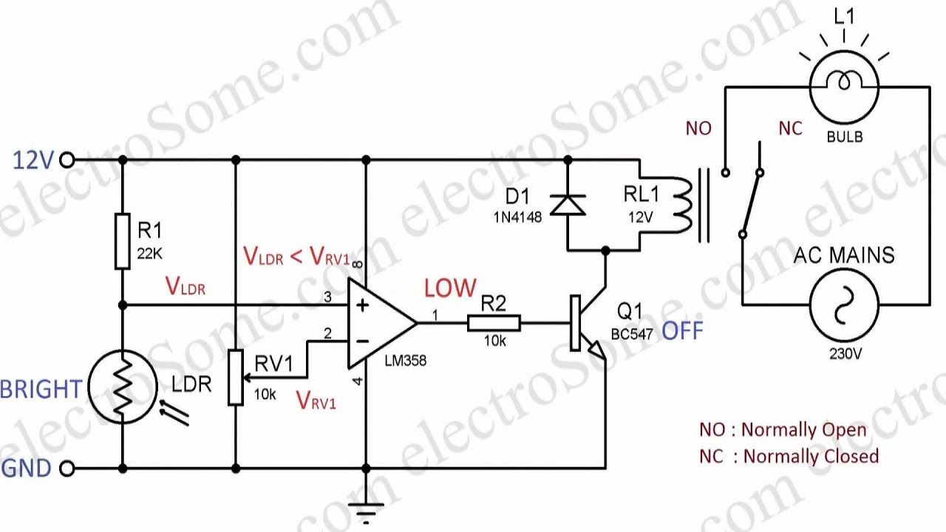

**During the soldering process. Testing the circuit**

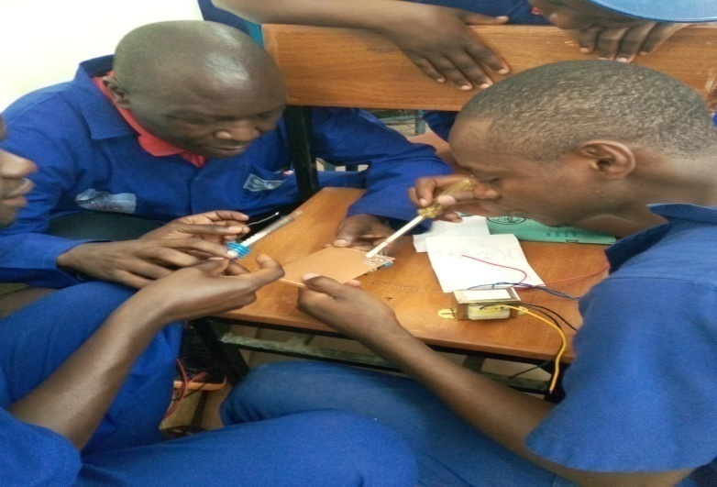

# **REFERENCE**

*[ 1 ] [Online]. Available:*

*www.tlcdirect.co.uk/Technical/Fire/GuideToFireAlarm1.pdfwww.systemsensor.*