**WEB-BASED PEDIATRIC CLINIC APPOINTMENT SCHEDULING AND MANAGEMENT SYSTEM**

Justin Neri D. Costudio, Bulacan Polytechnic College, Malolos

Jhay Arron M. Joaquin, Bulacan Polytechnic College, Malolos

Vir Henrick L. Malate, Bulacan Polytechnic College, Malolos

Tanya J. Melo, Bulacan Polytechnic College, Malolos

Cherry Ann A. Resuello, Bulacan Polytechnic College, Malolos

Erwin P. Tagulao, Bulacan Polytechnic College, Malolos

**ABSTRACT**

The **Web-based Pediatric Clinic Appointment Scheduling and Management System** is designed to optimize and automate the appointment booking and management process for pediatric clinics. The system aims to address common issues such as manual booking, double-booking, and patient management inefficiencies. By transitioning to an online system, clinics can reduce administrative workload, improve patient satisfaction, and ensure better record-keeping. The system offers features such as appointment scheduling, patient records management, and reporting tools for clinic administrators. The system is expected to improve operational efficiency, reduce human error, and provide patients with a user-friendly and convenient way to schedule their visits to the clinic.

**I. INTRODUCTION**

In today's rapidly changing world, healthcare providers are constantly looking for ways to improve their services, especially in pediatric care, where young patients require careful attention. Most pediatric clinics in the Philippines still rely on manual processes for appointment scheduling and patient management, which can lead to inefficiencies and errors such as double-booking, missed appointments, or loss of vital records. These issues not only burden clinic staff but also negatively impact patient satisfaction and the quality of care. The rise of web-based solutions presents a unique opportunity to transition these traditional processes into more modern and efficient systems. By integrating technology into clinic operations, healthcare providers can enhance their service delivery, reduce administrative workloads, and improve patient outcomes. The Web-based Pediatric Clinic Appointment Scheduling and Management System seeks to automate the clinic’s scheduling and management processes, providing both clinic staff and patients with a more reliable, convenient, and efficient method to handle appointments and records. This system is designed to ensure that pediatric clinics can focus more on delivering quality care rather than getting bogged down by administrative tasks.

**Purpose and Description**

The primary purpose of this project is to develop a web-based system that will automate the appointment scheduling and management process for pediatric clinics. The system will allow clinic staff to easily manage patient appointments and keep accurate records of patient visits. Patients, on the other hand, will benefit from an easier and faster way to schedule their clinic visits online.

The system will include features such as:

* An appointment booking system where patients or parents can select available slots.
* A patient management module to keep track of patient information and medical history.
* A notification system to remind both the clinic and patients of upcoming appointments.
* Automated follow-up scheduling that allows the system to automatically suggest follow-up appointments based on the patient's treatment plan or previous visits.
* Dynamic appointment availability that updates in real-time, showing patients the most current available slots to reduce waiting times and increase booking efficiency.
* Reporting tools for clinic administrators to monitor appointment statistics.

**Objectives of the Project**

The objectives of this project are as follows:

* To develop a web-based system that automates the scheduling and management process for pediatric clinics.
* To reduce the incidence of scheduling errors such as double-booking or missed appointments.
* To provide a convenient and user-friendly platform for patients to book appointments online.
* To enhance clinic staff efficiency by streamlining patient record management.
* To implement a notification system that alerts patients of upcoming appointments.
* To introduce automated follow-up scheduling to improve patient care continuity.
* To provide dynamic appointment availability to optimize booking processes.

**Statement of the Problem**

This project aims to address these issues by developing a web-based system that automates the scheduling and management process for pediatric clinics. The system will reduce scheduling errors, enhance clinic staff efficiency, improve patient experience by enabling easy appointment booking, and ensure continuity of care through automated follow-up scheduling. Additionally, the system will include a dynamic scheduling feature to optimize appointment availability and a notification system to alert patients of upcoming appointments, ensuring a seamless and efficient process for both patients and staff.

Furthermore, the research aims to answer the following questions:

1. How can a web-based system be developed to automate the scheduling and management processes for pediatric clinics?
2. How can a convenient and user-friendly platform be provided for patients to easily book appointments online?
3. How can a notification system be implemented to alert patients about their upcoming appointments?
4. What can be done to introduce automated follow-up scheduling to improve continuity of patient care?
5. How can dynamic appointment availability be provided to optimize the booking process for both patients and clinic staff?

This study addresses the current challenges in pediatric clinic appointment scheduling and management by proposing a smart system that enhances efficiency, reduces administrative workload, and improves the overall patient and parent experience in a clinical environment.

**Scope and Limitations of the Study**

The scope of the system covers the automation of appointment scheduling, patient information management, and notification services. The system will be accessible via the web and will cater primarily to pediatric clinics in the Philippines. The system is designed to improve the overall efficiency of clinic operations by reducing the workload on administrative staff and minimizing the risk of human errors in scheduling. The system's limitations include the exclusion of online payment services and teleconsultation features, as its primary focus is on appointment scheduling and basic patient information management. Additionally, the system does not handle inventory management for medical supplies or medications, which will continue to be managed manually by the clinic staff.

**II. REVIEW OF RELATED LITERATURE AND STUDIES**

**Foreign Studies**

Nayak (2021), “Online Appointment Scheduling System” the purpose for developing online appointment scheduling is to make it easier for patients and regular checkups. It is preferable to use the PC, visit a website, and schedule an appointment than to go to the clinic and wait in line for a long time. Olujulo, Oluwatomiwa Enoch (2021), “Online Doctor Appointment Booking System”, the aim of this study was to produce an information system that will provide a means of scheduling appointments with the doctors at the university remotely through a mobile device resulting in the reduction of waiting time at the university health center. This study involved the identification of the user and system requirements, specification of the system design with the UML language and implementation of the system. A review of related works was done to identify the expected behaviour of appointment booking systems. Informal interviews were conducted with the students and staff of the university to elicit user requirements. UML diagrams were used to specify the design of the system. Sheily Mendoza, Ranzel Cloie Padpad, Amira Flores Vael and Cindy Alcazar (2020), “Appointment Scheduling System”, Patient’s satisfaction and comfort are the priorities of every hospital. With the traditional appointment system, patients have been experiencing long waiting time, which causes dissatisfaction. This study designed a new web-based appointment scheduling system the “InstaSked” which could reduce the waiting time experienced by patients. It is designed for patients (booking their appointment), medical secretaries (managing patient list), doctors, and management (monitoring patients). The system used an integration of the Six Sigma methodology, DMADV (define, measure, analyze, design, and verify), and BPM (business process management). Alejo J. (2021), about “Online Appointment Scheduling System” the experience of a long waiting time and its associated psychological discomfort can be overwhelming, and Philippine hospitals are under pressure to find ways to reduce waiting time. This calls for more effective process management, system improvement, health care improvement, and re-engineering of existing processes to improve overall efficiency. Wordingham J. (2021), about “Online Appointment Scheduling System”, the most common challenge for hospitals, the managers, and employees is to reduce operational costs and reach efficiency targets. Meanwhile, most hospitals operate with limited resources. The quest to streamline the organization has traditionally prevented patients from moving comfortably throughout their visits and re-visits. Instead, patients are often placed in long waiting lines while receiving minimal information throughout their stay.

**Local Studies**

Arumugam et al. (2018) developed a web-based appointment scheduling system for hospitals utilizing a rule-based algorithm. This system enables patients to book appointments online and provides healthcare providers with a user-friendly interface for managing appointments. Their findings demonstrated that the system effectively reduced waiting times and improved patient access. Such a system could be highly beneficial for the Outpatient Department of Bukidnon Provincial Hospital in Kibawe, Bukidnon. By implementing this system, patients would experience improved access and shorter waiting times, while healthcare providers could efficiently manage schedules. Real-time data on patient appointments and resource utilization provided by the system can help optimize resources and enhance overall efficiency. Additionally, automated reminders could minimize no-show rates, further contributing to improved service delivery. Souza et al. (2014) designed a flexible and customizable web-based appointment scheduling system for hospital outpatient clinics. The system allowed healthcare providers to adapt it to their specific needs. It was shown to be effective in reducing waiting times and enhancing patient satisfaction. This underscores the potential of such systems to improve access, reduce waiting times, and increase efficiency in hospital and outpatient clinic settings. However, success depends on factors such as acceptance by patients and providers, technical expertise and support, and seamless integration with existing processes. Further research is recommended to evaluate the long-term impacts on patient outcomes and healthcare delivery. Tebra (2024) highlighted that clients prioritize simplicity and flexibility in appointment scheduling. Online scheduling empowers clients to book appointments conveniently, accommodating their schedules even outside typical business hours. This approach is particularly beneficial for individuals with work or other obligations during the day. Sminq (2019) emphasized that traditional methods of arranging doctor appointments often require significant effort, such as making phone calls or visiting clinics. Challenges like connectivity issues or long waiting times can arise. In contrast, online appointment systems offer a secure and convenient alternative, allowing patients to book appointments efficiently while safeguarding their information. The adoption of technology in healthcare services, including online scheduling, reflects a broader trend toward enhancing service quality and convenience. Drlogy (2020) observed that traditional phone-based booking methods often lead to missed appointments due to forgetfulness. Online scheduling systems mitigate this issue by incorporating reminder features. These systems also allow patients to cancel or reschedule appointments, reducing no-show rates. Manual tasks are minimized, as the system automates booking, cancellation, and rescheduling processes. Patients can conveniently check doctor availability and book appointments with ease, streamlining the entire process. Thamrin (2020) discussed how pre-scheduled patient appointments enable healthcare institutions to plan resource allocation effectively, reducing staff stress and enhancing efficiency. Appointment scheduling systems also aid in managing patient flow, ensuring smoother operations. Beyond healthcare, these solutions have proven useful for other industries such as restaurants, salons, and spas, especially in scenarios requiring controlled indoor capacity to ensure safety.

**Theoretical Framework**

*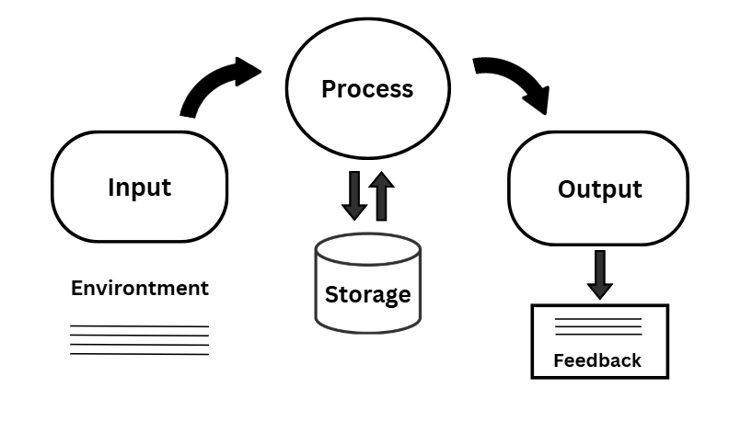Figure 1. Theoretical Framework*

In developing a Web-Based Pediatric Scheduling and Management System, the study is anchored on Systems Theory, which highlights the structured interaction of various components within a system to achieve efficiency and reliability. This theory suggests that an organized flow of input, process, storage, and output enhances overall system functionality (Von Bertalanffy., 1968). A relevant study that supports this concept is the Electronic Health Record (EHR) System, which enables seamless patient information management by integrating data collection, processing, and retrieval mechanisms. By utilizing a systematic approach, healthcare facilities can improve appointment scheduling, minimize errors, and ensure better patient service (Zhang et al., 2020). Applying this theory to the proposed system ensures a structured, efficient, and secures scheduling process for pediatric clinics, enhancing both patient experience and clinic operations.

#### **Technology Acceptance Model (TAM)**

The Technology Acceptance Model (TAM) provides insight into how users adopt and utilize new technology. It highlights two primary factors that influence adoption:

* **Perceived Usefulness (PU):** The extent to which users believe the system enhances their efficiency.
* **Perceived Ease of Use (PEOU):** The level of effort required to use the system.

By applying TAM, the pediatric scheduling system is designed to be intuitive and beneficial, ensuring that parents and medical staff find it practical and easy to navigate, ultimately leading to its successful adoption.

#### **System Development Life Cycle (SDLC)**

The SDLC offers a systematic approach to software development, ensuring that the pediatric scheduling system is built with precision and meets user needs. The key phases include:

* **Planning:** Establishing system objectives and requirements.
* **Analysis:** Understanding user needs and workflows.
* **Design:** Developing system architecture and user interface.
* **Implementation:** Building and deploying the system.
* **Testing & Maintenance:** Evaluating functionality, security, and ensuring continuous improvements.

Following the SDLC ensures that the system is robust, scalable, and adaptable to future advancements in pediatric healthcare management.

#### **Queuing Theory**

Queuing Theory helps in optimizing service efficiency by managing patient appointment flow effectively. Efficient scheduling is crucial in pediatric clinics to minimize wait times and improve service delivery.

The system utilizes queuing principles to:

* Allocate time slots based on availability and priority.
* Reduce congestion during peak hours.
* Provide real-time schedule updates to both staff and parents. By incorporating Queuing Theory, the system enhances clinic operations, ensuring that patients receive timely and organized care.

This theoretical framework serves as the foundation for the web-based pediatric scheduling and management system. Through the integration of TAM, SDLC, and Queuing Theory, the system is designed to be efficient, user-friendly, and aligned with healthcare best practices. These theories provide a structured approach to its development, implementation, and long-term sustainability, ultimately enhancing the quality of pediatric healthcare services.

**Conceptual Framework**

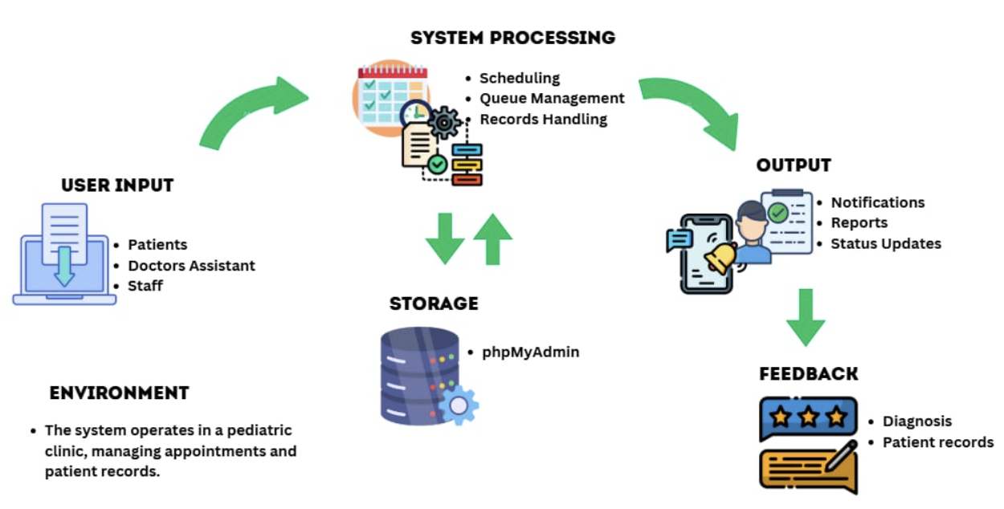

*Figure 2. Conceptual framework*

The conceptual framework of the proposed system is based on the principles of Systems Theory and translates these into practical components tailored for pediatric healthcare. The system is designed to optimize clinic scheduling, patient records management, and administrative workflow.

The key components include:

* **Input:** Patient appointment requests, doctor availability, and registration details
* **Processing:** Automated scheduling, real-time updates, and queue management
* **Storage:** Centralized database for secure patient record-keeping
* **Output:** Appointment confirmations, patient notifications, and clinic reports
* **Feedback:** Performance insights for administrators and patient history tracking

By integrating these elements, the system aims to improve clinic efficiency, reduce scheduling conflicts, and enhance overall patient satisfaction. The structured design ensures that pediatric clinics benefit from a more organized, secure, and user-friendly management system.

**Technical Background of the Project**

A web-based Pediatric Clinic Appointment Scheduling and Management System streamline the process of booking and managing patient appointments in a pediatric healthcare setting. It features an easy-to-use interface for patients and healthcare providers to schedule, view, and modify appointments. The system also stores patient medical histories, sends automated reminders, and tracks patient flow to ensure efficient clinic operations. Security measures, such as data encryption and secure access, ensure compliance with privacy regulations.The platform is scalable, accessible from various devices, and can integrate with other healthcare systems like Electronic Health Records (EHR). It improves efficiency, reduces no-shows, and enhances patient and provider experiences.

*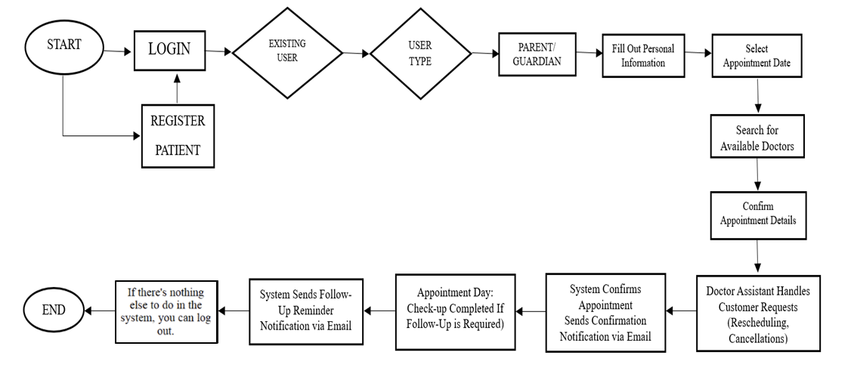 Figure 3. System Flowchart to make an Appointment*

*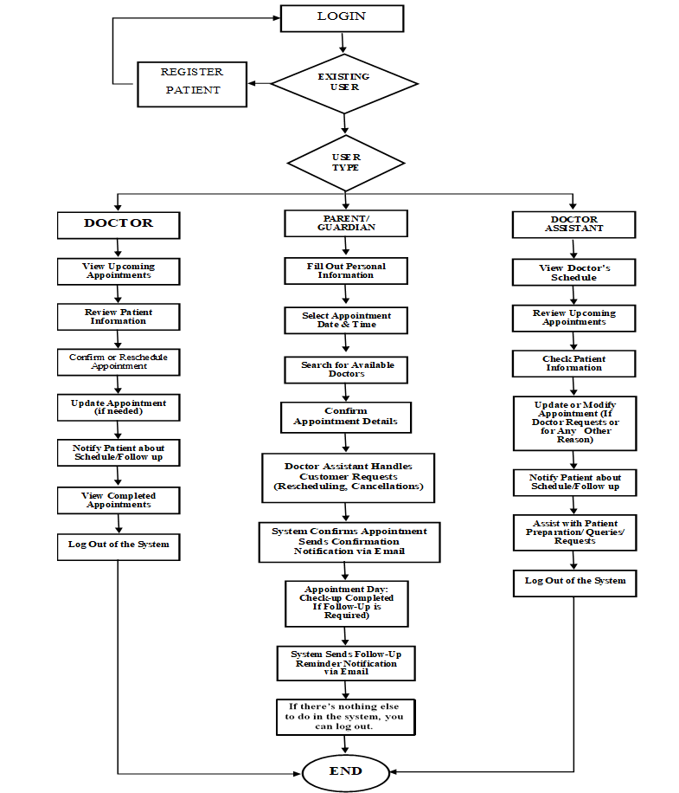Figure 4.* *Web Based Pediatric Clinic Appointment Scheduling and Management System Flowchart*

**Technical Background of the System**

The Web-Based Pediatric Clinic Appointment Scheduling and Management System is designed to optimize clinic operations by enabling patients to book, modify, or cancel appointments online while providing clinic staff and doctors with tools to manage schedules and patient data efficiently. The system utilizes a combination of HTML, CSS, and JavaScript for a responsive and interactive frontend, with PHP and MySQL handling backend functionality, including database management and server-side processes. AJAX is employed to facilitate real-time updates, allowing users to view available appointment slots and receive instant feedback without reloading pages. The platform includes features such as user registration, role-based access control, appointment tracking, and reporting for administrative oversight. Security measures like SSL encryption protect sensitive data, while the system is deployed on a reliable hosting platform, ensuring availability and performance. This web-based system enhances the overall patient experience, streamlines clinic management, and reduces administrative burden, making the appointment process more efficient and accessible.

**HTML (Hypertext Markup Language)** - The system's structure and content presentation are designed using HTML. It provides the foundation for creating web pages by organizing the layout of text, images, forms, and buttons for user interactions.

**CSS (Cascading Style Sheets)** - CSS is used for styling the web application, ensuring an appealing and responsive design. It includes visual elements like colors, fonts, margins, and grid systems to enhance user experience.

**JavaScript** - JavaScript enables interactivity and dynamic content updates. Features such as form validation, interactive appointment calendars, and live feedback are implemented using JavaScript.

**jQuery** - A lightweight JavaScript library, jQuery simplifies DOM manipulation, event handling, and animations. It ensures cross-browser compatibility and accelerates the development process.

**PHP (Hypertext Preprocessor)**- is the core server-side scripting language used for handling application logic. It processes user requests, performs CRUD (Create, Read, Update, Delete) operations on the database, and securely manages user authentication.

**MySQL** - serves as the relational database management system (RDBMS) for storing patient records, appointment details, schedules, and administrative data. It ensures efficient data storage and retrieval through optimized queries.

**AJAX (Asynchronous JavaScript and XML)** - is used to create a seamless user experience by enabling real-time updates without requiring full page reloads. It improves system performance and responsiveness, particularly for features like appointment booking and availability checks.

**Hosting** - The system is hosted on a web server that supports PHP and MySQL. Hosting ensures the system is accessible to users via the internet, enabling patients and staff to interact with it from any location.

**III. METHODOLOGY**

In this project, a web-based pediatric clinic appointment scheduling and management system is developed using the Agile Methodology. Agile is determined due to its adaptability, continuous improvement, and regular input, which guarantee that the system satisfies the changing requirements of parents and healthcare professionals.

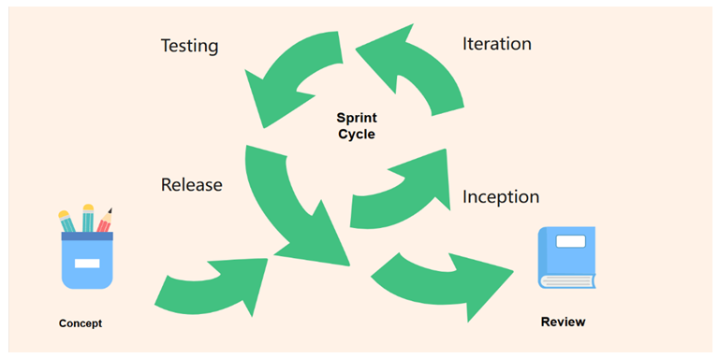*Figure 5. Agile Software Development*

**Concept Phase**

The first step in the Concept Phase is to determine the main goals of the system, which include making appointment scheduling easier, effectively managing patient records, and guaranteeing smooth communication between medical staff and parents. To gather requirements and determine the project's sustainability, important participants are consulted, such as parents, doctors, and clinic employees

**Inception Phase**

During the Inception Phase, the development team establishes the fundamental features of the system, including real-time updates, appointment scheduling, user authentication, and reminders. The development of a project backlog lists the most important features for early deployment. In addition, the team establishes the development environment and chooses the right technological system, ensuring a strong basis for future iterations.

**Iteration Phase**

In the Iteration Phase, the system is created in short sprints, each concentrating on a particular feature, such as scheduling integration, patient registration, or alerting systems. Agile methods like sprint planning meetings and daily stand-ups provide ongoing cooperation and prompt adjustment to any required modifications. The system's functionality is improved and refined at the conclusion of each sprint by integrating participant feedback.

**Testing Phase**

The testing phase ensures that every feature is fully verified prior to deployment by operating across development. Bugs, usability problems, and security issues are checked using both automated and human testing techniques. Parents and clinic employees participate in user acceptability testing (UAT) to make sure the system satisfies their requirements and expectations.

**Release Phase**

The Release Phase involves the deployment of a stable version of the system in a live environment. Users and clinic employees can attend training classes to become familiarized with the functionalities of the system. Before going live, a soft launch could be held to get early feedback and fix any unresolved problems.

**Review Phase**

Lastly, the Review Phase entails getting feedback from participants and users to evaluate the system's functionality. To keep the system effective, user-friendly, and in line with the changing demands of the clinic, regular updates and enhancements are planned based on user feedback. Pediatric clinics can rely on the appointment scheduling and administration system because of its iterative methodology, which ensures ongoing improvement.

**IV. RESULT OF THE STUDY**

This chapter presents the results of the survey conducted to evaluate the existing system and compare it with the proposed system. The survey was administered to IT Expert, Admin of the clinic, Staff, and Users to assess various factors such as Functional Suitability, Performance Efficiency, Compatibility, Interaction capability, Reliability, Security, Maintainability, Flexibility and Safety. The collected data is analyzed through tables and graphs to highlight key findings and differences between the two systems. This analysis aims to demonstrate the potential improvements and advantages of implementing the proposed system.

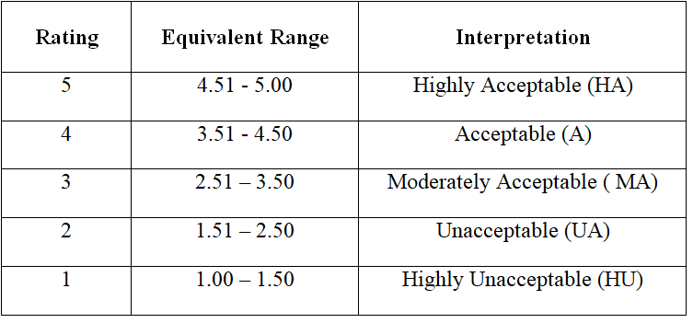*Table 1: Scale*

**Existing and Proposed**

*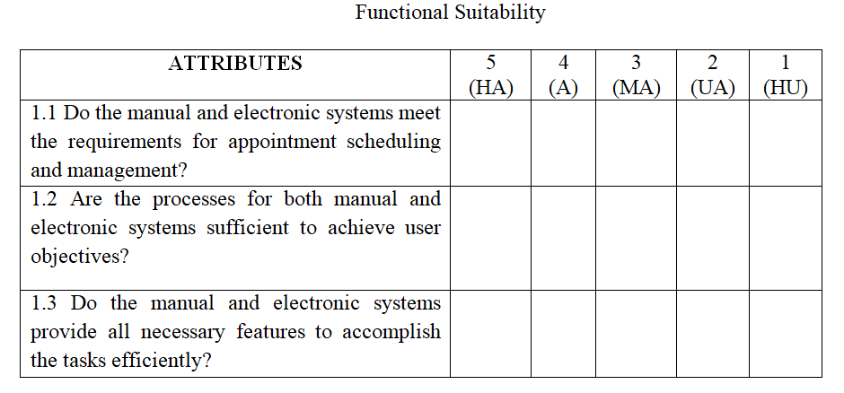Table 2 : Functional Suitability*

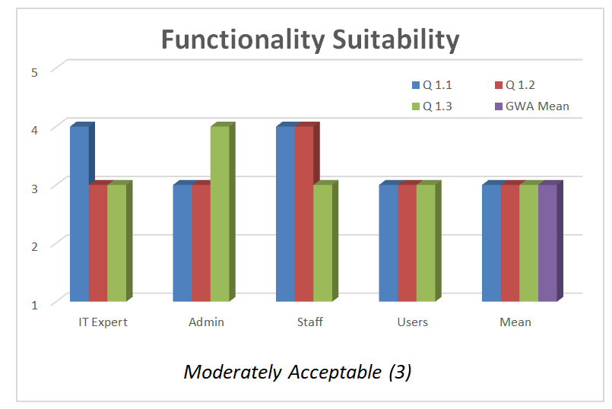*Figure 6. Responses for Functional Suitability of the Existing System*

*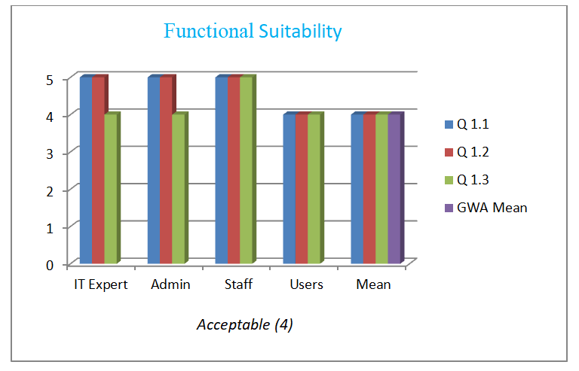Figure 7. Responses for Functional Suitability of the Proposed System*

The analysis shows that the functional suitability of the proposed system with the average mean of 4 surpasses the existing system with the average mean of 3 by performs more effectively than the existing one, providing a seamless user experience with improved navigation, optimized appointment scheduling, and enhanced overall interaction for users.

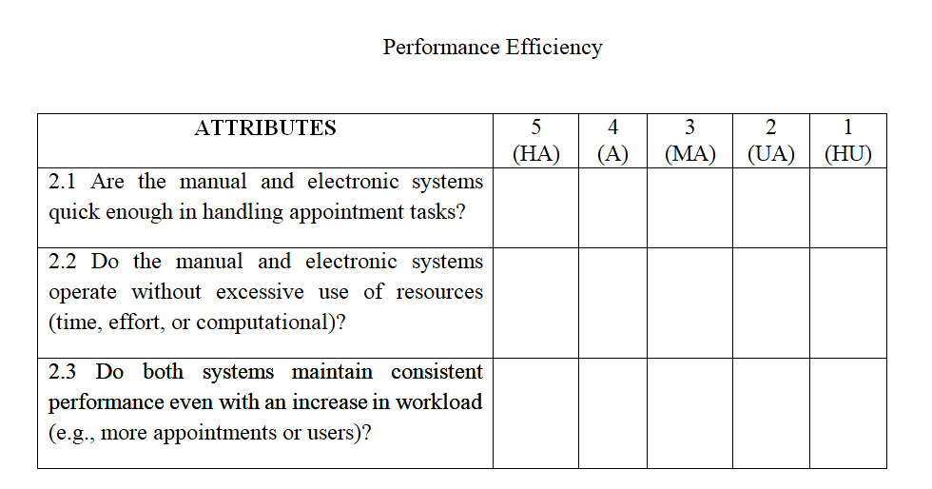*Table 3: Performance Efficiency*

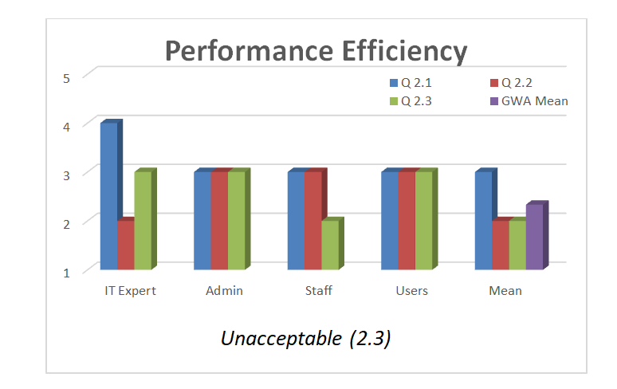*Figure 8. Responses for Performance Efficiency of the Existing System*

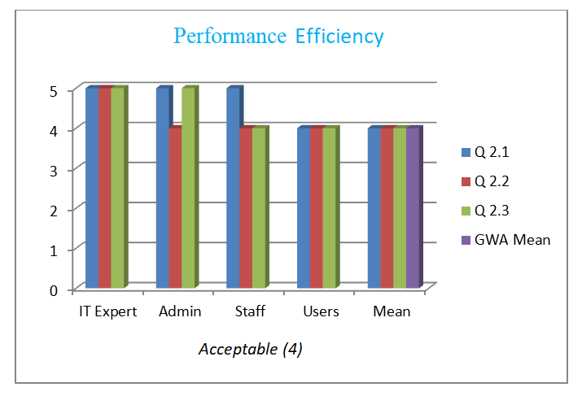*Figure 9. Responses for Performance Efficiency of the Proposed System*

The analysis indicates that the performance efficiency of the proposed system with the average mean of 4 outperforms the existing system with the average mean of 2.3, offering a more fluid users experience characterized by improved navigation, optimized appointment scheduling, and an overall enhancement in user interaction

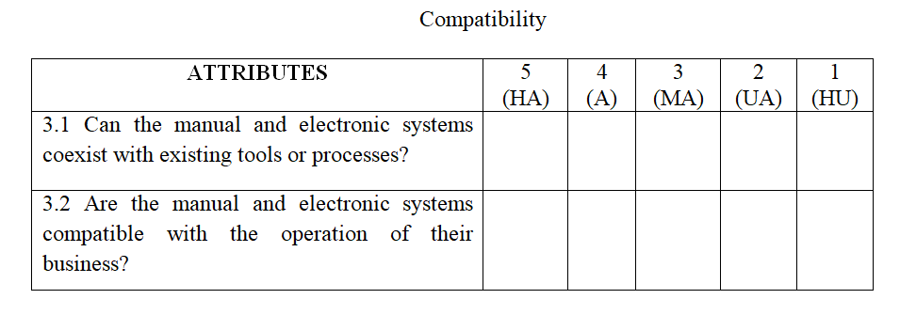*Table 4: Compatibility*

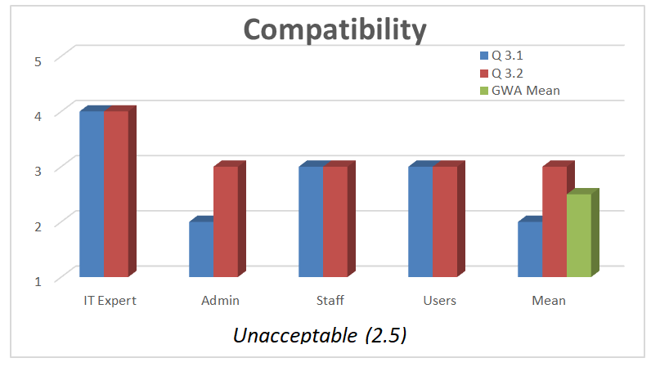*Figure 10. Responses for Compatibility of the Existing System*

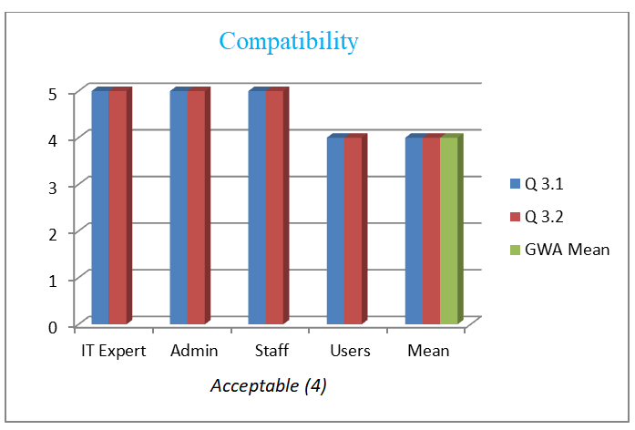*Figure 11. Responses for Compatibility of the Proposed System*

The examination of the survey shows that compatibility of the proposed system with the average mean of 4 outperforms the existing system with the average mean of 2.5, providing a more seamless user experience through better navigation, refined appointment scheduling, and an overall enhancement in user interaction.

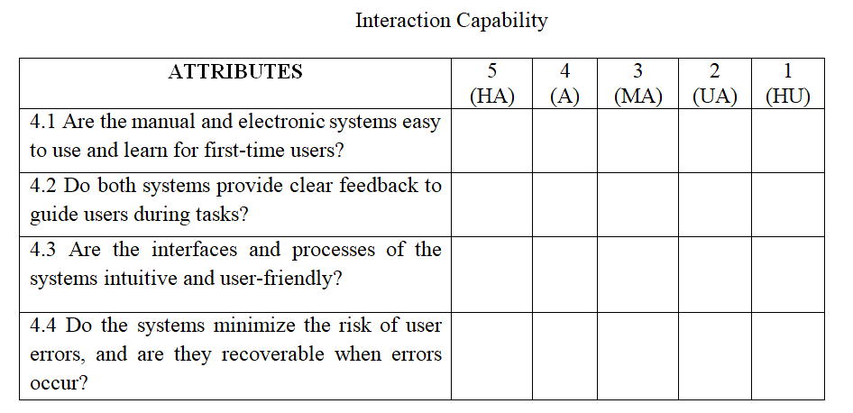*Table 5: Interaction Capability*

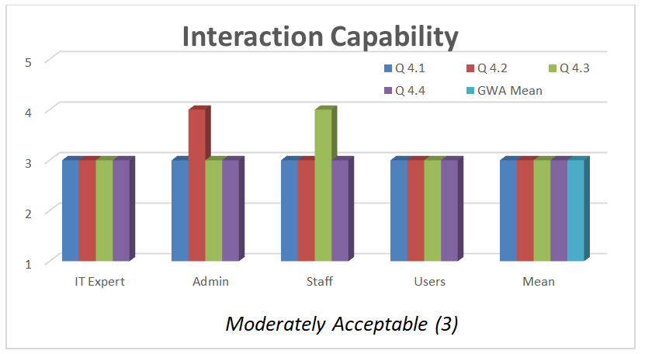*Figure 12. Responses for Interaction Capability of the Existing System*

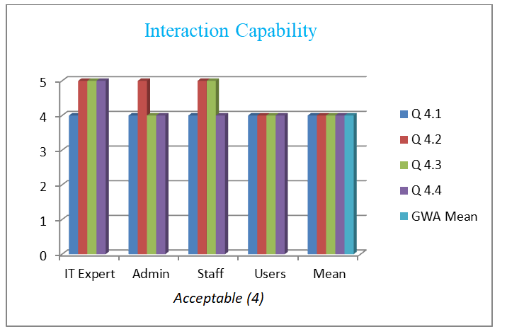*Figure 13. Responses for Interaction Capability of the Proposed System*

The evaluation of the survey results shows that interaction capability of the proposed system with the average mean of 4 surpasses the existing system with the average mean of 3, by elevating usability, efficiency, and overall satisfaction, thereby facilitating a smooth experience through optimized navigation and appointment scheduling.

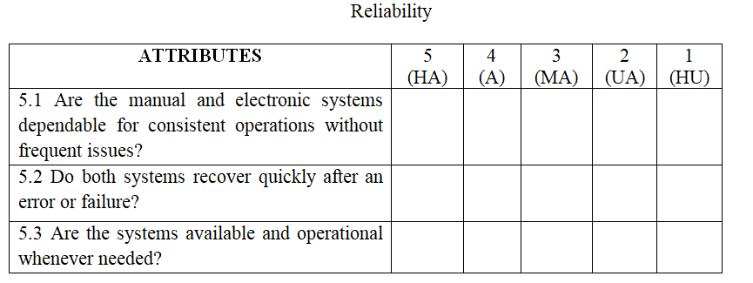*Table 6: Reliability*

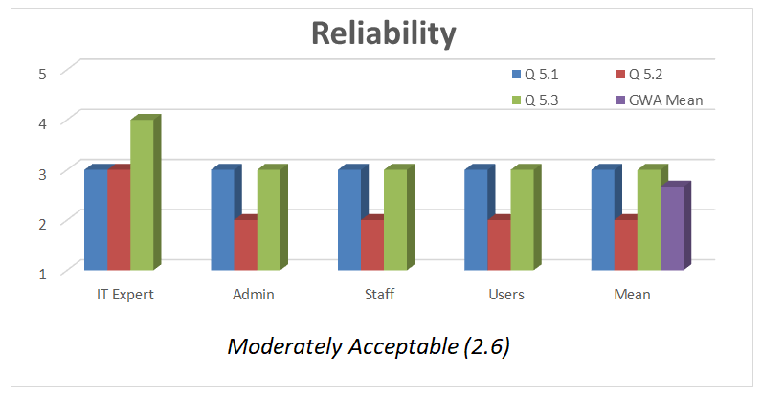*Figure 14. Responses for Reliability of the Existing System*

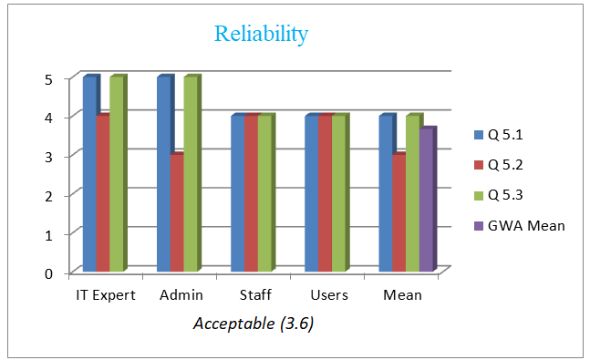*Figure 15. Responses for Reliability of the Proposed System*

The analysis of the survey shows that reliability of the proposed system with the average mean of 3.6 outperforms the existing system with the average mean of 2.6. It facilitates a seamless user experience through enhanced navigation, more effective appointment scheduling, and increased system stability for users.

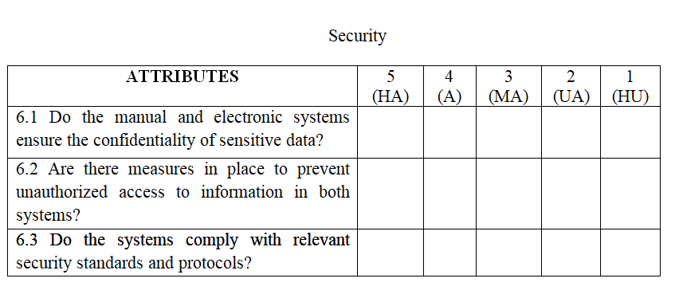*Table 7: Security*

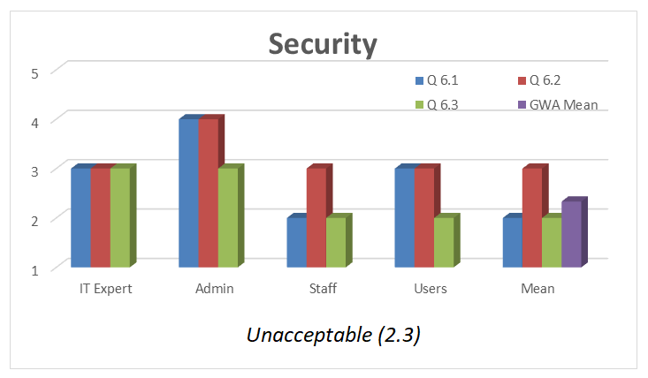*Figure 16. Responses for Security of the Existing System*

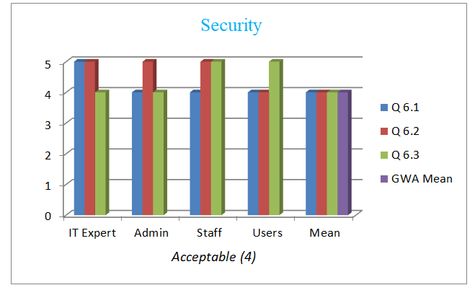*Figure 17. Responses for Security of the Proposed System*

Based on survey the security of the proposed system with the average mean of 4 surpasses the existing system with the average mean of 2.3. It enhances user protection by ensuring secure data handling, safe appointment scheduling, and a more reliable system experience.

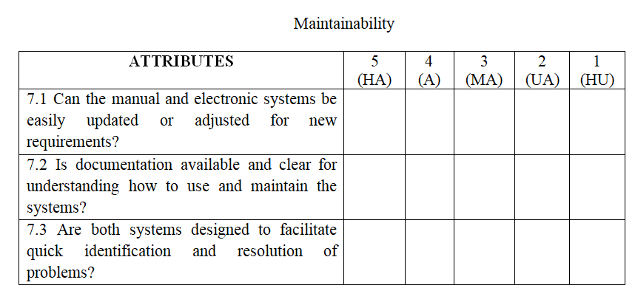*Table 8: Maintainability*

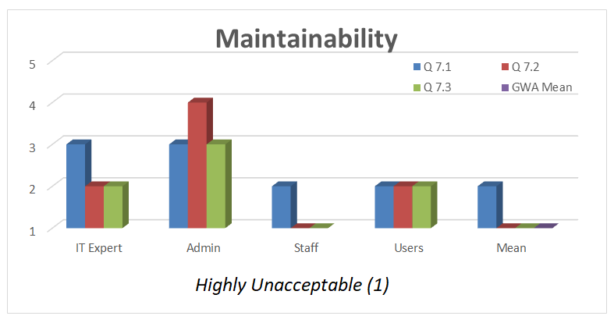*Figure 18. Responses for Maintainability of the Existing System*

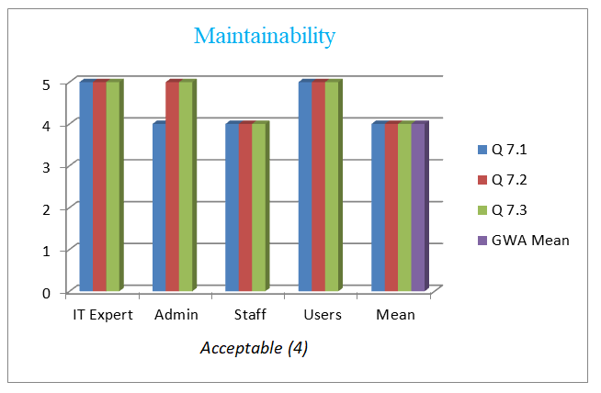*Figure 19. Responses for Maintainability of the Proposed System*

The survey analysis shows that maintainability of the proposed system with the average mean of 4 outperforms the existing system with the average mean of 1, because it is easier to maintain than the existing one. It features improved structure, optimized appointment management, and streamlined navigation, ensuring long-term efficiency and adaptability.

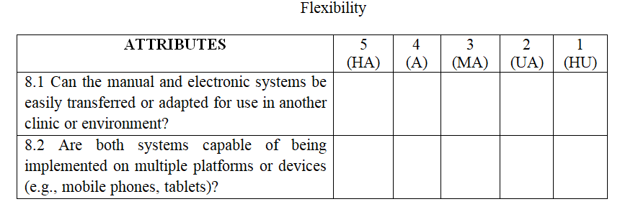*Table 9: Flexibility*

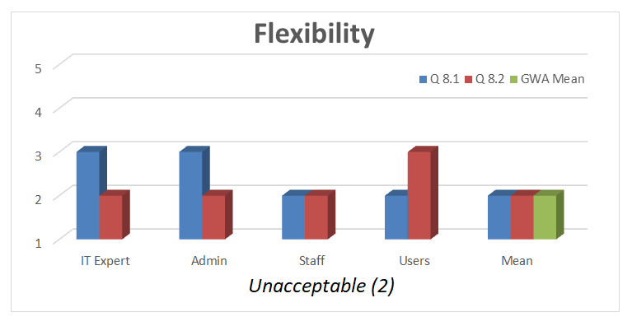*Figure 20. Responses for Flexibility of the Existing System*

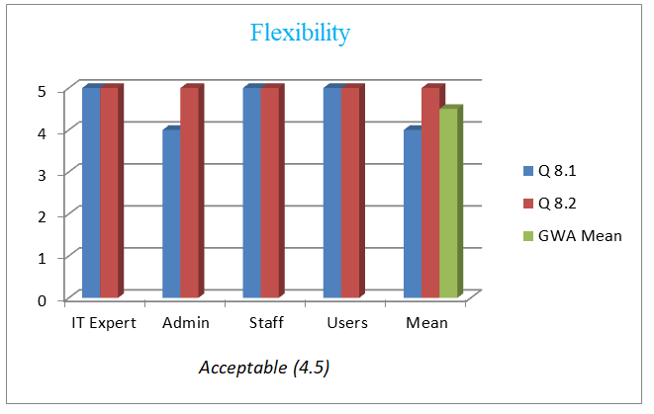*Figure 21. Responses for Flexibility of the Proposed System*

The survey analysis shows that maintainability of the proposed system with the average mean of 4.5 outperforms the existing system with the average mean of 2, because it is more adept at accommodating user requirements, providing enhanced navigation, effective appointment scheduling, and a more integrated overall experience.

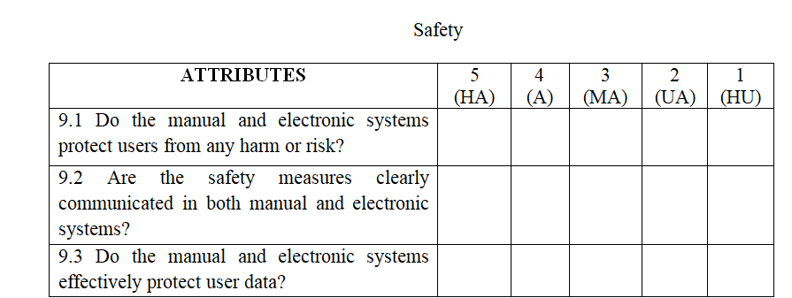*Table 10: Safety*

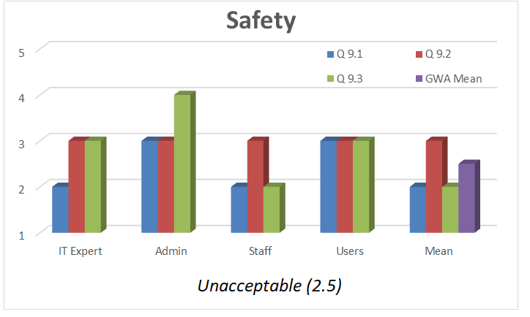*Figure 22. Responses for Safety of the Existing System*

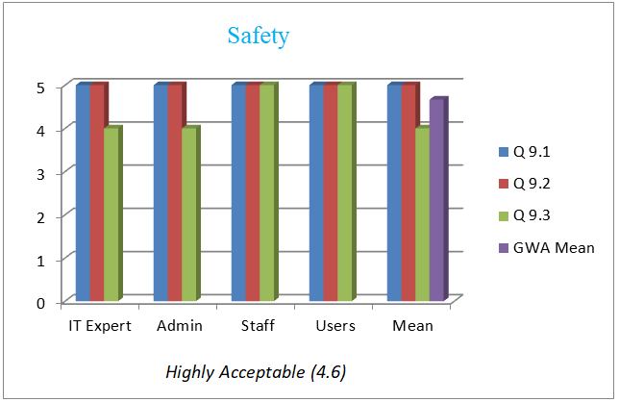*Figure 23. Responses for Safety of the Proposed System*

The analysis of the survey shows that safety of the proposed system with the average mean of 4.6 outperforms the existing system with the average mean of 2.5, because it ensures a safer user experience, minimizes risks, enhances data protection, and provides a secure environment for appointment scheduling and overall interaction.

**Overall ratings of the survey for the existing system**

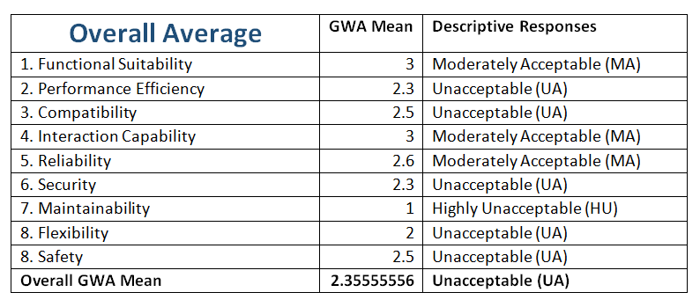*Table 11. Average responses for the existing system*

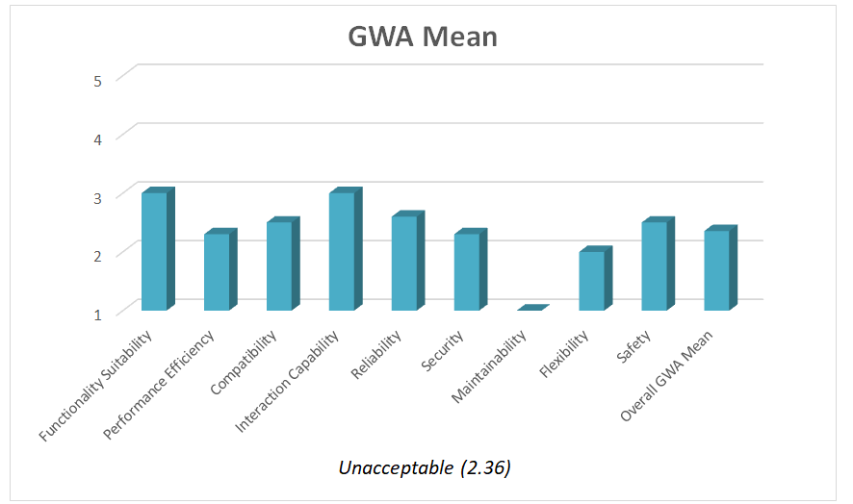*Figure 24. Graphical Representation for Existing System*

The evaluation of the existing system reflects an overall performance rating of Unacceptable (UA), with an average score of 2.36. While certain aspects, such as Functional Suitability, Interaction Capability, and Reliability, were assessed as Moderately Acceptable (MA), several key areas require improvement. Performance Efficiency, Compatibility, Security, Flexibility, and Safety were rated Unacceptable (UA), indicating areas where the system does not meet expected standards. Notably, Maintainability received the lowest rating of Highly Unacceptable (HU), suggesting significant challenges in system upkeep and adaptability. These findings highlight the need for enhancements, particularly in performance, security, and flexibility, to improve overall usability and functionality.

**Overall ratings of the survey for the proposed system**

**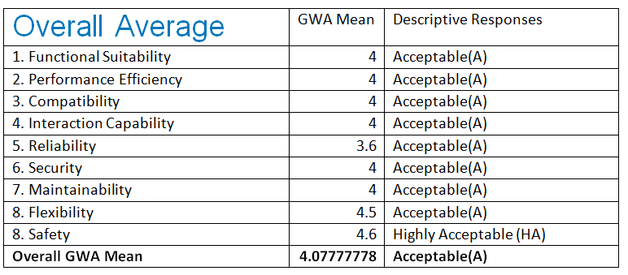***Table 12. Average responses for the proposed system*

**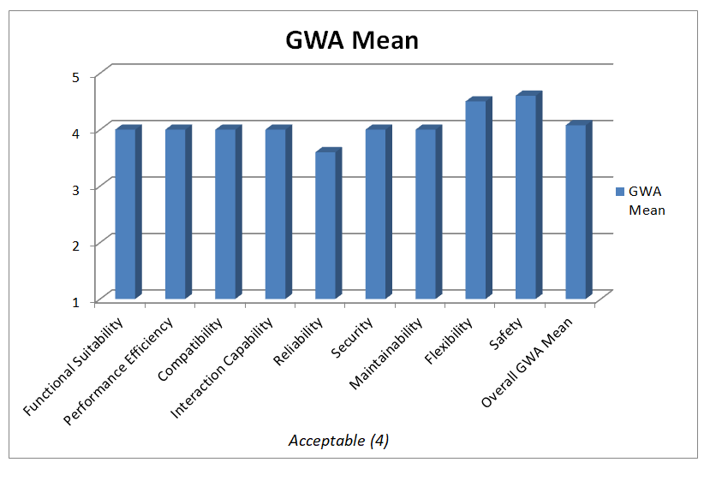***Figure 25. Graphical Representation for Proposed System*

The assessment of the proposed system shows an overall GWA mean of 4.08, categorizing its performance as Acceptable (A). Key areas such as Functional Suitability, Performance Efficiency, Compatibility, Interaction Capability, Security, Maintainability, and Flexibility received an Acceptable (A) rating, indicating that the system meets expected operational standards. Reliability, with a score of 3.6, is slightly lower but remains within the acceptable range. Safety received the highest rating of 4.6, classified as highly Acceptable (HA), highlighting its strong performance in this aspect. These findings suggest that while the system is generally effective, there may be opportunities for further refinement, particularly in enhancing reliability and overall functionality.

**V. FINDINGS, CONCLUSION, RECOMMENDATION**

**Findings**

The Web-based Pediatric Clinic Appointment Scheduling and Management System effectively improved scheduling efficiency by reducing double-booking and missed appointments. Its real-time updates allowed patients to easily see and select available slots, streamlining the booking process. The system also reduced the administrative workload on clinic staff, allowing them to focus more on patient care.Patients found the online booking platform convenient and easy to use, leading to higher satisfaction and reduced waiting times. The notification system successfully reminded patients of upcoming appointments, which decreased no-show rates. The automated follow-up scheduling feature helped maintain regular check-ups, ensuring continuity of care.The patient management module accurately tracked patient information, reducing errors linked to manual record-keeping. Overall, the system effectively addressed the issues of manual scheduling and patient management, improving clinic efficiency, patient satisfaction, and continuity of care, while also pointing to opportunities for future enhancements.

**Conclusion**

The development of the Web-based Pediatric Clinic Appointment Scheduling and Management System effectively addresses the challenges associated with manual booking and patient management processes in pediatric clinics. Through the automation of scheduling, patient record management, and notification systems, the system enhances operational efficiency, minimizes human errors such as double-booking, and significantly improves the patient experience. By providing a user-friendly platform for patients to book appointments online, the system also reduces administrative workload and allows clinic staff to focus more on delivering quality patient care. The Web-based Pediatric Clinic Appointment Scheduling and Management System successfully meet its objectives by streamlining the scheduling process, minimizing administrative errors, and enhancing patient care experiences. It serves as a valuable tool for pediatric clinics aiming to modernize their operations and improve service delivery. Future enhancements could include additional features like teleconsultation, online payment integration, and expanded medical record functionalities to further support comprehensive pediatric healthcare management.

**Recommendation**

The following recommendations are made in order to enhance the Web-Based Pediatric Clinic Appointment Scheduling and Management System:

* User-Friendly Interface: Use an easy and simple design to make the system simple for staff, physicians, and parents to use. Automated Reminders: Include email alerts to help parents remember the child's appointments and minimize scheduling errors. Data Security: To prevent unauthorized access to patient and clinic data, improve security measures.
* Mobile Compatibility: For simpler access, make sure the system functions well on tablets and smartphones.
* Regular updates and Maintenance: To address issues, enhance performance, and introduce new features as required, do routine testing and upgrades.

These recommendations will contribute to the system's increased effectiveness, security, and patient-friendliness for pediatric clinics.

**References**

Economist. (2004) A survey of health care finance. 372(8384), 3–14. Esogbue, A.O. and Singh, A. (1976) A stochastic model for an optimal priority bed distribution problem in a hospital ward. Operations Research, 24(5),

Cayirli, T.E. and Veral, H.R. (2003) Outpatient scheduling in health care: a review of literature

Tebra. (2024, February 29). How online scheduling accelerates practice efficiency and patient trust - Tebra. <https://www.patientpop.com/whitepapers/3-benefits-of-online-scheduling/>

Effective Online Medical Appointment System. (2019). *INTERNATIONAL JOURNAL OF SCIENTIFIC & TECHNOLOGY RESEARCH*, *8*(09), 803–804. <https://www.ijstr.org/final-print/sep2019/Effective-Online-Medical-Appointment-System.pdf>

Effective Online Medical Appointment System. (2019). *INTERNATIONAL JOURNAL OF SCIENTIFIC & TECHNOLOGY RESEARCH*, *8*(09), 803–804. <https://www.ijstr.org/final-print/sep2019/Effective-Online-Medical-Appointment-System.pdf>

Nayak (2021) “Online Appointment Scheduling System” Retrieved 04/20/23from Https://Medium.Com/Sminq/How-Beneficial-Is-An-Online-Appointment-System-In-Comparison-With-The-Traditional-Appointment.

Olujulo, Oluwatomiwa Enoch (2021), “Online Doctor Appointment Booking System” Retrieved 04/20/23 from <Http://Ir.Mtu.Edu.Ng/Jspui/Handle/123456789/275>

Sheily Mendoza, Ranzel Cloie Padpad, Amira Flores Vael and Cindy Alcazar (2020), “Appointment Scheduling System”, Retrieved 04/20/23 fromhttps://www.researchgate.net/publication/335545798_A_WebBased_InstaSked_Appointment_Scheduling_System_at_Perpetual_Help_Medical_Center_Outpatient_Department

Alejo J., (2021), “Online Appointment Scheduling System”. Retrieved 04/13/23fromhttps://www.studocu.com/ph/document/southernphilippinescollege/bachelor-in-elementary-education/chapter-1-hospital-appointing-and-schedulingsystem/

Wordingham J. (2021) “Online Appointment Scheduling System” Retrieved04/20/23 from <https://www.studocu.com/ph/document/southernphilippinescollege/bachelor-in-elementary-education/chapter-1-hospital-appointing-and-scheduling>

Robinson, S., & Lee, K. (2024, October 21). What is an electronic health record (EHR)? Health IT and EHR. <https://www.techtarget.com/searchhealthit/definition/electronic-health-record-EHR>