Hardware Design Choices

### AC Load

Originally, our shunt resistor value was 0.5645Ω

Figure : Original Calculation for Shunt Resistor

However, we cannot get this specific value using E12 values. The closest we can get to 0.5645Ω is two 1Ω resistors in parallel.

Figure : Calculation for new Shunt Resistor

### DC Regulator and Power LED

We had chosen our Rreg1 value to be 22 ohms because it was the closest E12 value to 20 ohms. However, Duleepa recommended that we should we have two resistors in parallel because the resistor has low power rating so we might burn our components. We decided to go ahead with his feedback because our circuit will have better heat distribution leading to a longer lifetime.  
We found that putting 27Ω and 82Ω resistors in parallel was the closest we can get to 20Ω.

Figure : Calculation for Regulator Resistors in parallel

We chose a 48uF and 10uF electrolytic capacitors because it is good for low frequency decoupling. We used 100nF ceramic capacitors for high frequency decoupling. However, when we acquired the ceramic capacitors from the components store, we measured the voltage limit, and it was 16V. This is too low for our requirements, so this is not implemented in our final PCB.

### Offset Generator

We decided to use a buffer to maintain a 2.1V offset. Using E12, the closest voltage we could get was 2.0625V using a 33kΩ and 47kΩ voltage divider. We also put a 100nF ceramic capacitor for high frequency decoupling.

Figure : Calculation for Offset Resistor values

### Voltage Sensing Amplifier

We wanted to have no common ground voltage in our voltage sensing. From our Lab 2 calculation, this meant that R1/R2 = R3/R4. We chose to have all resistor values to be 100k.

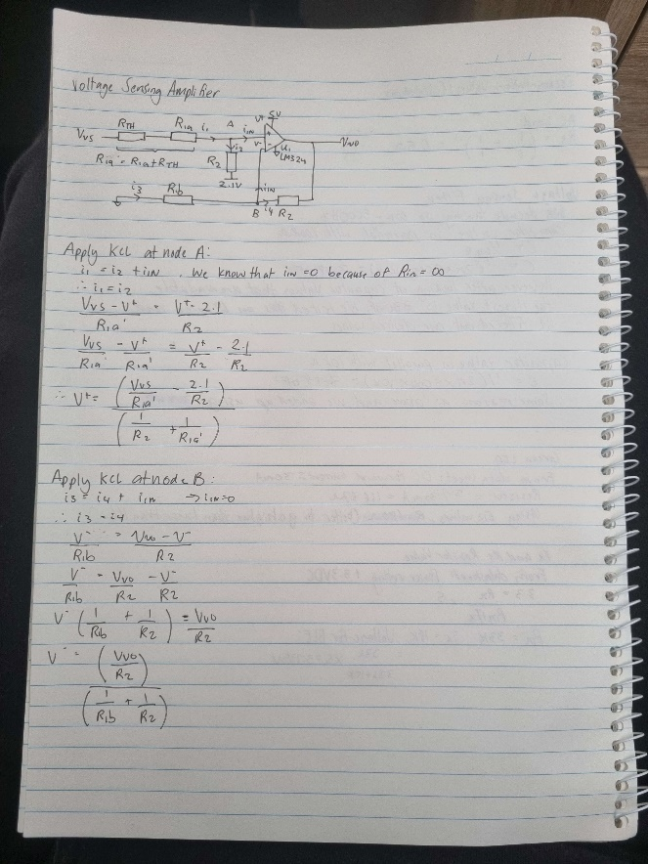

Figure : Resistor Values for Voltage Sensing Part 1

Figure : Resistor Values for Voltage Sensing Part 2

For our second order filter, we chose a breakpoint frequency of 5kHz. When looking at our LTSpice simulation, the magnitude starts to decrease below 500Hz. Since our desired frequency is 500Hz, we do not want our signal to be filtered at 500Hz. Also, the signal may not exactly be 500Hz so we want to capture ranges slightly bigger or smaller than 500Hz. These capacitor values also apply to the Current Sensing Amplifier.

Figure : Capacitor Values for Voltage and Current Sensing Filtration

Figure : Calculating Current Sensing Resistors

We know that R2 = 2.1044*R1. Using E12 values, we chose R1 = 47k and R2 = 100k

### Comparator (Zero Crossing Detector)

Initially, hysteresis was the choice because we only had a low pass filter. Once we used a cascading low pass filter, we tested the circuit without hysteresis and found that it made no difference. So, to save us resources and time, we decided to not implement hysteresis and use a normal comparator.

We removed the potential implementation of a comparator for the current sensing due to being limited to only 4 OPAMP in the IC.

### Test LEDs

Figure : Resistor value for LEDs

### BLE Header

Figure : Resistor values for Tx and Rx for the BLE module

### Decoupling Capacitors

The purpose of these decoupling capacitors is to provide 5V if at any point the power supply was not able to. We chose 100nF because it can respond quickly to voltage fluctuations if the voltage drops below 5V.

### PCB

We tried testing our regulator after soldering it onto the PCB. The regulator smoked up once we connected the input of the PSU to our PCB. So initially we thought there was a problem with the barrel jack or our PCB traces. We only soldered the resistors to our input voltage and checked the output of that to verify our PCB. Turns out that it works properly, and the problem is with the regulator. It is mostly something with the ratings of the regulator. So, we have to look into it and change our regulator resistances or the regulator itself.