

**MACHAKOS UNIVERSITY**

**DEPARTMENT OF CIT**

**INFORMATION TECHNOLOGY**

**UNIT: UNIFIED MODELING LANGUAGE**

**NAME: Maash Daud**

**REG No: J77-1591-2022**

**CAT:2**

**Question 1**

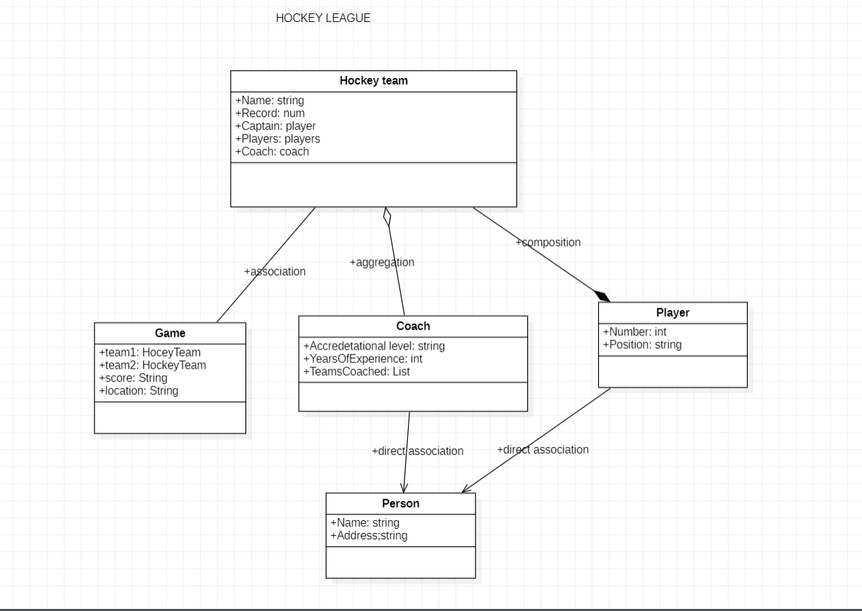

**QUESTION TWO**

**a)**

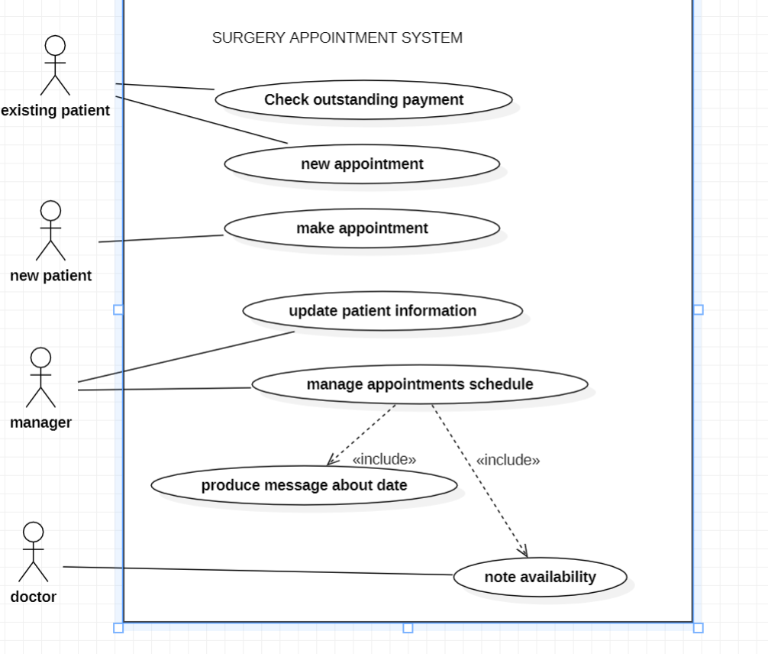

2b)

Actor refers to is an internal / external user or external system with which a system being modeled interacts with

for example we have patient doctor and manager as our actors above

include is a relationship that adds additional functionality that are not specified in the base use case. eg record availability and producing schedule information .

Exclude is a relationship is used to include optional behavior from an extending use case in an extended use case

2c)

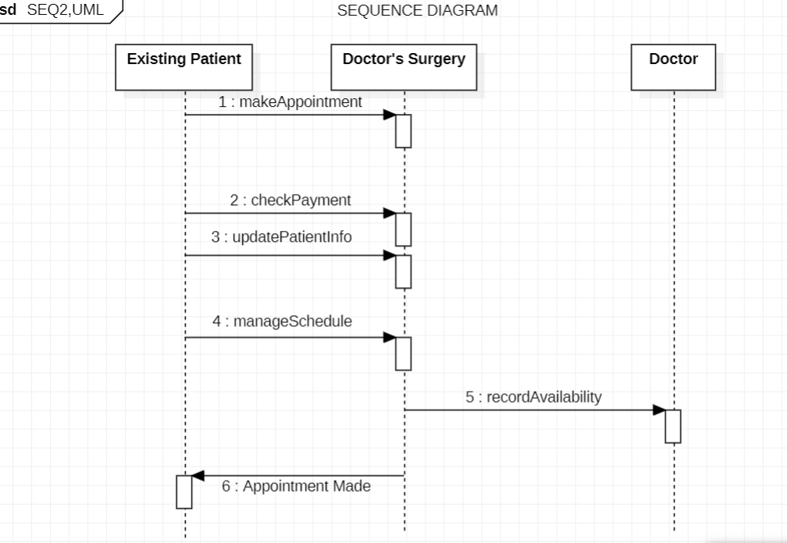

**QUESTION 3**

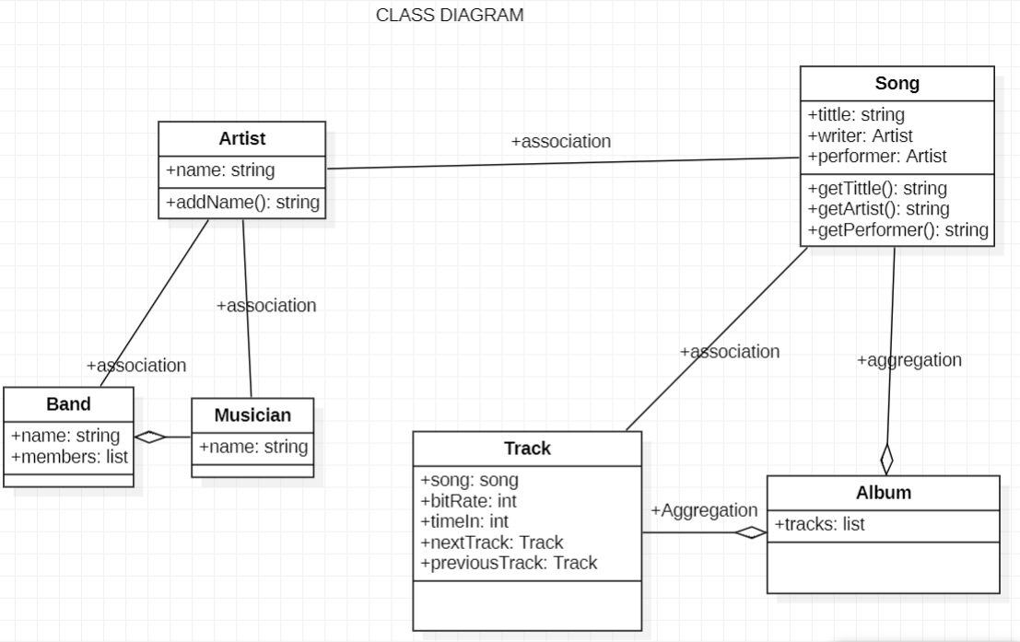

**QUESTION FOUR**

