Milestone 3 Payment: Ksh 55,000

Milestone 2 Payment: Ksh 39,000

Milestone 1 Payment: Ksh 81,500

Note: You’re also expected to analyze and restructure existing code. You’re laying the foundation for everything that follows.

Total Project Amount: Ksh 175,500

**NRWA E-Water Permitting System Key Milestones**

## Milestone 1

Start Date: Monday 7th July 2025

End Date: Friday 11th July 2025

**Key outputs**

* Complete workflow of Surface Water Permit
* Generation of dynamic E-water Permit Certificate PDF

**Acceptance Criteria**

1. **Applicant section**

* An applicant should be able to apply for a Surface Water Permit once logged in
* An applicant should be able to pay for permit application fee
* An applicant should be able to monitor progress of his or her application
* An applicant should be able to receive email/ SMS alerts after each stage of the application

1. **Approver Section**

* After an applicant applies, the first approver should be able to access the application form, verify the application and make a recommendation to the next approver and so on until the last approver makes the final approval
* The workflow should be configurable whereby the systems administrator should be able to add or remove a stage in the workflow including who does what at a particular workflow stage.
* The workflow must be able to flow in both forward and backward direction. In a case where there is a query, the current approver can refer back the application to previous approvers for clarification.
* The workflow steps must follow the business process steps highlighted in the figure 1 diagram below
* The client must be notified of the decisions made at each stage via emails

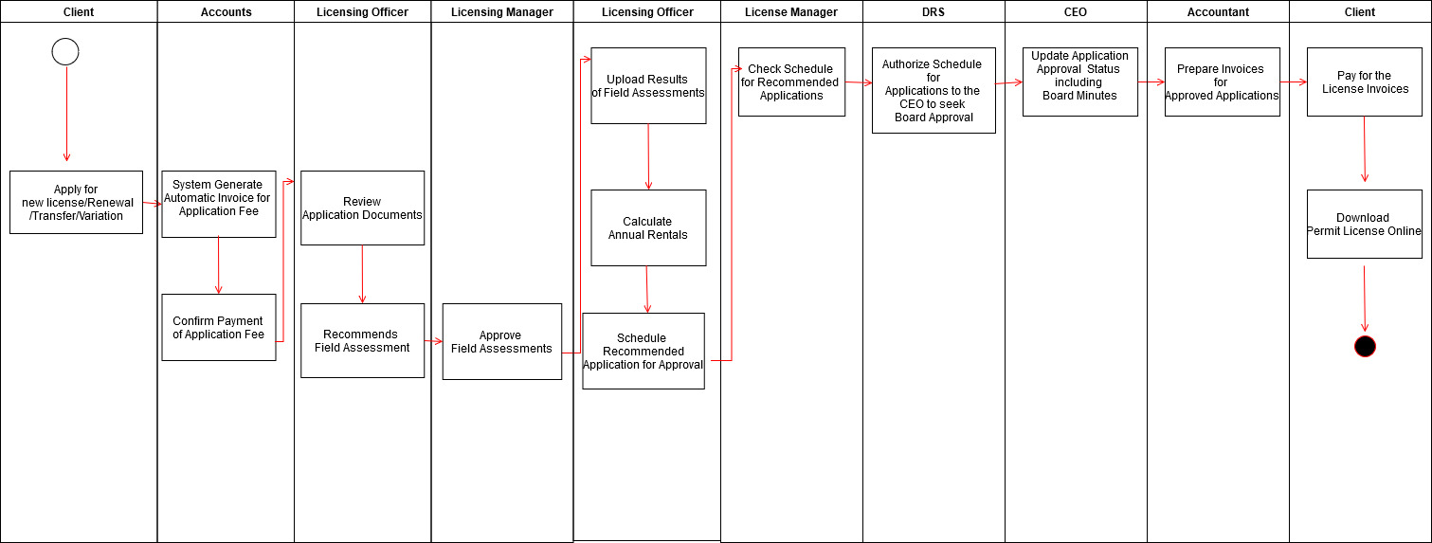

Figure 1workflow

## Milestone 2

Start Date: Monday 14th July 2025

End Date: Friday 18th July 2025

**Key outputs**

* Complete the workflow for all the forms highlighted in Table 1.

**Acceptance Criteria**

1. **Applicant section**

* An applicant should be able to apply for a relevant E-Water Permit once logged in
* An applicant should be able to pay for permit application fee
* An applicant should be able to monitor progress of his or her application
* An applicant should be able to receive email and sms alerts after each stage of the application
* An applicant can be able to apply for multiple licenses if need be

1. **Approver Section**

* After an applicant submits an application, the first level of approver should be able to access the application form, verify the application and make a recommendation to the next approver.
* The workflow should be configurable where the systems administrator should be able to add or remove a stage in the workflow including who does what at a particular workflow stage.
* The workflow must be able to flow in both forward and backward direction. In case there is a query, the current approver can refer back the application to previous approvers for clarification.
* The workflow steps must follow the business process steps highlighted in the figure 1 diagram below
* The client must be notified of the decisions made at each stage via emails

**Table 1**

|  |  |  |
| --- | --- | --- |
| **S/N** | **Permit Category** | **Type of License/Permit** |
| 1 | Ground and Surface Water Permit | Registration of Existing Right |
|  |  | New License Application |
|  |  | Renewal of expiring/expired license |
|  |  | Provisional License |
|  |  | License Variation |
|  |  | Transfer of License |
| 2 | Effluent Discharge Permit | Registration of Existing Right |
|  |  | New License Application |
|  |  | Renewal of expiring/expired license |
|  |  | License Variation |
|  |  | Transfer of License |
|  |  |  |
| 3 | Borehole Drilling and Constructors Permit | Registration of Existing Right |
|  |  | New License Application |
|  |  | Renewal of expiring/expired license |
|  |  | Provisional License |
|  |  | License Variation |
|  |  | Transfer of License |
|  |  | Borehole Rehabilitation Permit |
|  |  | Borehole Drilling License-New |
|  |  | Borehole drilling License Renewal |

## Milestone 3

Start Date: Monday 21st July 2025

End Date: Friday 25th July 2025

**Key outputs**

* The system must be able to generate all the documents highlighted in table 2 below
* The system must be able to generate each of the reports specified in table 3. This include the statistics dashboard and visualizations
* The system must be able to integrate with third-party systems such as the water resources information system and payment gateways via APIs
* The final product must be deployed on the client servers
* User manuals for the system
* Source code and the necessary technical documentation

**Acceptance Criteria**

1. **Output documents**

The system should be able to generate all the pdf documents as indicated in Table 2 below

*Table 2 Expected pdf outputs*

|  |  |
| --- | --- |
| 1 | Invoice |
| 2 | Receipt |
| 3 | Water Abstraction Permit |
| 4 | Effluent Discharge Permit |
| 5 | Borehole Drilling Permit |
| 6 | Borehole Constructors Permit |

1. **Output reports**

***Table 3 Output reports***

|  |  |
| --- | --- |
| **Type of Report** | **Description** |
| Water Allocation Level | This report provides information on which water resource areas or units have high degree of water abstraction relative to runoff |
| Water Discharge Distribution | This report provides information on which water resource areas or units have high effluent discharge relative to national total discharge |
| Water Use Distribution | This report provides information on which water resource areas or units have high abstraction relative to national abstraction |
| Water Permits Distribution | This report shows the distribution of approved licences over the resource areas and distributions |
| Water Licence Debt Distribution | This report shows the distribution of licensing related debts as percentages of total debt over the resource areas and units |
| Water Licence Revenue Distribution | This report shows the distribution of the licensing revenue as the percentages of total revenue over the resource areas and units |
| Largest Water Users | This report lists the top (n) largest water users |
| Largest Water Discharge | This report lists the top (n) largest water use discharge permits |
| Largest Debt Holders | This report lists the top (n) largest licensing debt holders |
| Largest Revenue Licences | This report lists the top (n) largest water users in terms of revenue |