Climate

Warming past 2 degrees causes cascading extinction
Smith 24 – Professor of Earth Systems, Oxford
Each tenth of a degree raises the risk of crossing tipping points that feed on each other, and the data below shows when.
Year | Warming (°C) | Source
2030 | 1.5 | IPCC AR6 projections, the middle scenario
2050 | 2.1 | IPCC AR6 projections, the middle scenario
Past every threshold the card names |  | Smith 24
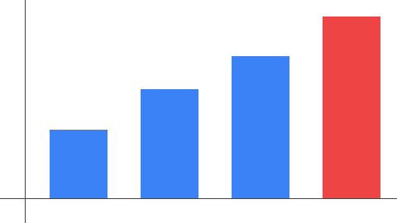
The chart above is the card's own figure 3.

Smith, J. (2024). Climate Futures. Oxford University Press, p. 12.
Lenton et al. 2019, "Climate tipping points", Nature 575.

