**Forceful**

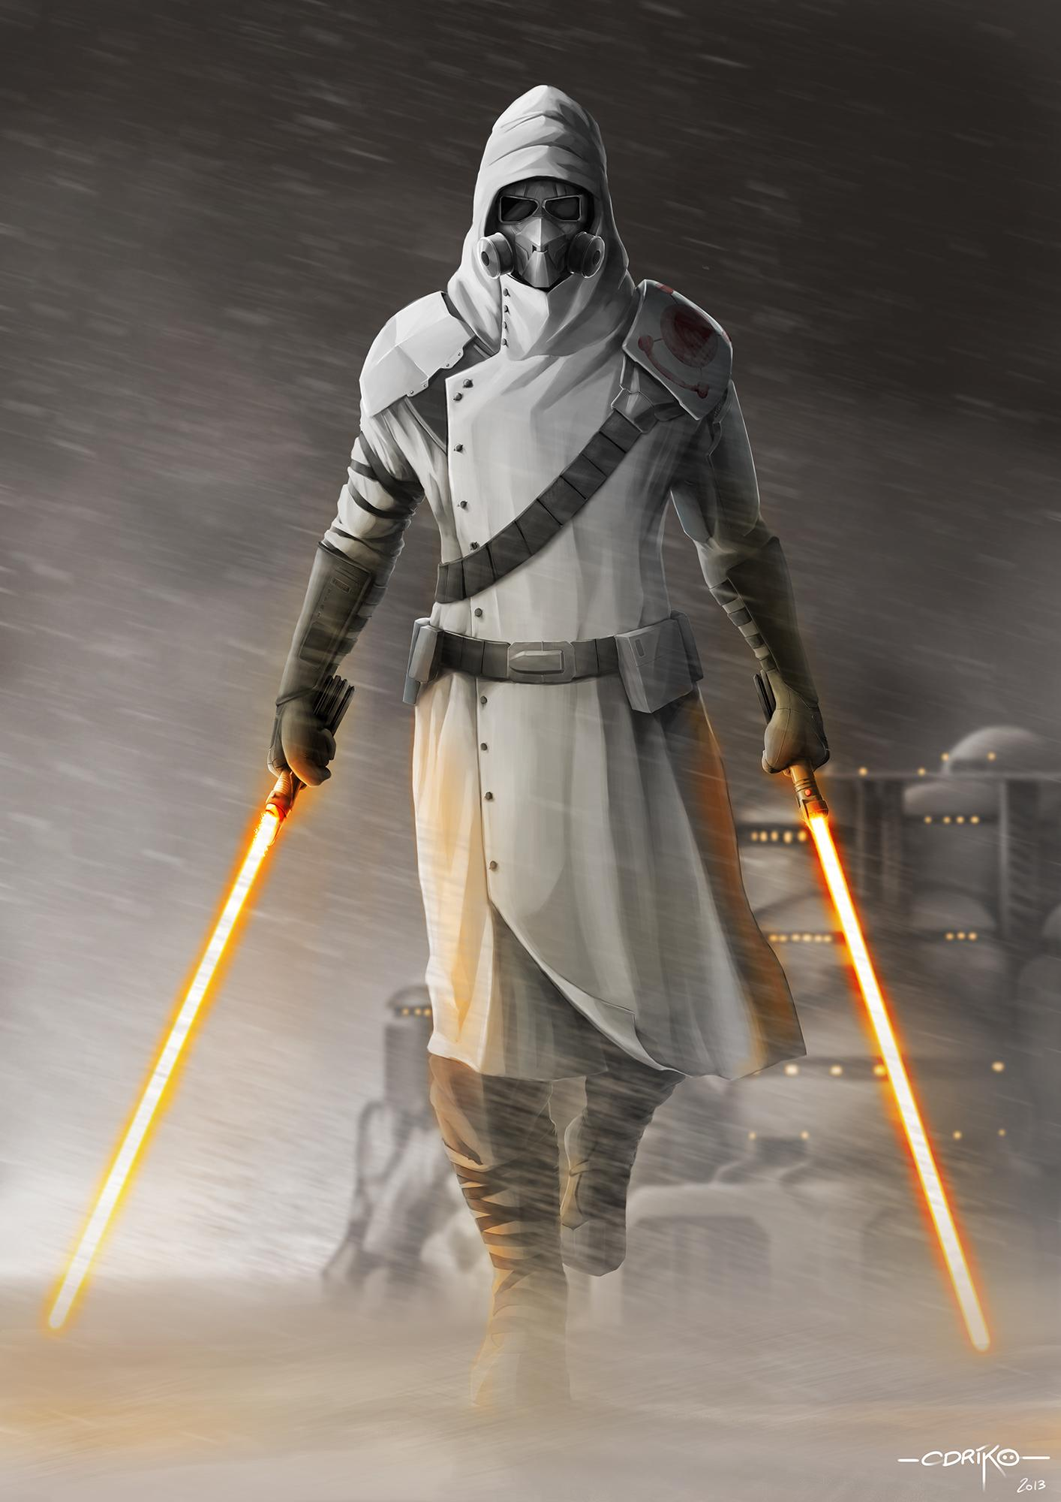

Epilogue: Three Years Later…

Version 0.2

Dedicated to God

# **Chapter 1: Lhoka**

“State your name,” the bored guard told us.

“Amber Randrel,” Amber told the guard, “And my assistant.”

The guard quickly looked up Amber on his holopad, “Very well then. You can enter.”

The large, metal door slid open, allowing Amber and I to walk into the massive complex owned by the Hutt family.

“Wow!” I whispered to Amber, “It’s much bigger on the inside!”  
“That’s because a good portion of the building is underground,” Amber informed me.

“Where’s that ship you wanted?” I whispered back as we walked slowly down the red carpet covering the aisle. On either side of the aisle was fancy, golden fencing that kept buyers from touching the featured collection of rare spaceships.

“I forgot the name,” Amber said, “But I’ll know it when I see it. It looks very strange.”

“Why do you want it again?” I pressed.

Amber laughed, “Leo wanted to harvest a bunch of parts off of it.”

I chuckled, “What’s he working on now?!”

“No clue. He never tells me until he’s almost done.”

At the end of the very long hangar, Amber found the spaceship she was after.

“That’s it!” Amber cried out, “Check out those engines?”

“You weren’t kidding,” I grimaced, “That *is* ugly.”

“*THAT*,” a nearby curator addressed us, “Is a genuine BG-11!”

“And that’s cool because…?” I asked him.

“Because!” the curator said excitedly, “It was one of the first ships ever designed by the esteemed Garvle Humpfer!”

Amber, who didn’t have the heart to tell the curator she had no idea who Garvle was, nodded her head and continued to the grand spiraling staircase that led to the second floor. Standing in front of the staircase was a pair of armed guards and a perfectly dressed stewards.

“Only royalty is allowed here,” the steward informed Amber, “Your assistant is not allowed on the second floor.”

“I promise I won’t cause any trouble,” I insisted.

Amber waved it off, “I’ll be fine.”

The steward nodded and let Amber pass while I was stuck. Grimacing, I hurried back through the hangar towards the exit.

“Lhoka? Do you copy?” Amber asked me through our shortwave earpiece radio system.

“Copy that,” I said, “Call if you have troubles.”

“Not likely,” Amber said, “Everyone up here looks like they haven’t done a stitch of work their entire lives.”

“Any Hutts there?” I asked, as I headed back out the front, sliding door and into the main streets of Quirzky.

“Just some distant cousin of Jobba,” Amber noted, “But I’m going to go silent here for a bit. Don’t want to attract any undue attention.”

“Ten-four,” I said, “I’m going to roam the bazaar and see if I can’t find any good deals on something.”

It was a planet wide celebration of some random holiday I didn’t know about, but Amber had found out that there was going to be a large amount of auctions sporting rare goods and had insisted that we go. There were plenty of tents that displayed various weapons, parts, droids, and even slaves that passerbys could purchase, but nothing piqued my interest until I passed a large food stand selling colo claw fish. Leo loved colo claw fish and frequently purchased varieties of the dish to share with Amber and I. This happened so much that I had started to develop a taste for it as well, and when I passed the food stand, I found that I had to give it a try.

“You’re selling colo claw fish?” I asked the tall Besalisk manning the booth.

“That I do!” he replied, “What can I do for you?”

“Show me what you got,” I told him, slapping down some credits.

“I have the best recipe in the galaxy,” the Besalisk insisted, “You will be more than pleasantly surprised.”

“Prove it,” I laughed, “I’ve got a friend that loves this stuff, and I want to see what you can do.”

“Nephew!” the Besalisk yelled back to the cook, “One plate of colo claw fish please!”

There was a grunt from the small, tin shack at the back of the tent as the cook started on my order.

“Been slow today?” I asked him as I leaned against the counter.

“Kinda,” the Besalisk replied, “It’s right in between breakfast and lunch, so we haven’t gotten a whole lot of customers yet.”

I pointed to the sign advertising his food stand, “Are you Jong of Jong’s Club?”

“That’s me,” Jong said, “I’ve been in this business for a while now!”

“Oh, so you have an actual club based out of somewhere?”

“Yep,” Jong said, “We do brisk business with locals and travellers.”

“Huh, I may have to stop by sometime, *if* your colo claws are good enough,” I chuckled.

“Oh, it will be,” Jong insisted, “Say, where are you from?”

“Oh, I just sort of travel around,” I said casually, “Why?”

“It’s just that I don’t see a lot of Togrutas anymore,” Jong stated, “The last one I saw was a slave to some guy that stopped by at my club two years ago.”

I grunted, “Wars haven’t exactly favored my species. It’s been even longer than two years since I last saw a pure Togruta.”

“Are you here by yourself or with some others?” Jong continued.

“You ask a lot of questions,” I said suspiciously.

“Just curious,” Jong laughed, “I’m bored too.”

“My friend and I came here to buy a spaceship from the Hutt auction,” I told Jong, “But I’m just the ‘assistant’ so I wasn’t allowed to follow her onto the second floor.”

“Woah, so your friend is a bit on the rich side of the spectrum. What does she do?” Jong said.

“Oh, a little of this and a little of that. Nothing in particular,” I said.

“One Colo Claw Fish delight,” the cook announced, stepping out from the shack and handing me the seafood specialty.

As I reached out to take it, the cook suddenly paused and stared at me.

“What?” I said, “Is something wrong?”  
“Lhoka,” the cook breathed, recognizing who I was.

“You know her?” Jong asked.

“Of course I do!”

“Wait a minute!” I exclaimed, “PING?!”

“That’s me!” Ping said excitedly, finally remembering to actually pass me my food, “What are you doing here?”

“Nothing,” I said curtly, grabbing my food, “I’ll see you guys.”

“Wait!” Ping shouted after me, “I…”

Without waiting to hear what he had to say, I hurried off into the crowd of shoppers. I was already wanted by the Empire, and I couldn’t risk having anyone actually know who I was. A quarter of a mile later, I came across a large dining area with several tables. At one end, a bunch of gruff looking guys were auctioning off a wide variety of droids. I sat down at a nearby table and dug into my food, keeping an eye on the auction and the surrounding passerbys. Ping being in the general vicinity made me very nervous. It had been a good three years since I had last seen him, and I had assumed he had been killed, until now…

“Seven thousand credits!” the auctioneer yelled over the buzz of the crowd, “Do I have anyone willing to pay eight thousand for this brand new translation droid?”

The spices on my colo claw fish interested me more than a translation droid. Ping may have made some questionable life choices, but his cooking, I had to admit, was second to none.

“Sold to the guy with the blue face!” the auctioneer rambled on, “Next, we have an old, but incredibly versatile astromech droid!”

I groaned and looked over at the line up of other droids about to be auctioned as I finished up my early lunch.

“Lhoka!” Ping said excitedly, plopping down at my wooden table, “What’s up?”

“Ping,” I growled in a low voice, “What are you doing here? I specifically remember giving off vibes that said I don’t want you here!”

“I know,” Ping admitted, “But it’s been so long! How are you doing?!”

“I *was* doing good, until you showed up,” I sighed.

Ping stared at me, “What is wrong? Are you upset at me?”

“Oh I don’t know,” I growled, “Maybe because last time I saw you, you were actively trying to kill me? And also maybe because I’m wanted by the Empire in a variety of capacities, and I don’t like having people who know me standing around and making my identity known?!”

“You’re wanted by the Empire?” Ping gasped.

“Aren’t you?” I countered.

“Okay, so maybe I have made some poor choices before in my life,” Ping admitted, “But I’m older now and wiser!”

“You’re only like seventeen now, right?”

“Almost eighteen!” Ping stated, “And nearly as tall as Jong.”

“I saw,” I said, “I’m not blind.”

“Are you here with Leo and Amber?” Ping wanted to know next.

“I am *not* saying,” I declared defiantly.

“But you said you have a friend that likes colo claw fish, and you’re also with a friend that you referred to as a ‘she’,” Ping reminded me, “Which would insinuate that you are still hanging around with Amber and Leo.”

I growled, “Just stay out of my way, and we’ll get along fine.”

“Wait, so if I leave you alone, you’ll be fine with me?” Ping asked.

“Sure, sure,” I answered.

“Cool! Then maybe we can hang out sometime!” Ping exclaimed.

“I am *not* hanging out with you,” I told Ping, “Not now, not ever.”

“Seriously?” Ping whined, looking me up and down, “But I’m a nice guy, and you’re still single, right?”

“Oh, for crying out loud!” I cut him off, standing up, “I need to go now.”

“Can I come with you?” Ping asked eagerly.

“Ping,” I nearly shouted at him, “Leave...me...alone? Got it?”

Ping, taken aback by me, quickly retreated as I hurried into the ever-growing crowd of people. It was bad enough that Ping was still around, but it was even worse that he recognized me and wanted to “hang” out.

“Lhoka, are you still there?” Amber whispered to me over my earpiece.

“Yep,” I answered, “What’s going on?”

“The auction is about to begin, so we’re all heading down to the hangar now,” Amber informed me, “I’m ready to meet back up.”

“I’m on my way,” I said.

After shoving my way through the bazaar’s crowd and reminding the auction’s guards who I was, I finally managed to get back inside and meet up with Amber.

“My ship is one of the last to be auctioned,” Amber sighed, “Since it’s one of the least valuable.”

“Hopefully it won’t take too long then,” I asserted.

All around us, pompously dressed royalty and merchants mingled chatting about various news and rumors. Amber, although not royalty or a merchant, was certainly dressed to impress and looked like a model.

“Attention ladies and gentlemen!” a perfectly dressed man shouted to the crowd of people inside the hangar, “Let us start off the bidding with this perfectly conditioned Jedi starfighter!”

This was punctuated by the main, steel door being blasted open and three squads of stormtroopers running into the hangar.

“Oh bother,” Amber muttered.

Around us, all of the other rich humans, aliens, and other creatures screamed and ran out of the way.

“Lhoka, go to the second floor where you’ll find a security room,” Amber said, as the storm troopers raced into the crowd, “Find out how to open this hangar’s doors, so I can fly the spaceship out.”

“Got it,” I told Amber.

“I’ll cover you,” Amber said, “It shouldn’t be too hard to hold these troopers off.”

As I pushed my way through the panicking people, I plotted out the quickest way to reach the spiral staircase leading to the second floor. Behind me, the storm troopers came across Amber who fought back using her double-bladed lightsaber with practiced ease. Luckily, Amber and I had been closer to the back of the hangar than the front, so I managed to make good time through the crowd and raced towards the stairs. Just like last time, two armed guards stood in front of the stairs, blocking access, but I just leapt over them using a Force jump and kept on running.

“Hey you!” one of the guards yelled after me, “Stop!”

“Sure,” I mumbled to myself, taking two steps at a time.

At the top of the stairs, I found myself in a lavish ballroom type setting. I snatched a few pastries off of a nearby platter as I ran across the ballroom and down the only other hallway. Soon enough, I skidded to a stop in front of a locked, unlabeled door.

“Nothing a lightsaber can’t solve,” I laughed to myself, shoving my lightsaber through the electronic lock.

With a shower of sparks, the door clicked open, and I rushed inside.

Despite the myriad of buttons, levers, and controls, I quickly surmised that the main hangar doors were controlled by about thirty sliders that were connected to an electronic board right underneath a large window that looked out over the hangar below. Amber was making quick work of the storm troopers as frightened royalty surged past the fence line and took cover behind priceless spaceships - much to the auctioneer’s horror.

Keeping my fingers crossed, I immediately started pushing all the sliders forward. These, in turn, did open the hangar’s doors causing further confusion down below. Behind me, the two guards finally caught up and advanced upon me, their spears pointing directly at my head.

“Sayonara suckers!” I told them cheerfully, slicing off the tips of their spears with my lightsabers and racing back out of the control room.

Angered, one of the guards leapt at me, sending us spiraling into a large, glass window along the corridor. However, my lightsaber was still on, so the impact of us hitting the window plus my lightsaber plunging into it and compromising the basic structure caused the window to break - dropping us into the alley far down below. I landed below no worse for the wear, but the guard splattered down beside me. I wasn’t familiar with this dingy alleyway, but I randomly chose the left passageway and ran along it, hoping to find my way back to the hangar to make a quick getaway with Amber. Unfortunately, when I finally arrived at the South end of the bazaar, I promptly ran into a squad of stormtroopers.

“There she is!” one of the troopers yelled to his comrades, “Get her!”

“Oh great,” I mumbled, racing back the way I had just come.

The alley was honestly pretty crummy and smelled like garbage and sewage. I hoped I wouldn’t splatter too much of it on my new outfit that Amber had just bought for me for this occasion. Hurtling a nearby crate, I vaulted into a small dead end lined with dumpsters.

“Bother,” I snorted, “I guess I’ll just have to face them dead on.”

That’s when a small starfighter roared overhead, and someone leapt out of the cockpit and into the alleyway.

“Aha!” the Inquisitor smirked, “We finally met, Lhoka.”

“Should I know you?” I asked, brandishing my lightsaber.

“Not really,” he said, “But I’ll be glad to finish you off.”

“You wish,” I snorted, “Give me your best.”

“Gladly,” the inquisitor said, performing a leap attack.

Evading his preliminary blow, I somersaulted to the left and bounced off the side wall attacking him from the rear. The Inquisitor turned on the rapid rotating ability of his lightsaber and chopped at me mercilessly while I fought back, careful to not get boxed in.

“Harrraugh!” I cried out, suddenly turning on him and launching him backwards with a powerful Force push. The Inquisitor smashed into a wall but swiftly recovered and attacked again; just as the storm troopers finally caught up with me. I was very powerful, having trained under both Amber and Leo, but even someone like me would have trouble fighting off a powerful Sith Inquisitor and a squadron of troopers. Things were starting to look a bit unfortunate.

Amber had always told me that when you are out-gunned and out-maneuvered, the best thing to do is...RUN! I was off like a shot, plowing through the storm troopers and sprinting back down the alley again with the Inquisitor in hot pursuit. I almost reached the bazaar before the Inquisitor Force grabbed me and stopped my flight.

“Mwahahahaha,” he laughed, “Looks like you’re out of options.”

“Not completely!” a familiar voice spoke out from the crowd of people milling about the bazaar. As if on cue, Leo backflipped in front of me, “I’ve told you before to leave my apprentice alone.”

“So I’ve heard,” the Inquisitor spoke as more storm troopers converged on Leo and I, “But this time, I have the advantage.”

“Not really,” Leo laughed, blasting all our opponents away using an insanely strong Force push. Several of the troopers were flung into the crowd of people - causing screams and yells of confusion.

“That’s all you got?!” the Inquisitor taunted Leo, racing back to attack.

“Nope,” Leo laughed, pulling out his lightsabers, “I also have this!”

The Inquisitor, his lightsaber spinning deadly fast, attacked but was no match for Leo’s dueling skills. Before he really realized what was happening, the Inquisitor was flattened on the ground, his lightsaber snapped out of his grasp. Around us, some of the storm troopers pulled themselves to their feet and started blasting again at Leo, but he electrocuted them all with Force lightning.

“And I’ll take this as a memento of our fight,” Leo announced, picking up the beaten Inquisitor’s lightsaber and hanging it on his belt.

“You won’t get away with this,” the Inquisitor groaned.

Leo zapped him again for effect as a large, dark shadow suddenly covered the scene of our battle.

“AMBER!” Leo yelled excitedly, “A pleasant surprise!”

“Just in time, I see,” Amber said into our earpieces while the back of the spacecraft opened up. Leo boosted me up into the spacecraft; then followed himself. Meanwhile, the crowd of bazaar shoppers stared up at us.

“Let’s go before we attract any *more* attention than we already have,” Leo groaned, as Amber maneuvered our newly stolen spacecraft between the tall spires of the city.