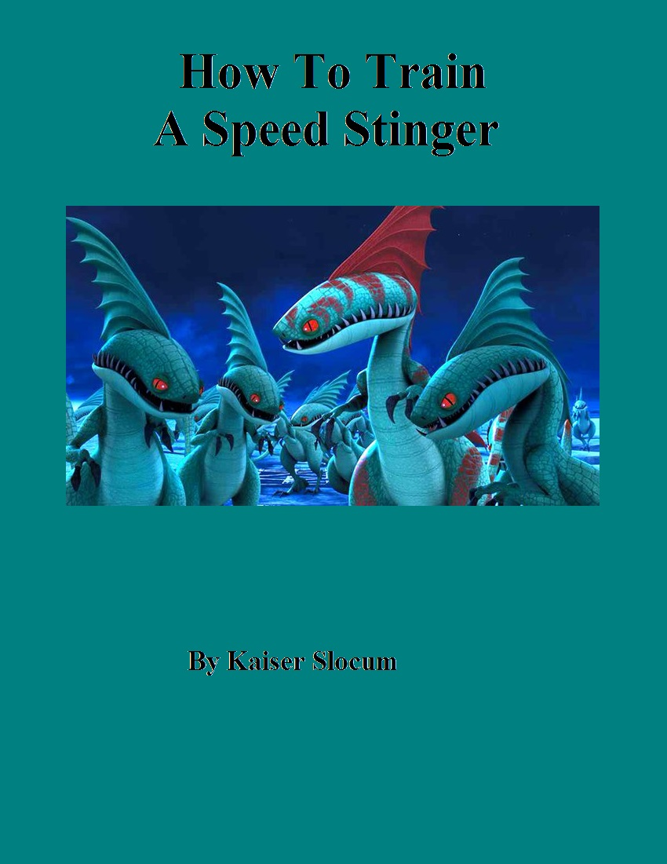

**This book is dedicated**

**in memory of Rod Metzger**

How To Train A Speed Stinger, First Edition, revised and updated. Version 2.9: Plot Finished

Copyright ⓒ 2020 by Kaiser P. Slocum. All rights reserved by God.

Printed in the United States of America. No part of this book may be used or reproduced in any manner whatsoever without written permission except in the case of brief notation embodied in critical articles and reviews.

For information address HamsterPublishers Inc.

Cover Art: Copyright by Dreamworks Animations

Chapter Art: Copyright by School of Dragons

Editing: Kaiser Slocum

HamsterPublishers books may be purchased for education, business, or sales promotional use.

For information, please contact: slocumkaiser@gmail.com

Or visit: http://citstudent.lanecc.edu/~slocumk473/HowToTrainASpeedStinger/buyPage.html

Designed by Kaiser Slocum

Library of Congress Cataloging-in-Publication Data

Slocum, Kaiser Peter

How To Train A Speed Stinger / Kaiser Slocum

Protected under Creative Commons License:

[Attribution-NonCommercial-NoDerivatives 4.0 International](http://creativecommons.org/licenses/by-nc-nd/4.0/)

# **Table of Contents**

**Table of Contents** **1**

**Chapter 1: Challenge** **2**

**Chapter 2: Shock** **7**

**Chapter 3: Ultimatum** **11**

**Chapter 4: Battle** **23**

**Chapter 5: Escape** **33**

**Chapter 6: Betrayed** **39**

**Chapter 7: Pranked** **50**

**Chapter 8: Assault** **60**

**Chapter 9: Discovery** **71**

**Chapter 10: Injured** **78**

**Chapter 11: Hatched** **83**

**Character Relations:** **93**

**Acknowledgements** **95**

# **Chapter 1: Challenge**

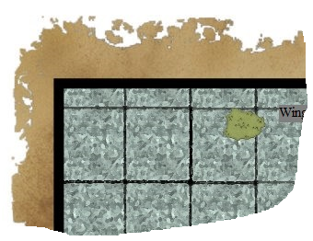

“You little nitwit!” the older warrior hissed in my face, “You think you have what it takes to get through this mountain?! Well you don’t, you won’t, and you can’t. I guess I’ll make your suffering shorter, by ‘borrowing’ your food. You won’t mind will you?”

I shook my head quickly, signaling I didn’t want any trouble and wouldn’t give him any if he took my food.

“In fact,” continued the warrior after ripping my food pouch off my back, “what if you had a little accident and never came out of the mountain!”

This statement worried me considerably, and I think my eyes got a little larger.

“What if a freak accident happened,” he continued as he munched on my yak stick, “and you fell off a cliff, and I was there to see it and tried to help but you pushed me away. That’d be really – Hey!”

I took the opportunity while he was distracted with wolfing down my food to squirm away and run off. Although I was running as fast as I could, spurred on by the danger behind me, it was still not enough, and he quickly caught up. When I heard his breathing, I whipped out my Odin’s Storm from my back, back flipped over him, and swung at him. This move caught the older warrior by surprise, but he dodged out of the way and pulled out his own sword. Unfortunately for him, he put too much effort into swinging the sword in an arc toward my neck. This allowed me to parry and deftly twist the sword away when it was caught between the Odin Storm’s “tongs.” As I swung the sword behind me, I looked him straight in the eyes.

“Now who’s the wimp?” I challenged. The warrior started backing up, fear showing in his eyes.

“Kockler, Johannen!” he screamed, “I could use some help!”

From somewhere else in the vast caverns under Bewilderbeast Mountain, my sensitive ears picked up on the sound of running feet. Things were about to get just that much harder.

~ ~ ~ ~

The circle of children around me quickly yelled in protest.

“What happened next?” a boy with short brown hair eagerly asked – his eyes as round as saucers.

“Ha, well, things just kept getting worse!” I stated - keeping up the suspense.

“But you are so amazing, and the other Berserkers were supposed to be your friends!” another tall girl spoke up.

“I know, but I was young then; and not as strong. Plus, I didn’t expect to have to protect myself from other warriors.”

“What happened next?!” the teacher prodded, interested in my story as well.

Well, I knew there wasn’t a lot of time before the other warriors arrived, so I raced forward – pressing the warrior in front of me into a panicked run. He continued down the main trail, but I took the left fork. Running like crazy, I took a left, then a right. Eventually, I reached a narrow ledge that jutted several hundred feet above the ground. A single pebble, dislodged by my foot, tumbled over the edge - I never heard it hit the ground. Pushing myself against the cave’s wall, I inched my way around the ledge until I reached another tunnel. Then, I kept on running – not bothering to keep track of where I was anymore. If I couldn’t get out alive anyway, there was no point in keeping track of the right path out of this stupid mountain. Just when I thought that I had lost them, a creepy, dry voice echoed through the tunnel.

“Well, well, well, here you are little one!”

I spun around to see another, more crazed-looking warrior advancing on me - his torch eerily reflecting our shadows off the walls of the tunnel. He advanced on me slowing with his axe poised over his head - looking for the kill.

With a yelp, I turned back around and lunged forward into the darkness – but forgot that there was only a skinny ledge. My feet teetered on the edge of the ledge as I quickly back tracked, but the warrior blocked my way and swung his axe straight at my head.

I was able to dodge out of the way, but doing so caused me to lose my balance - I plunged over the edge of the cliff.

I jammed my Odin’s Storm into where I thought the cliff wall was (though I wasn’t sure since it was pitch black) and held on. Amazingly, my weapon met rock, and my freefall came to an abrupt stop with my arms feeling like they were being yanked out of their sockets. After the crashing of rocks and boulders ceased, I listened for the crunch of footsteps up above - almost too faint to be heard but noticeable nonetheless. The footsteps became quieter and quieter as he sauntered off, undoubtedly thinking that I had plunged to my death. Pressing myself against the cliff’s wall, I tried to find a foot hold – but I couldn’t see anything and my legs couldn’t find anything supportive.

Then, I had an idea. Being careful to remain pressed against the wall, I pushed up on the handle of my Odin’s so that its points worked towards the wall. Then, in a quick motion, I pulled it straight out and jammed the left point as far as I could into the wall. This simple process worked – though it slammed me face first into the wall (since my hands were occupied with my weapon). Amazingly, my weapon held, but, unfortunately, my face didn’t.

I had designed my weapon myself – it was like an axe, but without any middle section and the outside stems arced in a shallow parabolic pattern. I was impressed that my weapon was helping me through all of these scrapes I was continually finding myself in. Carefully, I maneuvered the Odin’s Storm and jammed the right point into the wall – then the left – then the right – and so on. This was incredibly time consuming and also costly in terms of arm strength (for every turn, I only moved down about another foot). I had no way of knowing how close I was to some resemblance of floor, but I honestly didn’t care. I was going to give whatever strength I had before I plummeted to my death. After what felt like forever, I was having significant trouble rotating the Odin’s Storm in the wall, and after even longer, my grip strength was starting to significantly fail. Thus, I put into action my backup plan.

I used a little more strength to rotate the Odin’s Storm a complete 360 degrees and dug out a nice sized chunk of rock which fell into my open mouth. Then, I spit it out and started counting how long it took to hit the ground. To my surprise, it hit the ground in only about one second, and I could also hear it bounce along the ground as well. With this encouragement, I coaxed my arms and hands into giving me just a little more effort and continued down the cliff until my grip failed altogether. I fell for a little; then my feet met the ground. I bent my knees until they met my face, but it wasn’t enough. I collapsed onto the ground with a loud snap and a searing pain in my left knee, besides the pain in my face. I groped around for my weapon and slung it back onto my back, then started hobbling on my right leg. At this point, I was in serious pain, and my face really hurt after the face plant.

I quickly realized that I wasn’t going to get anywhere unless I came up with a plan of action on how to get out of the mountain; so I stopped and listened.

To my left, I heard a faint noise, and I recognized it as the sound of running water. It appeared to be coming somewhere to my left, so I crawled and limped onward. After a while, my hands ran into a solid wall of rock, but the sound of rushing water still sounded like it was coming from the left. I slowly, painfully crawled forward through what felt like a U-turn.

When I ran into a wall again, I realized that there was light seeping into the cave– quite a lot of it actually. With excitement seeping through my tired body, I hobbled toward the light and found myself in a room filled with ice. Great icicles hung from the ceiling and emerged from the floor - some of which must have been several meters thick. As I continued through the cave and towards the source of light, I saw my reflection in the ice - my face, arms, and legs were all dirty, scraped, and coated with blood. Suddenly, my reflection was disturbed. The icicle that I was currently passing had an intriguing rupture in its purity. Near the base of it was an egg-like object that looked sort of like a beach shell. Its swirly pattern captivated me. So, instead of worrying about my life, I decided to take the shell with me. I figured that I would show it to my dad, Fishlegs, who was always very interested in sea and animal life. After I hurriedly hacked it out of the icicle - rubbing my already damaged hands raw, I continued hobbling onward. At the end of the massive cavern, I came upon an opening to the outside in which I could see some trees and flowers. Slowly, I made my way outside and realized that I was about halfway down the mountain – I could even see some of the defense lookout towers and a catapult or two down below me. The descent down the rest of the mountain was ludicrously hard – even for a fit kid like me (did I forget to mention I was only 10?). The last thing I remembered was approaching a catapult way up on the top of a steep, grassy slope – then I must have passed out.

~ ~ ~ ~ ~ ~

I woke up in my house with my mother (“Heather” as she was affectionately called by my dad) looking down at me.

“Hey Mom,” I groaned.

“Oh, Kaizar! I’m so glad you are okay. You made it through the mountain faster than any warrior ever has – but what happened to you? You look like you were attacked by a wolf! Your left leg was even broken!”

“It’s a long story,” I replied through gritted teeth, because my leg was really hurting. Then, I remembered my seashell.

“Mom, was I found with a funny-shaped seashell?” I asked.

“Why yes, you were. I put it over there on your desk,” she replied – pointing over to my wooden desk, where, indeed, it was partially wrapped in thick cloth lying in a box.

“It is very intricate, so I wrapped it up to keep it from getting damaged. You go back to sleep now, Auntie Mala set your leg, so it will be healing I think.”

“Thanks Mom,” I replied – then fell back to sleep.

It was about the middle of the night when I awoke again. I was awakened because there was a funny and disturbing noise coming from my desk. I carefully pulled off my covers and inspected my left leg. Indeed, there was a large, crudely shaped cast over it, but it wasn’t hurting much anymore so I gingerly lifted it off the bed and set it down on the floor. Then, I grabbed a nearby stick (using it like an improvised crutch) and slowly made my way to my desk where my parents had lit a small torch for me. On my desk, the white cloth housing the seashell was shaking rapidly. I carefully pulled the cloth off the shell and found that the shell was shaking very violently, and it felt quite warm – almost burning (thus I quickly set it back down again). Then, it exploded!

The top part of the shell sailed off and punched a nice hole through the ceiling of my room, while another part launched horizontally and slammed into a picture of a Razorwhip that my mother had made – leaving a nasty scorch mark. The third fragment of shell flew out my door. I was wondering where it had landed when I heard a yell from my parents’ room – Dad! Before I could check on him though, there was a funny “squawk!” and I quickly looked down with amazement – because there before me was an animal that I had never seen before. It had two powerful legs, a long mouth and a nice, slender tail with a spike on the end of it.

I stared at the funny creature lying on the length of cloth in front of me… and it stared up at me. Then, Dad stumbled in.

No offense to him, but he has an ample frame and when he is stumbling around in the dark, it is nothing short of a maelstrom. Anyway, he barges into my room.

“Kaizar! What are you doing! You’re supposed to be in – “

“GRRROWL!

The little creature in front of me stood up shakily and gave a funny, squeaky growl at Dad. Dad in turn let out a scream and fell over – squashing my mini model of a Bewilderbeast that Uncle Dagur had made for me on my fifth birthday into a million pieces.

“SPEEDSTINGER!” he yelled.

“Shing!”

From outside my room, I heard the tell-tale sign of my mom extending her collapsible, double-bladed axe.

She vaulted into the room expertly, but tripped over Dad and ran into the wall.

“Oof!” Dad said.

“Grrrr” said the creature in front of me.

Mom quickly caught her balance and moved closer to inspect the small creature in front of me. When she saw the broken piece of shell on the ground below the dragon painting, understanding dawned upon her.

“Wait a minute! That wasn’t a seashell; that was a speedstinger egg!” she exclaimed.

At this point, Dad managed to stand up and pointed his beefy finger at me.

“What are you doing with a baby speed stinger?” he exclaimed. Before I could answer, the baby stinger raced forward, leaped off the table, flew directly over Dad’s right arm while stabbing him, and hit the floor in a defensive stance – growling.

“OWE!” Dad wailed – then reached for the torch on the wall, but - funny enough - his arm had straightened out and his hand didn’t work. Instead, he just slammed his hand into the door. I flinched.

“Umm, what should I do?” I asked Mom.

“Could you try calling it off?” she asked.

“How exactly do I call off a ‘speedstinger’?” I asked.

“Just talk to it like you would a yak,” she said.

“Stop, you beast!” I roared in my best you-better-behave-yak voice. Immediately the speed stinger, backed up to me, but didn’t let down his tail which he was waving menacingly in the air.

“What do I do now?” I asked Mom.

“Reach your hand out towards it slowly,” Dad finally chimed in once he had regained his balance. I reached my hand out toward it warily – not wanting to suffer the same paralyzing effect that Dad had experienced. The baby speedstinger turned towards me, but instead of attacking me, it came forward and put its head up to my hand and closed its eyes.

“Awe, I never have gotten tired of that sight,” commented Dad.