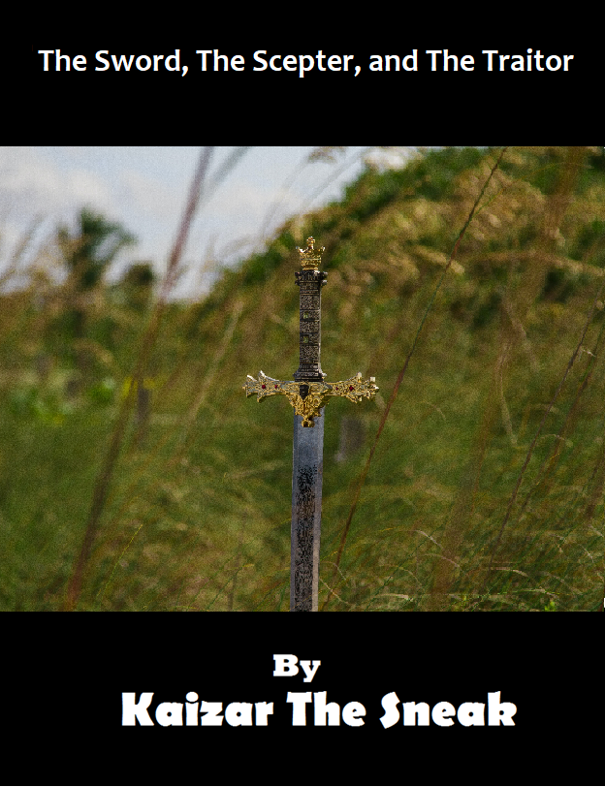

***This book is dedicated to***

***Danielle Juno (DJ)***

***The best friend anyone could ever have***

The Sword, The Scepter, and The Traitor, First Edition, revised and updated. Copyright ⓒ 2021 by Kaiser Slocum: Version 2.0. All rights reserved by God. Printed in the United States of America. No part of this book may be used or reproduced in any manner whatsoever without written permission except in the case of brief notation embodied in critical articles and reviews. For information address HamsterPublishers Inc.

HamsterPublishers books may be purchased for education, business, or sales promotional use.

*Designed by Kaiser Slocum.*

Library of Congress Cataloging-in-Publication Data

Slocum, Kaiser.

The Sword, The Scepter, and The Traitor / Kaiser Slocum.

Protected under Creative Commons License:

[Attribution-NonCommercial-NoDerivatives 4.0 International](http://creativecommons.org/licenses/by-nc-nd/4.0/)

**Table of Contents**

**Chapter 1: Alina’s Journey** **1**

**Chapter 2: Leo’s Adventure** **2**

**Chapter 3: Lea’s Path** **7**

**Chapter 4: Leo’s Flight** **14**

**Chapter 5: Lea’s Plight** **19**

**Chapter 6: Alina’s Summoning** **20**

**Chapter 7: Lea’s Trek** **27**

**Chapter 8: Leo’s Kidnapping** **35**

**Chapter 9: Lea’s Vision** **44**

**Chapter 10: Leo’s Observations** **46**

**Chapter 11: Alina’s Advance** **49**

**Chapter 12: Leo’s Destiny** **60**

**Sneak Peak: The Return** **69**

**Author Bio** **70**

# **Chapter 1: Alina’s Journey**

“Can you remind me again why we are doing this?” Lea asked Leo.

“Because Alina *insisted* on going on an *adventure*,” Leo said, rolling his eyes, “Even though I have told her time and time again that there is nothing interesting in these woods except maybe ticks.”

“But have you really explored these woods!?” I snapped at Leo.

“Sure, lots of times,” Leo said, “What do you think I do with all my time?!”

“I thought you bullied kids at school,” I told him.

“Leo doesn’t bully kids,” Lea defended her brother.

“Then how come he has no friends, not even a girlfriend!” I smirked.

“I just…I just don’t make friends,” Leo mumbled.

“Because you’re a jerk. Your whole family is so boring,” I told them, “If it wasn’t for me, you probably would just watch TV all summer long!”

“It wasn’t *my* idea to have our cousin come over here for the summer!” Leo snapped back, “That was your parents’ idea.”

I was thinking of something to say in return, but before I could, I spotted something through the thick foLeage of the forest.

“Hey! Is that a…a house over there?” I said, trotting over to my left.

“There are *no* houses in this forest,” Leo laughed, “You’re going loony!”

“My eyes *never* lie,” I retorted.

“Hey! There is a house there!” Lea said, following me, “Look Leo!”

Leo reluctantly trailed behind us as I made my way to the abandoned house. It was at least thirty years old and in complete disrepair. The roof was so sunk in that it looked like it could be a nice swimming pool during the rainy months.

“But…but,” Leo began, “How can this be?! I’ve been through these woods a bazillion times, and I’ve never seen this!”

“Maybe you’re blind?” I suggested, walking over to the front door.

“Very funny,” Leo sighed.

“I’m going inside!” I announced, pulling open the rusty door.

“You will do no such thing!” Leo yelled after me, “Mom left me in charge, and if anything was to collapse on you, I’d get the blame!”

“I’d like to see you get the blame!” I snapped, closing the door behind me for effect.

# **Chapter 2: Leo’s Adventure**

“Alina!” I yelled at her as she walked into the abandoned shack. The off-balance door then slammed shut behind her.

“Ugh! Obeying orders is *not* her forte!” I grunted.

“Maybe we should just give her some grace,” Lea said timidly from next to me.

“Psssh, her parents and ours put me in charge, and as of such, I need to make sure you all are safe. I’m going in after her,” I replied, striding to the door and throwing it open.

“You coming?” I asked Lea.

“Uh, um, I’m not sure that I want to…,” Lea trailed off.

“Scaredy-cat,” I mumbled, “Stay RIGHT there.”

With that, I marched through the doorway and carefully closed the door behind me - not wanting to bring the roof down on my head.

What I saw astonished me greatly. I had expected a rundown interior with some rotting boards and a whole lot of plant life weaving up through what was left of the floorboards. Instead, I found a well-cared for stone room, with a myriad of weapons, shields, and suits of armor lining the walls and piled on the floor. I quickly spun around and saw that the back of the door that I had just closed behind me was constructed of heavy wood and metal. As much as I hated to admit it, Alina had apparently been right - I had not explored these woods well enough if this entire house was in here!

With all this epic, medieval armor and weapons around, my first thought was what to sample, and, of course, the weapons were my first choice. After accidentally pricking my thumb on a mace, I slowed down and carefully unpacked each weapon from the boxes on the floor. My favorite turned out to be an ornate sword with a lion head carefully sculpted at the bottom of the broadsword’s hilt. Even the blade looked brand new and extremely sharp.

“Ha, hah!” I declared, “Feel the might of the almighty Leo!”

I jumped up into the air and brought the sword down on an imaginary enemy.

“Lea!” I said, opening the door again, “Check out what I found!”

Unfortunately, Lea was not outside anymore. Instead, there was a full-blown medieval battle going on. Arrows flew through the sky, and knights, with white fabric draped over their armor and a red eagle emblazoned on that fabric, epicly battled similar knights in black armor with a picture of some similar type of bird on theirs. In addition, I noticed several grotesque creatures and a few elven-like humans running around.

“ZWONG!” an arrow zipped right over my head and embedded in the heavy wooden door just an inch above my unkept, brown hair - jolting me from my shock and eliciting a gut reaction from me - to slam the door shut again.

“What was going on? Where was I? What happened to my friends?!” I couldn’t seem to wrap my mind around the fact that I was in a whole different world, but I knew I had to be. This was way too elaborate to be a joke of any kind. Plus, they would have had to demolish all the forest outside which would have been impossible. Then again, the fact that I *was* in a whole new dimension was a bit far-fetched...ok… insanely far-fetched! Of course, I worried a bit about Alina and Lea, but before I could make any decisions on what to do next, the door on the other side of the room was flung open and an old lady careened into the room – slamming that door shut behind her. My eyes got just that much wider.

“Who-who are you?” I asked, my mouth going dry.

“Don’t be stupid,” she said in a cracked voice. The old lady turned directly towards me, giving me a good look at her face. If I had been scared before, I certainly was now. She was a hag – or at least what I thought a hag would look like.

“White or dark knight?” the hag demanded of me.

Before I could answer, there was a significant commotion outside and a mace smashed a huge hole through the hag’s door. Without a second thought, she started waving her stick and mumbling an incantation. Not wanting to look totally idiotic, I raced for the nearest suit of armor and attempted to put it on while the door was ripped to shreds as whoever was on the outside attempted to force their way in. It took a while since I found out that armor consists of more than just one shirt or pants. Just as I shoved a massive, heavy helmet onto my head, the hag threw open what was left of the door and launched a barrage of lightning bolts from her staff into the hall outside. Just about as quickly, an arrow plugged right into the hag’s side. There was a hair-raising scream from her, and she keeled over. I would have expected blood to go everywhere, but instead, she just disappeared – leaving a pile of clothes, a bag, and her staff behind. I stifled a yell and retreated backwards into the room; even though there wasn’t much farther back I could go. At this point, there was some more pounding of feet and a black knight and white knight immediately appeared in the doorway – battling it out.

“Clang!” “Berang!” “BAAAAM!”

The black knight finally got the better of the white one and stabbed him in the stomach, causing his prompt disappearance.

“Who are you?” a gruff voice from inside the helmet of the black knight spoke to me as he spotted me not more than a minute later.

“I’m…I’m a soldier?” I stammered.

“No you’re not!” the black knight barked, jumping across the room and grabbing me by my helmet. He dragged me to his face and flipped open my visor, staring at me.

“Oh no!” he shouted, “You’re one of those deliverers!”

“A what?!” I yelped.

“I’m gonna kill you!” he screamed, drawing a dagger from his belt and plunging it at me.

As fast as I could, I brought my sword out in front of me to block where I thought the dagger would slice at me. Under normal circumstances, I would have been dead meat, but as luck would have it (or perhaps divine intervention), the black knight did something uncharacteristic of those trying to stab you; he sliced at me with it, instead of thrusting it. Thus, my weak sword block did the trick. Unfortunately, the black knight was many times stronger than I, and he swiftly pressed my sword against my chest with his dagger. Mustering all my strength, I gripped my sword harder and tried to press back, if only to get the dark knight’s foul breath away from me. Something strange happened then, though. My sword glowed blue, faintly at first, but the harder I gripped my sword, the stronger the glow got. It didn’t take long for the knight to notice this, and he jumped back in alarm.

“What are you doing?!” he exclaimed.

“How should I know?!” I said, before I thought better of it. However, as soon as he had let go of me, I steadied myself and relaxed my grip on my sword. Instantaneously, a blue arc of energy flew off my sword and collided with the dark knight. There was a small explosion; followed by some charred armor floating and clanging to the ground where the knight had been standing only a second ago..

“Oh…my…goodness,” I thought to myself, “I have powers here!”

I grinned what I imagined was a slightly evil grin and gripped my sword tightly again. As I expected, my sword glowed blue. I squeezed the sword even tighter, then bent backward and thrust the sword forward with all my might, letting my grip relax at the same time. Instantly, a powerful orb of energy blasted out of my sword – it’s back-kick forcing me backward into the wall. The energy hit the wall opposite me and exploded - immediately filling the air with more smoke and ashes.

Coughing and stumbling about, I made my way into the current building’s hallway. By the time the smoke cleared enough to see, it was apparent that I had successfully blasted a hole through the stone wall - completely revealing the battlefield outside. Although it was cool that I had done that, I had now made myself an easy target, so I raced like mad down the hallway – trying to get away from the battlefield. Despite my new-found powers, I wasn’t going to risk hand-to-hand combat with seasoned warriors. At the end of the deserted hallway, I found a spiral staircase that led into the ground – a basement of sorts I assumed. Without a second thought, I quickly descended the flight of stairs, and at the bottom, I found a small dungeon with many cells. Right in front and guarding all the cells was another black knight resting his feet on a small stool. When I came to a halt in front of him, he sprang to his feet.

“Who are you?!” he demanded of me gruffly.

“Uh, I’m Leonard?” I said.

“What divination is this?!” the knight roared, “You’re no ally!”

He sprang at me with a spear that he had been carrying, but I yanked up my sword to block the blow, swiftly realizing that my sword was half as long as it had been five minutes ago. Apparently, the tip of it had been blown off – my “power” had been too much for the sword to handle.

The soldier stopped in mid stride and stared at my sword, “What happened to your weapon?”

“Uh, I think I blasted the tip off,” I told him.

“Wait, how?” he said.

I squeezed the handle of my sword and said, “Like this!”

I then aimed it at the knight and relaxed my grip. There was a much smaller explosion this time, but it was still sufficient to do the job.

“Heheheh,” I said to myself, confidence starting to return to me.

“It’s Leo time!” I said, raising my sword into the air. Only, there was nothing left of my sword by this time – just the handle that I was holding.

“Rats,” I mumbled, dropping the handle on the ground. Knowing that it was just a matter of time before someone found me down here, I decided to search for another weapon and see if there were any prisoners that I could release - assuming that they would help me escape in return. Luckily, there was another sword in a nearby wooden box as well as an old fashioned key ring, but the latter didn’t look half as cool as my previous sword and the former was of a type that I had only seen in those medieval movies.

With my sword and keys in hand, I walked through the “dungeon,” looking to my right and left for any cells with someone actually in them. For being a dungeon, it was surprisingly empty. I had expected lots of skeletons strapped to the wall in chains and rotting corpses – but there were none of those.

I was just considering heading back upstairs when I reached the end of the dungeon and finally noticed a locked cell. Inside, there was a human wearing some simple chains around the wrists and ankles and with a heavy sack tied over the head.

There was no movement from the figure, but I unlocked the cell (after a bit of trouble figuring out how the old fashioned lock mechanism worked) and cautiously moved inside. The prisoner still made no movement, but I quickly discovered that it was a female elf. The green, almost earthy clothing had me convinced fairly quickly, but she was pretty badly banged up judging by the mud and dirt stains on her outfit as well as the scrapes and bruises visible on her arms.

Rather timidly, I untied the rope and removed the sack off the elf’s head and said, “Hey.”

The elf blinked and raised her head, looking up at me.

“Who are *you*?” she asked, “I said I won’t tell you anything!”

“I’m not a captor,” I informed her, fumbling with the locks on her chains, “I’m here to let you go… I think?”

I still wasn’t sure who the “bad guys” and “good guys” of this world were, but the black knights seemed to have serious issues - especially considering they had already tried to kill me twice. I flipped open my visor and said, “See! I’m not bad.”

The elf stared at me for a minute; then, just as I unlocked the last of her binds, she gasped, “You’re a deliverer!”

“A what?” I asked for the second time, “What *is* a deliverer?”

“You don’t know?!” she said to me, “You are one of the three people destined to deliver our kingdoms!”

“Uh…. I just got here, and I don’t think I belong here,” I replied honestly, “I don’t even know how to sword fight!”

“Hahaha,” she giggled, “That’s funny! I’m Ember!”

“I’m, Leon-,” I started to say, but before I could finish, Ember grabbed the chains that I had just removed from her wrists and slung them at me. Instinctively, I blocked with my sword, but that movement caught me off balance, and she slammed me hard in the stomach with her fists. For being a girl and me wearing armor, she was insanely strong, and I sagged to the ground.

“Ooooh!” I groaned.

“Oh! I’m so sorry!” she said, bending down to help me back up, “You weren’t kidding! You can’t fight to save your life, and I’m in bad condition too!”

“Tell me about it!” I moaned, clutching my stomach, “I’m from a whole different world where sword-fighting is rarer than a Dodo bird!”

“A what?!”

“Nevermind.”

“I’m not sure why the prophecy would send us an incompetent hero, but your golden eye color does not lie. You must be one,” she said confidently.

“I have golden colored eyes?” I gasped.

“Look in your sword’s reflection,” she told me.

I did and was astounded, “My eyes have changed colors!”

Ember stood up, “Thanks for the assistance, though. You certainly are a deliverer – born to free the enslaved and bring freedom to the heavy-hearted.”

I nodded politely, “Now, can you tell me what’s going on?!”