**7500P PHY Reference**

**Version 1.0.0**



<http://www.wiznet.co.kr>

**Table of Contents**

1 Documentation conventions 4

1.1 Register Bit Conventions 4

2 Register Descriptions 5

2.1 Introduction 5

2.2 Register Map 5

2.2.1 Register Page mode Control Register 5

2.2.2 Control Register 5

2.2.3 Status Register 7

Document History Information 9

**List of table**

Table 1 Register Map 5

Table 2 Page Mode Control Register 5

Table 3 Control Register 5

Table 4 Status Register 7

1. Documentation conventions
   1. Register Bit Conventions

Each register is shown with a key indicating the accessibility of the each individual bit, and the initial condition:

|  |  |
| --- | --- |
| Key | Bit Accessibility |
| RW | Read/Write |
| SC | Self-Clearing |
| RO | Read Only |
| LL | Latching Low |
| LH | Latching High |
| (TP) | for twisted pair operation |
| (FX) | for fiber operation |
| (e-fuse) | only available for IP101G(dice) |

1. Register Descriptions
   1. Introduction

7500P PHY is an IEEE 802.3/802.3u compliant single-port Fast Ethernet Transceiver for both 100Mbps and 10Mbps operation. 7500P PHY, IP101G, has MII(Media Independent Interface) and it supports MII Register.

* 1. Register Access

7500P PHY MII Register can be accessed through MDC/MDIO. 7500x Library supports Software MDC/MDIO to access 7500P PHY MII Register.

Please refer [W7500x_Library_Examples/ioLibrary/MDIO](https://github.com/Wiznet/W7500/tree/master/W7500x_Library_Examples/ioLibrary/MDIO).

The more details of MDC/MDIO Format is here(3. MII Register Access).

* 1. Register Map

Table 1 Register Map is a port of IP101G Registers.

Table 1 Register Map

|  |  |  |
| --- | --- | --- |
| **Register** | **Description** | **Default** |
| 0x20 | Page Control Register | 0x0010 |
| 0x00 | Control Register | 0x3100 |
| 0x01 | Status Register | 0x7849 |

* + 1. Register Page mode Control Register

This is the description of MII register 0x20, page control register.

The other bits are reserved. User is inhibited to access to these registers. It may introduce abnormal function to write these registers.

Table 2 Page Mode Control Register

|  |  |  |  |  |  |
| --- | --- | --- | --- | --- | --- |
| **PHY** | **MII** | **ROM** | **R/W** | **Description** | **Default** |
|  | 20[4:0] |  | R/W | REG16~31_Page_Sel[4:0]  Register Page Select | 0x10 |

* + 1. Control Register

This is the description of MII register 0x00, control register.

Table 3 Control Register

|  |  |  |  |
| --- | --- | --- | --- |
| **Bit** | **Name** | **Description** | **Default value**  **(h):3100** |
| 15 | Reset | When set, this action will bring both status and control register of the PHY to default state.  This bit is self-clearing.  1 = Software reset  0 = Normal operation | 0, RW/SC |
| 14 | Loopback | This bit enables loopback of transmit data to the receive data path, i.e., TXD to RXD.  1 = enable loopback  0 = normal operation | 0, RW |
| 13 | Speed Selection | This bit sets the speed of transmission.  1 = 100Mbps  0 = 10Mbps  After completing auto-negotiation, this bit will reflect the speed status.(1: 100Mbps, 0: 10Mbps) | 1, RW |
| 12 | Auto-Negotiation Enable | This bit determines the auto-negotiation function.  1 = enable auto-negotiation; bits 13 and 8 will be ignored.  0 = disable auto-negotiation; bit 13 and 8 will determine the link speed and the data transfer mode, under this condition. | 1, RW(TP)  0, RO(FX) |
| 11 | Power Down | This bit will turn down the power of the PHY chip and the internal crystal oscillator circuit if this bit is enabled. The MDC and MDIO are still activated for accessing to the MAC.  1 = power down  0 = normal operation | 0, RW |
| 10 | Isolate | 1 = electrically Isolate PHY from MII but not isolate MDC and MDIO | 0, RW |
| 9 | Restart Auto-Negotiation | This bit allows the auto-negotiation function to be reset.  1 = restart auto-negotiation  0 = normal operation | 0, RW/SC |
| 8 | Duplex Mode | This bit sets the duplex mode if auto-negotiation is disabled (bit 12 = 0)  1 = full duplex  0 = half duplex  After completing auto-negotiation, this bit will reflect the duplex status.(1:Full duplex, 0:Half duplex) | 1, RW |
| 7 | Collision Test | 1 = enable COL signal test | 0, RW |
| 6:0 | Reserved |  | 0, RO |

* + 1. Status Register

This is the description of MII register 0x01, status register.

Table 4 Status Register

|  |  |  |  |
| --- | --- | --- | --- |
| **Bit** | **Name** | **Description/usage** | **Default value**  **(h):3100** |
| 15 | 100Base-T4 | 1 = enable 100Base-T4 support  0 = suppress 100Base-T4 | 0, RO |
| 14 | 100Base-TX  Full Duplex | 1 = enable 100Base-TX full duplex support  0 = suppress 100Base-TX full duplex support | 1, RO |
| 13 | 100Base-TX  Half Duplex | 1 = enable 100Base-TX half duplex support  0 = suppress 100Base-TX half duplex support | 1, RO |
| 12 | 10Base-T  Full Duplex | 1 = enable 10Base-T full duplex support  0 = suppress 10Base-T full duplex support | 1, RO |
| 11 | 10Base-T  Half Duplex | 1= enable 10Base-T half duplex support  0 = suppress 10Base-T half duplex support | 1, RO |
| 10:7 | Reserved |  |  |
| 6 | MF Preamble  Suppression | The IP101G will accept management frames with preamble suppressed. The IP101G accepts management frames without preamble. A Minimum of 32 preamble bits is required for the first SMI read/write transaction after reset. One idle bit is required between any two management transactions as per IEEE802.3u specifications. | 1, RO |
| 5 | Auto-Negotiation Complete | 1 = auto-negotiation process completed  0 = auto-negotiation process not completed | 0, RO |
| 4 | Remote Fault | 1 = remote fault condition detected(cleared on read)  0 = no remote fault condition detected | 0, RO/LH |
| 3 | Auto-Negotiation | 1 = able to perform auto-negotiation  0 = unable to perform auto-negotiation | 1, RO |
| 2 | Link Status | 1 = valid link established  0 = no valid link established | 0, RO/LL |
| 1 | Jabber Detect | 1 = jabber condition detected  0 = no jabber condition detected | 0, RO/LH |
| 0 | Extended  Capability | 1 = extended register capability  0 = basic register capability only | 1, RO |

1. MII Register Access

W7500P PHY’s MII register can be accessed by MDC and MDIO. Users can control MDC/MDIO through GPIOx. MDC/MDIO format is shown in the below table. To access MII register in W7500P PHY, MDC should be at least one more cycle than MDIO. That is, a complete command consists of 32 bits MDIO data and at least 33 MDC clocks. When this interface is idle, MDIO is in high impedance.

Table 5 Interface Format

|  |  |
| --- | --- |
| Frame  format | <Idle><start><op code><PHY address><Register address><turnaround><data><Idle> |
| Read  Operation | <Idle><01><10>< $A_{4}A_{3}A_{2}A_{1}A_{0}$ >< $R_{4}R_{3}R_{2}R_{1}R_{0}$ ><Z0>< $b_{15}b_{14}b_{13}b_{12}b_{11}b_{10}b_{9}b_{8}b_{7}b_{6}b_{5}b_{4}b_{3}b_{2}b_{1}b_{0}$ ><Idle> |
| Write  Operation | <Idle><01><01>< $A_{4}A_{3}A_{2}A_{1}A_{0}$ >< $R_{4}R_{3}R_{2}R_{1}R_{0}$ ><10>< $b_{15}b_{14}b_{13}b_{12}b_{11}b_{10}b_{9}b_{8}b_{7}b_{6}b_{5}b_{4}b_{3}b_{2}b_{1}b_{0}$ ><Idle> |

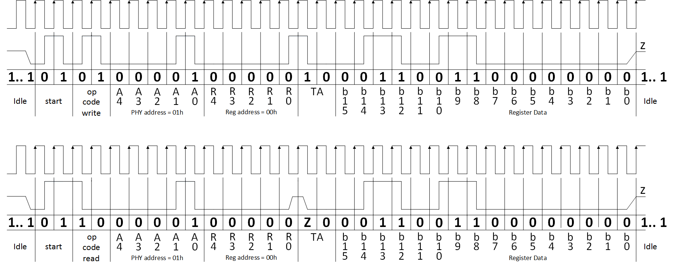

Figure 1 MDC/MDIO Format

* 1. How to Access PHY MII Register
* How to Write Access

|  |
| --- |
| {  START:  // Set GPIO(Value, Length)  Set GPIO(0x05, 4); // Start bits 01, Write Access 01  Set GPIO(PHY address, 5); // PHY address  Set GPIO(REG address, 5); // MII register  Set GPIO(0x02, 2); // turnaround bits 10  Set GPIO(DATA, 16);  } |

* How to Read Access

|  |
| --- |
| {  START:  // Set GPIO(Value, Length)  Set GPIO(0x06, 4); // Start bits 01, Read Access 10  Set GPIO(PHY address, 5); // PHY register  Set GPIO(REG address, 5); // MII register  Set GPIO(CLR, 2); // turnaround bits high impedance  Val = Get GPIO(DATA, 16);  } |

* How to get PHY address

|  |
| --- |
| {  START:  // Loop to find PHY address  for(i=0; i<8; i++)  {  Set GPIO(0x05, 4); // Read Access  Set GPIO(i, 5); // PHY address  Set GPIO(0x01, 5); // PHY Status Register (0x01)  Set GPIO(CLR, 2); // turnaround bits high impedance  Val = Get GPIO(DATA, 16); // To check LINK bit in PHY Status Register.  if(Val != 0) return i; // i is PHY address  }  } |

Document History Information

|  |  |  |
| --- | --- | --- |
| **Version** | **Date** | **Descriptions** |
| Ver. 1.0.0 | 19APR2016 | Initial Release |
| Ver. 1.0.1 | 31JAN2018 | 1. Add 2.2 Register Access 2. Add 3 MII Register Access |

**Copyright Notice**

Copyright 2015 WIZnet Co., Ltd. All Rights Reserved.

Technical Support: <http://wizwiki.net/forum>

Sales & Distribution: sales@wiznet.co.kr

For more information, visit our website at <http://www.wiznet.co.kr>