Create a Loopback Plug for an RJ-45 Ethernet Interface

Action
To create a loopback plug, cross pin 1 (TX+) and pin 3 (RX+) together, and cross pin 2 (TX-) and pin 6 (RX-) together. You need the following equipment to create the loopback:
- A 6-inch long CAT5 cable
- An RJ-45 connector
- A crimping tool
Figure 21 illustrates how to create a loopback plug for an RJ-45 Ethernet interface.

Figure 21: RJ-45 Ethernet Loopback Plug
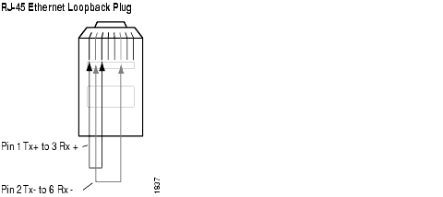

What It Means
When you create and then test a physical loopback, you are testing the RJ-45 interface of the PIC. This action is recommended if a field engineer is available to create the physical loop as it provides a more complete test of the PIC

