STORE MANAGEMENT SYSTEM
23CS54C – MODERN WEB TECHNOLOGIES
Submitted by
HARIRAAM B 24104085
In partial fulfillment for the award of the degree
of
BACHELOR OF ENGINEERING/TECHNOLOGY
in
COMPUTER SCIENCE AND ENGINEERING/ INFORMATION TECHNOLOGY

NATIONAL ENGINEERING COLLEGE
(An Autonomous Institution affiliated to Anna University, Chennai)
K.R.NAGAR, KOVILPATTI - 628503
OCTOBER - 2026

NATIONAL ENGINEERING COLLEGE
(An Autonomous Institution affiliated to Anna University, Chennai)
K.R.NAGAR, KOVILPATTI - 628503
BONAFIDE CERTIFICATE
This is to certify that this project report, “Store Management System”, is the bonafide work of B HARIRAAM(24104085) who carried out the project work under my supervision.
Course Instructor/Guide
Submitted to the 23CS54C – MODERN WEB TECHNOLOGIES Viva-Voce examination held at National Engineering College, K.R.Nagar, Kovilpatti on ____________
Internal Examiner Co Examiner

TABLE OF CONTENTS
CH NO TITLE PAGE NO
1 INTRODUCTION 3
2 OBJECTIVES 4
3 DESCRIPTION 5
4 CLASS DIAGRAM 6
5 TABLE STRUCTURES 7
6 ER DIAGRAM 16
7 TECH STACK 18
8 MODULES 19
9 CONCLUSION 70
CHAPTER 1

INTRODUCTION
In the modern business environment, the efficient management of store operations plays a vital role in ensuring the smooth functioning of manufacturing and trading organizations. Handling procurement, inventory, material movement, and billing through manual or paper-based methods is time-consuming, error-prone, and lacks transparency. There is an urgent need for a reliable, digital solution that brings all these operations under one unified platform.
The Store Management System is a comprehensive, full-stack web application designed to digitize and automate the complete lifecycle of store operations from raising purchase orders to issuing materials to departments. The system was developed to meet the real-world operational requirements of KR Exports, a trading and export organization, and is deployed in a live production environment.
The application is organized into three major functional domains: Master Data Management, which covers all foundational records such as items, suppliers, departments, and stores; Transaction Management, which handles day-to-day operations including purchase orders, gate inwards, receipts, bill entries, item issues, and gate passes; and Reports & Analytics, which provides management with real-time visibility into all store activities through dynamic, exportable reports.
The system is hosted at https://krexports.org and is supported by a Jenkins-based CI/CD pipeline for automated builds and deployments, making it production-ready and maintainable. This report documents the design, development, and implementation of the Store Management System, providing a complete technical overview of its architecture, features, and functionality.
CHAPTER 2

OBJECTIVES
- To Digitize Store Operations: Replace manual record-keeping with a digital system to improve accuracy, efficiency, and data accessibility.
- To Centralize Master Data: Maintain consistent and accurate master data for items, departments, suppliers, stores, and other entities.
- To Automate the Procurement Lifecycle: Streamline procurement from purchase orders to bill verification with complete traceability.
- To Track Material Movement: Monitor and record all inward and outward movement of goods for effective inventory control.
- To Manage Item Issuance to Departments: Record item issuance to departments to ensure accountability and proper stock management.
- To Enforce User Authentication and Role-Based Access: Secure the application using JWT authentication and protected routes to prevent unauthorized access.
- To Provide Dynamic Reporting and Analytics: Generate detailed reports and export them to Excel for effective analysis and decision-making.
- To Ensure System Security and Reliability: Implement security measures such as Helmet, CORS, rate limiting, and payload restrictions to protect the system.
- To Deploy a Scalable, Maintainable Architecture: Use a modular REST API architecture with separate frontend, backend, and database layers for easier maintenance and scalability.
- To Enable Continuous Deployment via CI/CD: Automate application builds and deployments using Jenkins for consistent and efficient production updates at KR Exports.
CHAPTER 3

DESCRIPTION
The Store Management System is a full-stack web application developed to manage and automate store and inventory operations at KR Exports. The system consists of five major functional areas:
1. Master Data Management
This module maintains centralized master records, including departments, suppliers, stores, items, product heads and sub-heads, units of measure (UOM), parties, purchase types, and states. These records ensure consistency and accuracy across all store transactions.
2. Transaction Management
This module manages day-to-day store activities, including Purchase Orders, Gate Inward, Material Receipts, Bill Entry, Bill Verification, Item Issue, Gate Pass In, Gate Pass Out, and Purchase Order Cancellation. Each transaction is linked to relevant master data, ensuring traceability, accountability, and effective inventory control.
3. Reports and Dashboard
The Reports module generates dynamic reports for purchase orders, receipts, item issues, bills, and gate pass activities using filters such as date, department, supplier, and item. Reports can be exported to Excel for further analysis. The Dashboard provides an overview of pending orders and recent store activities.
4. Security and Access Control
The system uses bcrypt for password hashing and JSON Web Token (JWT) authentication to secure user access. Protected API routes, Axios response interceptors, and request rate limiting help prevent unauthorized access and manage invalid or expired sessions.
5. Technology and Deployment
The application uses React for the frontend, Node.js for the backend, and MySQL with Sequelize for database management. It is deployed at https://krexports.orgsvg, with a Jenkins CI/CD pipeline automating application builds and deployments. The modular architecture supports maintainability, scalability, and future enhancements.
CHAPTER 4

CLASS DIAGRAM
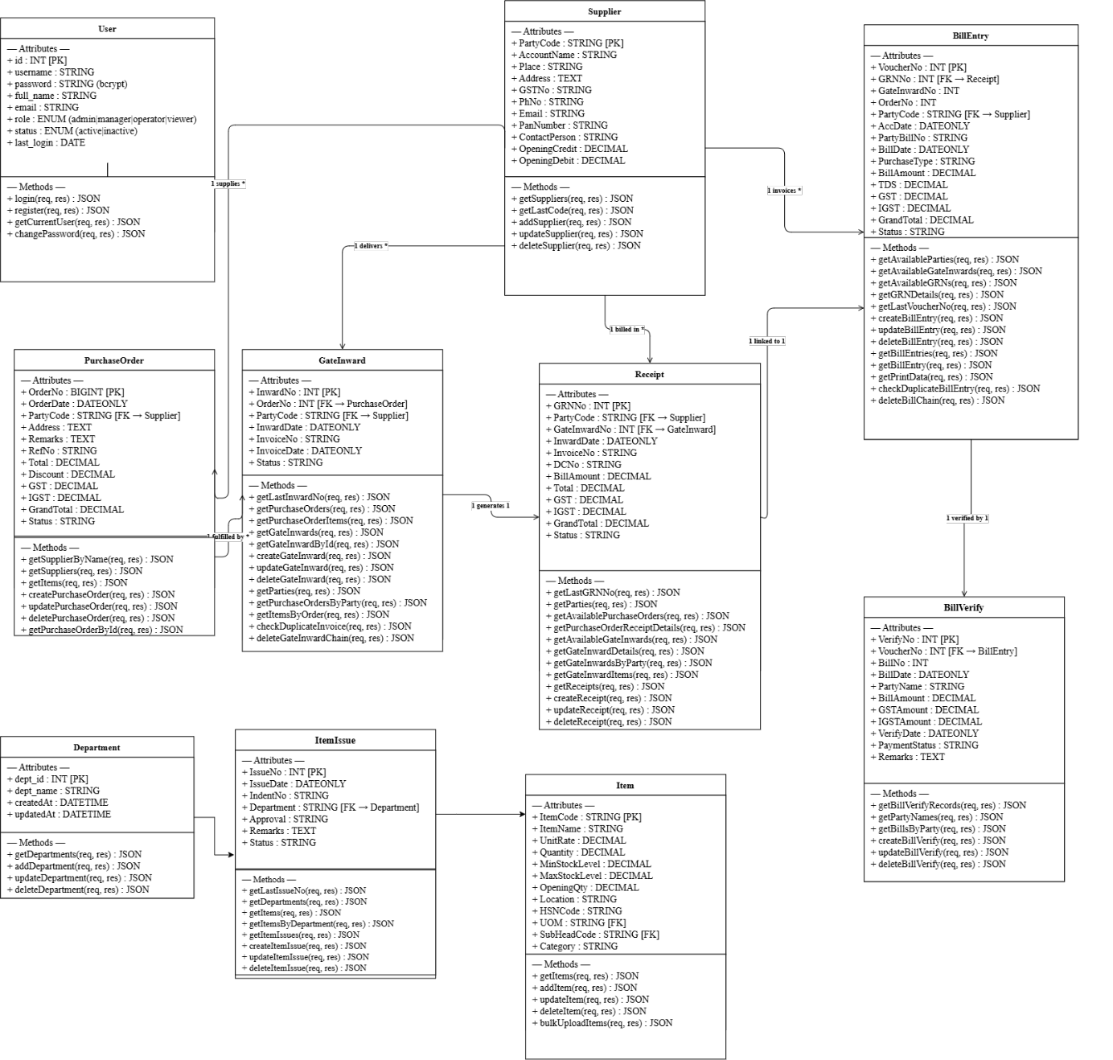
CHAPTER 5

TABLE STRUCTURES
Users
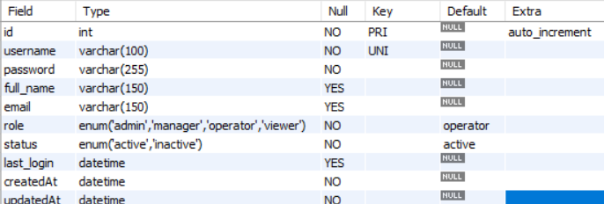

Supplier Details
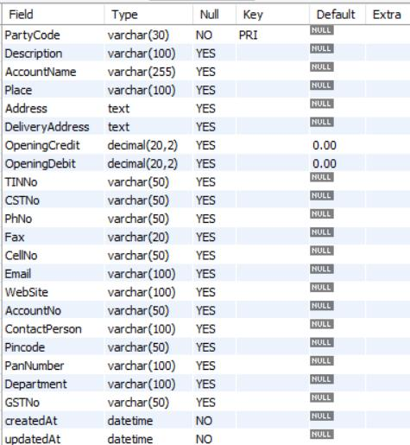

Uoms :
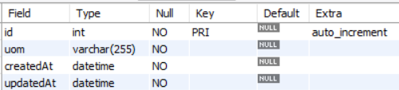

States :
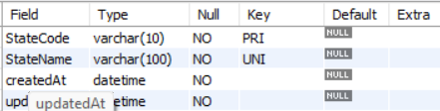

Sub_Heads :
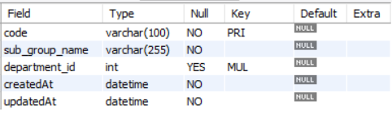

Store Master :
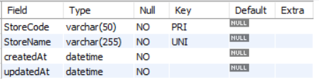

ProductHead :
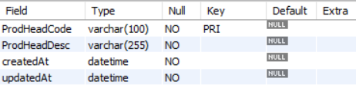

Department :
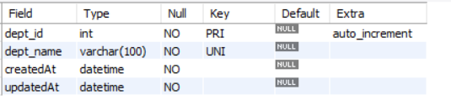

Purchase_Type :
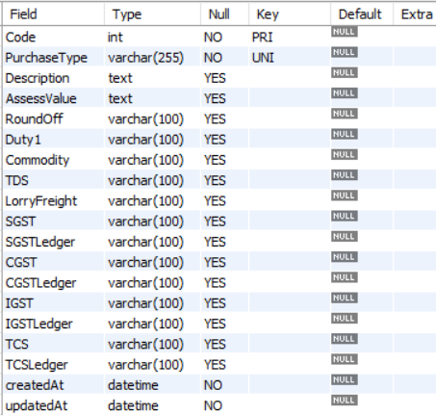

ItemMaster :
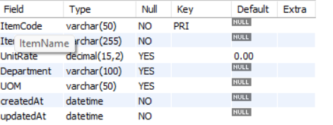

Party_master :
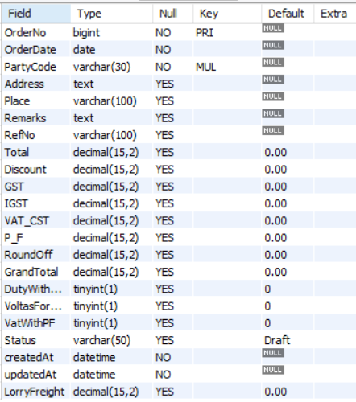

Purchase_orders :
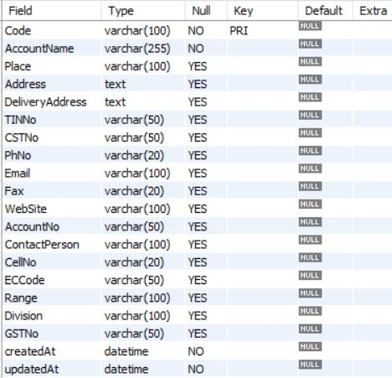

Purchase_order_details :
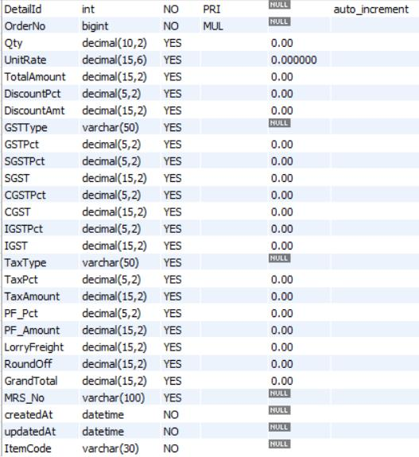

Item :
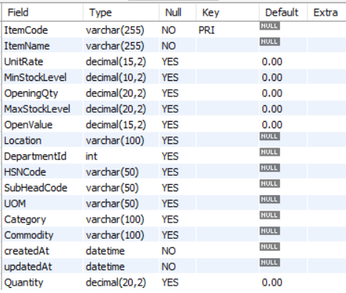

Gate_inward :
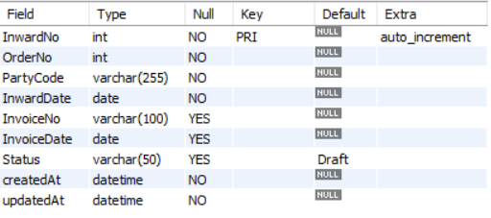

Gate_inward_details :
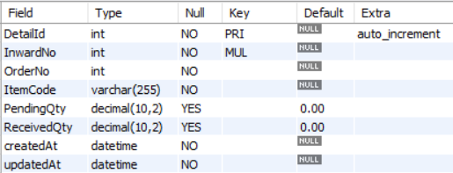

Receipts
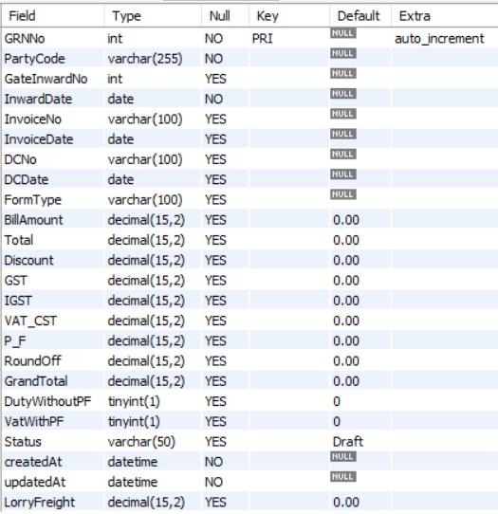

Receipt_details :
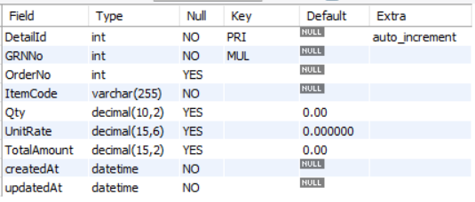

Bill_entry_details :
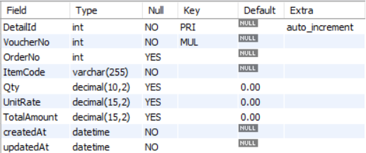

Item_issue :
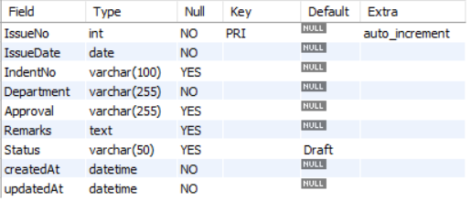

Item_issue_detail :
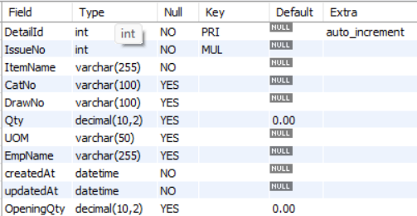

Bill_entries :
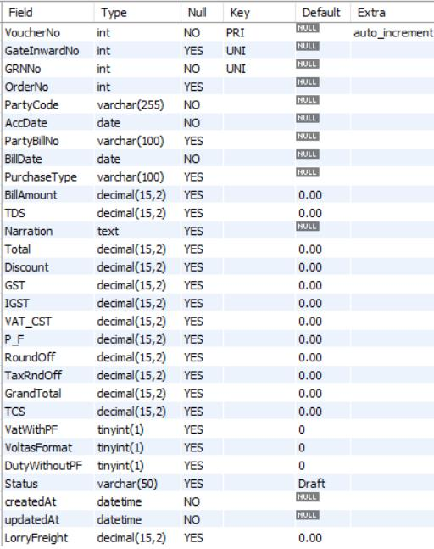

Cancel_orders :
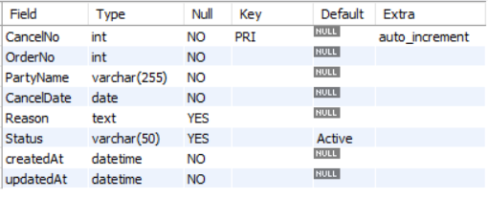

CHAPTER 6

ER DIAGRAM
ADDITIONAL MASTER TABLES
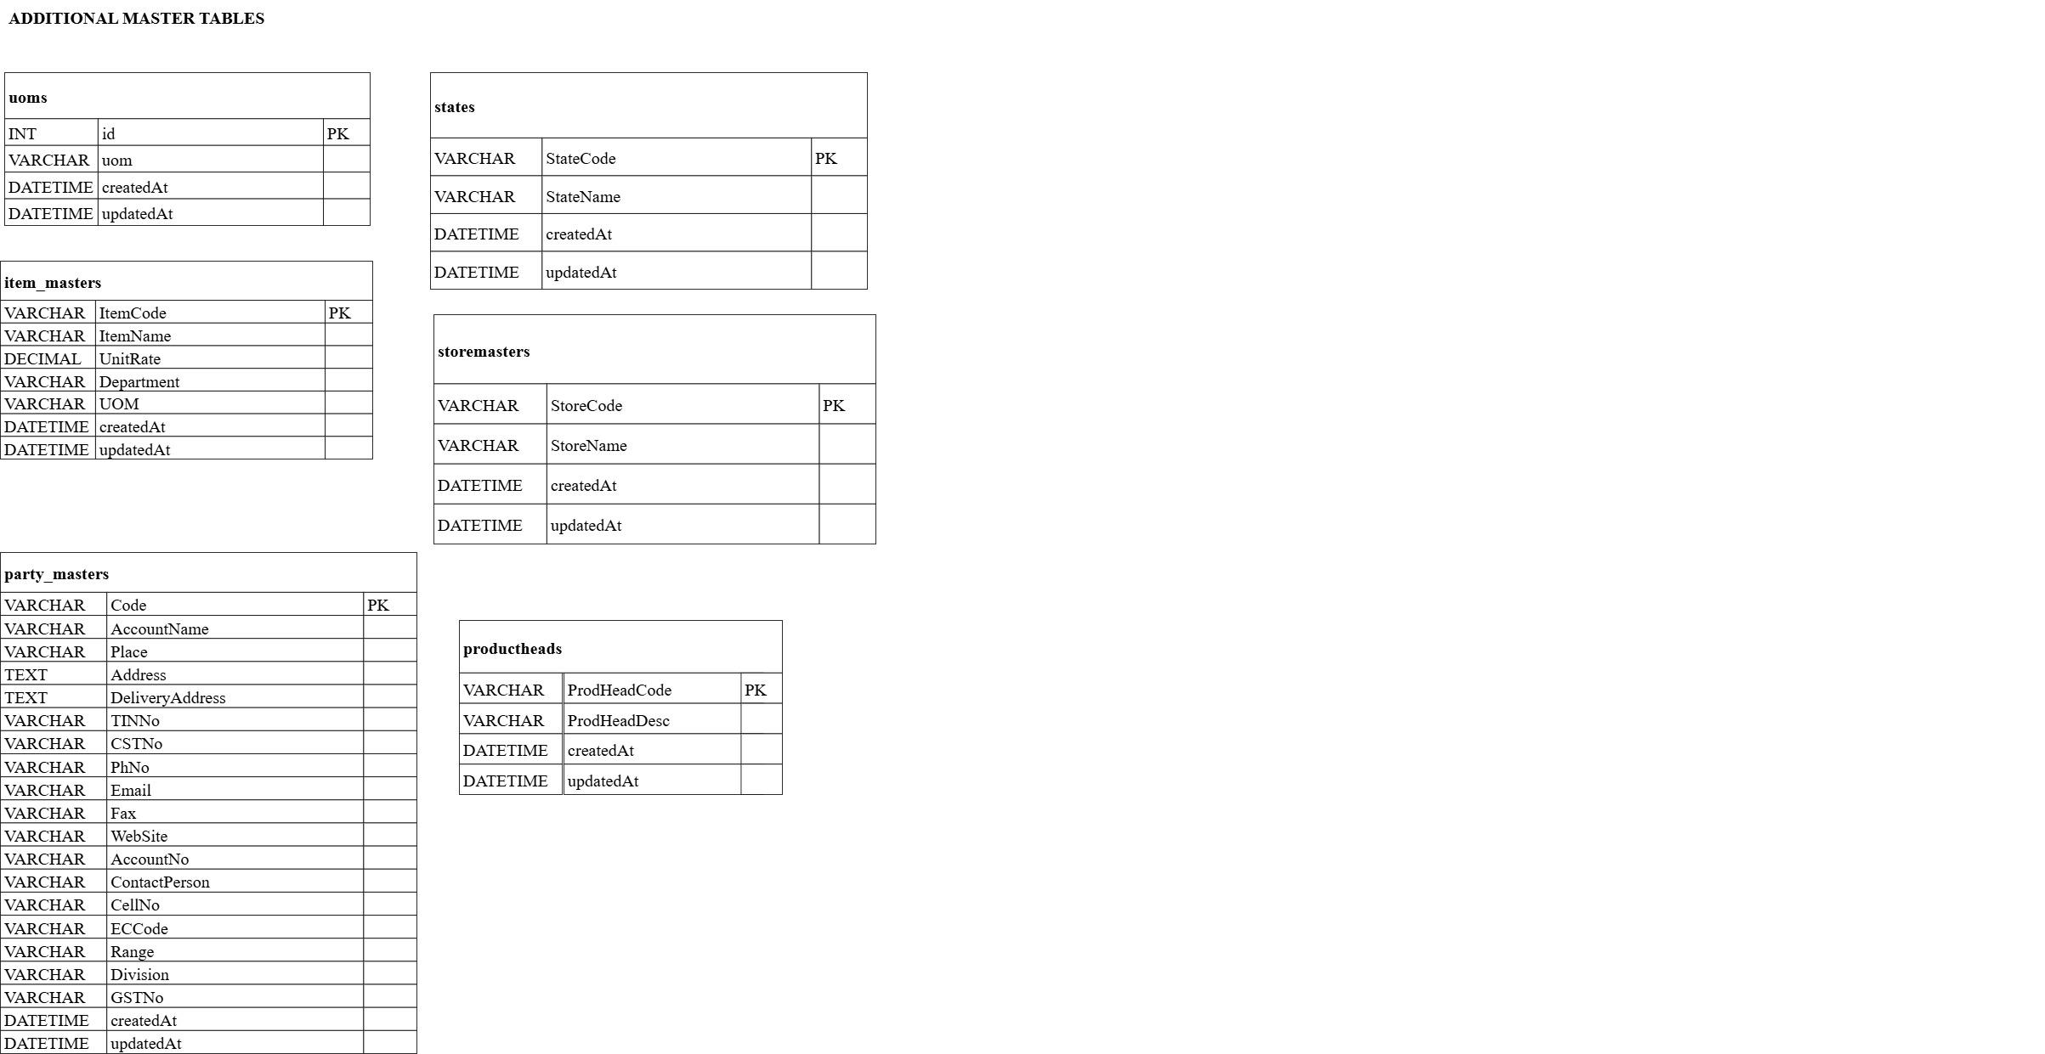

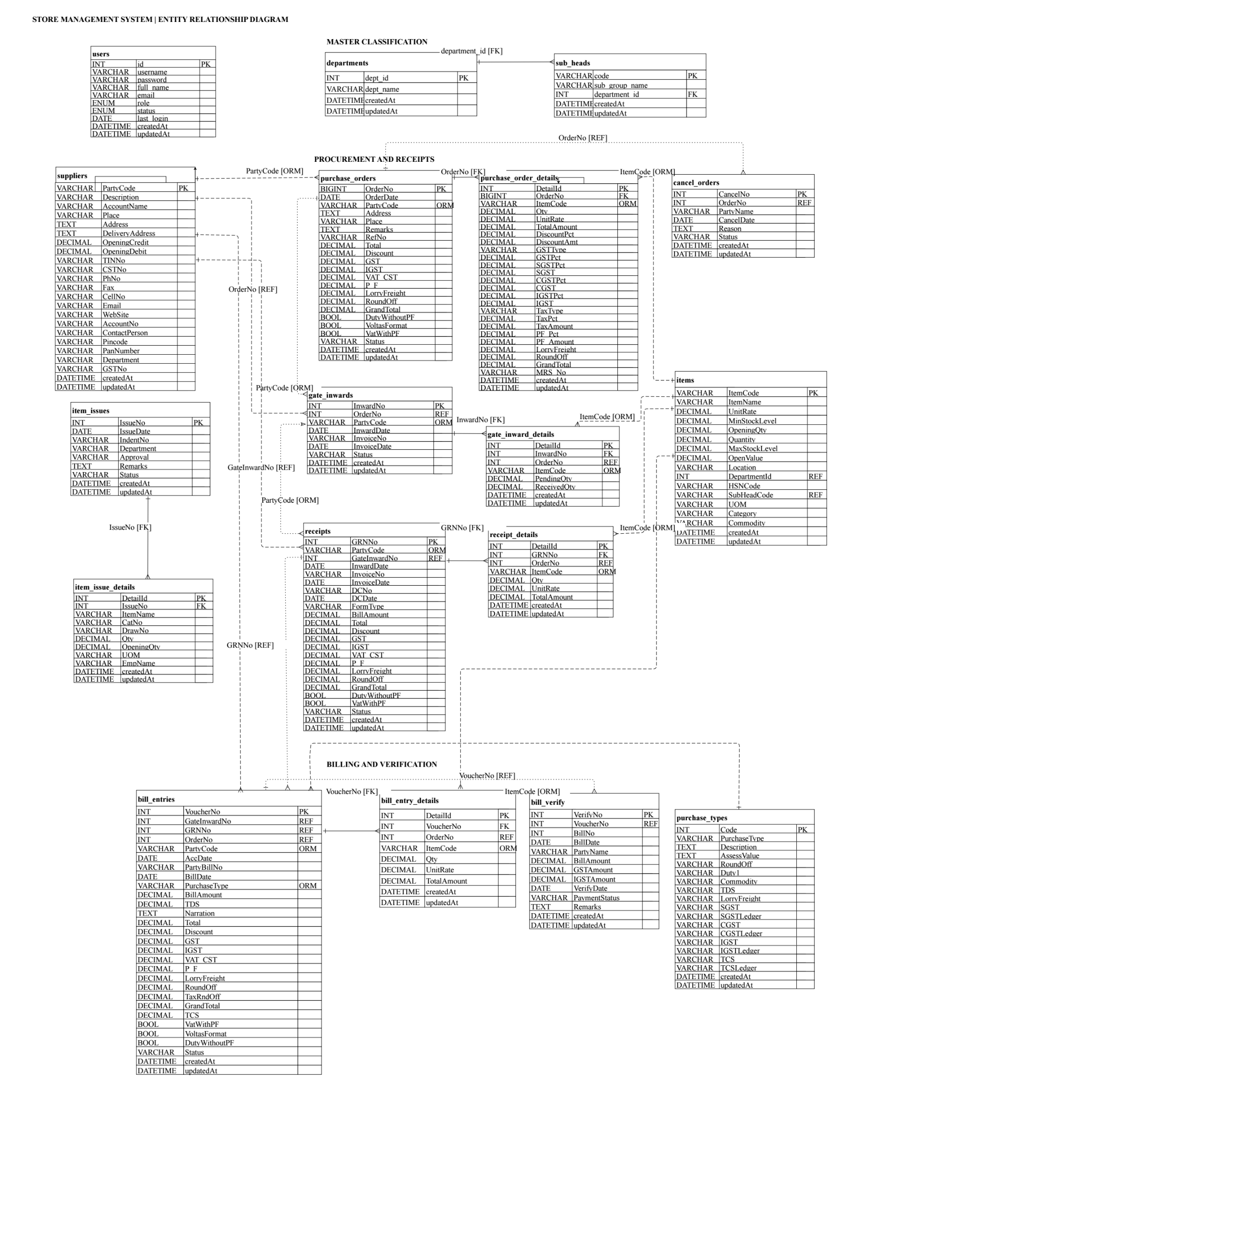
CHAPTER 7

TECH STACK

7.1 TECH STACK
Layer | Technology | Purpose
Frontend | React.js (Vite) | Single-page application with dynamic UI
State Management | Redux Toolkit | Centralized application state
HTTP Client | Axios | REST API communication with JWT auth
Backend | Node.js + Express.js v5 | RESTful API server
ORM | Sequelize v6 | Database abstraction and model management
Database | MySQL (via mysql2) | Relational data storage
Authentication | JSON Web Tokens (JWT) | Stateless, token-based user authentication
Security | Helmet, CORS, bcryptjs | HTTP hardening, rate limiting, password hashing
Reports | ExcelJS | Server-side Excel report generation
CI/CD | Jenkins (Jenkinsfile) | Automated build and deployment pipeline

7.2 ARCHITECTURE OVERVIEW
Layer | Technology | Purpose
Model | Sequelize ORM + MySQL | Defines data structure, handles DB queries, manages relationships and validations
View | React.js + Redux | Renders the UI, manages user interaction, communicates with the server via Axios
Controller | Node.js + Express.js | Receives HTTP requests, applies business logic, coordinates between Model and View
CHAPTER 8

MODULES

8.0 Design Approach
Each module of the Store Management System is described here the way a system design problem is solved: by walking through the same seven steps in the same order, every time. This keeps the explanation of every module complete and comparable, and shows why each design decision was taken rather than only what the screen looks like.
Step | Question it answers | Presented in each module as
1. Functional requirements | What must the module do? | Section x.1
2. Non-functional requirements | How fast, how big, how available? Where does the CAP trade-off fall? | Section x.2
3. Tech stack | Which tools suit this problem, and why? | Section x.3
4. Back-of-the-envelope | How many users, requests and how much storage? | Section x.4
5. Low-level architecture | Which components exist and who talks to whom? | Section x.5 (diagram + request flow)
6. API design | What is the contract between client and server? | Section x.6
7. DB design | Which tables, keys and indexes store the data? | Section x.7

Shared baseline for all modules
Non-functional baseline. Every request travels through Helmet (HTTP hardening), CORS, a payload size limit, a rate limiter and the JWT authentication middleware before it reaches a controller. All data lives in a single MySQL database, so the system chooses consistency over availability in CAP terms (CP): a user may briefly be unable to save if the database is unreachable, but two users can never see conflicting versions of a purchase order or a stock balance. Money columns use DECIMAL, never floating point, so totals reconcile exactly.
Sizing baseline (assumptions).
Quantity | Estimate | Basis
Named users | ≈ 20 | Store, purchase, accounts and management staff of one organization (assumption)
Working days / year | 300 | Assumption
Requests per user per day | ≈ 300 | Form loads, dropdown look-ups and saves (assumption)
Total requests per day | 20 × 300 = 6,000 | Derived
Average load | 6,000 ÷ 28,800 s ≈ 0.2 req/s | Spread over an 8-hour working day
Peak load | ≈ 2–5 req/s | 10× to 25× the average, e.g. start of shift
Total tables | 29 | Live schema

A single Node.js process and one MySQL instance handle this load comfortably. The design keeps the application stateless (JWT instead of server sessions), so extra Node.js instances can be added behind a load balancer if usage grows.
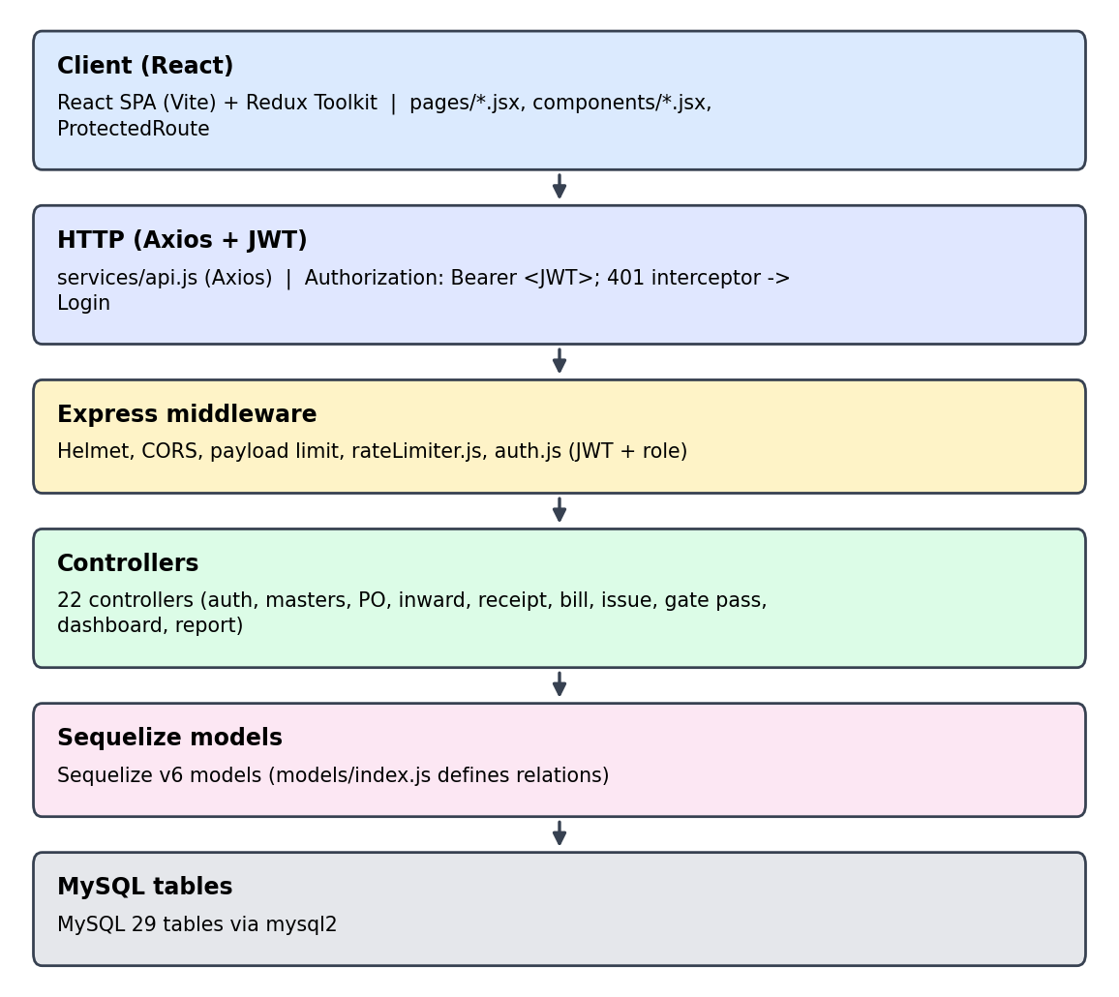
Fig 8.0 Overall request flow of the Store Management System

8.1 FOLDER STRUCTURE
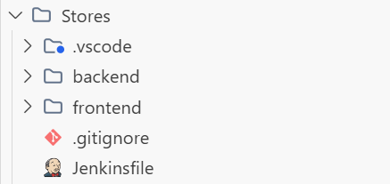
Fig 8.1.1 Highlevel view of project
8.1.1 BACKEND FOLDER
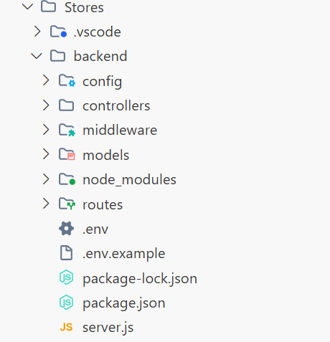
Fig 8.1.2 – Backend Folder Structure – Overall organization of backend files and directories showing modular architecture.
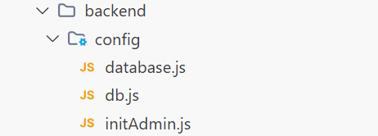
Fig 8.1.3 config Folder structure
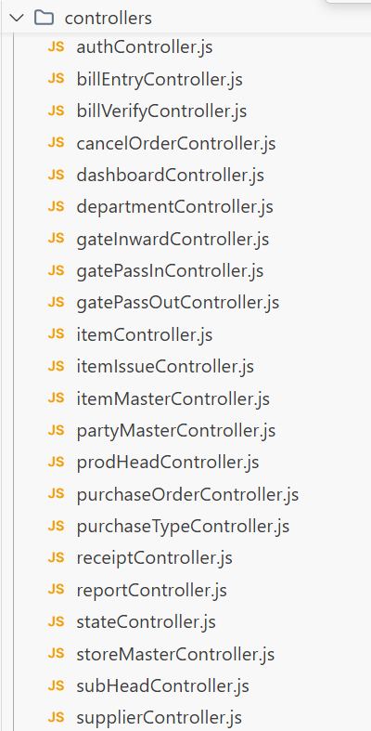
Fig 8.1.4 Controller Folder
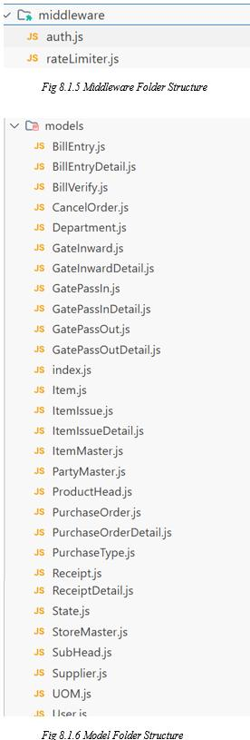

8.1.2 FRONTEND FOLDER
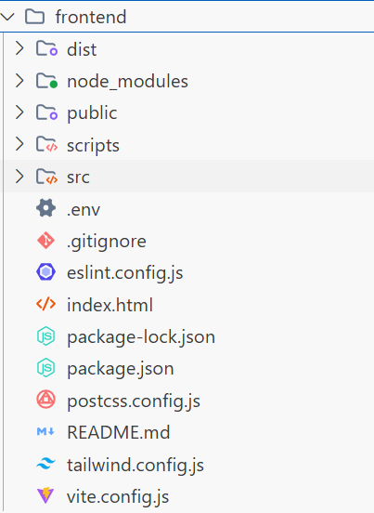
FIG 8.1.7 Structure of Frontend Folder
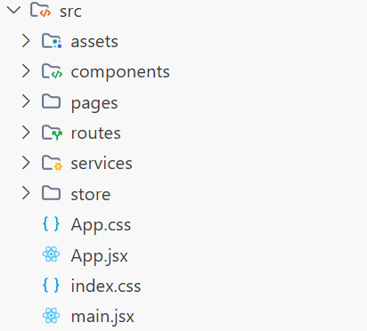
Fig 8.1.8 Structure of frontend/src
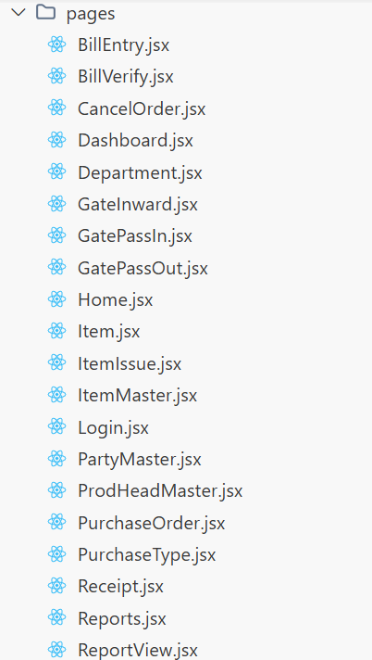
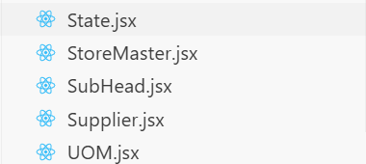
Fig 8.1.9 Structure of frontend/src/pages Folder
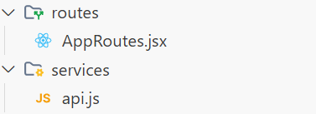
Fig 8.1.10 Structure of frontend/src/routes and frontend/src/services
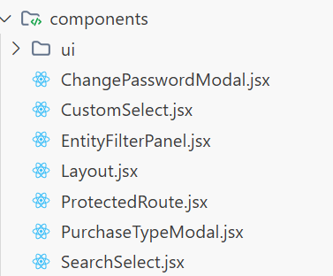
Fig 8.1.11 Structure of frontend/src/components

8.2 USER AUTHENTICATION & ACCESS CONTROL

8.2.0 Purpose & Scope
Provides tokenized authentication, secure credential management, and Role-Based Access Control (RBAC) across the enterprise, preventing unauthorized data modifications.

8.2.1 Functional Requirements
What the module must do:
- A user signs in with a username and password and receives a signed JWT plus a profile (id, full_name, role).
- A signed-in user can change their own password; administrators can register new users.
- Four roles – admin, manager, operator, viewer – decide which endpoints a user may call.
- Each account has an active / inactive status so access can be withdrawn without deleting the record, and the last login time is stored.
- The browser redirects unauthenticated users to the login screen (protected routes) and handles an expired or invalid token centrally.
Out of scope: self-service sign-up, social login / SSO and multi-factor authentication.

8.2.2 Non-Functional Requirements
How well the module must do it (the system-wide baseline in the chapter introduction also applies):
- Security: passwords are stored only as bcryptjs hashes with auto-generated salts; the hash is never returned by the API.
- Brute-force defence: at most 15 login attempts per 15 minutes per IP address on /api/auth/login.
- Session length: tokens expire after 12 hours, which limits the damage of a stolen token while avoiding repeated logins in one shift.
- Scalability: because tokens are stateless, any server instance can validate a request without a shared session store.
- Latency target: login under 500 ms (dominated by the deliberate cost of bcrypt); token verification adds only microseconds per request.
- CAP: the user table is a single MySQL source of truth – consistency is preferred, so a disabled account is refused immediately on the next login.

8.2.3 Tech Stack
Concern | Choice | Why it fits this module
Password hashing | bcryptjs (salted) | Pure JavaScript, no native build step on the Jenkins/production server
Session | JSON Web Token, 12 h | Stateless; the client keeps the token and sends it in the Authorization header
Abuse control | rateLimiter.js middleware | Applies the 15 per 15 minute limit only to the login route
HTTP hardening | Helmet, CORS | Standard security headers and a restricted set of allowed origins
Client guard | ProtectedRoute.jsx + Axios interceptor | Redirects to /login when no token exists or the server answers 401

8.2.4 Back-of-the-Envelope Estimation
Figures marked “live” come from the running system; the rest are working assumptions used to size the design.
Quantity | Estimate | Basis
Users | ≈ 20 rows, < 10 KB | Assumption (≈ 0.5 KB per row)
Logins per day | ≈ 40 | 20 users × about 2 logins (12-hour tokens)
Login burst | ≈ 20 logins in 5 minutes | Start of shift ≈ 0.07 login/s
CPU per login | ≈ 100 ms | Typical bcrypt compare; one core handles ≈ 10 logins/s
Brute-force ceiling | 1,440 attempts / day / IP | 15 attempts × 96 windows of 15 minutes
Authenticated calls | ≈ 6,000 / day | Each one verifies the JWT signature

8.2.5 Low-Level Architecture
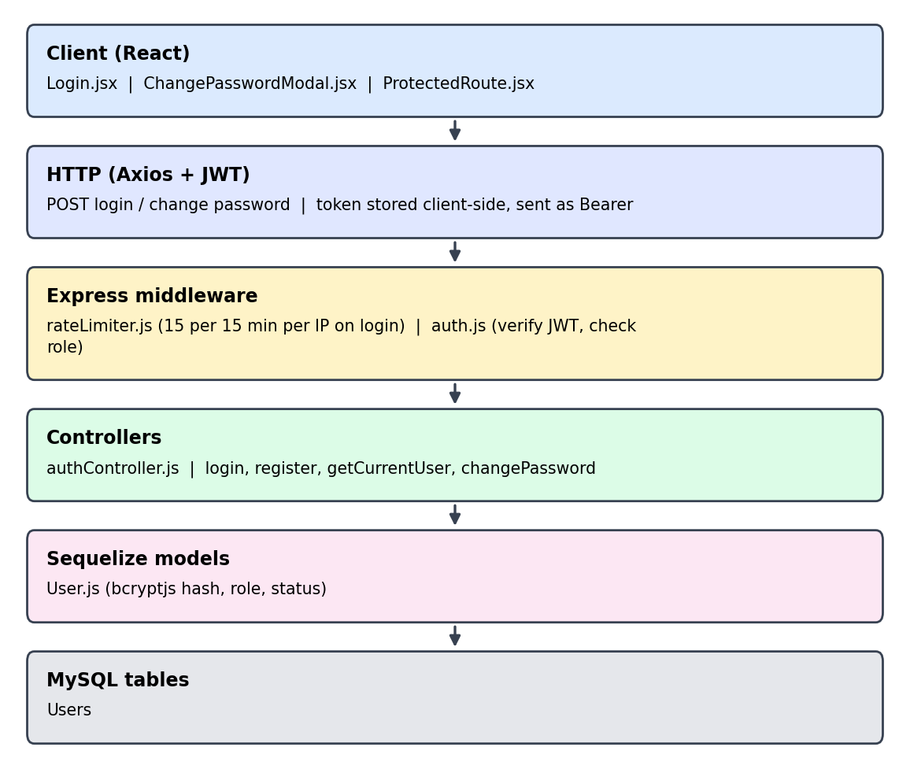
Fig 8.2.A Low-level architecture – USER AUTHENTICATION & ACCESS CONTROL
Request flow:
- Login.jsx posts the credentials; rateLimiter.js counts the attempt for the caller’s IP.
- authController looks the user up by username (unique index), checks that the status is active, and compares the password with the stored bcrypt hash.
- On success it updates last_login, signs a JWT (12 h) and returns the token with the profile.
- The client stores the token; api.js adds it as a Bearer header on every later request.
- auth.js verifies the signature and expiry and checks the role before the route handler runs.
- A 401 response triggers the Axios interceptor, which clears the session and sends the user back to the login screen.

8.2.6 API Design
Only /api/auth/login is public. The remaining paths are representative routes derived from the authController methods.
Method | Endpoint | Purpose / contract
POST | /api/auth/login (public) | Body: username, password. Returns JWT bearer token and user profile (id, full_name, role). Rate limited.
POST | /api/auth/register | Admin only. Creates a user with a hashed password and a role.
GET | /api/auth/me | Returns the profile of the signed-in user from the token.
PUT | /api/auth/change-password | Body: current and new password. Stores a new bcrypt hash.

8.2.7 DB Design
Table | Keys & indexes | Key columns
Users | PK id (auto increment)  UNIQUE username | username varchar(100), password varchar(255) hash, full_name, email, role enum(admin, manager, operator, viewer) default operator, status enum(active, inactive) default active, last_login, createdAt, updatedAt
- The unique index on username makes the login look-up a single index read and prevents duplicate accounts.
- No other table has a foreign key to Users, so authentication can be changed independently of the store data.

8.2.8 Screenshots
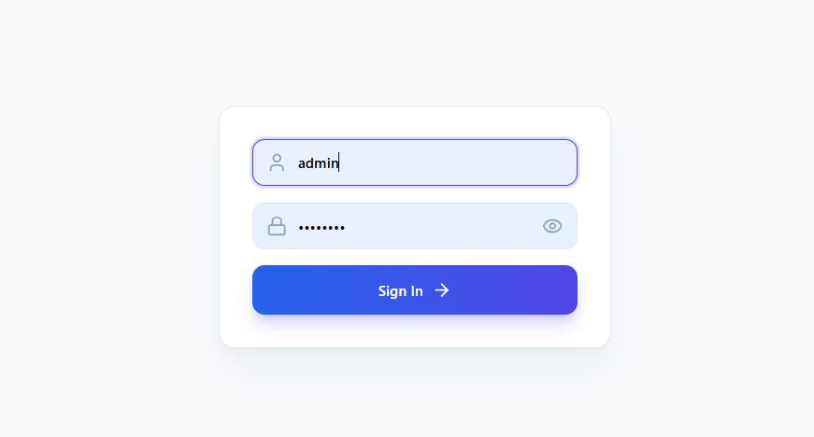
Fig 8.2: User Login & Authentication Interface

8.3 MASTER DATA MANAGEMENT

8.3.0 Purpose & Scope
Unifies foundational reference datasets and enterprise catalogs that establish the baseline for all store operations, inventory classification, and vendor management.

8.3.1 Functional Requirements
What the module must do:
- Create, view, edit and delete records for: Item, Supplier, Department, Store Master, Product Head, Sub Head, UOM, State, Purchase Type, Party Master and Item Master (gate-pass items).
- Central item catalog: item code, name, department, sub head, UOM, unit rate, opening stock, min / max stock level (reorder level), HSN code, location.
- Supplier registry: account name, place, address, delivery address, GSTIN, PAN, contact details and opening credit / debit.
- Search and filter large lists: suppliers by department, place and GST status; items by department, sub head and UOM; sorting and page size.
- Bulk upload of items from a CSV file.
- Purchase Type records carry accounting formulas (assessable value, round off, lorry freight) and SGST / CGST / IGST / TCS ledger mappings.
- Provide searchable reference dropdowns to every transaction screen so users pick, rather than type, master values.

8.3.2 Non-Functional Requirements
How well the module must do it (the system-wide baseline in the chapter introduction also applies):
- Read-heavy: masters are read many times more often than they are changed (roughly 100 reads per write), so look-ups must be fast.
- Scale of lists: with 5,490 suppliers and 11,011 items, lists are paginated on the server (10 per page by default) and never loaded whole.
- Data quality: unique keys on department name, state name, store name and purchase type prevent duplicates; item and sub head records link to their parent through department_id / SubHeadCode.
- Access control: write endpoints are restricted by role (for example, the viewer role is read-only).
- CAP: consistency first – a new supplier or item must be visible to every user as soon as it is saved, because transactions depend on it immediately.

8.3.3 Tech Stack
Concern | Choice | Why it fits this module
List UI | React pages + EntityFilterPanel, SearchSelect, CustomSelect | One reusable filter and dropdown set for every master screen
Server paging | Sequelize queries with limit / offset and where-filters | Keeps the response small even for the 11,011-row item catalog
Bulk load | bulkUploadItems endpoint (CSV) | Loads the opening catalog without typing each row
Persistence | MySQL, one table per master | Simple relational lookup tables with primary and unique keys

8.3.4 Back-of-the-Envelope Estimation
Figures marked “live” come from the running system; the rest are working assumptions used to size the design.
Quantity | Estimate | Basis
Suppliers | 5,490 rows ≈ 6.6 MB | Live count; ≈ 1.2 KB per row
Items | 11,011 rows ≈ 6.6 MB | Live count; ≈ 0.6 KB per row
Small masters | 31 departments, 14 UOMs, 33 states, 73 purchase types (< 100 KB) | Live counts
One 10-row page | ≈ 10 KB | vs. ≈ 6.6 MB for a full item dump – the reason for server-side paging
Bulk item upload | 11,011 rows → 23 batches of 500 | 11,011 ÷ 500 = 22.02, rounded up
Request rate | ≈ 3 req/s at peak | Each transaction form loads 3–5 look-ups

8.3.5 Low-Level Architecture
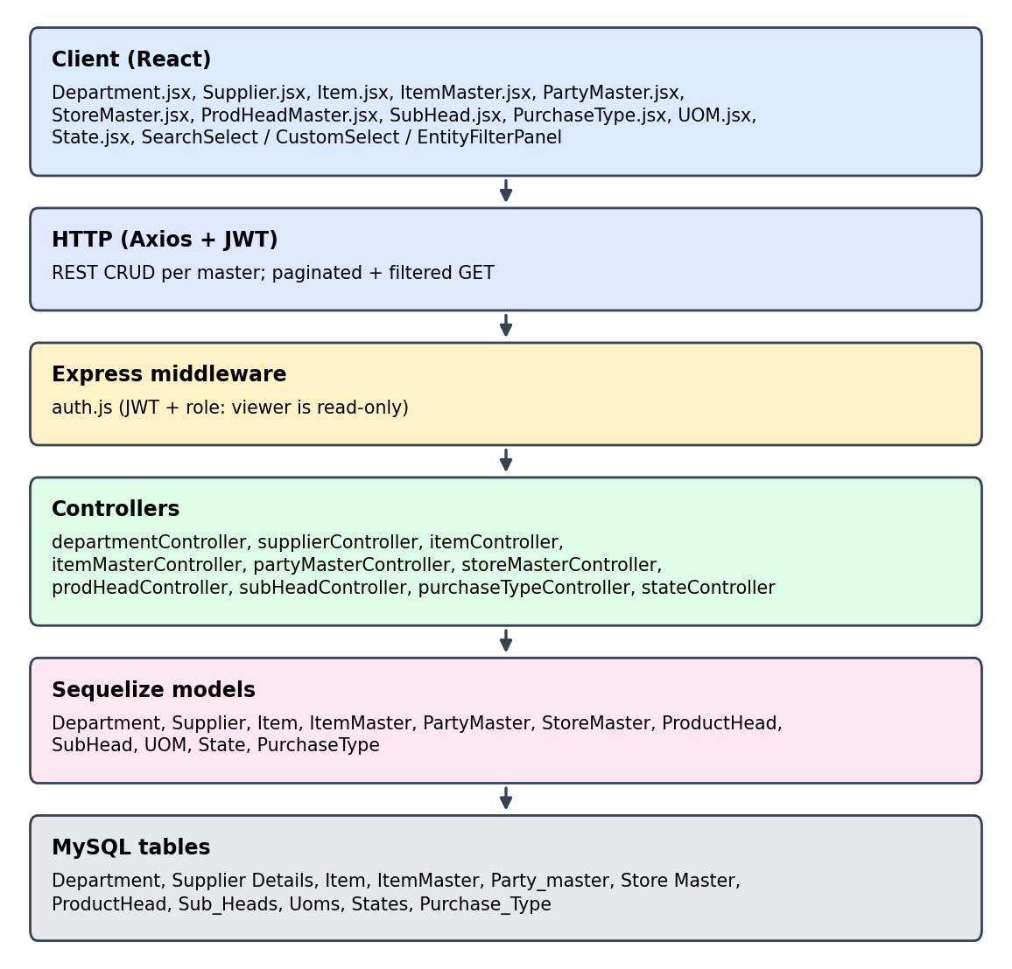
Fig 8.3.A Low-level architecture – MASTER DATA MANAGEMENT
Request flow:
- A master page (for example Item.jsx) sends a GET with search text, filter values, sort and page size as query parameters.
- The matching controller turns them into a Sequelize where / order / limit clause and returns the page plus the total count.
- Add / edit forms POST or PUT one record; the controller validates required fields and unique keys before writing.
- Transaction screens reuse the same endpoints through SearchSelect, so every dropdown shows current master data.

8.3.6 API Design
{master} stands for one of: departments, suppliers, items, item-masters, party-masters, store-masters, product-heads, sub-heads, uoms, states, purchase-types. Paths are representative routes derived from the controller methods in Chapter 4.
Method | Endpoint | Purpose / contract
GET | /api/{master} | List with search, filters, sort, page and limit; returns rows and total count.
GET | /api/{master}/:id | One record by its primary key.
POST | /api/{master} | Create a record (item, supplier, department, store, UOM, state, purchase type …).
PUT | /api/{master}/:id | Update an existing record.
DELETE | /api/{master}/:id | Delete a record.
GET | /api/suppliers/last-code | Next supplier party code (getLastCode).
POST | /api/items/bulk-upload | Create many items from an uploaded CSV (bulkUploadItems).

8.3.7 DB Design
Table | Keys & indexes | Key columns
Department | PK dept_id (auto)  UNIQUE dept_name | dept_name varchar(100)
Supplier Details | PK PartyCode varchar(30) | AccountName, Place, Address, DeliveryAddress, GSTNo, PanNumber, PhNo, Email, ContactPerson, OpeningCredit / OpeningDebit decimal(20,2)
Item | PK ItemCode varchar(255) | ItemName, UnitRate, MinStockLevel, MaxStockLevel, OpeningQty, Quantity, OpenValue, Location, DepartmentId, HSNCode, SubHeadCode, UOM, Category, Commodity
ItemMaster | PK ItemCode varchar(50) | ItemName, UnitRate, Department, UOM (returnable gate-pass items)
Party_master | PK Code varchar(100) | AccountName, Place, Address, GSTNo, ECCode, Range, Division (gate-pass parties)
Store Master | PK StoreCode  UNIQUE StoreName | StoreName varchar(255)
ProductHead | PK ProdHeadCode | ProdHeadDesc
Sub_Heads | PK code  MUL department_id | sub_group_name, department_id
Uoms | PK id (auto) | uom varchar(255)
States | PK StateCode  UNIQUE StateName | StateName varchar(100)
Purchase_Type | PK Code int  UNIQUE PurchaseType | Description, AssessValue, RoundOff, Duty1, Commodity, TDS, LorryFreight, SGST / CGST / IGST / TCS and their ledger columns
- Recommended extra index (not yet in the schema): an index on Item(DepartmentId, SubHeadCode) and on Supplier Details(Place) would speed the department / sub head / place filters as the catalogs grow.

8.3.8 Screenshots
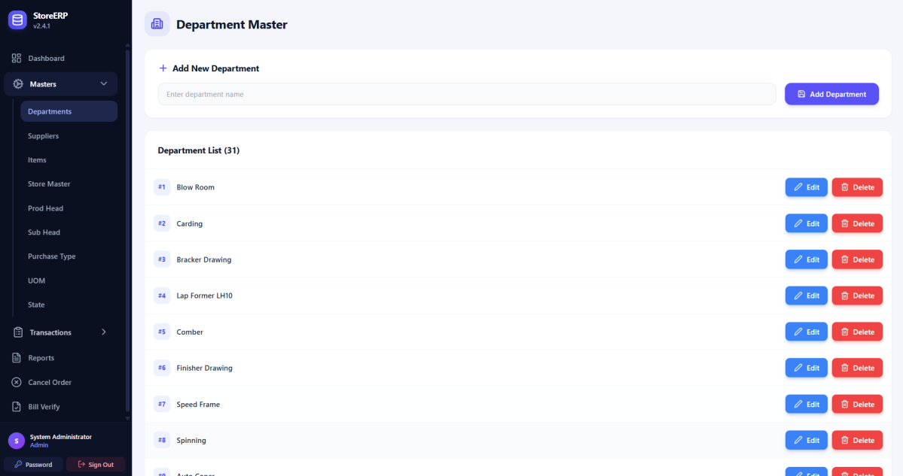
fig 8.3.1 Department master list
The screen lists departments and provides controls to add, edit, or delete department records. The department names appear in a single list, allowing the user to review the organizational units used in store transactions. Maintaining these records provides consistent department selections when materials are issued or reports are filtered.
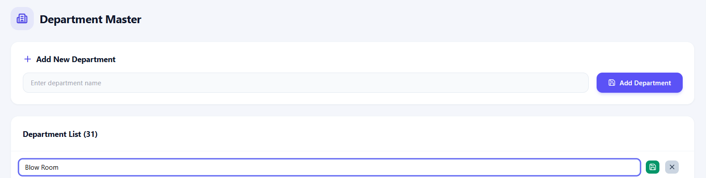
fig 8.3.2 Editing a department
An existing department name can be changed in the list and saved or cancelled using the adjacent controls. The selected row changes into an editable text field, while the save and cancel icons control whether the revision is retained. This enables corrections to a department name directly from the list without opening a separate entry screen.
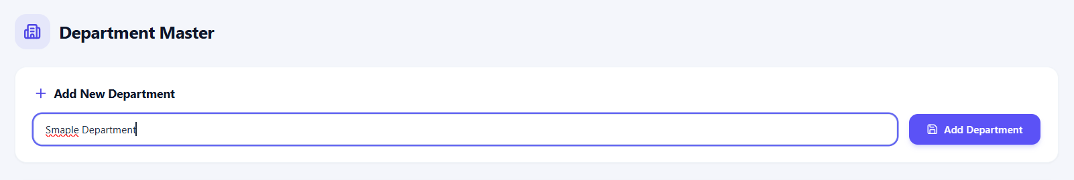
fig 8.3.3 Adding a department
The user enters a department name and selects Add Department to create a new record. The screenshot shows a sample name entered in the new department field, ready for submission. This step establishes a department record that can subsequently be selected in the relevant master data and transaction screens.
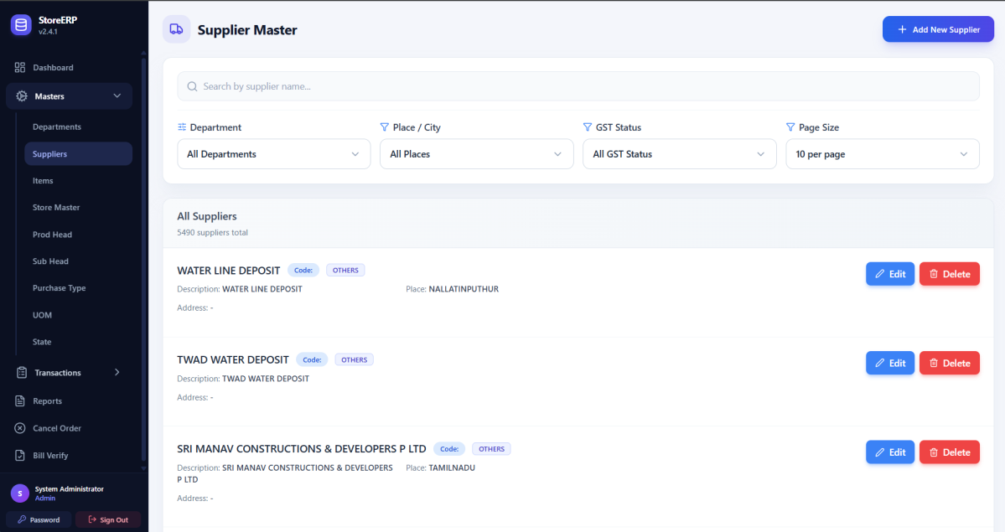
fig 8.3.4 Supplier master list
The supplier registry displays vendor records with search, filtering, and edit or delete controls. The interface combines supplier search with department, place, GST status, and page size filters. Each supplier entry presents identifying information and action buttons so users can locate a vendor and maintain its details from the same screen.
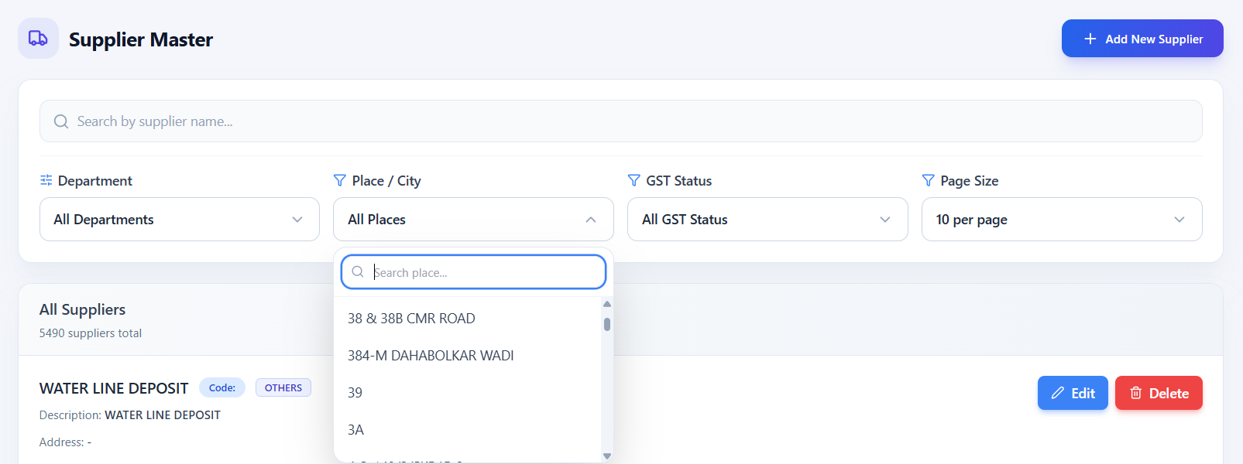
fig 8.3.5 Filtering suppliers by place
The place dropdown narrows the supplier list to vendors associated with a selected location. The open dropdown includes a search field and available supplier locations. Selecting a place helps users find vendors in a particular area, while the other filters can further narrow the records displayed.
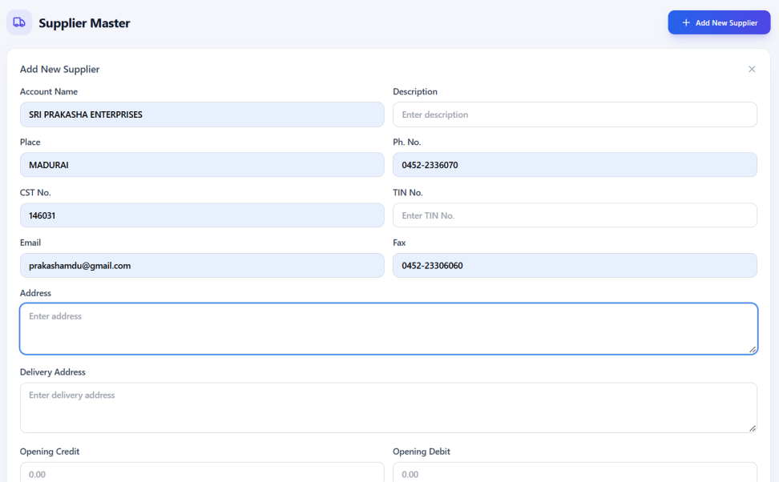
fig 8.3.6 New supplier entry
The supplier form captures identification, contact, address, and opening balance information for a new vendor. The entry panel groups supplier identity and communication details with address and commercial information. Recording these details gives purchase and inward transactions a consistent vendor reference and reduces repeated manual entry.
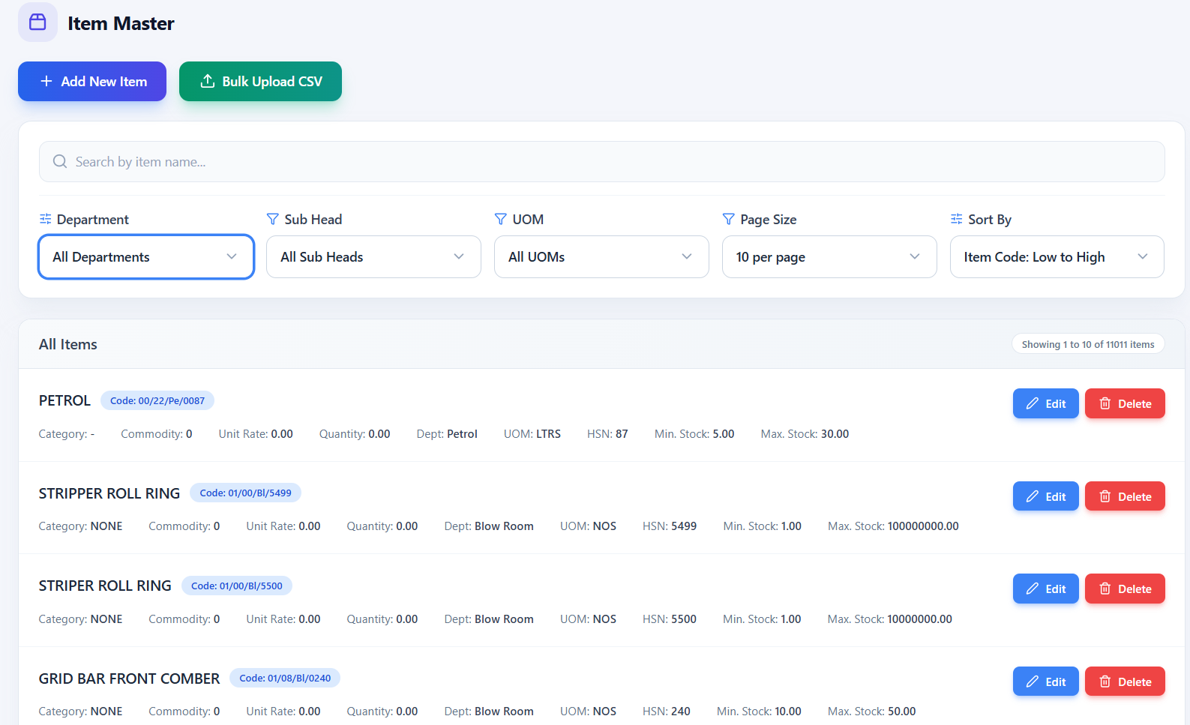
fig 8.3.7 Item master list
The item catalog displays stock items with their classifications, units, rates, and stock levels, alongside maintenance controls. The list presents item codes and descriptions together with department, classification, unit, and stock information. Search, sorting, and filters help users navigate a large catalog, while the add and upload controls support maintaining item records.
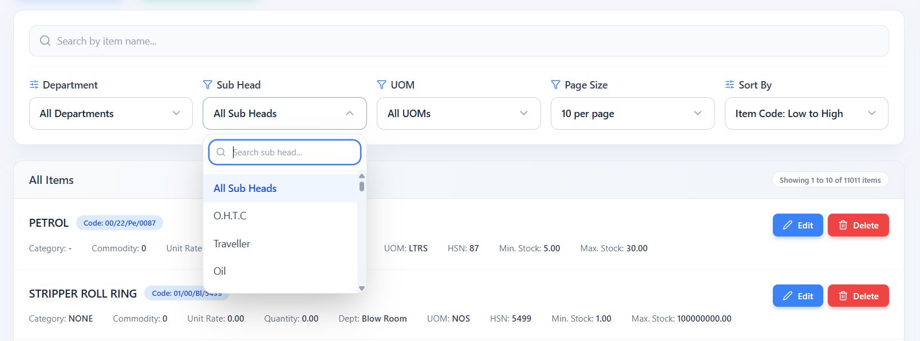
fig 8.3.8 Filtering items by sub head
The sub head dropdown filters the item catalog by the selected product classification. The open sub head selector shows the available classifications and a search box for locating a specific option. Applying this filter helps users review related items together and find an item without scanning the entire catalog.
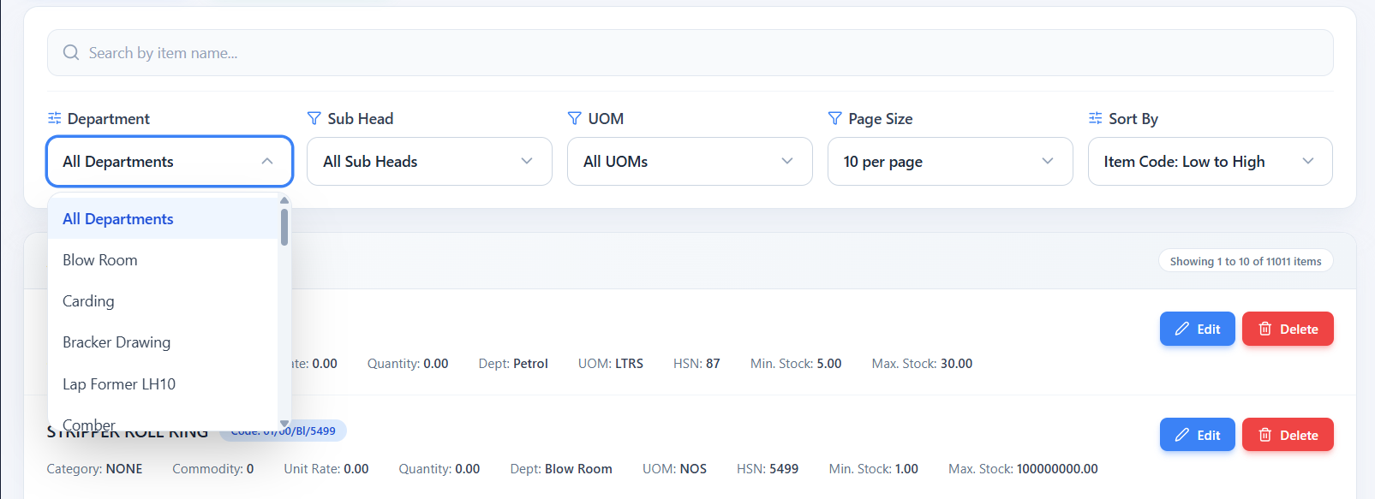
fig 8.3.9 Filtering items by department
The department dropdown limits the displayed items to those associated with the selected department. The department selector displays organizational units that can be used to narrow the catalog. This view helps users review the items associated with a particular department alongside the existing sub head and unit filters.
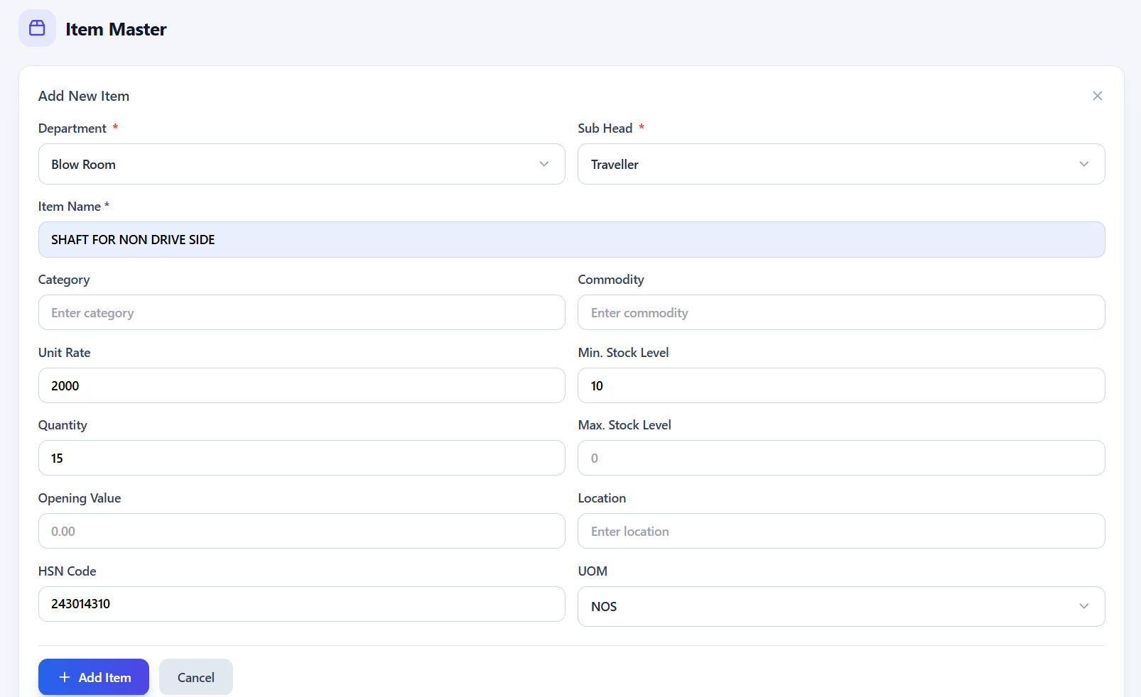
fig 8.3.10 New item entry
The item form records department, classification, item name, unit, stock, and pricing details before saving the item. The form brings the item identification and classification fields together with quantity and commercial fields. Completing these fields defines the reference information used when the item is selected in purchase, receipt, and issue transactions.
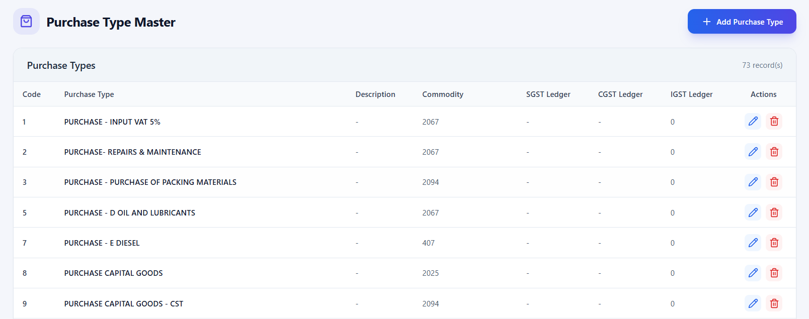
fig 8.3.11 Purchase type master list
Purchase types are listed with their codes and ledger mappings, with controls to add or modify entries. The table places each purchase type alongside its description, commodity, and tax ledger columns. This allows users to review the accounting references associated with different purchase categories and access the edit or delete actions for a record.
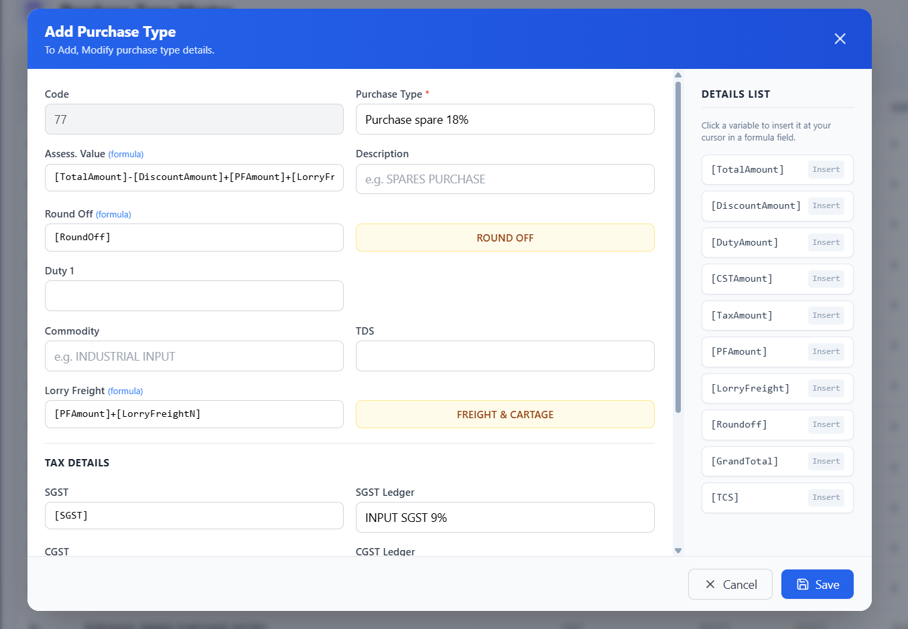
fig 8.3.12 Adding a purchase type
The form captures a purchase type and its related accounting and tax ledger information. The entry dialog groups purchase category details with the ledger fields required for accounting. The visible save and close controls allow users to submit the completed record or leave the entry process.
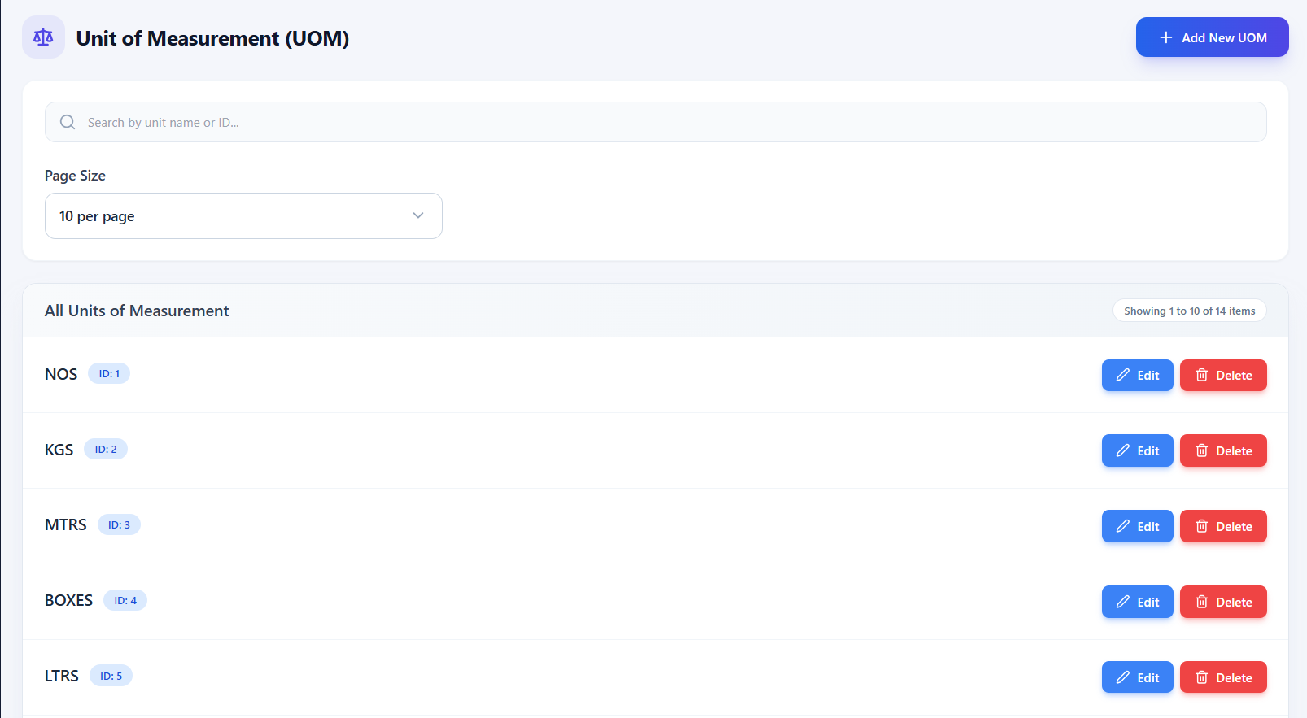
fig 8.3.13 Unit of measurement master list
The screen maintains measurement units used for item quantities and provides edit and delete controls. The list displays unit names and their codes, with a page size control for browsing the records. A shared unit registry helps keep quantity labels consistent when items are entered and used in store transactions.
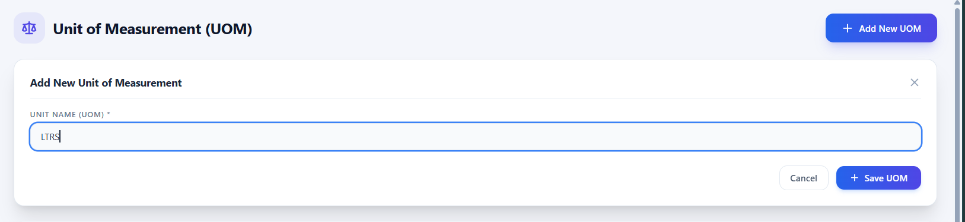
fig 8.3.14 Adding a unit of measurement
The user enters a unit name and selects Save UOM to make it available for item records. The screenshot shows the unit name field populated with LTRS and the save and cancel controls underneath. Saving the entry adds a reusable measurement label for item quantities, while cancellation leaves the entry unfinished.
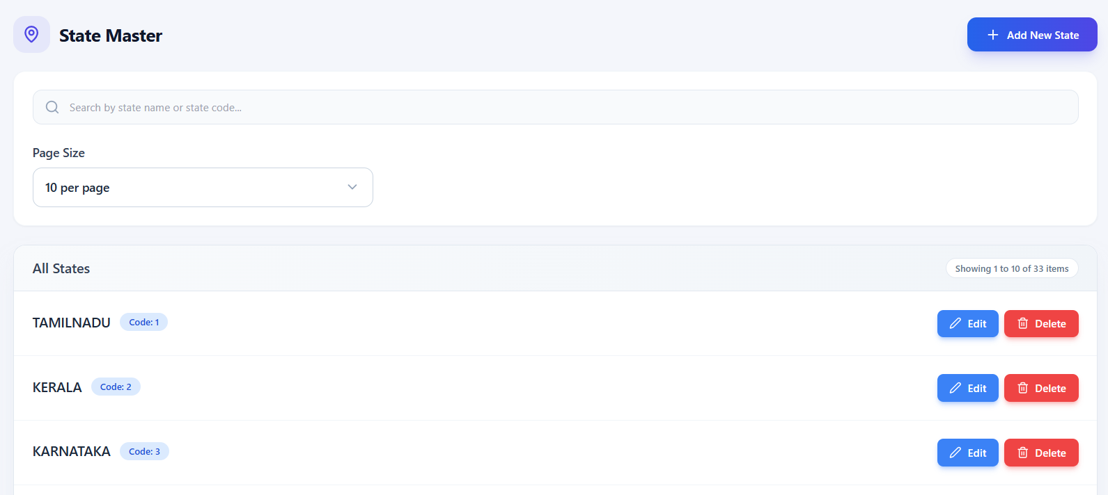
fig 8.3.15 State master list
The state registry supports searching and maintaining state names used in supplier and transaction records. The screen displays individual state records with their codes and edit or delete actions. The search field helps users locate a state quickly when maintaining the reference data used for vendor addresses and tax jurisdiction.

8.4 PURCHASE ORDER (PO) MANAGEMENT

8.4.0 Purpose & Scope
Orchestrates the procurement lifecycle, from raising purchase orders with approved vendors to multi-item price calculations, status tracking, and authorized order cancellations.

8.4.1 Functional Requirements
What the module must do:
- Raise a PO for a supplier: order date, party, address / place, reference number and remarks; the PO number (for example PO-772) is generated automatically in sequence.
- Multi-item line engine: each line takes item, quantity, unit rate, discount %, GST type (SGST + CGST or IGST), packing & forwarding, lorry freight and MRS number, and shows the line total instantly.
- Order summary: items subtotal, total discount, total tax, P&F, lorry freight, round off and grand total.
- Lifecycle tracking: Draft → Pending / Approval → Approved → Inward Created → Completed / Cancelled.
- Register: search by order number, party or reference; filter by party and status; sort; expand a row to see its lines; copy, edit or delete a PO.
- Controlled cancellation: a PO is cancelled only with a mandatory reason, and not once its items have arrived at the gate.

8.4.2 Non-Functional Requirements
How well the module must do it (the system-wide baseline in the chapter introduction also applies):
- Accuracy: amounts are DECIMAL(15,2) and unit rates DECIMAL(15,6), so a PO total always matches the sum of its lines. Example (Fig 8.4.3–8.4.4): ₹20,000 − ₹1,800 discount = ₹18,200; GST is 18 % of (₹18,200 + ₹5,000 P&F + ₹5,000 freight) = ₹5,076; grand total = ₹18,200 + ₹5,000 + ₹5,000 + ₹5,076 = ₹33,276.
- Atomicity: the header and all its lines are saved together in one transaction; a PO never exists half-saved.
- Unique numbering: the PO number is allocated on the server and the primary key is the final guard against duplicates when two clerks save at the same time.
- Server-side validation: totals sent by the browser are recomputed on the server before saving.
- Auditability: every cancellation stores a reason and date; all tables carry createdAt / updatedAt.
- Responsiveness: the register opens in under 1 second; line details load only when a row is expanded.
- CAP: consistency first – the status of a PO must be identical for the store, accounts and management at all times.

8.4.3 Tech Stack
Concern | Choice | Why it fits this module
Entry form | React modal with live calculation | The user sees line and grand totals while typing, before the PO is saved
Numbers | MySQL DECIMAL(15,2) / (15,6) | Exact arithmetic for money and fractional unit rates
Atomic save | Sequelize transaction | Header and detail rows commit or roll back together
Dropdowns | SearchSelect for party and item | Searchable over 5,490 suppliers and 11,011 items
Status | Status column (varchar, default Draft) | One field drives the register, the dashboard and the cancel rule

8.4.4 Back-of-the-Envelope Estimation
Figures marked “live” come from the running system; the rest are working assumptions used to size the design.
Quantity | Estimate | Basis
POs to date | 772 | Live (latest PO-772)
New POs per day | ≤ 15 | Assumption (peak)
POs per year | 15 × 300 = 4,500 | Derived
Lines per PO | ≈ 3 | Assumption → 13,500 lines / year
Storage per PO | ≈ 3.4 KB | 1 KB header + 3 lines × 0.8 KB
Storage per year | ≈ 15 MB (≈ 150 MB in 10 years) | 4,500 × 3.4 KB
API calls | ≈ 75 / day for creation | 15 POs × about 5 calls (party, items, number, save …)
Register page | ≈ 15 KB | 10 rows with totals

8.4.5 Low-Level Architecture
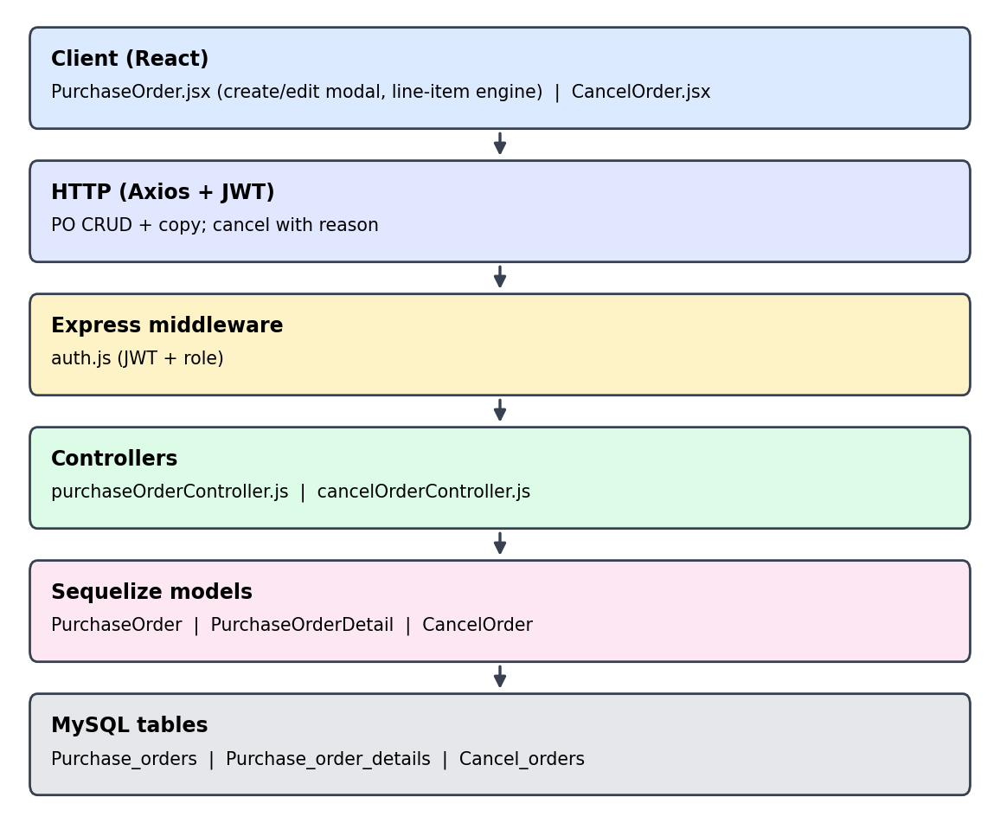
Fig 8.4.A Low-level architecture – PURCHASE ORDER (PO) MANAGEMENT
Request flow:
- PurchaseOrder.jsx opens the create modal; the next PO number and the party list are fetched.
- The user picks a party (address and place are filled in) and adds item lines; the page calculates each line and the summary.
- Save sends the header and all lines in one request; purchaseOrderController recomputes the totals and writes Purchase_orders and Purchase_order_details in a single transaction.
- Later stages (gate inward, receipt) read this PO by OrderNo and move its status forward.
- Cancel: cancelOrderController checks that no gate inward exists for the order, stores the reason in Cancel_orders and marks the PO cancelled.

8.4.6 API Design
All endpoints below are protected by the JWT middleware (auth.js) unless marked public. Paths are representative REST routes derived from the controller methods in the class diagram (Chapter 4).
Method | Endpoint | Purpose / contract
GET | /api/purchase-orders | List with search, party, status, sort and paging; returns header, item count and grand total.
GET | /api/purchase-orders/:id | One PO with its lines (getPurchaseOrderById).
GET | /api/purchase-orders/suppliers | Supplier look-up by name for the party dropdown.
GET | /api/purchase-orders/items | Item look-up for the line editor.
POST | /api/purchase-orders | Create PO: header + lines[]; server computes totals; returns OrderNo.
PUT | /api/purchase-orders/:id | Update header and replace lines.
DELETE | /api/purchase-orders/:id | Delete a PO.
POST | /api/cancel-orders | Body: OrderNo, CancelDate, Reason (mandatory). Rejected if the PO already has a gate inward.

8.4.7 DB Design
Table | Keys & indexes | Key columns
Purchase_orders | PK OrderNo bigint  MUL PartyCode → Supplier | OrderDate, Address, Place, Remarks, RefNo, Total, Discount, GST, IGST, VAT_CST, P_F, LorryFreight, RoundOff, GrandTotal, Status (default Draft)
Purchase_order_details | PK DetailId (auto)  MUL OrderNo | ItemCode, Qty, UnitRate (15,6), DiscountPct / DiscountAmt, GSTType, SGST / CGST / IGST %, amounts, PF_Amount, LorryFreight, MRS_No, GrandTotal
Cancel_orders | PK CancelNo (auto) | OrderNo, PartyName, CancelDate, Reason, Status (default Active)
- Relationships: one Supplier has many POs; one PO has many detail lines; a PO may have one cancellation record.
- Existing indexes on PartyCode and OrderNo serve the party filter and the line look-up. Recommended additions: an index on Purchase_orders(Status, OrderDate) for the status filter and the dashboard counts.

8.4.8 Screenshots
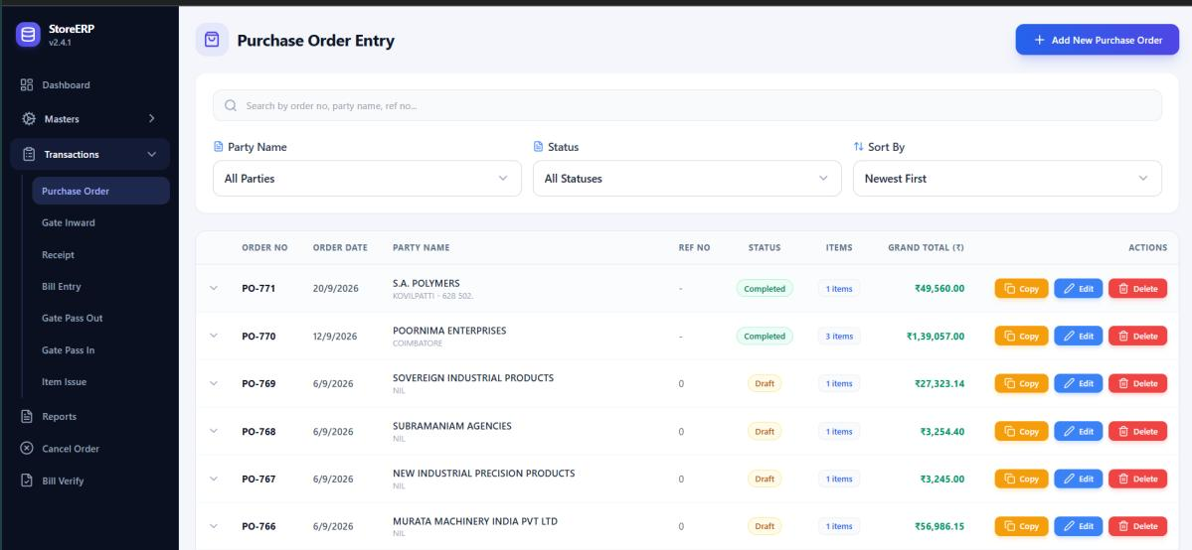
fig 8.4.1 Purchase order list
Purchase orders are displayed with supplier details, status, item count, and total value, together with copy, edit, and delete controls. The register combines order identifiers and dates with party names, reference numbers, status labels, and totals. Search and filter controls help users locate a purchase order, while the item count provides access to its detailed contents.
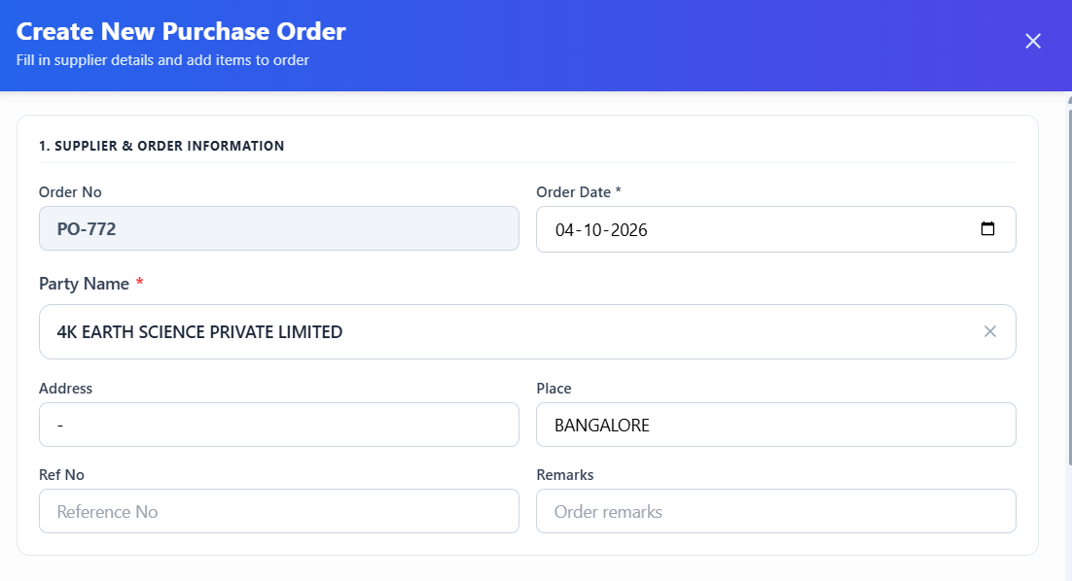
fig 8.4.2 Creating a purchase order
The order form captures the order date, supplier, and item information before the purchase order is saved. The form separates supplier and order information from the item entry and order summary areas. Users can add the required materials and review the assembled order before selecting the save control.
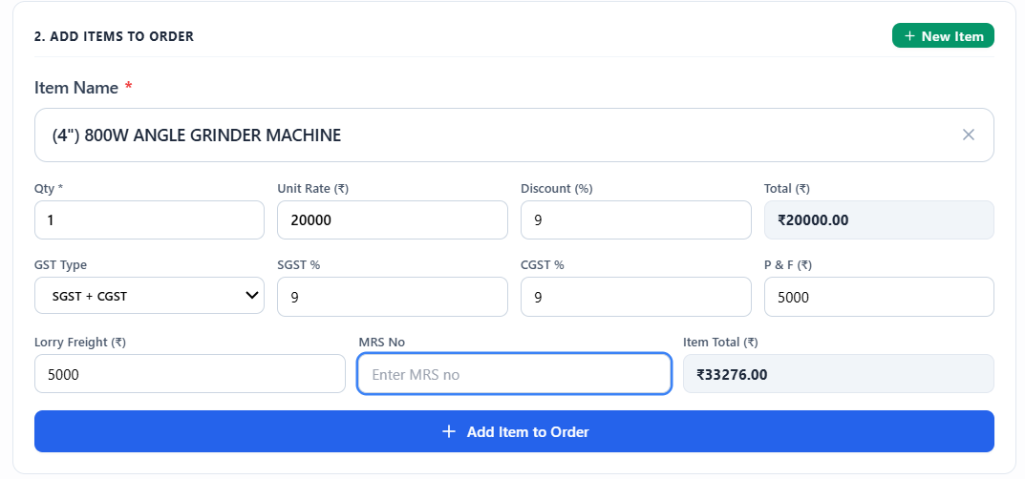
fig 8.4.3 Purchase order item calculation
The item entry area records quantity, unit rate, discount, tax, and additional charges and shows the calculated item total. The visible example includes a selected item, quantity, unit rate, GST fields, packing and forwarding, and freight charges. The calculated total gives users a way to review the financial effect of these entries before adding the line to the order.
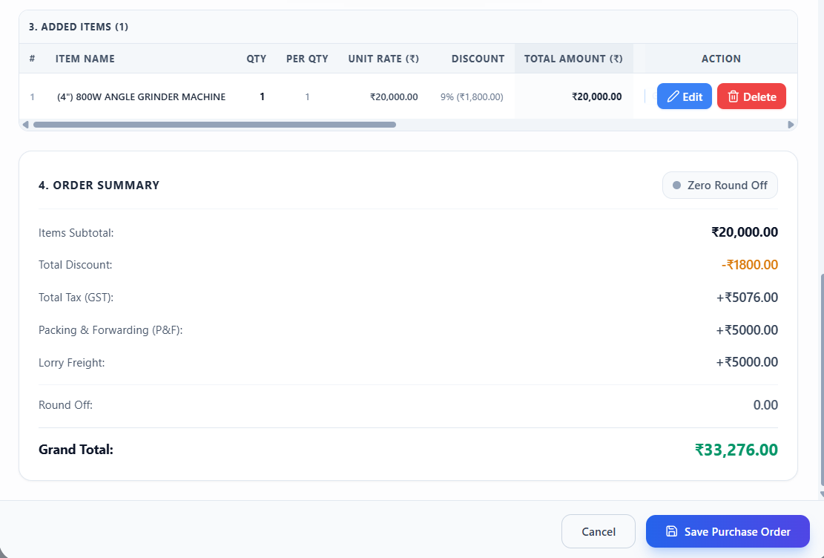
fig 8.4.4 Purchase order financial summary
The order summary displays the added items and a breakdown of charges and taxes leading to the grand total. The added items appear above a summary of the basic amount, discount, taxes, and additional charges. Reviewing this breakdown helps users check that the final order value reflects the intended quantities and commercial terms.
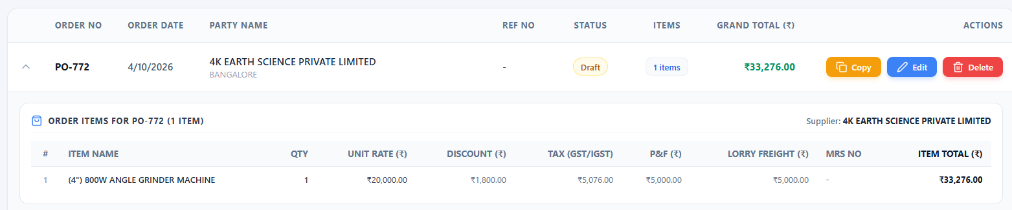
fig 8.4.5 Expanded purchase order details
Expanding an order reveals its line items, quantities, unit rates, discounts, taxes, and item totals. The expanded row keeps the purchase order header visible while showing the underlying material details. This allows the user to compare the order total with its individual quantities, rates, and charges without opening the edit form.

8.5 GOODS INWARD & INVENTORY RECEIPT (GRN)

8.5.0 Purpose & Scope
Manages the physical arrival of materials. Combines gate consignment logging with formal Goods Receipt Note (GRN) stock induction.

8.5.1 Functional Requirements
What the module must do:
- Gate Inward: log an arrival with an automatic inward number (for example GI-771), inward date, party, the purchase order being delivered, and the supplier’s invoice number and date.
- Record received quantity against pending quantity for each PO line; one PO can have several inward batches (partial deliveries).
- Duplicate invoice check: warn when the same supplier invoice is entered twice.
- Receipt (GRN): select party and PO, pick the gate-inward batches covered, add invoice, DC number and dates, confirm received items with rate, and enter discount, GST, P&F, lorry freight and round off to get the grand total.
- Receiving goods updates the stock balance of the received items and advances the PO status to Inward Created / Completed.
- Registers with search, party filter and sort; expand a GRN to trace it back to its gate inward and PO; edit and delete (the delete removes the linked chain consistently).

8.5.2 Non-Functional Requirements
How well the module must do it (the system-wide baseline in the chapter introduction also applies):
- Traceability: PO → Gate Inward → GRN is linked by OrderNo and GateInwardNo, so any stock line can be traced to the order that created it.
- Integrity: received quantity cannot exceed what is still pending on the PO line; the same invoice cannot be booked twice.
- Atomic chain operations: creating a GRN (header, lines, stock update, status change) and deleting a chain run in one transaction.
- Responsiveness: the dependent dropdowns (party → open POs → PO items) answer in under 500 ms.
- Auditability: createdAt / updatedAt on every row; status values (Draft, InwardCreated) show progress.
- CAP: consistency first – stock must never be counted twice or lost if two users receive against the same PO.

8.5.3 Tech Stack
Concern | Choice | Why it fits this module
Dependent dropdowns | React + SearchSelect | Selecting a party filters the PO list; selecting a PO loads its pending items
Numbering | Server-side last-number look-up (getLastInwardNo, getLastGRNNo) | Sequential GI and GRN numbers shown in the form
Transactions | Sequelize transaction | Receipt, stock update and status change succeed or fail together
Quantities | DECIMAL(10,2) | Handles fractional quantities such as kilograms or litres

8.5.4 Back-of-the-Envelope Estimation
Figures marked “live” come from the running system; the rest are working assumptions used to size the design.
Quantity | Estimate | Basis
Receipts to date | 770 (GRN-260771 latest) | Live
Gate inwards per year | ≈ 5,400 | 4,500 POs × 1.2 batches (assume 20 % are delivered in two parts)
Receipts per year | ≈ 4,500 | About one GRN per PO
Storage | Gate inward ≈ 7 MB / yr; receipts ≈ 12 MB / yr | 5,400 × 1.3 KB; 4,500 × 2.7 KB
Dependent look-ups | 3 calls per entry | Party → POs → items
Register page | ≈ 15 KB | 10 rows with amounts

8.5.5 Low-Level Architecture
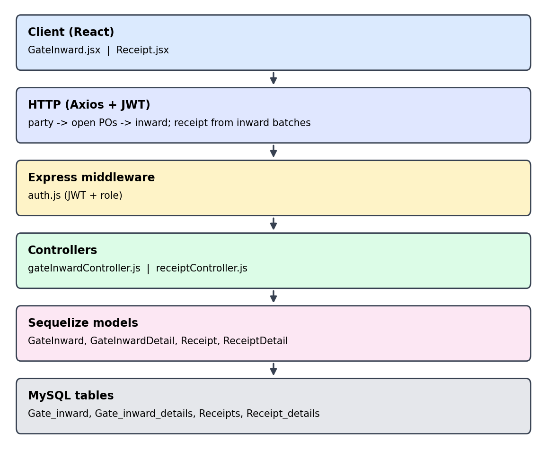
Fig 8.5.A Low-level architecture – GOODS INWARD & INVENTORY RECEIPT (GRN)
Request flow:
- GateInward.jsx: the user chooses a party; gateInwardController returns that party’s open POs (getPurchaseOrdersByParty) and, after a PO is chosen, its items with pending quantity (getItemsByOrder).
- Save writes Gate_inward and Gate_inward_details; the duplicate-invoice check runs first.
- Receipt.jsx: the user chooses a party and PO; receiptController lists the available gate-inward batches and their items (getAvailableGateInwards, getGateInwardItems).
- Save writes Receipts and Receipt_details, updates stock, and moves the PO status forward in the same transaction.
- Bill Entry (next module) later reads the GRN by GRNNo.

8.5.6 API Design
All endpoints below are protected by the JWT middleware (auth.js) unless marked public. Paths are representative REST routes derived from the controller methods in the class diagram (Chapter 4).
Method | Endpoint | Purpose / contract
GET | /api/gate-inwards | List with search, party filter, sort, paging.
GET | /api/gate-inwards/last-no | Next inward number (getLastInwardNo).
GET | /api/gate-inwards/purchase-orders/:partyCode | Open POs of a party (getPurchaseOrdersByParty).
GET | /api/gate-inwards/items/:orderNo | PO lines with pending quantity (getItemsByOrder).
GET | /api/gate-inwards/check-invoice | Duplicate invoice check (checkDuplicateInvoice).
POST / PUT | /api/gate-inwards[/:id] | Create or update an inward with its detail lines.
DELETE | /api/gate-inwards/:id | Delete the inward chain (deleteGateInwardChain).
GET | /api/receipts | List GRNs with party filter, sort, paging.
GET | /api/receipts/last-grn-no | Next GRN number (getLastGRNNo).
GET | /api/receipts/available-gate-inwards | Gate-inward batches not yet received (getAvailableGateInwards).
POST / PUT | /api/receipts[/:id] | Create or update a GRN: header, lines, financial summary.
DELETE | /api/receipts/:id | Delete a GRN.

8.5.7 DB Design
Table | Keys & indexes | Key columns
Gate_inward | PK InwardNo (auto) | OrderNo, PartyCode, InwardDate, InvoiceNo, InvoiceDate, Status (default Draft)
Gate_inward_details | PK DetailId (auto)  MUL InwardNo | OrderNo, ItemCode, PendingQty, ReceivedQty
Receipts | PK GRNNo (auto) | PartyCode, GateInwardNo, InwardDate, InvoiceNo / Date, DCNo / DCDate, FormType, BillAmount, Total, Discount, GST, IGST, VAT_CST, P_F, LorryFreight, RoundOff, GrandTotal, Status
Receipt_details | PK DetailId (auto)  MUL GRNNo | OrderNo, ItemCode, Qty, UnitRate (15,6), TotalAmount
- Recommended additions: indexes on Gate_inward(OrderNo) and Receipts(PartyCode, InwardDate) to speed the dependent dropdowns and the register filter.

8.5.8 Screenshots
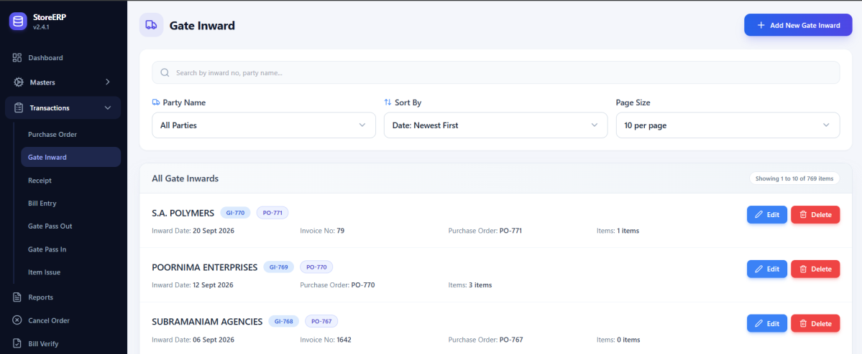
fig 8.5.1 Gate inward list
The gate inward register displays incoming consignments and provides search, supplier filtering, and record maintenance controls. The list places supplier names and inward identifiers beside record actions, while the controls above support searching and sorting. This register helps users locate a recorded material arrival for review or further processing.
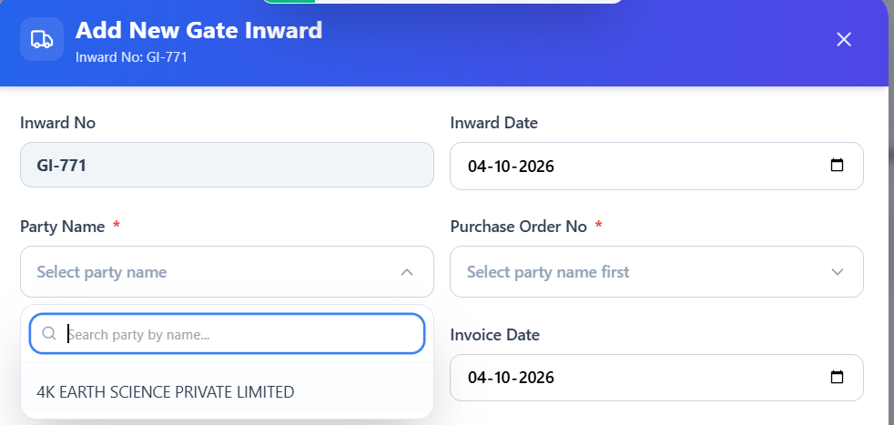
fig 8.5.2 Selecting a supplier for gate inward
The supplier dropdown identifies the party delivering materials before a purchase order is selected. The entry dialog shows the inward number and date together with a searchable party selector. Choosing the supplier establishes the context for the purchase order and invoice fields that follow in the inward entry workflow.
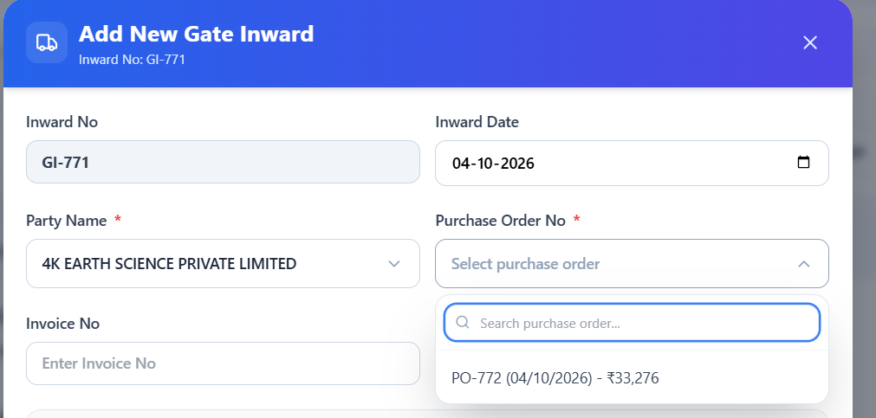
fig 8.5.3 Linking gate inward to a purchase order
The purchase order dropdown links the inward record to an order for the selected supplier. The screenshot shows a purchase order option for the selected party, including its order date and value. Linking the arrival to that order provides a reference for checking the incoming materials against the procurement record.
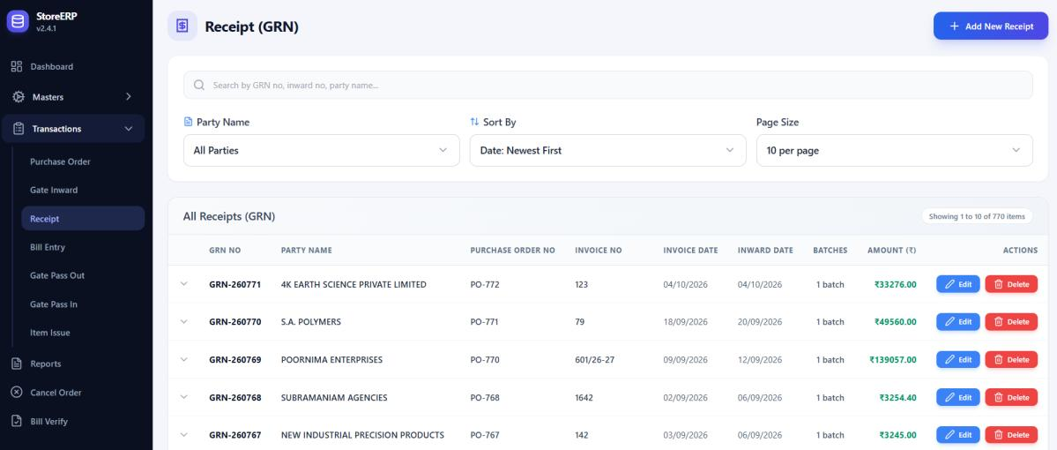
fig 8.5.4 Goods receipt register
The receipt list displays goods receipt records with supplier, purchase order, invoice, inward, and amount information. The register brings receipt dates and identifiers together with related purchase order and invoice references. Users can filter the list by party, review receipt amounts, and open the available actions for an existing goods receipt.
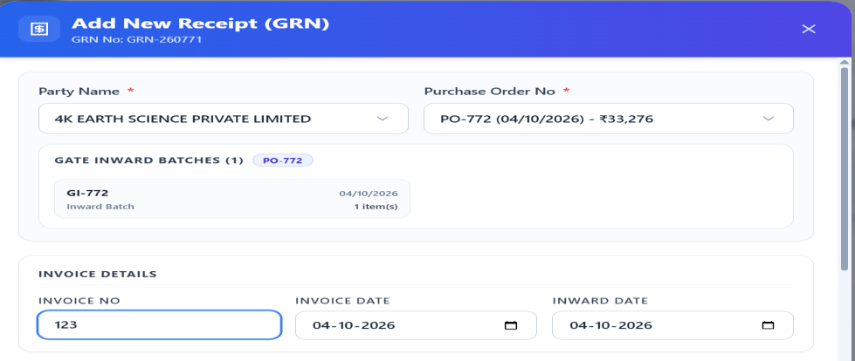
fig 8.5.5 Creating a goods receipt
The receipt form links a supplier and purchase order, captures invoice information, and allows received items to be added. The form includes the selected supplier and purchase order, invoice details, and an area for adding received materials. These entries connect the receipt to the purchasing workflow and record the item quantities and values being received.
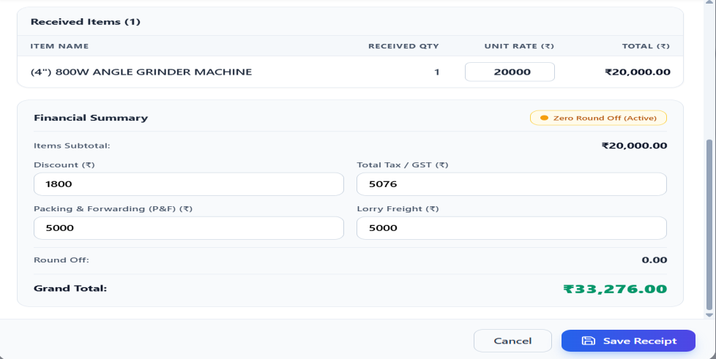
fig 8.5.6 Goods receipt financial summary
The receipt summary displays received item values, discount, tax, and transport charges before the receipt is saved. The received item list appears above the financial summary, allowing its quantity and rate to be checked against the calculated amount. The user can review the total and additional charges before selecting Save Receipt.
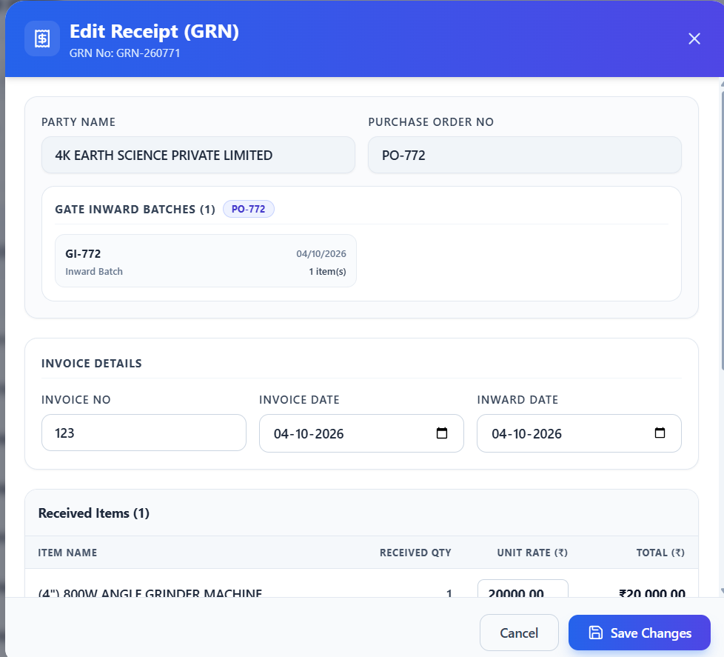
fig 8.5.7 Editing a goods receipt
An existing receipt can be opened to review or update its invoice, item, and financial details and save the changes. The edit dialog retains the receipt references while presenting the item and financial fields for modification. The save changes control allows corrections to be recorded after the user reviews the revised details.
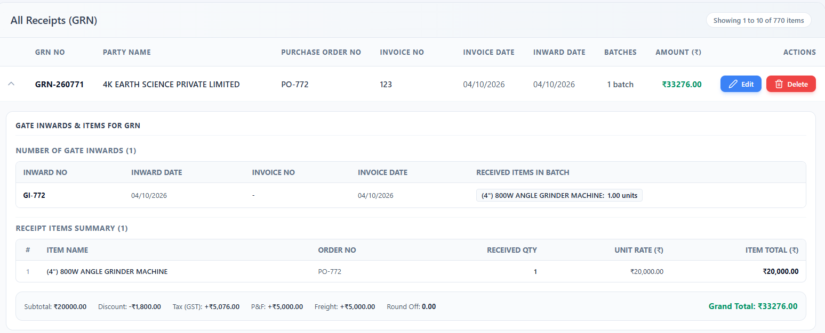
fig 8.5.8 Expanded goods receipt details
The expanded receipt shows linked gate inward information and the received item quantities, rates, taxes, and totals. The expanded view separates the gate inward details from the receipt item summary. It lets users trace the received material to its inward record and inspect the quantity, unit rate, tax, and total associated with the receipt.

8.6 BILL ENTRY

8.6.0 Purpose & Scope
Handles financial booking of supplier invoices against physically received goods, and records the verification of each booked bill before payment.

8.6.1 Functional Requirements
What the module must do:
- Book a supplier invoice against a received GRN: pick the party, then the linked gate inward / GRN; the voucher number (for example VCH-769) is generated automatically.
- Capture party bill number, bill date, accounting date and purchase type; the narration is pre-filled (“Being Supply of … as per Bill no …”).
- Show billed items (item, PO, quantity, rate, amount) taken from the GRN, with a financial breakdown: subtotal, discount, GST, IGST, VAT / CST, P&F, lorry freight, round off, TDS / TCS and grand total (bill amount).
- Support both intra-state (CGST + SGST) and inter-state (IGST) tax amounts.
- Three-way traceability: PO, GRN and bill are linked, so the ordered rate, the received quantity and the billed amount can be compared.
- Duplicate bill check, edit, delete (with the linked chain) and print of the voucher.
- Bill Verify: record the verification date, payment status and remarks for each booked bill.

8.6.2 Non-Functional Requirements
How well the module must do it (the system-wide baseline in the chapter introduction also applies):
- No double billing: the schema enforces one bill per GRN and per gate inward through unique keys.
- Financial accuracy: all amounts are DECIMAL(15,2); the grand total is recomputed on the server.
- Atomicity: bill header, billed lines and the chain delete run in one transaction.
- Auditability: accounting date, voucher number, verification date and remarks are stored for each bill.
- Print performance: a voucher renders in under 1 second.
- CAP: consistency first – the accounts team must always see the same bill amount as the store.

8.6.3 Tech Stack
Concern | Choice | Why it fits this module
Source of truth | GRN lines copied into Bill_entry_details | The bill is built from received goods, not retyped
Uniqueness | UNIQUE keys on GateInwardNo and GRNNo | Database-level guard against double billing
Tax fields | GST, IGST, VAT_CST, TDS, TCS columns | Covers the tax forms used by the purchase types
Print | getPrintData endpoint + print view | Voucher printout straight from the register

8.6.4 Back-of-the-Envelope Estimation
Figures marked “live” come from the running system; the rest are working assumptions used to size the design.
Quantity | Estimate | Basis
Bills to date | 768 (VCH-769 latest) | Live
Bills per year | ≈ 4,500 | About one bill per GRN
Storage per bill | ≈ 3 KB | 1.5 KB header + 3 lines × 0.5 KB
Storage per year | ≈ 14 MB | 4,500 × 3 KB
Available-GRN query | a few hundred rows | Only GRNs not yet billed for the chosen party
Request rate | < 1 req/s | Back-office entry work

8.6.5 Low-Level Architecture
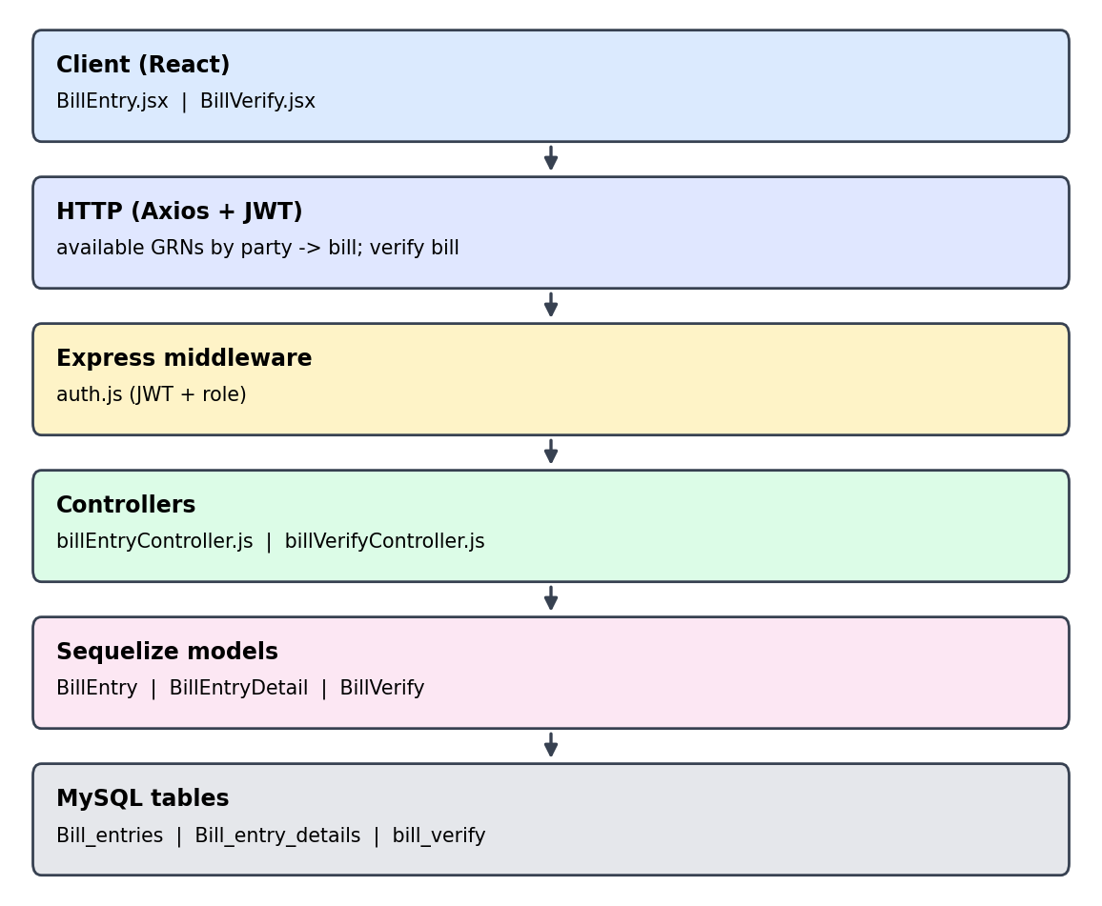
Fig 8.6.A Low-level architecture – BILL ENTRY
Request flow:
- BillEntry.jsx asks billEntryController for parties that still have unbilled goods (getAvailableParties).
- After the party is chosen, available gate inwards and GRNs are listed; selecting one loads its items (getGRNDetails).
- The user completes the bill details; save writes Bill_entries and Bill_entry_details in one transaction. The unique keys reject a second bill for the same GRN.
- BillVerify.jsx lists bills by party (getBillsByParty) and stores the verification record in bill_verify.
- Print uses getPrintData to render the voucher.

8.6.6 API Design
All endpoints below are protected by the JWT middleware (auth.js) unless marked public. Paths are representative REST routes derived from the controller methods in the class diagram (Chapter 4).
Method | Endpoint | Purpose / contract
GET | /api/bill-entries | Register with party filter, sort and paging.
GET | /api/bill-entries/last-voucher-no | Next voucher number (getLastVoucherNo).
GET | /api/bill-entries/available-parties | Parties with unbilled GRNs (getAvailableParties).
GET | /api/bill-entries/available-grns | Unbilled GRNs and gate inwards (getAvailableGRNs, getAvailableGateInwards).
GET | /api/bill-entries/grn/:grnNo | GRN lines for billing (getGRNDetails).
GET | /api/bill-entries/check-duplicate | Duplicate bill check (checkDuplicateBillEntry).
POST / PUT | /api/bill-entries[/:id] | Create or update a bill: header + billed lines + financial breakdown.
GET | /api/bill-entries/:id/print | Voucher print data (getPrintData).
DELETE | /api/bill-entries/:id | Delete the bill chain (deleteBillChain).
GET / POST / PUT / DELETE | /api/bill-verify | List, create, update and delete verification records; party-names and bills-by-party look-ups.

8.6.7 DB Design
Table | Keys & indexes | Key columns
Bill_entries | PK VoucherNo (auto)  UNIQUE GateInwardNo  UNIQUE GRNNo | OrderNo, PartyCode, AccDate, PartyBillNo, BillDate, PurchaseType, BillAmount, TDS, Narration, Total, Discount, GST, IGST, VAT_CST, P_F, LorryFreight, RoundOff, TaxRndOff, GrandTotal, TCS, Status
Bill_entry_details | PK DetailId (auto)  MUL VoucherNo | OrderNo, ItemCode, Qty, UnitRate, TotalAmount
bill_verify | PK VerifyNo  FK VoucherNo → Bill_entries | BillNo, BillDate, PartyName, BillAmount, GSTAmount, IGSTAmount, VerifyDate, PaymentStatus, Remarks
- Relationship: one GRN is billed by exactly one bill entry, and one bill entry is verified by one verification record.
- The bill_verify table is shown in the class diagram and ER diagram; its column list is not part of the Chapter 5 table screenshots.

8.6.8 Screenshots
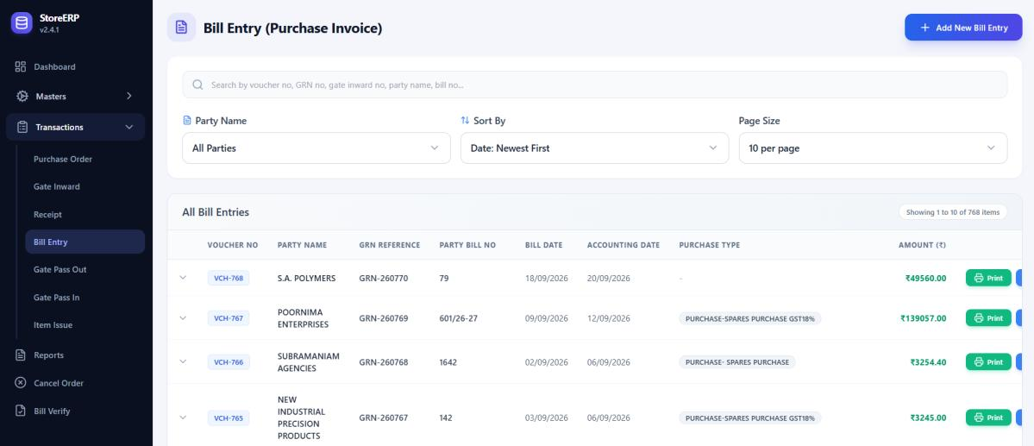
fig 8.6.1 Bill entry register
The bill register displays supplier invoice records, accounting dates, purchase types, and amounts, with print and maintenance controls. The table presents invoice numbers, party names, bill and accounting dates, purchase types, and amounts. Search and party filters help users locate an invoice, and the available actions support reviewing or maintaining a bill record.
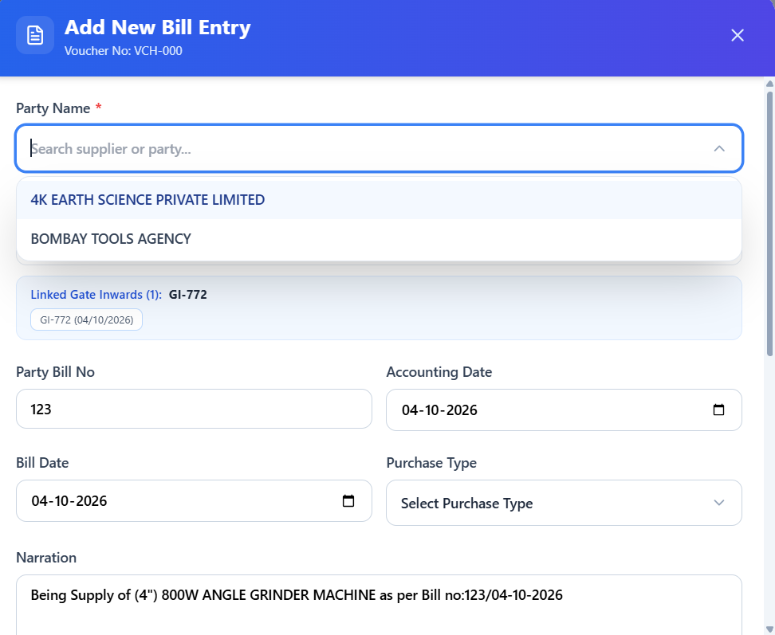
fig 8.6.2 Creating a supplier bill entry
The bill form selects a supplier and receipt and captures invoice, accounting date, and purchase type details. The searchable party selector helps identify the vendor whose receipt will be billed. The remaining visible fields capture invoice and accounting information so the bill can be recorded with the appropriate transaction references.
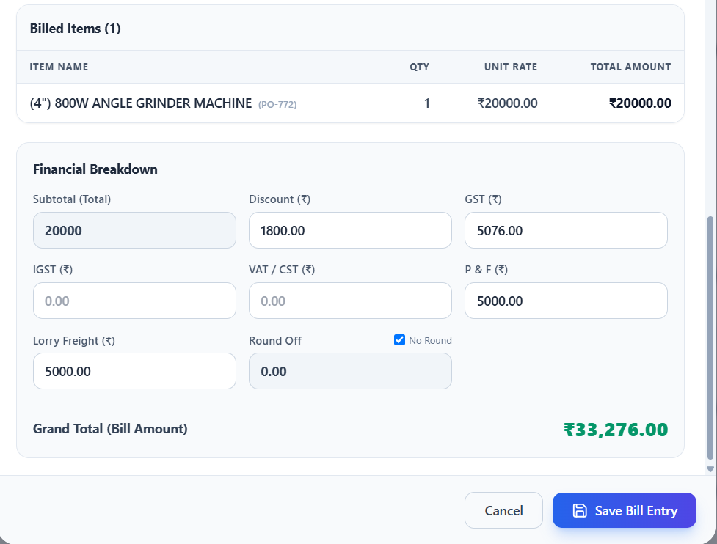
fig 8.6.3 Bill entry financial breakdown
The billing area shows item values and fields for discount, tax, freight, and other charges, along with the grand total. The item table is followed by a financial section containing discount, GST, packing and forwarding, freight, and round off fields. The displayed grand total provides a final value to check before the user saves the bill entry.
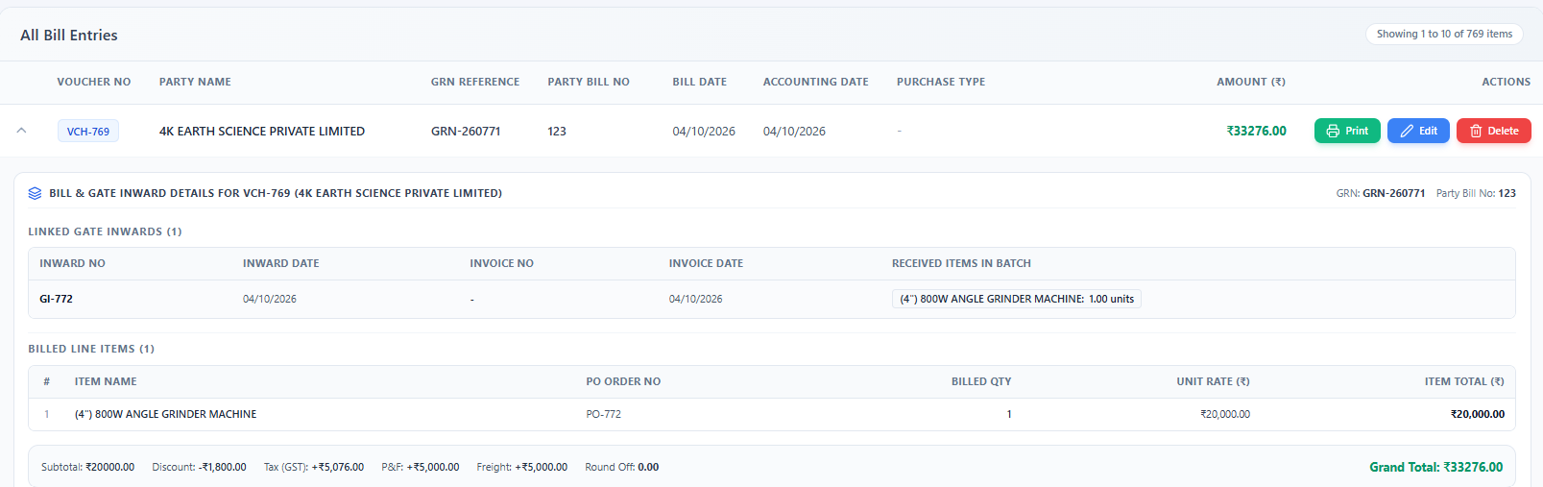
fig 8.6.4 Expanded bill entry details
Expanding a bill reveals the linked inward records and billed line items for reviewing quantities, rates, and totals. The expanded row shows the supporting inward details and a separate table of billed items. This gives users a convenient view of the references, quantities, unit rates, and item totals supporting the invoice amount.

8.7 MATERIAL REQUISITION & GATE PASS MOVEMENT

8.7.0 Purpose & Scope
Controls internal inventory consumption by departments and regulates the physical outbound / inbound movement of tools, machinery, and non-inventory goods through the gate.

8.7.1 Functional Requirements
What the module must do:
- Item Issue: create an issue voucher (for example ISS-0004) with date, department, indent number, approver / issued-by and remarks.
- Show the department’s items with available stock and a status badge (In stock, Low stock, Out of stock); the user enters an issue quantity that must not exceed the stock.
- Filter the item list, see the count of selected items and total units, then confirm & save; the stock balance is reduced by the issued quantity.
- Edit or delete an existing issue; list issues by department.
- Gate Pass Out / In: record tools, machinery and non-inventory goods leaving or re-entering the premises with party, items and quantities.
- Returnable (RGP) and non-returnable (NRGP) passes, and return reconciliation of items coming back against open passes.

8.7.2 Non-Functional Requirements
How well the module must do it (the system-wide baseline in the chapter introduction also applies):
- Stock integrity: stock must never go negative – the quantity is validated on the server inside a transaction that locks the item rows being issued.
- Concurrency: two storekeepers issuing the same item at the same moment are serialized by the row lock, so the second sees the reduced balance.
- Usability: a department can have hundreds of items; the list is filterable and shows the remaining stock as the user types.
- Accountability: each issue stores the department, indent number, approver and employee name for every line.
- CAP: consistency first – an out-of-date stock figure would allow over-issue, so correctness outranks availability.

8.7.3 Tech Stack
Concern | Choice | Why it fits this module
Stock check | Server-side validation + Sequelize transaction | Prevents over-issue and negative stock
Item list | React table with live filter and remaining-stock indicator | Fast data entry for large catalogs
Numbering | getLastIssueNo | Sequential voucher numbers
Gate pass | GatePassOut / GatePassIn models with detail tables | Separate outward and inward movement records

8.7.4 Back-of-the-Envelope Estimation
Figures marked “live” come from the running system; the rest are working assumptions used to size the design.
Quantity | Estimate | Basis
Issues per day | ≈ 30 | Assumption (store with 31 departments)
Issues per year | 30 × 300 = 9,000 | Derived
Lines per issue | ≈ 4 | Assumption
Storage | ≈ 2.1 KB per issue → ≈ 19 MB / yr | 0.5 KB header + 4 lines × 0.4 KB
Items per department | 11,011 ÷ 31 ≈ 355 | Live counts
Department item list | ≈ 53 KB | 355 rows × ≈ 150 bytes – small enough to load at once
Gate passes | ≈ 5 / day → ≈ 2 MB / yr | Assumption (1,500 × 1.5 KB)

8.7.5 Low-Level Architecture
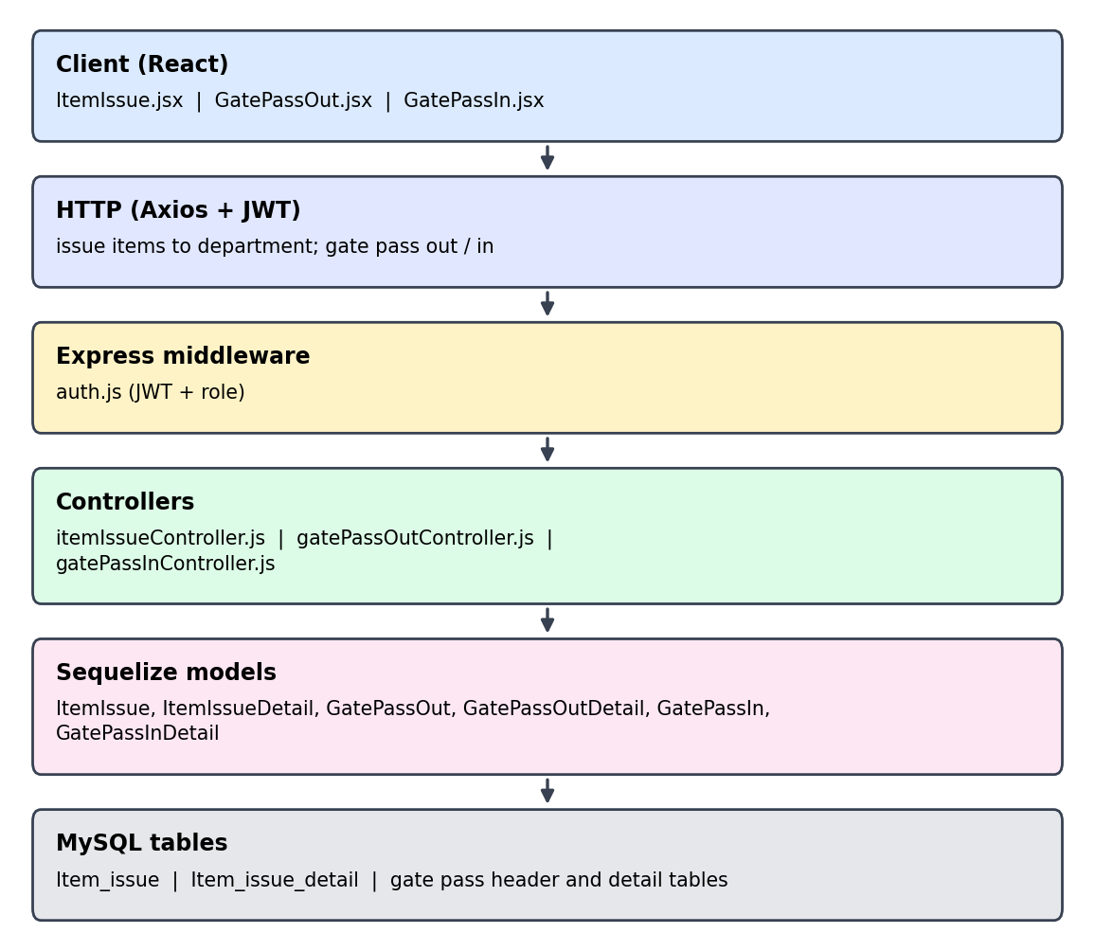
Fig 8.7.A Low-level architecture – MATERIAL REQUISITION & GATE PASS MOVEMENT
Request flow:
- ItemIssue.jsx loads departments and, when one is chosen, its items with current stock (getItemsByDepartment).
- The user enters issue quantities; the page flags any quantity above the available stock.
- Save sends header and lines; itemIssueController re-checks stock inside a transaction, writes Item_issue and Item_issue_detail, and reduces the item balance.
- GatePassOut.jsx / GatePassIn.jsx record movement; a returning item is matched against its open outward pass.

8.7.6 API Design
All endpoints below are protected by the JWT middleware (auth.js) unless marked public. Paths are representative REST routes derived from the controller methods in the class diagram (Chapter 4).
Method | Endpoint | Purpose / contract
GET | /api/item-issues | List issues with filters and paging.
GET | /api/item-issues/last-no | Next issue number (getLastIssueNo).
GET | /api/item-issues/departments | Department list for the form.
GET | /api/item-issues/items/:department | Items of a department with available stock.
POST | /api/item-issues | Create issue: header + lines[]; rejects any line above stock.
PUT / DELETE | /api/item-issues/:id | Update or delete an issue.
GET / POST / PUT / DELETE | /api/gate-pass-out, /api/gate-pass-in | List, create, update and delete outward and inward gate passes.

8.7.7 DB Design
Table | Keys & indexes | Key columns
Item_issue | PK IssueNo (auto) | IssueDate, IndentNo, Department, Approval, Remarks, Status (default Draft)
Item_issue_detail | PK DetailId (auto)  MUL IssueNo | ItemName, CatNo, DrawNo, Qty, UOM, EmpName, OpeningQty
Gate pass tables | GatePassOut, GatePassOutDetail, GatePassIn, GatePassInDetail | Header and detail pair for outward and inward movement
- The four gate pass models exist in the backend (Fig 8.1.6); their column definitions are not included in the Chapter 5 table screenshots.
- Recommended addition: an index on Item_issue(Department, IssueDate) for the department-wise issue report.

8.7.8 Screenshots
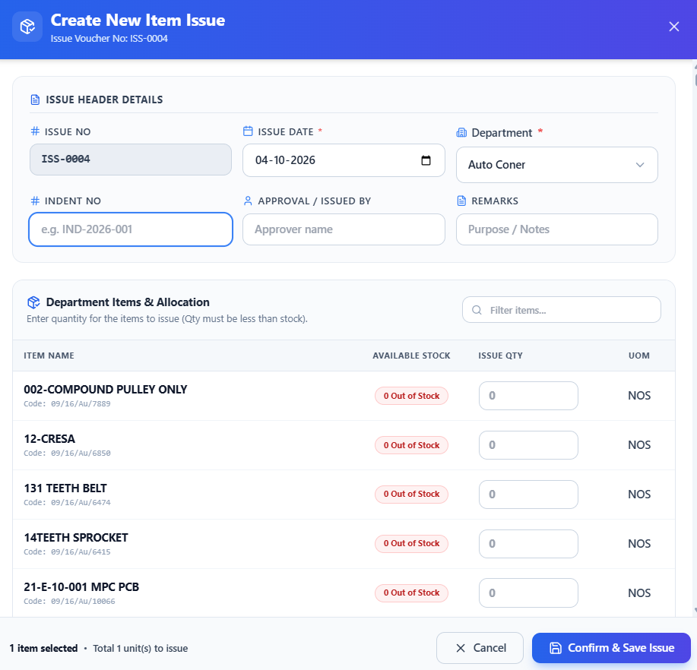
fig 8.7.1 Creating a gate pass outward
The outward gate pass form records pass details and destination information and allows items and quantities to be selected for movement. The upper form records the outward movement information, while the item selection area lists available materials and quantity fields. Users can assemble the materials for the pass and check the selected quantities before submitting the outward record.
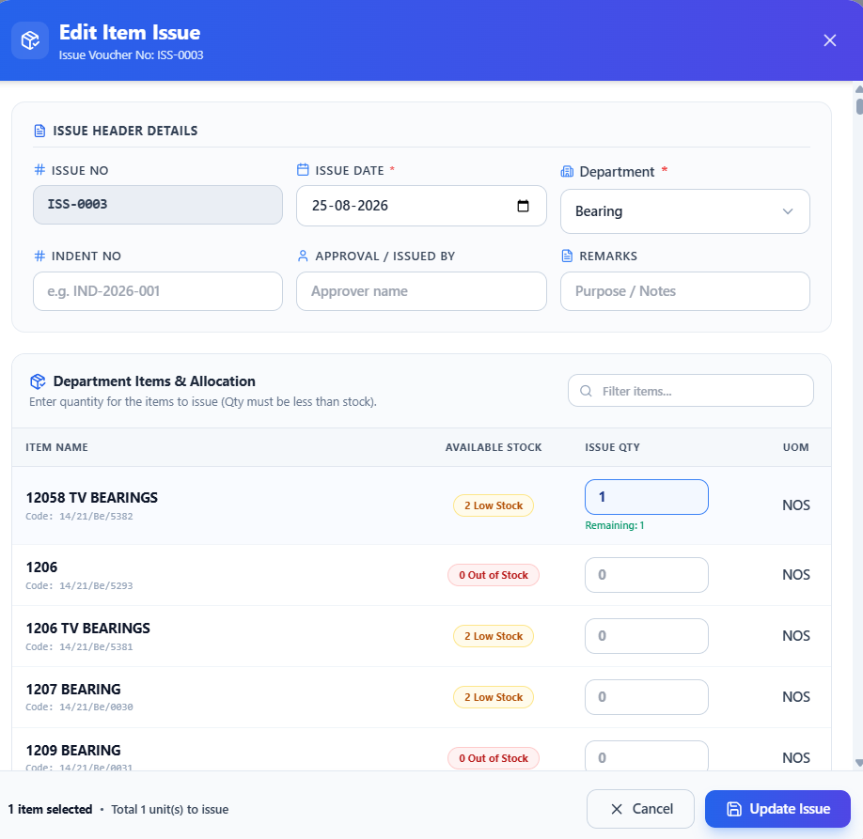
fig 8.7.2 Editing a gate pass outward
The edit form lets the user revise an existing outward gate pass, including its movement details and item quantities. The existing pass is reopened with its information and item selection controls visible. Users can review the recorded movement, adjust the relevant fields or quantities, and use the update control to retain the changes.

8.8 EXECUTIVE DASHBOARD & BUSINESS ANALYTICS

8.8.0 Purpose & Scope
Provides operational transparency and business intelligence through live KPI monitoring and multi-criteria transactional report generation with spreadsheet and document exports.

8.8.1 Functional Requirements
What the module must do:
- Dashboard KPI cards: active purchase orders, items in stock, gate passes outward and pending verifications, with a manual refresh.
- Monthly transactions chart (POs, gate-in, gate-out), a status overview and the recent gate inward log.
- Low-stock alerts: flag items whose stock has fallen to or below the configured minimum (OpeningQty ≤ MinStockLevel).
- Reports & Registers in six categories – Purchase, Billing, Receipt, Stock, Issue and Others – each with a named report (for example Department Wise Order Details, Date wise receipt register).
- Filters: from / to date, report name, department (multi-select), party and item; preview on screen, then save.
- Export: formatted Excel (.xlsx) workbooks built with ExcelJS, and printable PDF documents.

8.8.2 Non-Functional Requirements
How well the module must do it (the system-wide baseline in the chapter introduction also applies):
- Read-only: the module never modifies transactional data, so it cannot corrupt stock or bills.
- Performance: a one-year report completes in under 3 seconds and the dashboard in under 2 seconds.
- Memory safety: large exports are streamed to the browser instead of being assembled fully in memory.
- Freshness: figures reflect committed data; the Refresh button re-queries on demand rather than polling.
- Scalability path: heavy reports can move to a MySQL read replica later without changing the API.
- CAP: consistency preferred – a report must match what the transaction screens show.

8.8.3 Tech Stack
Concern | Choice | Why it fits this module
Aggregation | Sequelize / SQL GROUP BY queries in dashboardController, reportController | Computes counts, monthly totals and department-wise sums in the database
Charts | React dashboard components | Monthly bar chart and status bars
Excel | ExcelJS (server-side) | Formatted, streamed .xlsx files
PDF | jsPDF | Vector printable documents
Filters | EntityFilterPanel, date inputs | One filter panel reused across report types

8.8.4 Back-of-the-Envelope Estimation
Figures marked “live” come from the running system; the rest are working assumptions used to size the design.
Quantity | Estimate | Basis
Dashboard load | ≈ 5–6 aggregate queries | KPIs, monthly series, recent log
Dashboard loads per day | ≈ 100 | 20 users × 5 loads → ≈ 600 queries / day
One-year purchase report | ≈ 13,500 rows | 4,500 POs × 3 lines
Result size | ≈ 2.7 MB in memory | 13,500 × ≈ 200 bytes
Stock report | 11,011 rows ≈ 2.2 MB | Live item count × ≈ 200 bytes
Excel file | ≈ 1 MB | Compressed .xlsx (assumption)

8.8.5 Low-Level Architecture
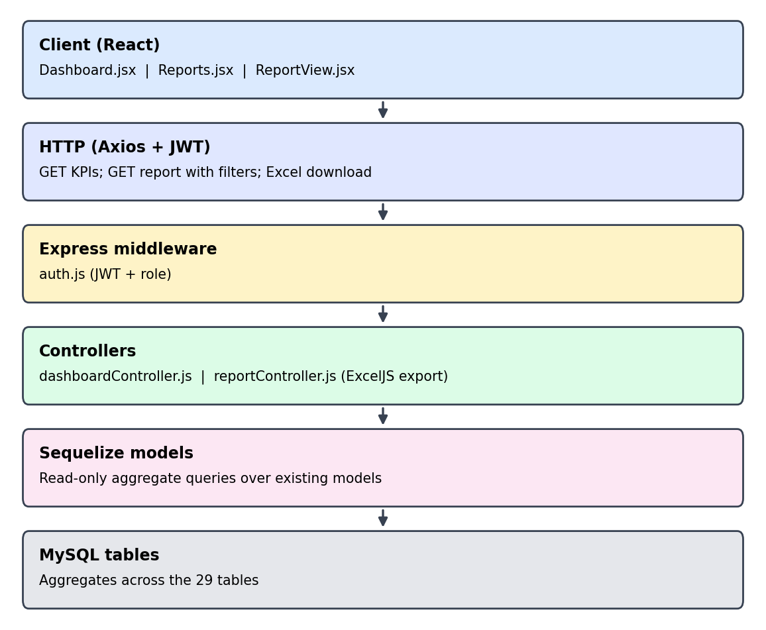
Fig 8.8.A Low-level architecture – EXECUTIVE DASHBOARD & BUSINESS ANALYTICS
Request flow:
- Dashboard.jsx calls the dashboard endpoints on load and on Refresh.
- Reports.jsx sends the chosen report name, date range and department / party filters.
- reportController builds one SQL query per report, joins header and detail tables, groups by department or date, and returns rows for the on-screen grid.
- Save Report asks the same controller to stream the rows into an ExcelJS workbook, which the browser downloads.

8.8.6 API Design
All endpoints below are protected by the JWT middleware (auth.js) unless marked public. Paths are representative REST routes derived from the controller methods in the class diagram (Chapter 4).
Method | Endpoint | Purpose / contract
GET | /api/dashboard/summary | KPI counters: active POs, items in stock, gate passes, pending verifications.
GET | /api/dashboard/monthly | Monthly counts of POs, gate-in and gate-out.
GET | /api/dashboard/recent-inwards | Latest gate inward entries.
GET | /api/reports/:name | Query: from, to, department[], party, item. Returns grid rows for preview.
GET | /api/reports/:name/export | Same filters; streams an .xlsx file.

8.8.7 DB Design
Table | Keys & indexes | Key columns
No new table | Read-only | Aggregated queries across the 29 tables via dashboardController.js and reportController.js
Tables read | Purchase_orders (+details), Gate_inward, Receipts (+details), Bill_entries, Item, Item_issue (+detail), gate pass tables | Date columns OrderDate, InwardDate, BillDate, IssueDate drive the report filters
- Recommended indexes for report speed as data grows: OrderDate, InwardDate, BillDate and IssueDate on their tables, and a computed check of Quantity against MinStockLevel for the low-stock alert.

8.8.8 Screenshots
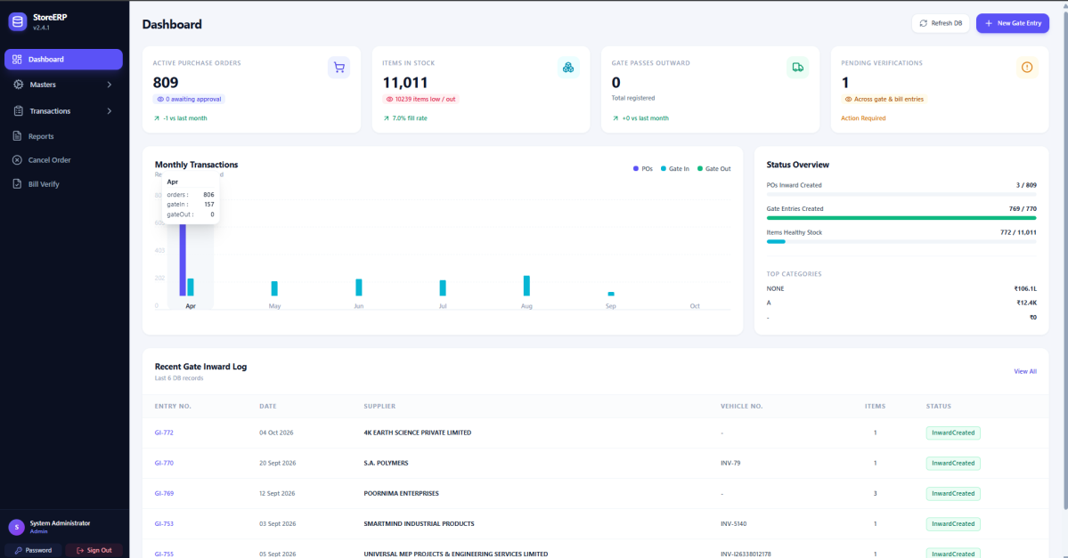
fig 8.8.1 Operational dashboard
The dashboard summarizes store activity through metric cards, monthly charts, and recent purchase order records. The screen combines summary cards with charts and lists of recent store activity. It provides a consolidated overview that helps users identify current workload and inspect recent procurement information before opening a detailed transaction screen.
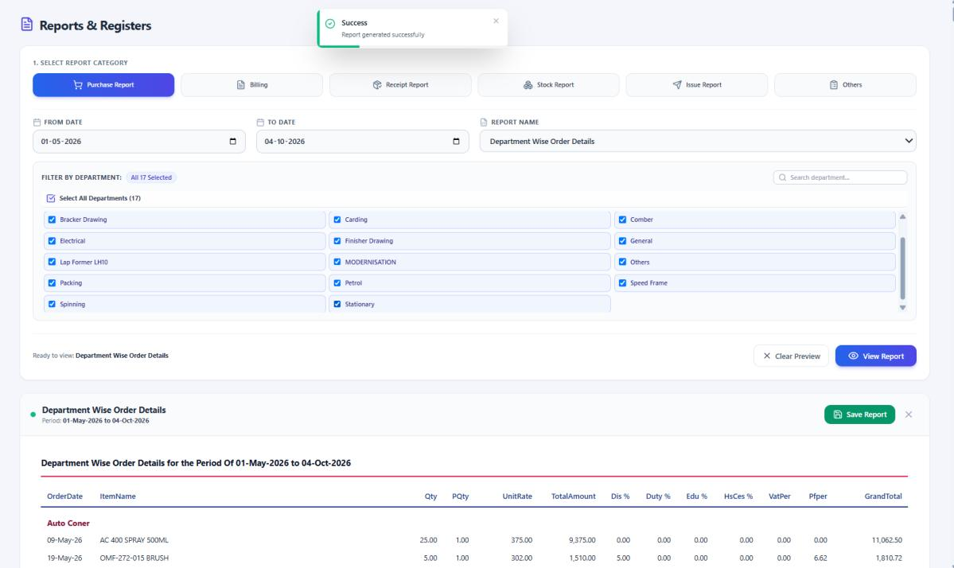
fig 8.8.2 Department wise issue report
The report screen uses filters and selectable columns to generate a department wise item issue report and offers an Excel export. The report setup area provides date and entity filters together with a list of columns that can be included in the output. The generated table underneath presents the selected issue information, and the export control makes the result available for spreadsheet review.
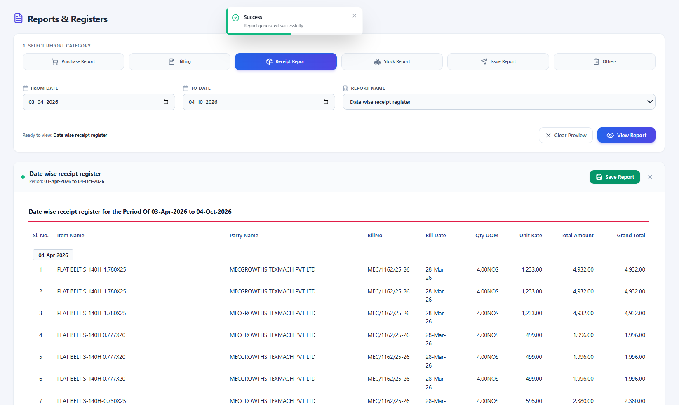
fig 8.8.3 Date wise order report
The reporting screen displays order records for the selected criteria, including supplier and value details, with an Excel export option. The screen places report criteria above a table containing order dates, supplier details, and monetary values. Users can review the generated records for the chosen period and export the result for further comparison or record keeping.
CHAPTER 9

CONCLUSION
The Store Management System provides a complete digital solution for managing the major activities involved in store and inventory operations. The system integrates master data management, purchase orders, gate inward entries, goods receipts, bill processing, item issues, gate passes, dashboards, and reports within a single application. By replacing manual records and disconnected processes, it improves the accuracy, consistency, and accessibility of operational information. The application was developed using React for the frontend, Node.js and Express for the backend, and MySQL with Sequelize for database management. Its client-server architecture supports structured communication between the user interface, application server, and database. JWT authentication, password hashing, role-based access control, request rate limiting, and protected routes help secure the system and prevent unauthorized access. The completed project demonstrates how a web-based information system can simplify store operations, reduce repetitive work, minimize recording errors, and improve decision-making. Its modular structure makes the application easier to maintain and allows additional features to be introduced in the future. Overall, the Store Management System successfully meets its objective of providing a secure, organized, and efficient platform for managing store activities at KR Exports.

