**DIPLOMA IN COMPUTER SCIENCE SCHOOL OF COMPUTING**

**Assessment: Assignment**

|  |  |
| --- | --- |
| **Course Code:** | **DCS3003** |
| **Course Name:** | **Website Design** |
| **Academic Session:** | **September 2023** |
| **Lecturer’s Name:** | **Ms Teo Choon Yeh** |

|  |  |
| --- | --- |
| **Release Date:** | **15th September 2023** |
| **Submission Due Date:** | **5th November 2023** |

**Weightage**

**)**

**%**

**(**

**:**

**Marks**

**Obtained**

**:**



**15**

# Student’s Declaration

I certify that this assignment is my own work, and appropriately acknowledged wherever material adapted from other sources. I understand that plagiarism, cheating, collusion, fraud, fabrication or falsifications of data are not acceptable. I agree that if at any time it is shown that I have significantly misrepresented material submitted to Crescendo International College, any marks or credits awarded to me on the basis of that material may be revoked.

|  |  |  |  |
| --- | --- | --- | --- |
| Student Name | FOO WEN JIE | Student  ID | DCS2309148 |
| Signature |  | Date |  |

# 

# Assignment Description

1. **Assignment Title:** Website Design – Assignment

1. **Course Learning Outcomes Covered**

CLO1 Explain website development practically based on design

requirements (C2, PLO2)

CLO2 Manipulate with guidance a functional website given design

specifications (P3, PLO3)

Build an interactive website to provide commercial solutions and

CLO3 meet organization requirements

(P3, PLO8)

1. **Assignment Background Information**

Students are able to acquire knowledge in XML (Extensible Markup Language) and are able to comprehend the significance of XML usage in HTML webpages.

1. **DETAILS OF ASSIGNMENT TASK**

## Assignment Brief

HTML and XML are related to each other, where HTML displays data and describes the structure of a webpage, whereas XML stores and transfers data. HTML is a simple predefined language, while XML is a standard language that defines other languages.

## Your task

1) Describe the importance of XML in HTML. (not less than 1000 words)

2) Create a HTML page for application of XML.

# Guidelines to students

1. In this assignment you will research and write an essay not less than 1000 words. You essay should reference books, academic conference and journal papers, and other reputable news sources in making its argument. You should cite where these are used in the text and include a reference list at the end of the essay.
   * Please refer **Harvard** citation

[(https://www.mendeley.com/guides/harvard-citation-guide)](https://www.mendeley.com/guides/harvard-citation-guide).

* + Note the reference list does **NOT** count towards the essay word count.

**NOTE**:

* + Explain all the obtain information in paragraphs.
  + Separate different point in different paragraphs.
  + Label the figures (if any).

1. **STRUCTURING AND FORMATTING YOUR SUBMISSION**

Your assignment must include, but not limited to the following: Assignment Cover Page

* + Assignment Brief (Student’s Declaration must be signed)
  + Table of Content (TOC)
  + Introduction
  + Contents **(Use appropriate title and subtitle)**
  + Conclusion
  + Reference List (Harvard referencing style)
  + Appendices (if applicable)

**NOTE:**

* + Your assignment should be well structured, clear and concise, and should contain accurate spelling and grammar.
  + **Times New Roman/Arial, 12 font sizes, 1.5 lines spacing, JUSTIFIED.**
  + Contents should be organised under **appropriate headings**.
  + Tables, diagrams, charts should be labelled.
  + Appendices should be numbered and make sure you refer your reader to them as required.
  + The page orientation should be ‘portrait’ Pages should be numbered.
  + One sided printing.
  + Use Harvard style for citation and referencing.
  + Supply a word count at the end of your assignment (excluding content page, diagrams, charts, tables, appendices and reference list).
  + **YOUR REPORT MUST BE TAPE BIND.**

1. **IMPORTANT NOTES:** 
   * Submission time: **5th November 2023 (before 5.00 p.m.)**

Table of Contents

Student’s Declaration 2

Assignment Description 3

Assignment Brief 3

Your task 3

Guidelines to students 4

INTRODUCTION 6

CONTENTS 7

1)Importance of XML in HTML 7

2)HTML page for application of XML 10

2.4 Codes 12

CONCLUSION 16

REFERENCES 17

INTRODUCTION

In the ever-evolving landscape of web development, the synergy between various technologies plays a pivotal role in shaping the digital realm. XML (Extensible Markup Language) and HTML (Hypertext Markup Language) are two essential components of this landscape. While XML and HTML perform diverse functions, their interaction is critical. In this essay, we will look at the significance of XML in the context of HTML, elaborating on its function in data structuring, data interchange, integration, online services, the Semantic online, configuration, and document structuring.

1. IMPORTANT OF XML IN HTML

First, data structuring. A key idea in computer science and software development is data structure. It entails setting up data in an orderly fashion that makes effective manipulation, retrieval, and storage possible. Building software systems that are both efficient and maintainable requires proper data organization. HTML is mainly used for organizing and presenting material on the web, but XML is a flexible markup language intended to store and transfer data. Configuration files, data interchange protocols, and database records are examples of structured data that may be organized and represented using XML since it allows you to specify your own tags and data structures. Besides that, data exchange. Data exchange is the process of sharing and transmitting data between various systems, applications, or entities—often across several platforms, networks, or technologies—is known as data exchange. It is an essential component of contemporary computers, allowing communication between dissimilar parts and promoting information flow. It is common practice to exchange data between many platforms, applications, and systems using XML. It offers a uniform method for encoding and representing data so that a variety of computer languages and technological tools may parse and comprehend it. Data integration, APIs, and web services all depend on this compatibility. Moreover, HTML integration. To build dynamic and feature-rich web pages, HTML integration is the process of merging HTML (Hypertext Markup Language) with additional technologies, such as scripting languages, stylesheets, and server-side languages. The foundation for organizing and displaying content on the internet is HTML, and its combination with other technologies improves the usability and interactivity of web applications. XML is an effective method for combining structured data with online content since it can be integrated into HTML documents. For instance, web apps can extract and display data in an organized way by using XML to establish unique data formats (like RSS or Atom feeds) within an HTML page. Then, Web services and APIs. Web services and APIs (Application Programming Interfaces) are essential elements of contemporary software development and the larger digital ecosystem. They are essential in facilitating communication and facilitating the smooth operation of many software systems, apps, and services. Many online services and APIs communicate using XML as the data format. When a web application requests a web service, it frequently transmits or gets data in XML format, which makes it easier to parse and extract useful information. Next, The Semantic Web is a developing concept and collection of technologies that aim to improve the meaning, comprehension, and use of the World Wide Web for both humans and machines. Its goal is to enhance web material with a layer of structured data and metadata so that computers can comprehend the context and meaning of web resources more fully. The possibilities of XML go beyond the Semantic Web. Data can be given semantic meaning by utilizing XML schemas like OWL (Web Ontology Language) and RDF (Resource Description Framework). This is essential for the Semantic Web's evolution, where data is not only exposed but also processed and comprehended semantically by machines. Applications that are more intelligent and context-aware can be made possible by using this strategy. Configuration and metadata are crucial components in software development and data management processes since they facilitate the configuration, description, and management of diverse system, application, and data characteristics. Configuration refers to the settings, parameters, and choices that specify how software programs and systems behave are referred to as configuration. It specifies how a system must operate and adjust to certain needs.Configuration files and metadata are the ideal places for XML's adaptability. It gives developers a logical, comprehensible manner in which to specify settings and parameters. This is frequently seen in database schemas, software configuration files, and other situations where machine-readable but human-editable data representation is essential. For document structure, when it comes to written or digital documents, document structure is very important for content organization and presentation. It includes how sections, formatting, content pieces, and navigation are arranged. These factors combined affect how readable, clear, and useful a page is. The structure of documents, whether they are in print or digital format, is essential to clear communication and the sharing of information. While HTML establishes the structure and display of web documents, XML goes beyond the bounds of web content to specify the format of any data. Because of its adaptability, XML may be used to structure documents in a wide range of data-rich situations, including eBooks, scientific data, and web pages.

1. HTML PAGE FOR APPLICATION

* 1. CODES

1. FOOWENJIE_DCS2309148.html

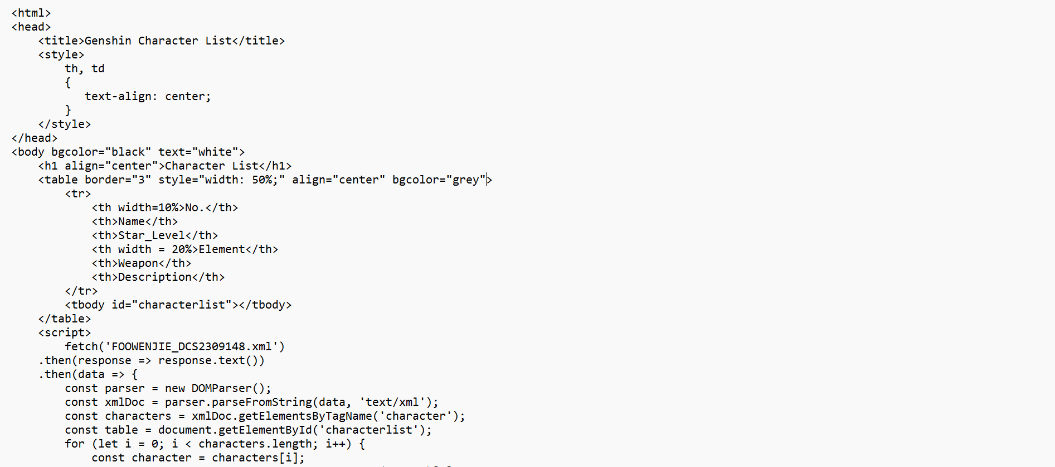

1. FOOWENJIE_DCS2309148.xml

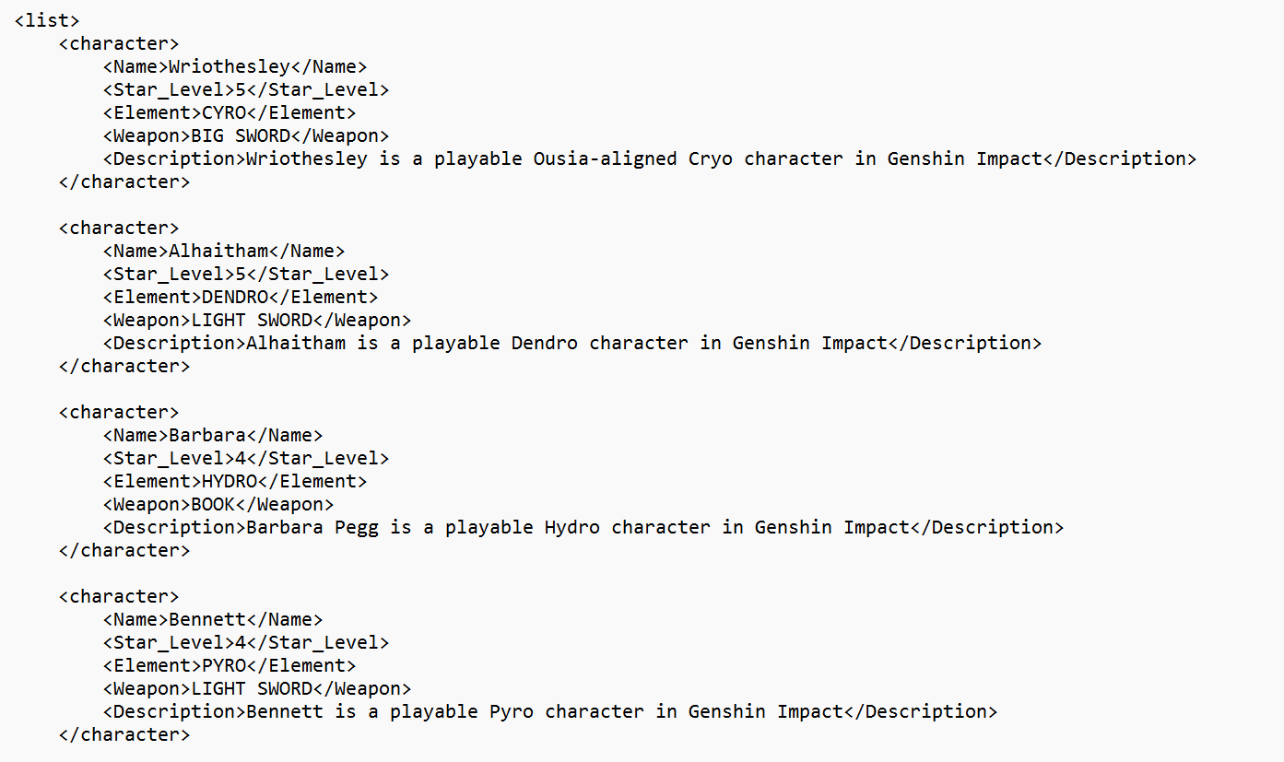

**Conclusion**

To sum up, the significance of XML inside the framework of HTML integration cannot be emphasized enough. Web development is given a new dimension by its unique features, which include document structuring, web services, web services integration, data interchange, and web services. By expanding HTML's capabilities into the field of structured data representation and interchange, XML enhances HTML and creates a more connected, data-rich, and understandable digital world. The web's symbiotic relationship is still what keeps it going strong and drives its constant evolution. In the field of web development, the incorporation of XML into HTML represents a revolutionary advance. It's about the significant ramifications and synergy that this collaboration brings to the digital landscape, not just about a basic cohabitation. In this mutually beneficial partnership, XML enhances HTML with a variety of functionalities that have broad applications.

**REFERENCES**

1. W3Schools. (n.d.). XML - What is XML? <https://www.w3schools.com/xml/xml_whatis.asp> (Accessed October 23, 2023).
2. Online Class Notes. (2023). The Importance of XML in Web Applications.Available at: <https://onlineclassnotes.com/explain-importance-of-xml-in-web-applications/> (Accessed October 26, 2023).