数据库实验报告

专业：软件工程 姓名：王佳颉 学号：1412641 年级：大二

1. 题目：建立员工数据库并进行一系列查询。
2. 查询代码及结果：
3. Select person_name from works where company_name=’First Bank Corporation’; 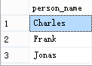
4. select works.person_name,city from works,employees where works.company_name='First Bank Corporation' and employees.person_name=works.person_name;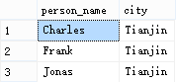
5. select works.person_name,street,city from works,employees where works.salary>10000 and works.person_name=employees.person_name;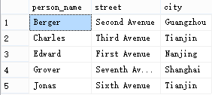
6. select person_name from employees where city in(select city from company join works on company.company_name=works.company_name where employees.person_name=person_name);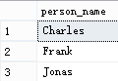
7. select T.person_name from employees as T,employees as S,manages where T.street=S.street and T.city=S.city and T.person_name=manages.person_name and S.person_name=manages.manager_name;
8. (select person_name from works) except (select person_name from works where works.company_name='First Bank Corporation');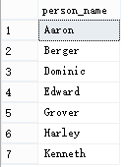
9. select person_name from works where salary>all(select salary from works where company_name='Small Bank Corporation');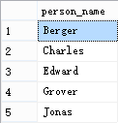
10. 修改代码：

（1）update employees set city='new town' where person_name='Aaron';

（2）update works set salary=salary*1.1 where company_name='Ateck Shower Corporation';

（3）update works set salary=salary*1.1 where person_name in(select manager_name from manages);

（4）update works set salary= case

When person_name in(select manager_name from manages)and salary<=10000 then salary*1.1

When person_name in(select manager_name from manages)and salary>=10000 then salary*1.1

End;

（5）delete from works where company_name=’Aaron’;