数据库实验报告

专业：软件工程 姓名：王佳颉 学号：1412641 年级：大二

1. 题目：建立图书馆数据库并进行一系列查询。
2. 查询代码及结果:：
3. Select name,year from title where callnumber in(select callnumber from author where lname=’Churchill’);
4. select name,ISBN from title where callnumber in (select callnumber from book where borrowermemno in(select memno from member where fname='Jhon' or fname='Susan'));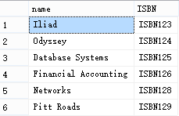
5. select fname,lname,driverlicno from member where memno in(select borrowermemno from book where callnumber in(select callnumber from title where name=’lliad’))and memno in(select borrowermemno from book where callnumber in(select callnumber from title where name=’Odyssey’));
6. select fname,lname,driverlicno from member where memno in(select borrowermemno from (select borrowermemno,callnumber from book where callnumber in(select callnumber from author where lname='Collins') union select borrowermemno,callnumber from book where callnumber in(select callnumber from author where lname='Collins'))as midtab group by borrowermemno having count(borrowermemno)=(select count(lname) from author where lname='Collins'));
7. select phonenumber from member where memno in(select borrowermemno from book where callnumber in(select callnumber from author where lname=’Tanenbaum’));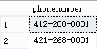
8. select member.fname,member.lname,member.memno,book.book_id from member,book where member.memno=book.borrowermenno group by book.bookid,member.fname,member.lname,member.memno having(select count(book.borrowermemno)from book where member.memno=book.borrowermemno>3 order by count(book.book_id)desc;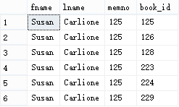
9. select Member.Fname,Member.Lname,Member.MemNo from member where Member.MemNo not in(select Member.MemNo from Member, Book where Member.MemNo = Book.BorrowerMemNo group by Member.MemNo having count(Book.BorrowerMemNo)>=1);
10. select Member.Fname from Member where Member.MemNo not in(select Book.BorrowerMemNo from Book where Book.CallNumber=(select Title.CallNumber from Title where Title.Name='Pitt Roads'))and Member.PhoneNumber like '412%';