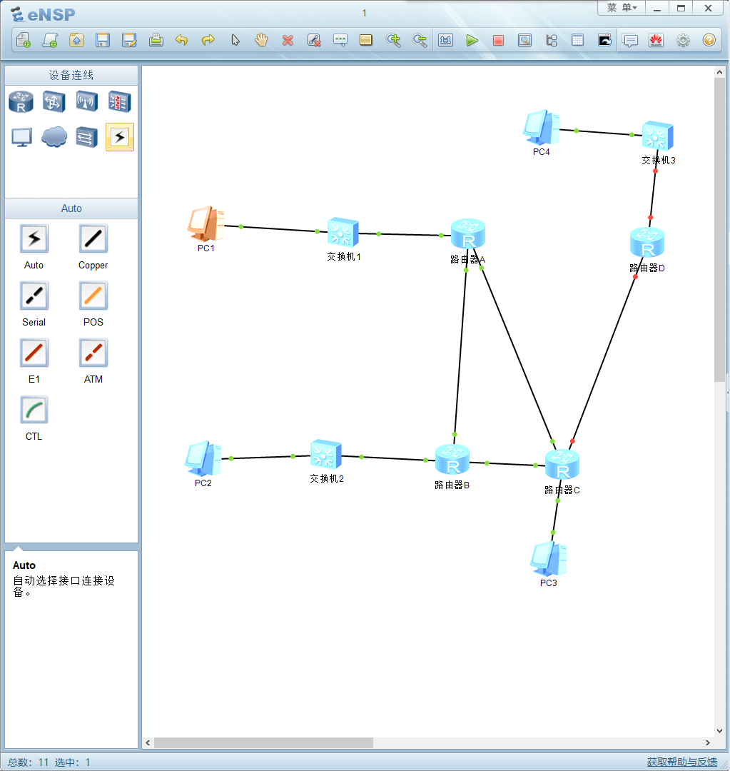

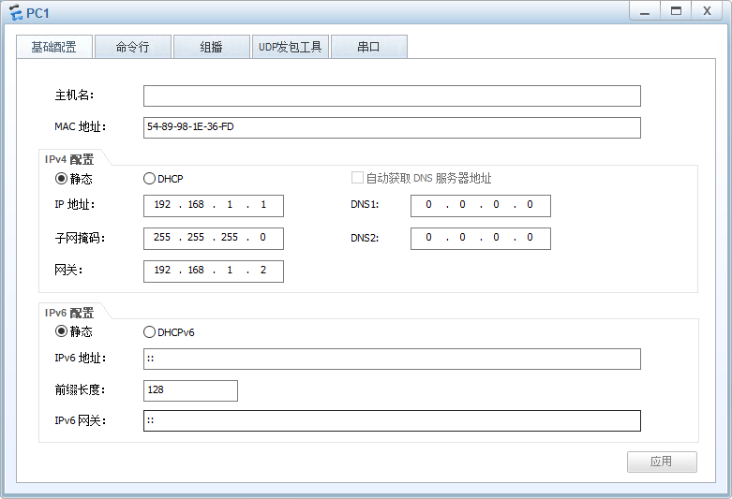

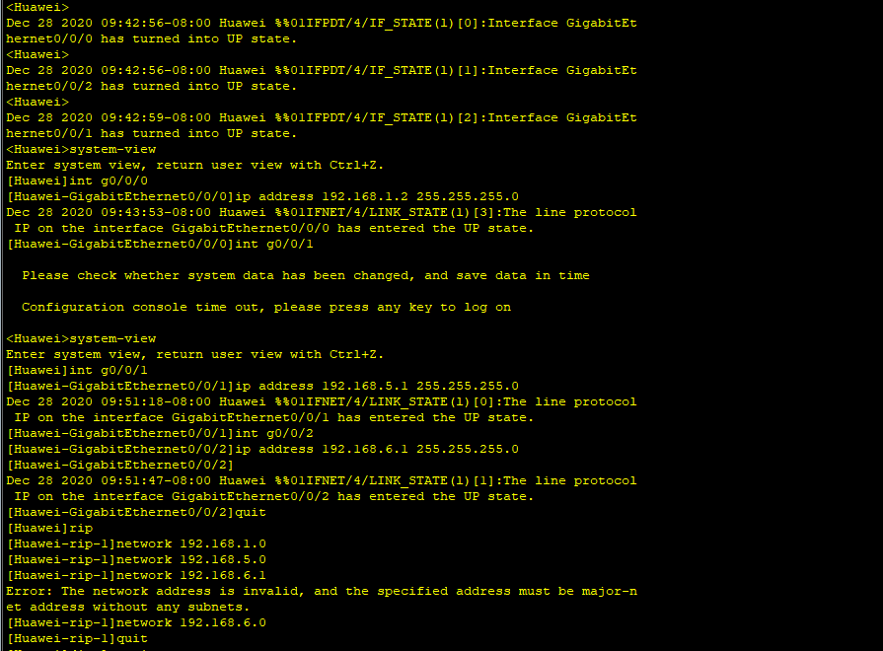

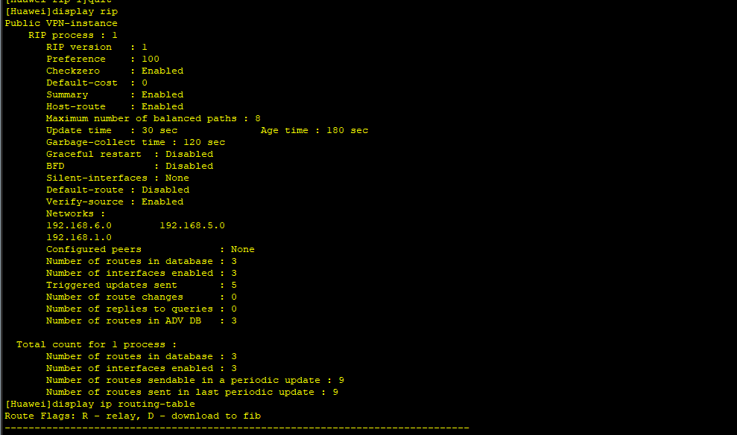

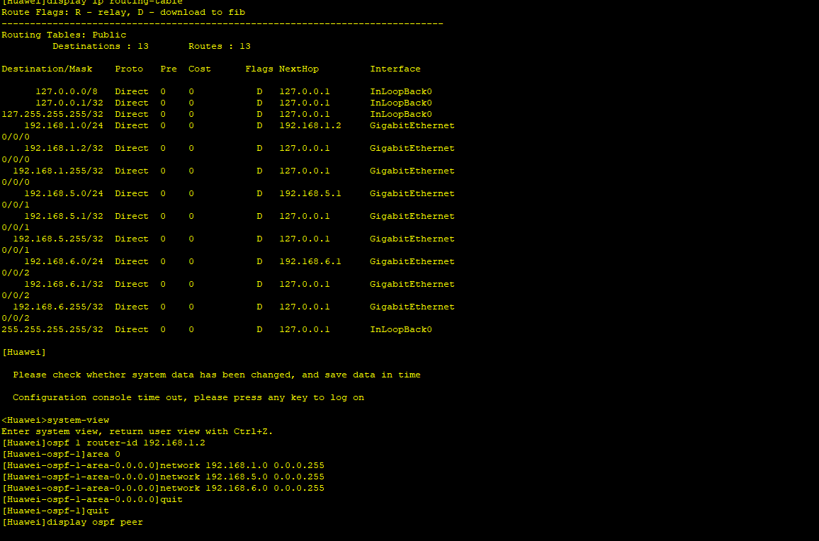

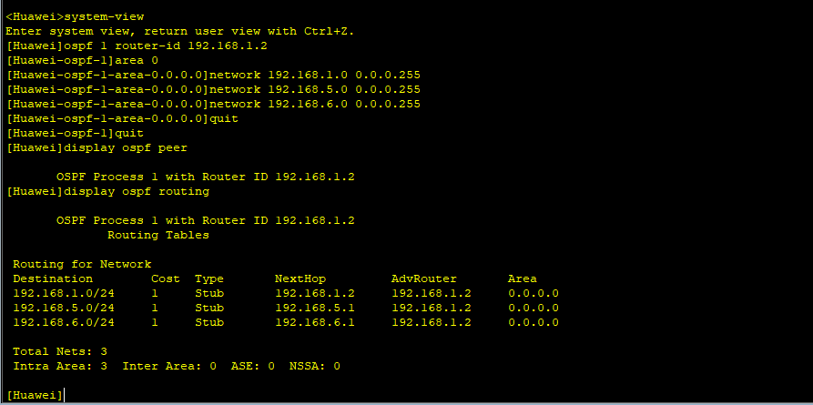

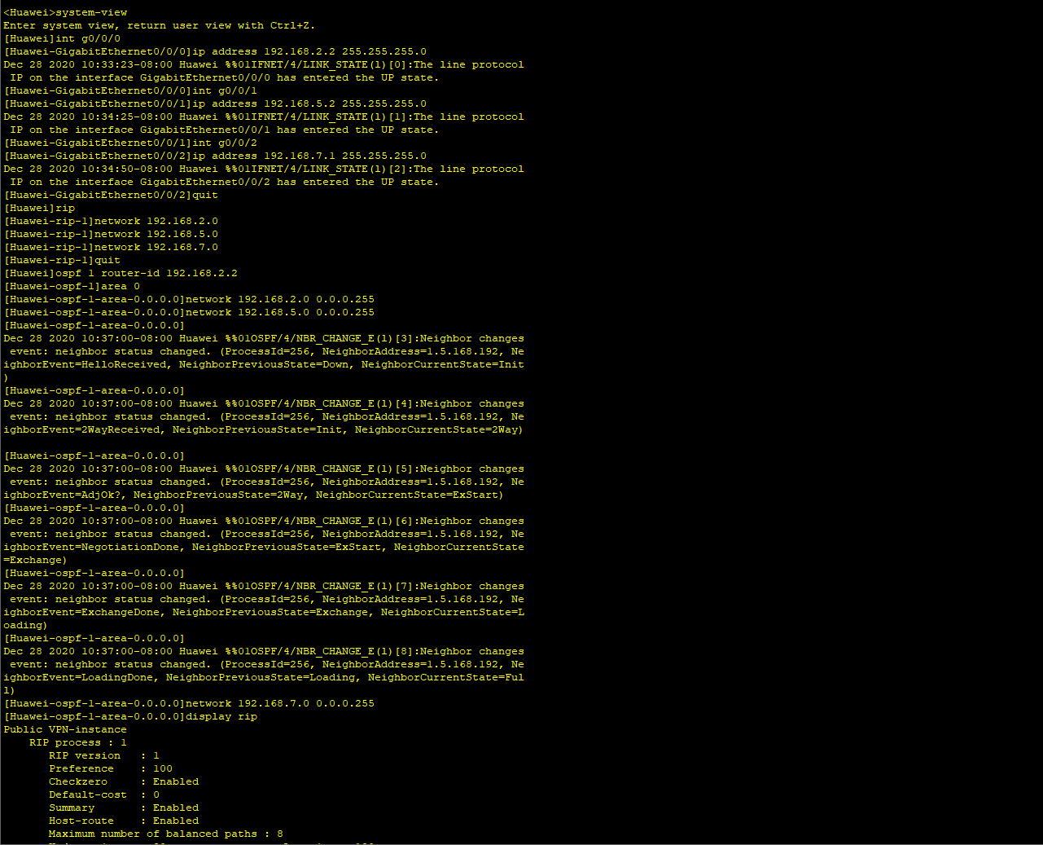

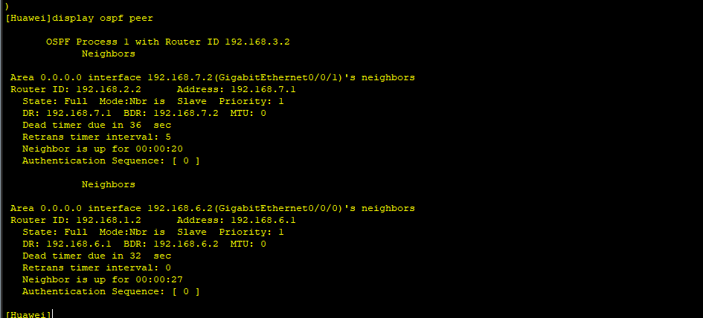

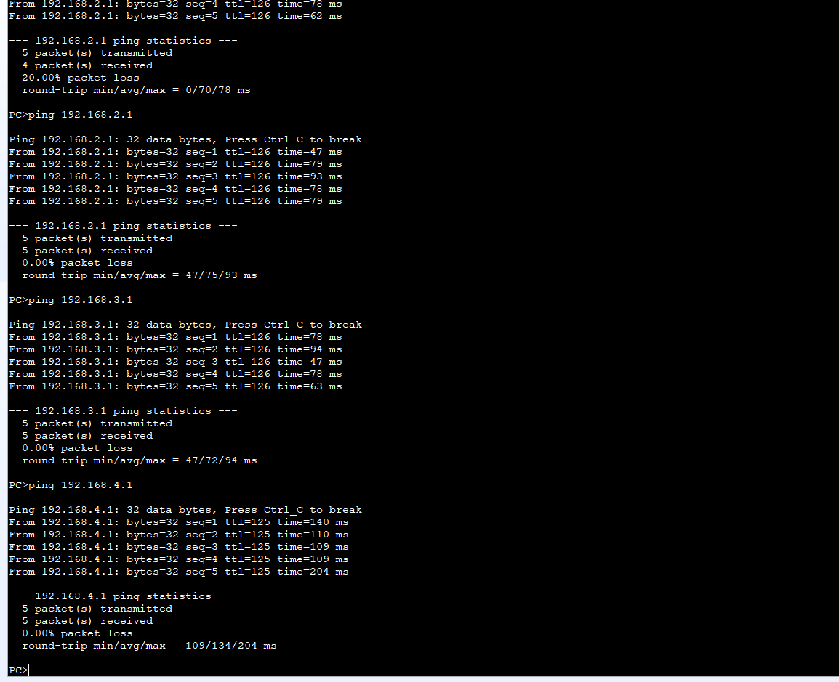

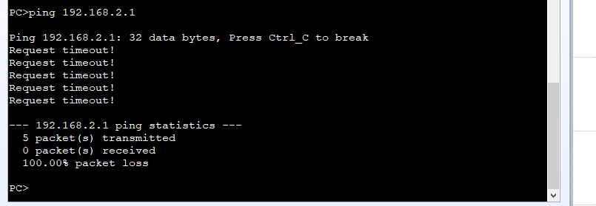

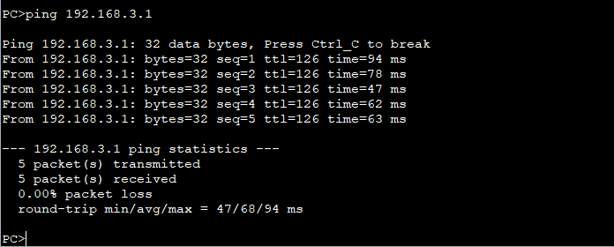

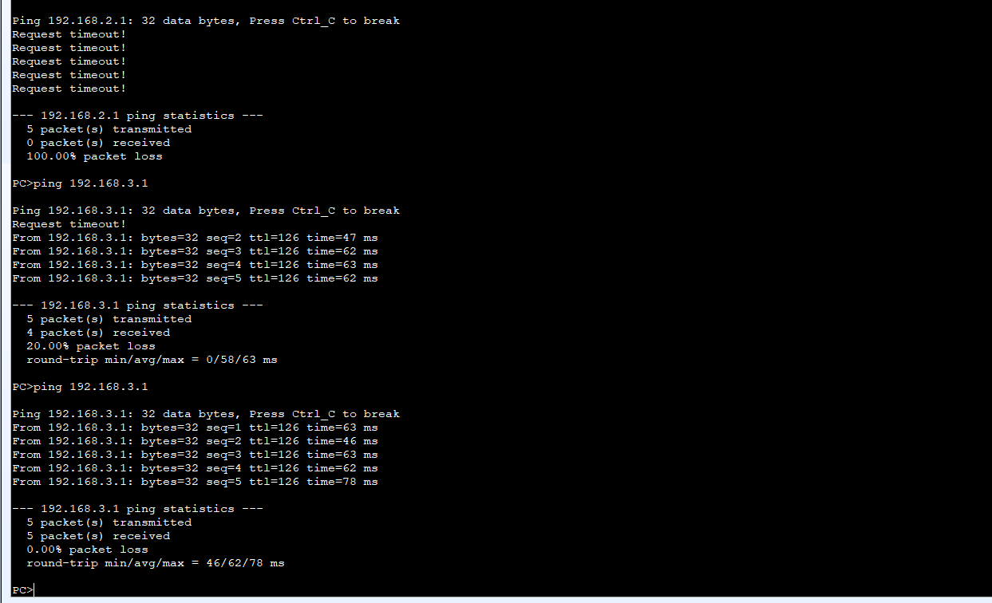

0x580x350x4F0x210x500x250x400x410x500x5B0x340x5c0x500x5A0x580x35

0x340x280x500x5E0x290x370x430x430x290x370x7D0x240x450x49

0x430x41 0x520x2D0x530x540x410x4E0x440x41

0x520x440x2D0x410x4E0x540x490x56

0x490x520x550x530x2D0x540x450x530x540x2D0x450x490x4C0x45

0x210x24 0x480x2B0x480x2A