**实验四 周期运动及傅里叶变换**

**课程名称： 计算机动画编程技术 实验日期： 2018－05－10**

**班级： 数媒1504 姓名： 王林超 学号： 1030515424**

**一、实验目的**

**1.借鉴第三章的方法，用程序模拟一种周期运动；**

**2.利用傅立叶变换（分解）或傅立叶反变换（合成）的知识，编程实现一段动画。二、实验内容**

**两个主题都要做；**

**不能与教程示例雷同。**

**三、实验代码**

import java.util.*;

int n = 5;

int f = 200;

float l = 90;

int w, h,time=0;

Spinner[] spinners;

LinkedList<Trail> trails;

LinkedList<Trail> trails_2;

//int slider;

float speed = TWO_PI / (f);

void setup() {

//slider = createSlider(0, 255, 100);

w = 500;

h = 300;

size(1500, 280);

frameRate(30);

trails = new LinkedList<Trail>();

trails_2 = new LinkedList<Trail>();

// create list of spinners

spinners = new Spinner[n];

spinners[0] = new Spinner(w/2, h/2, l, l, speed, speed, 0);

for (int i=1; i<n; i++) spinners[i] = spinners[i-1].spawnChild();

}

void draw() {

background(255);

time=time+2;

if(time>600)

{

trails_2.clear();

time=0;

}

fill(100);

textSize(50);

text("n="+n,400,50);

text("UP+1,DOWN-1,RIGHT+10,LEFT-10",600,50);

// update and draw trails

addTrail(spinners[n-1].endX, spinners[n-1].endY);

for (Trail trail : trails) {

if (trail.finished) trail.draw();

}

for (Trail trail : trails_2) {

if (trail.finished) trail.draw();

}

// addTrail(spinners[n-1].endX, spinners[n-1].endY);

// for (Trail trail : trails) {

// if (trail.finished) trail.draw();

// }

// draw spinners

strokeWeight(5);

for (int i=0; i<n; i++) {

float b = spinners[i].bright;

if (b < 1) {

stroke(0, 0, 255*b);

} else {

stroke(0, 255*(b-1), 255);

}

line(spinners[i].originX, spinners[i].originY, spinners[i].endX, spinners[i].endY);

if(i==n-1)

{

//line(550, spinners[i].originY, 550, spinners[i].endY);

ellipse(550, spinners[i].endY, 5, 5);

}

}

// update spinner positions

for (int i=0; i<n; i++) spinners[i].update();

// save frames the second time around

// if(frameCount >= 2*f) exit();

// if(frameCount >= f && frameCount % 4 == 0) saveFrame("../robo/fourier/##.png");

}

void addTrail(float x, float y) {

// finish most recently started trail

if (trails.size() > 0)

{

trails.peekFirst().finish(x, y);

}

if (trails_2.size() > 0)

{

trails_2.peekFirst().finish(550+time, y);

}

// start new trail

trails.addFirst(new Trail(x, y));

trails_2.addFirst(new Trail(550+time, y));

if (trails.size() >= 100)

{

trails.removeLast();

}

if (trails_2.size() >= 100)

{

trails_2.removeLast();

}

}

void keyPressed()

{

if (keyCode == UP)

{

n++;

Reset();

}

else if (keyCode == DOWN)

{

n--;

Reset();

}

else if (keyCode == RIGHT)

{

n= n+10;

Reset();

}

else if (keyCode == LEFT){

n= n-10;

Reset();

}

}

void Reset()

{

trails.clear();

trails_2.clear();

//spinners[0] = new Spinner(w/2, h/2, l, l, speed, speed, 0);

//for (int i=1; i<n; i++) spinners[i] = spinners[i-1].spawnChild();

spinners = new Spinner[n];

spinners[0] = new Spinner(w/2, h/2, l, l, speed, speed, 0);

for (int i=1; i<n; i++) spinners[i] = spinners[i-1].spawnChild();

time=0;

}

class Trail {

boolean finished;

float startX, startY;

float endX, endY;

float light;

// set starting point of trail

Trail(float x, float y) {

startX = x;

startY = y;

light = 0;

}

// set end of trail

void finish(float x, float y) {

endX = x;

endY = y;

finished = true;

}

// draw trail and fade

void draw(){

if(!finished) return;

stroke(255, 255*light, 255*light);

strokeWeight(2);

line(startX, startY, endX, endY);

light = light + 0.01;

}

}

**四、实验结果截图**

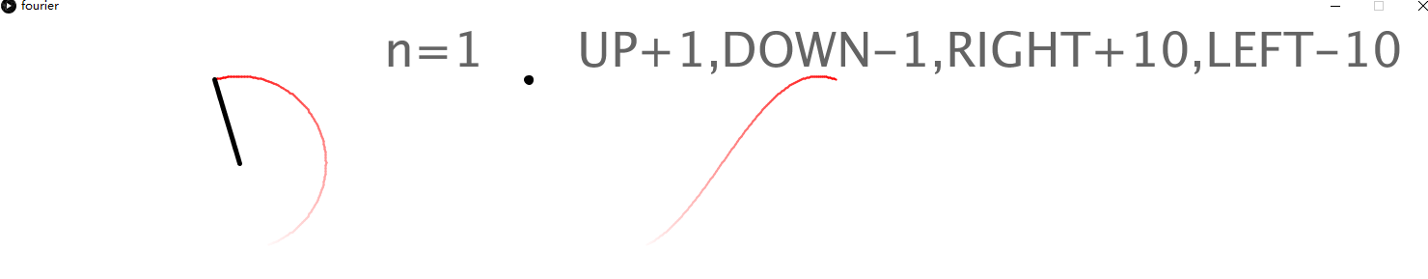

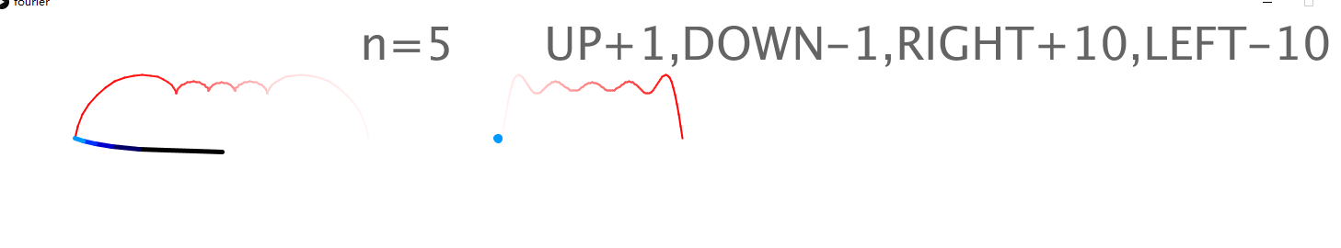

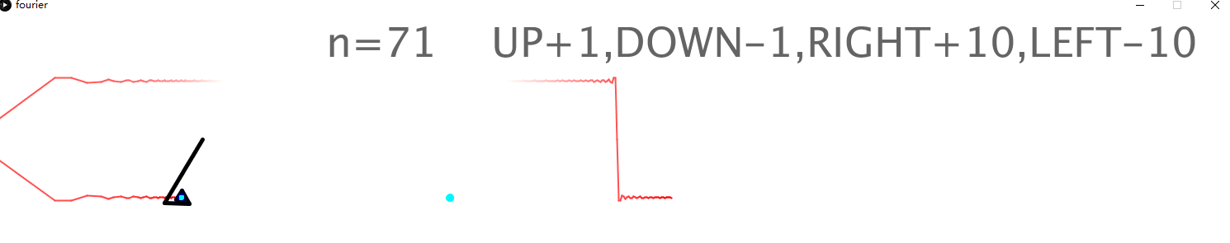

**五、实验体会**

加深了对傅里叶合成概念的理解。