https://rdfplayground.dcc.uchile.cl
Построить модель rdf по своей теме.

пример
BASE <example://>
PREFIX property: <property/>
PREFIX xsd: <XMLschema/>
PREFIX schema: <schema/>
PREFIX dcterms: <terms/>
PREFIX data: <data/>
PREFIX rdf: <rdf://>
PREFIX rdfs: <rdfs://>

<bob#me>
property:is "Man" ;
schema:knows <alice#friend> ;
property:birthDate "1990-07-04"^^xsd:date ;
schema:topic_interest data:painting015 .

data:painting015
dcterms:title "Mona Lisa" ;
dcterms:creator <Leonardo_da_Vinci> .

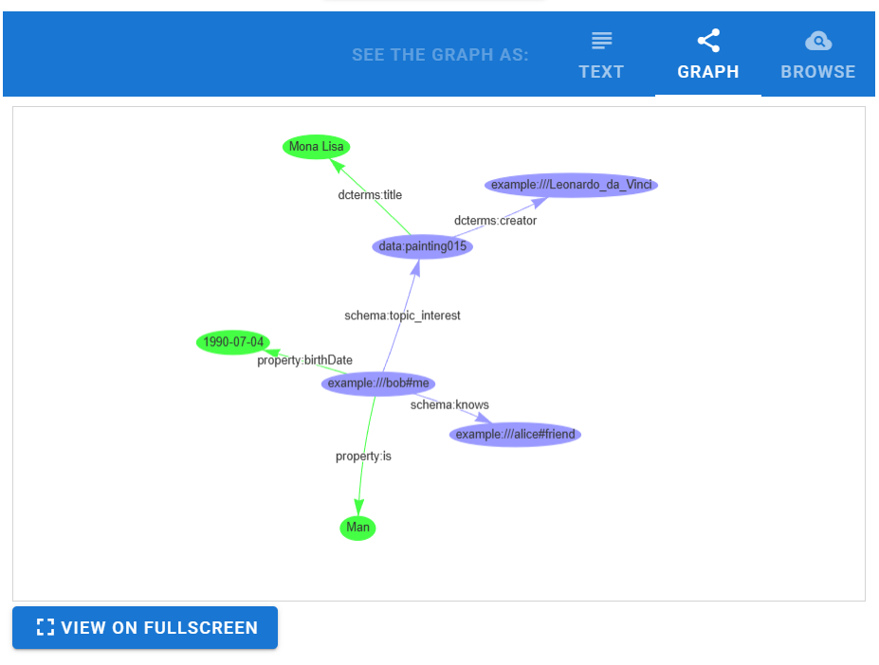
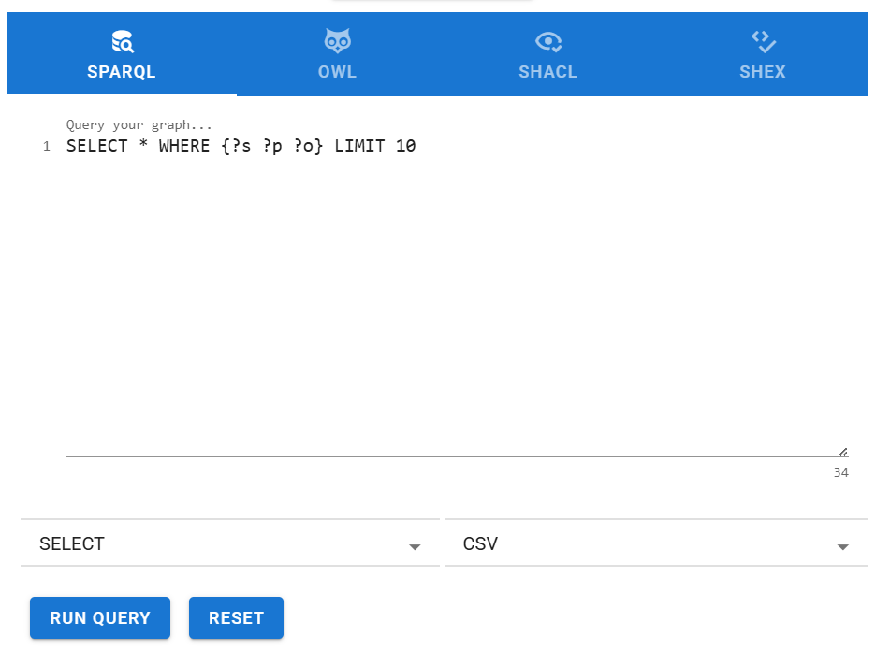
Result

example:///bob#me,example:///schema/topic_interest,example:///data/painting015
example:///bob#me,example:///property/birthDate,1990-07-04
example:///bob#me,example:///schema/knows,example:///alice#friend
example:///bob#me,example:///property/is,Man
example:///data/painting015,example:///terms/creator,example:///Leonardo_da_Vinci
example:///data/painting015,example:///terms/title,Mona Lisa

