FINAL YEAR PROJECT · HKU B.Sc. BIOINFORMATICS
Learning Cancer Mutation Landscapes from Large-Scale Somatic Mutation Testing Data
Project onboarding guide: the background, what others have done, our data and methods, and where the work stands today
Supervisor | Prof. Jason Wong
Data | AACR Project GENIE public release v19.0 (about 270,000 clinical tumour sequencing samples)
Snapshot date | 25 October 2026 (adds R figures, a novelty screen and a comparison with the SelectSim atlas)
Written for | Someone new to the project who wants to understand it end to end, without prior knowledge of the code
Status | Everything has finished running and is committed (including the 25 Oct additions). Numbers in this guide match the final outputs. Open items are listed in Part 11.

How to read this guide
The guide is written as one story in twelve parts. You can read it straight through, or stop after any part and ask questions. Terms in italics are explained in the glossary (Appendix A). Each part ends with the source files it was built from, so every claim can be checked.
Part | Title | You will learn | Reading time
1 | The story in one page | The whole project in five minutes | 5 min
2 | Background | What co-occurrence and exclusivity are, and why clinicians care | 10 min
3 | What has been done before | Published methods, the data they used, the gap we fill | 15 min
4 | The data: AACR GENIE | What is in the data, and the trap hidden in it | 10 min
5 | Aims and how they evolved | Why the project changed direction in September 2026 | 5 min
6 | Phase 1: cleaning the data | How raw files become a trustworthy table | 10 min
7 | Phase 2: testing gene pairs | The statistical core, and why we do not use the usual test | 20 min
8 | Phase 3: the lookup tool | What a clinician can ask, and how each answer is built | 10 min
9 | Phase 4: biological insight | What the patterns mean, and a blind spot we found | 10 min
10 | Independent checks | External validation in TCGA and head-to-head method tests | 10 min
11 | Where things stand | Progress, open decisions, caveats, next steps | 10 min
12 | Navigating the repository | Where everything lives, and how to reproduce it | 5 min

A suggested way to read
Session 1: Parts 1-5 (the why and the data). Session 2: Parts 6-7 (the pipeline and the statistics). Session 3: Parts 8-11 (the tool, the biology, the status). Part 12 is a reference.

PART 1

The story in one page
Start here. Everything else is detail.
A patient, and a question
A lung cancer patient's tumour report comes back listing a KRAS G12C mutation together with an STK11 mutation. The molecular tumour board asks: how common is this combination? Does it change how we treat this patient? Today nobody can answer quickly. Someone has to search a large public database by hand, and the one-hospital caseload is far too small to say anything reliable.

This project builds the answer. It uses AACR Project GENIE, a public database that pools clinical tumour sequencing from many hospitals (about 270,000 samples), to learn which gene alterations occur together, and which avoid each other, within each cancer type. It then turns that knowledge into a lookup tool for clinicians, and mines it for biological insight.

The story in five steps
- The data is messy in a way that silently biases results. Hospitals used 167 different gene panels. If a gene was not on a patient's panel, the file simply shows no mutation, which looks identical to tested and clean. Count those patients as clean and every frequency is wrong.
- Phase 1 cleans the data and records what was actually tested. It keeps likely-harmful alterations only (mutations, deep copy-number changes and driver gene fusions), one sample per patient, and tracks per patient which genes were tested for each type.
- Phase 2 tests every gene pair fairly. The usual test (Fisher's) calls 72% of pairs significant, because a few heavily mutated tumours make everything look linked. We use a test that compares each patient with their own number of alterations, adjust for cancer subtype, and require the result to replicate in other hospitals and, independently, in TCGA.
- Phase 3 is the lookup tool. It answers five clinical questions, from “what else is usually altered with this?” to “what treatment evidence exists?”. Simple per-gene prediction models beat the originally planned similarity matching.
- Phase 4 asks why. Exclusive pairs sit in the same biological pathway; a third of interactions change between cancer types; part of a famous KRAS association is explained by smoking. It also exposed a blind spot in our own method. A novelty audit then checked every robust pair against the literature and the largest recent atlas (SelectSim, 2026): the driver-pair landscape of common cancers turns out to be almost fully reported, so the project's distinct value lies in copy-number and fusion partners, panel-aware statistics, artefact audits and the tool.

The project at a glance
Item | Value
Samples → patients | 271,837 samples on 167 panels → 227,696 patients (one sample each)
Likely-harmful mutations kept | 3,458,550 → 1,644,226
Main analysis (Phase 2) | Non-hypermutated patients: 6,697 gene pairs (227 genes), 51 cancer types, 112,779 patients
Significant pairs | 1,824 (27.2%); 1,584 interaction candidates (426 co-occurring, 1,158 exclusive)
Replicated outside the main centre | 486 candidates; 65% of testable hits replicate, none in the opposite direction
Pass the copy-number burden check | 1,276 of 1,584 candidates
Gene fusions | 56,356 structural variants → 9,619 driver-fusion calls; fusion screen: 109 significant pairs
External validation (TCGA) | Replicated candidates keep the same direction in 94%; none reverses
Lookup tool | Five functions; partner prediction held-out AUROC 0.855 vs 0.82 base rate
Novelty audit (25 Oct) | 386 robust pairs checked against Europe PMC and the SelectSim atlas: all pairs SelectSim reports agree in direction; none of the 41 unreported pairs survives as a new driver interaction

Where it stands today (24 Oct 2026)
All four phases and a validation notebook (05) are built, re-run end to end with gene fusions, and committed. The methods were chosen by testing alternatives on the data, benchmarked against the published method families, and validated in an independent cohort (TCGA). The latest design is not yet supervisor-reviewed. See Part 11.

Source files for this part: README.md, docs/supervisor_summary.md, the original PLAN.md (deleted 24 Oct; in git history, commit 92e8234).

PART 2

Background
Why anyone cares whether two genes are altered in the same tumour.

2.1 What a tumour's genetic profile looks like
A tumour grows because of changes in its DNA. A clinical sequencing test reads a chosen list of genes (a gene panel, typically a few hundred genes) and reports three kinds of change, called alterations:
Alteration | What it is | Example
Mutation | A change in the DNA letters of a gene | KRAS G12C: one amino acid swapped, locking a growth switch on
Copy-number change | A gene is present in too many copies (amplification) or lost (deletion) | ERBB2 amplified in breast cancer; CDKN2A deleted in glioma
Gene fusion | Two genes are joined by a chromosomal rearrangement, creating a hybrid that is permanently active | ALK, ROS1 and RET fusions in lung cancer, all treatable with targeted drugs

A tumour usually has only a few true driver alterations (the ones that push growth) and many harmless passengers that happened along the way. Telling them apart is a core difficulty.

2.2 Drivers do not combine at random
If alterations were independent, two genes would be altered together exactly as often as multiplying their individual frequencies predicts. They are not. Two patterns stand out:
Pattern | Meaning | Typical biological explanation | Example
Mutual exclusivity | Rarely altered in the same tumour | Both hit the same pathway so one is enough (redundancy); or both together harm the cell (incompatibility) | KRAS vs EGFR in lung cancer: both switch on the same growth signal
Co-occurrence | Altered together more than chance | They cooperate, or one makes the other tolerable | KRAS + STK11 in lung cancer

2.3 Why clinicians care
- Prognosis and drug response change with the combination. STK11/KEAP1 alongside KRAS in lung cancer predicts a poor response to immunotherapy (Skoulidis & Heymach 2019).
- Some combinations block a drug. BRAF V600E together with NRAS in melanoma predicts resistance to BRAF inhibitors (CIViC, evidence level B).
- Fusion-positive lung cancers do worse with extra losses. TP53 or CDKN2A/B loss alongside ALK, RET or ROS1 fusions predicts poorer targeted-therapy outcomes (Jiang 2023).
- Rare combinations have no guidebook. A hospital sees a handful of any rare combination per year, so clinicians ask experts to look it up in GENIE by hand. This is the clinical origin of the project.

2.4 Why it is hard: four ways chance impersonates biology
Most apparent patterns in mutation data are not gene interactions. Four mechanisms create fake ones, and the whole of Phases 1 and 2 is organised around removing them.
Trap | Plain-language analogy | What happens in tumour data
1. Mutation load | A few students sit every exam. They appear in every pair of exam lists, which makes every pair look linked. | A few hypermutated tumours carry dozens of alterations, so almost any pair “co-occurs” in them.
2. Subtype mixing | Pool a football team and a swim team: football and swimming look mutually exclusive. | A “cancer type” can mix diseases with different drivers (pancreatic adenocarcinoma with neuroendocrine tumours), creating fake exclusivity.
3. One DNA event, two genes | One photocopy of a page reproduces two paragraphs together. | A single amplification covers neighbouring genes, or a whole chromosome arm is gained; two “alterations” are really one event.
4. Testing gaps | Counting “did not say no” as “said yes” in a survey where some people were never asked. | A gene absent from a patient's panel is recorded as “no mutation”, which is the same as tested and clean.

2.5 Why a large, pooled database
To say anything reliable about a rare combination you need tens of thousands of patients. TCGA, the standard research cohort, has about 10,000 tumours across 33 cancer types, which leaves too few per type. GENIE has about 27 times more samples, and its patients are real clinical cases rather than a research selection. The price is data that is much messier, which is why this project spends so much effort on data quality.
Questions worth asking at this point
• Why is co-occurrence harder to trust than exclusivity? (Part 3 explains: chance produces co-occurrence easily.)
• Does a significant pair mean the two genes interact? (No. Parts 7 and 9 show how often it does not.)

Source files for this part: docs/literature_review.md §1, README.md, the original PLAN.md (git history, commit 92e8234).

PART 3

What has been done before
A map of the field: the data other studies used, the methods they built, where they disagree, and the gap this project fills.
How this review was done
Searched Europe PMC (PubMed, PubMed Central and preprints), the Firecrawl research index and tool documentation between 30 Sep and 22 Oct 2026. It is a narrative, single-reviewer review (not a formal systematic review) with 42 references, each checked against Europe PMC metadata. Full texts were read for the papers the design rests on, including van de Haar 2019, Scharpf 2022 and SELECT (Mina 2017, Methods S1), checked statement by statement on 26 Oct; a few papers cited for a single point were read as abstracts. The SelectSim atlas (Nature Genetics, July 2026) was added on 25 October.

3.1 Data sources used in earlier work
Dataset | Type | Size | Strength | Weakness for this question
TCGA PanCanAtlas | Whole exome + copy number, research cohort | ~10,000 tumours, 33 types | Every gene tested in every tumour; matched normal; uniform processing | Too few patients per type for rare pairs; mostly primary, untreated tumours
ICGC/TCGA PCAWG | Whole genome | ~2,600 tumours | Covers non-coding DNA and rearrangements | Small
MSK-IMPACT | Clinical panel, one centre | ~10,000 at publication | Real clinical samples incl. metastases | One centre, one panel family
AACR GENIE | Clinical panels pooled from many centres | ~270,000 samples (v19) | By far the largest; real-world; enough for rare combinations | 167 panels; centre-specific pipelines; little clinical detail
GENIE BPC | GENIE subset with curated treatment/outcome | Thousands; 6 cancer types | Treatment and survival | Separate access; small
Cell lines | CRISPR and drug screens | ~1-2,000 lines | Can test whether a dependency is functional | Not patients

Key point
Almost every method paper was built and validated on TCGA, where every gene is tested in every tumour. GENIE breaks that assumption. This is why our Phase 1 tracks testing per patient, and why we use TCGA the other way round: as an independent validation cohort.

3.2 Method families
Published methods fall into six families. The last column says what we did with each: adopted, tested on our data, idea borrowed (when the method cannot run on panel data as published), or not used.

A. Simple pairwise tests: the common default
Method | Idea | Our status
Fisher's exact test | A 2×2 table per pair (both / A only / B only / neither) | Tested: miscalibrated on our data
cBioPortal “Mutual Exclusivity” tab (Cerami 2012; Gao 2013) | One-sided Fisher test plus log odds ratio | Same as Fisher
maftools somaticInteractions() (Mayakonda 2018) | Pairwise Fisher on a mutation table | Same as Fisher

Most single-disease GENIE papers (bladder, gastric, GIST, angiosarcoma, chordoma and others, 2024-26) report raw pairwise p-values like this, typically through cBioPortal.

B. Tests that respect each tumour's own alteration count: the current standard
Method | Data | Idea | Our status
DISCOVER (Canisius 2016) | TCGA pan-cancer | Each tumour gets its own alteration probability (estimated); Poisson-Binomial null | Tested: biased toward exclusivity on panel-sized gene sets
Rediscover (Ferrer-Bonsoms 2022) | — | Fast R version of DISCOVER | Tested: 69% false positives on our null benchmark
WeSME (Kim 2017) | TCGA | Permutations keeping each patient's and gene's totals fixed | Idea adopted: our test computes this null exactly
WExT (Leiserson 2016) | TCGA colorectal, endometrial | Exact test with per-sample, per-gene weights | Same family; superseded
Conditional (Rasch) test | GENIE | Each tumour's pair probability given its own alteration count; exact tail | Adopted in Phase 2

C. Sets of mutually exclusive genes (more than two)
MEMo (Ciriello 2012), Dendrix and Multi-Dendrix (Vandin 2012; Leiserson 2013), CoMEt (Leiserson 2015) and Mutex (Babur 2015) look for sets of genes that cover many tumours with little overlap, usually a pathway. They were built on TCGA and serve pathway discovery rather than pair-level clinical questions. Our lookup tool counts exact multi-gene combinations instead; we compared the Dendrix idea on GENIE (Part 10): a load-aware set score finds whole pathways three times as often.

D. Selection- and evolution-based methods
Method | Data | Idea | Our status
SELECT (Mina 2017, 2020) | 6-9k TCGA tumours + ~2k cell lines | Evolutionary dependencies; exclusivity ≈ redundancy, co-occurrence ≈ synergy; checked against CRISPR/drug screens | Re-implemented from its methods and benchmarked (Part 10.4): calibrated, best at ranking the strongest pairs; redundancy interpretation used in Phase 4
Coselens (Iranzo 2022) | TCGA, 16 types | Is a gene's protein-changing-to-silent ratio higher when another gene is mutated? | Idea borrowed: tested on GENIE panels (Part 10)
SelectSim (Iyer 2026) | GENIE v15 (MSK + DFCI) + TCGA; >70,000 tumours | Simulate mutations under independence keeping gene frequency and TMB within subtypes; TMB-weighted effect size | Compared pair by pair (Part 9.3)

E. Confounders and context
Paper | Finding | How we used it
van de Haar 2019 (Cell) | Re-ran five methods (incl. DISCOVER, Fisher) on 13 TCGA + MSKCC cohorts: most exclusivity they find tracks subtype and mutation load, not pathways -- even for load-aware DISCOVER | Adopted: subtype strata + load-conditional test
Park & Lehner 2015 | Interactions change between cancer types (30 of 52 re-testable ones were type-specific) | Adopted: Phase 4 heterogeneity test
Sanchez-Vega 2018 | 10 curated oncogenic pathways; exclusivity common within a pathway | Adopted: Phase 4 pathway test
MOSAIC (Campbell & Reyna 2026) | Methods cannot separate true exclusivity from subgroup structure | Addressed by subtype strata
CDCOCA, Zack 2013, Watkins 2020 | Copy-number co-occurrence must be judged against each tumour's copy-number complexity | Tested: burden check (Part 9)
GeneAccord (Kuipers 2021) | Clonal co-occurrence inside a tumour | Not used: panels have no clonal reconstruction

F. Allele-level, fusion and GENIE-scale studies: closest to this project
Paper | Data | Finding | How we used it
Scharpf 2022 | 66,372 GENIE tumours (27,257 tumour-normal for co-mutation) | RAS co-mutation depends on lineage and allele; Bayesian hierarchical model pooled across cancer types, with TMB-quintile and smoking-signature stratified checks | Smoking adjustment (Phase 4); pooling tested, small gain (Part 10)
Cook 2021 | 13,492 tumours | Each KRAS allele has its own partners in each tissue | Allele screen (Phase 4)
Vaeyens 2023 | 64,807 cBioPortal samples | BRAF/EGFR exclusivity depends on variant class | Variant-level lookup tool
Jiang 2023; Tang 2018; Zhang 2020 | Fusion-positive cohorts | TP53/CDKN2A loss common and prognostic with ALK/RET/ROS1 fusions | Fusion screen

The closest prior work: Scharpf et al. 2022
Same database, same concern with mutation load, and panel-aware denominators like ours. Differences: it covers RAS genes only; it stratifies mutation load into TMB quintiles rather than conditioning on each tumour's own count; it does not adjust for copy-number burden; and it offers no lookup tool. It found G12C/STK11 and G12C/KEAP1 strongest in low-TMB tumours, and fewer of them with a smoking signature -- consistent with our smoking adjustment.

The closest recent atlas: SelectSim (Iyer ... Mina, Ciriello, Nat Genet 2026)
Built a co-mutation atlas from GENIE v15 and TCGA (>70,000 tumours, 119 subtypes) and reports 892 independently validated co-mutations, including metastasis-specific ones and their rarity in normal tissue.
How it handles the GENIE trap: it keeps only the two largest centres (MSK, DFCI) and runs each panel separately or on the genes all panels share. What it does not cover: copy-number changes, fusions, the other 17 centres, or a lookup tool.
How we relate to it: every robust pair of ours that SelectSim reports for the same cancer type agrees in direction (an independent confirmation of both), while most of our copy-number and mixed pairs are outside its scope (Part 9.3).

3.3 Tools a clinician uses today
Tool | What it gives | What it lacks for this question
cBioPortal (incl. GENIE's instance) | Interactive counts; Fisher-based co-occurrence | No adjustment for load, subtype or testing gaps; one query at a time
OncoKB (Chakravarty 2017) | Evidence level per variant | Single variants, not combinations; licence needed
CIViC (Griffith 2017) | Open, curated clinical evidence, some combinations | No frequencies
Cancer Hotspots, COSMIC | Where recurrent mutations sit and how often | No co-occurrence statistics

3.4 Where the field disagrees, and what our data say
Debate | One side | Other side | What our data show
Biology or chance? | Mostly chance once heterogeneity is modelled (Canisius) | Co-selection is widespread (Mina 2020: 852 dependencies in >9,000 tumours, 44% co-occurring, robust to TMB; Iranzo) | Both: exclusive candidates outnumber co-occurring ~3:1 and are pathway-structured; some co-occurrences are strong and replicate (KEAP1/STK11)
What does exclusivity mean? | Pathway redundancy (Sanchez-Vega) | Artefact of subtype and load (van de Haar); incompatibility (El Tekle); redundancy shown in cell-line knockouts (Mina 2020) | All three occur: 3-4x within-pathway enrichment; subtype strata remove about a quarter of hits
Universal or tissue-specific? | Core interactions recur pan-cancer | Interactions rewire between tissues (Park & Lehner) | A third differ between types; 47 reverse; 21 universal
Gene or variant level? | Gene-level screens | Allele-specific partners (Cook; Scharpf) | Real but few: 10 of 201; partly smoking

3.5 The gap this project fills
- Panel-aware statistics at GENIE scale. The rigorous methods (family B) were built on TCGA; GENIE papers mostly use family A. We bring the rigorous method to GENIE and track testing per patient for mutations, copy number and fusions. None of the reviewed methods does the latter.
- Confounders handled together: load, hypermutation, subtype, one-DNA-event artefacts, copy-number complexity and centre effects, each tested before adoption, with rejected options documented.
- Validation built in: out-of-centre replication for every pair, an independent cohort (TCGA) and an independent statistical route (silent-mutation ratios).
- A clinical lookup tool combining variant-level frequencies, exact combination counts, an on-demand test, partner prediction and treatment evidence. Existing tools offer one of these each.
Questions worth asking at this point
• Why not simply use DISCOVER or Rediscover? (Part 7: they are biased toward exclusivity on panel-sized gene sets.)
• Why was TCGA not used as the main dataset? (Too few patients per cancer type; used for validation instead.)

Source files for this part: docs/literature_review.md §0-§5, §9; reference list in Appendix C.

PART 4

The data: AACR GENIE
What we analyse, what is in it, and the hidden trap that shapes the whole project.

4.1 What GENIE is
AACR Project GENIE (Genomics Evidence Neoplasia Information Exchange) is an international consortium of cancer centres that share clinical-grade tumour sequencing results in one public dataset. We use release v19.0: 271,837 samples, 3.46 million mutation records, copy-number calls for about 172,900 samples, and a fusion (structural variant) file. GENIE data cannot be redistributed, so it is kept out of git; only derived aggregate tables are tracked.

4.2 What is in the release
File | Size | Role
data_mutations_extended.txt | 3.46M rows, 1.0 GB | Somatic mutation calls, one row per variant per sample
data_CNA.txt | 1,004 genes × 172,875 samples | Copy-number calls (-2 deep deletion … +2 amplification); NA = gene not tested
data_clinical_sample.txt / _patient.txt | 271,837 rows / one per patient | Cancer type, panel, sample type; sex, survival fields
genomic_information.txt | 71 MB | Which gene each panel's probes cover
tmb_19.0-public.tsv | 271,838 rows | Tumour mutational burden per sample
data_sv.txt | 56,356 structural variants | Gene fusions and other rearrangements
assay_information.txt | 36 KB | Panel metadata (platform, claimed alteration types)

4.3 The trap: “not reported” does not mean “not mutated”
A worked example
A gene sits only on a small panel used for 800 of 5,000 lung cancer samples, and 40 of those 800 are altered. The true rate is 40/800 = 5%. Dividing by all 5,000 gives 0.8%, a number that only reflects which panel was used.
Every frequency, every pair test and every tool answer in this project divides only by the patients actually tested for the genes involved.

The raw files make this hard in two ways. Copy-number NA values are explicit, but mutation files only list mutations that were found, so testing must be reconstructed from the panel definitions. And, as the next table shows, the panel definitions themselves are sometimes wrong.

4.4 Problems found in the GENIE data itself
Each was checked directly against the data rather than trusting the documentation, and each would have silently biased results.
Problem | Evidence | What we do
Panel metadata overstates copy-number testing | 48 panels claim copy number; 20 have no samples in data_CNA.txt. 98,963 samples were counted “no change” when never tested. CDKN2A deletion in glioma: 17.4% → 34.4% once fixed (published ~30-40%) | Read testing per sample from the data (CNA_TESTED)
Copy-number and mutation gene lists differ | 16.2% of (panel, gene) pairs sequenced for mutations have no copy-number values | Separate copy-number coverage table
Panel gene lists overstate mutation reporting | 1,144 (panel, gene) pairs in 47 panels expect ≥10 mutated patients but report zero; e.g. JHU-500STP lists 760 genes, reports 46 | Partly fixed from the data: 8 panels that released no mutations count as untested. Statistical gaps documented, left as is
Fusion metadata is wrong too | 9 panels claim structural-variant detection but released none; 3 released fusions without claiming to | Fusion testing also read from the data (SV_TESTED)
Germline filter removed real mutations | At gnomAD 1e-4, ~104k real calls removed (JAK2 V617F lost 90%) through clonal haematopoiesis | Cutoff relaxed to 1e-3
Copy-number bystanders | 85,254 deep calls go the wrong way for the gene's role (deleted oncogene, amplified suppressor) | Dropped using OncoKB roles
Shallow copy-number calls not comparable | MSK panels report ±1 in ~5% of samples, DFCI panels in 98-99% | Deep calls only
TMB meaningless on small panels | ~61% of samples on panels <1 Mb come out “TMB ≥ 10” | TMB trusted only on panels ≥1 Mb
Corrupted gene coordinates | 33 of 19,605 genes have impossible spans (ZNF703 ~97 Mb) | Excluded from the gene-distance check

Why this matters beyond the project
This table is a contribution in its own right: it documents ways the public GENIE release can mislead anyone who takes the panel metadata at face value.

Questions worth asking at this point
• Why can mutation testing only be partly fixed from the data? (Some panels list genes they never report; only statistics can reveal it.)

Source files for this part: README.md (Problems found in the GENIE data), the original PLAN.md data inventory (git history, commit 92e8234), docs/supervisor_summary.md.

PART 5

Aims and how they evolved
The project changed shape on 24 September 2026. Knowing the history prevents confusion when you meet old wording.
When | Framing | Main deliverable
Original brief (supervisor) | Define co-mutation clusters of more than two genes; test them against survival; build an algorithm that assigns a new sample to a cluster. Constraints: include copy-number changes, and only likely-pathogenic mutations | Clusters + survival + assignment
Registered description (official FYP form) | Aim 1: genes whose mutations co-occur more than expected, within and across cancers. Aim 2: match a new patient's profile to similar cases and report how common the combination is | Pairwise co-occurrence + similarity matching
Refocused 24 Sep 2026 (with Prof. Wong) | Aim 1: a lookup tool for the clinic. Aim 2: scientific insight from the patterns | Lookup tool; insight analyses

Two numbering schemes
The registered form and the refocused plan both say “Aim 1 / Aim 2” but mean different things. In the refocused plan, Aim 1 = Phase 3 (tool) and Aim 2 = Phase 4 (insight). The registered “Aim 2” (match a patient to similar cases) is delivered by the tool.

Why the project was refocused
- Clinicians already ask Prof. Wong to look up rare combinations by hand. A tool that does it is directly useful.
- Phase 2's statistical gates (gene altered in ≥3% of patients; ≥5 patients expected to carry both) remove exactly the rare combinations clinicians ask about. For EGFR in lung cancer, 651 partner genes occur in at least 3 patients but only 28 are testable pairs. So the tool reads the Phase 1 tables directly and uses Phase 2 only to annotate its answers.
- GENIE survival data is coarse (year-level, a subset of centres), so multi-gene clusters and survival analysis were demoted to optional.
What the tool cannot do
It cannot predict treatment response. GENIE's main release has no treatment or response data, so therapy information comes from a knowledge base (CIViC). Outcome links would need GENIE BPC, which is a separate access request.

Source files for this part: README.md (Project aims; Registered project description), the original PLAN.md (git history, commit 92e8234) for the supervisor's brief.

PART 6

Phase 1: cleaning the data
No analysis happens here. The job is to build one table everyone can trust, and to record what was tested.
Notebook: notebooks/01_phase1_preprocessing.ipynb Output: alterations_long.parquet, clinical_tidy.parquet, panel_gene_coverage.parquet, cna_gene_panel_coverage.parquet
The question Phase 1 answers
“For every patient, which genes carry a likely-harmful alteration, and for every gene, was that patient actually tested?”

6.1 Step by step, with the reason for each choice
Step | What we do | Why
1. One sample per patient | 271,837 samples → 227,696 patients. Keep the sample with copy-number data, then the primary tumour, then the larger panel | A primary tumour and its metastasis share early mutations; keeping both counts the same pair twice
2. Hypermutation label | Use GENIE's official TMB, trusted only on panels ≥1 Mb | On smaller panels ~61% come out as TMB ≥ 10, which is noise
3. Record what was tested | Separate tables for genes tested for mutations (exon probes) and for copy number (read from data_CNA.txt). Per patient CNA_TESTED and MUT_TESTED | Frequencies must divide by patients actually tested (Part 4); the same is done for fusions
4. Keep likely-harmful mutations | Somatic, protein-changing, gnomAD frequency ≤1e-3. Missense also needs AlphaMissense pathogenic, or PolyPhen damaging and SIFT deleterious, or a cancerhotspots.org hotspot. 3.46M → 1,644,226 | Counting every raw variant would flood the analysis with passengers. AlphaMissense is newer and better calibrated; hotspots rescue known drivers (rule approved by Prof. Wong)
5. Copy number: deep calls only | Keep +2 and -2. Drop calls that contradict the gene's role (deleted oncogene, amplified suppressor): 377,216 → 291,962 | One-copy gains/losses are mostly arm-level passengers and differ wildly by centre (MSK ~5%, DFCI 98-99%); contradicting calls are usually bystanders next to the real target
6. Two-hit feature (separate) | A shallow deletion plus a damaging mutation in the same tumour suppressor is stored apart (putative_biallelic_tsg_events) | Prof. Wong's point: together they suggest both copies are gone, but alone a shallow deletion is no signal
7. Gene fusions | Keep events joining two different genes where one is a known fusion driver (OncoKB / Mitelman-recurrent list, antisense excluded); named after the driver, e.g. ALK_fusion. 56,356 structural variants → 9,619 driver-fusion calls | Fusions are rare but clinically decisive (ALK, ROS1, RET); a sample counts as fusion-tested only if its panel released structural variants
8. Combine | One table of 1,945,807 rows across 232,386 samples: mutations, copy number and fusions | Every later analysis starts here; no gene selection happens in Phase 1

Why the germline cutoff changed from 1e-4 to 1e-3
The first, stricter cutoff removed about 104,000 real cancer mutations. Many are acquired drivers that reach “healthy” reference donors through clonal haematopoiesis (blood cells with their own mutations). JAK2 V617F lost 90% of its calls; DNMT3A R882, SF3B1 K700E, MYD88 L265P and EGFR T790M were also hit. This is a good example of a filter that looks safe and quietly deletes the answer.

6.2 Gene fusions (added 22 October)
A gene fusion joins part of one gene to part of another through a chromosomal rearrangement. Some fusions switch on a kinase permanently and are the main driver of the tumour: ALK, ROS1 and RET fusions in lung cancer are treated with targeted drugs. The raw file lists 56,356 structural variants, but many are not driver fusions (deletions, one-sided calls, antisense events that make no working protein), so only the curated driver list is kept.
What fusions changed
985 lung cancer patients with ALK, ROS1 or RET fusions (9,619 driver fusions overall) were invisible before, and clinically this is one of the most common questions. Testing is read from the data as for the other types: 35 panels actually release fusions (218,130 samples are fusion-tested), 9 panels claim fusion detection but release none, and 3 release fusions without claiming to.

6.3 Result
Quantity | Before | After
Patients | 271,837 samples | 227,696 (one per patient)
Mutations | 3,458,550 | 1,644,226 likely-harmful
Structural variants | 56,356 | 9,619 driver-fusion calls
Deep copy-number calls | 377,216 | 291,962 direction-consistent
Samples with copy-number data | — | 172,874 (63.6%)
Combined alteration table | — | 1,945,807 rows, 232,386 samples

6.4 Compared with the literature
TCGA-based methods (DISCOVER, SELECT, WeSME) work on whole-exome data where every gene is tested, so they never face this problem. Most GENIE disease papers use cBioPortal counts that ignore it. Tracking testing per patient across mutations, copy number and fusions is the most distinctive element of the project.
Questions worth asking at this point
• Why keep only deep copy-number calls, given that a one-copy loss of a tumour suppressor can matter? (See the two-hit feature, step 6.)
• Why does Phase 1 not pick genes? (So every analysis filter lives in one place, the Phase 2 settings cell.)

Source files for this part: notebooks/01_phase1_preprocessing.ipynb, README.md (Phase 1), docs/supervisor_summary.md.

PART 7

Phase 2: testing gene pairs
The statistical core. For each cancer type, which pairs of genes go together more or less than chance, once chance is modelled honestly?
Notebook: notebooks/02_phase2_comutation_matrix.ipynb Output: comutation_pairs.parquet and companions

7.1 The problem with the usual test
The standard approach is Fisher's exact test (what cBioPortal uses). It assumes every patient has the same chance of carrying any alteration. In reality a few tumours carry most alterations, so almost every pair looks like it co-occurs. In the first version of this project Fisher's test called 72.3% of pairs significant. Prof. Wong's reaction, “half being significant sounds quite high”, was exactly right about the method.

7.2 The test we use, in plain terms
Intuition: compare each patient with their own baseline
A tumour with 30 alterations will carry almost any pair of genes by chance; a tumour with 2 will not. So for each patient we ask: given how many alterations this patient has, how likely is it that these two genes are both among them? Summing that over all patients gives the number of co-altered patients we should expect by chance, with an exact probability distribution. We compare it with the number actually observed.

- This is a conditional (Rasch-type) test with an exact Poisson-Binomial tail, followed by Benjamini-Hochberg false-discovery correction within each cancer type.
- It is the exact version of the permutation idea behind WeSME: reshuffle the data while keeping every patient's and every gene's totals fixed.
- DISCOVER-style methods estimate each patient's rate from their own few alterations, which pushes results toward “exclusive” on panel-sized gene sets.

Does the test tell the truth?
We checked on simulated data containing no real interactions, where about 5% of pairs should reach p < 0.05 by luck.
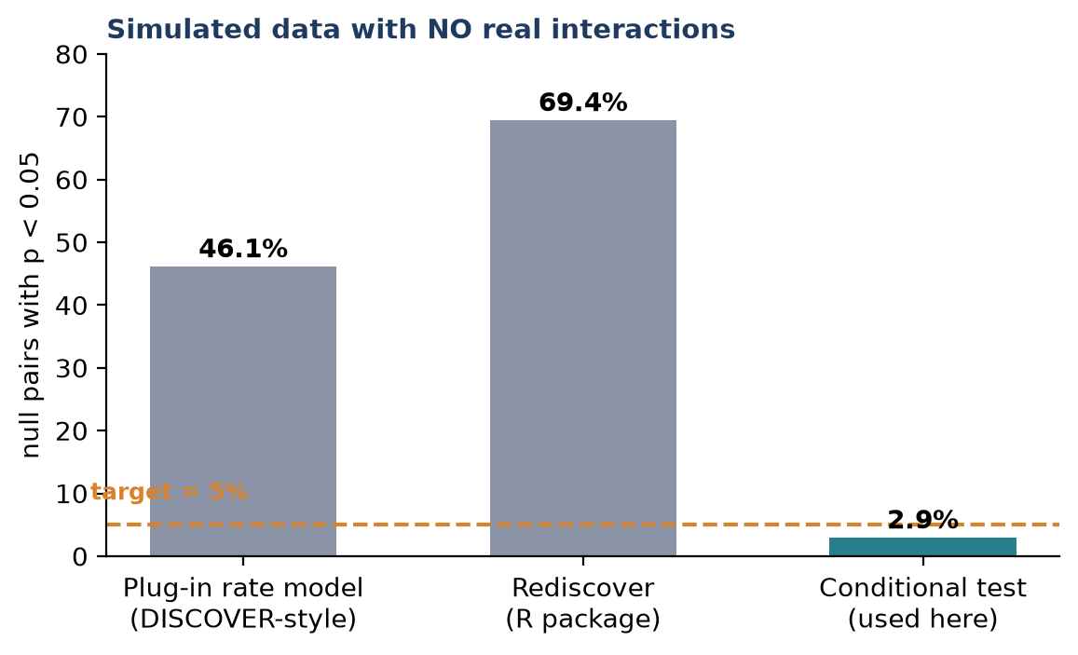
Figure 1. False positives on simulated null data (MSK-IMPACT468 benchmark). The conditional test is the only one near the 5% target; it also recovers 5 of 5 planted interactions.
The same ranking holds in a head-to-head comparison of every method family on real patients (Part 10.4). Its probability calculation matches Rediscover's on 990 of 990 benchmark pairs and 60-digit arithmetic to about 1e-12, so the difference between the tests is statistical, not a coding quirk. On real non-hypermutated patients with links destroyed, Fisher still calls 6-15% of pairs significant at p < 0.05, against 1.3-2.9% for the conditional test.

7.3 The design: four filters and five corrections
Step | What | Why
0. Who | Non-hypermutated patients (TMB < 10 on a panel ≥1 Mb): 159,390 patients. Hypermutated patients are analysed separately | Prof. Wong's suggestion; replication across centres rose from 44% to 66%
Filter 1 | Cancer types with ≥100 patients having both mutation and copy-number data → 51 types, 112,779 patients | “Altered” means mutation or copy number, so “not altered” must be checkable for both
Filter 2 | Genes altered in ≥3% (and ≥5) of that type's patients | Enough signal; counted over all patients so the gene must also be widely tested
Filter 3 | A pair is tested only if ≥50% of patients were tested for both genes | Removes pairs resting on one centre's panel; rarely binds
Filter 4 | ≥5 patients expected to carry both, decided from gene frequencies before seeing the result | Enough statistical power
Subtypes | Gene rates fitted within each detailed subtype (≥50 patients) | Pooled subtypes create fake exclusivity: pancreatic MEN1 vs SMAD4, glioma CIC vs PTEN, breast CDH1 vs ERBB2
One-DNA-event check | Remove pairs where one copy-number event hit both genes; neighbours (≤10 Mb) removed only when copy number drives the pair | Two point mutations are two separate events (Prof. Wong), so KEAP1/STK11 (lung) and PBRM1/SETD2 (kidney) stay
Weak-effect flag | Mark pairs within 1.5-fold of chance | With 10,000+ patients, tiny effects are significant (350 of 1,584)
Burden sensitivity flag | Re-test each pair with gene rates fitted within groups of copy-number burden; burden_robust = 1,276 of 1,584 candidates pass | Unstable genomes gain many genes at once (Kumar 2011; Zack 2013). Built into the main test it over-adjusts (loses CCND1/FGFR1), so it is a flag, not the default
Replication | Re-test every pair in MSK patients and in all other centres separately | A finding that holds in independent hospitals is far more credible

7.4 What it found
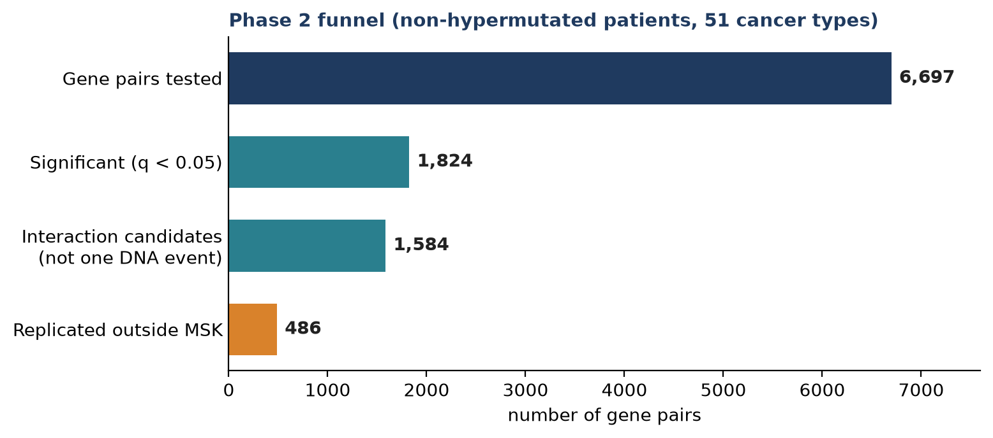
Figure 2. From pairs tested to replicated candidates. Of the 839 MSK hits testable in other centres, 65% replicate and none reverses direction.
- 1,824 of 6,697 pairs significant (27.2%), down from 72.3%, on a smaller, driver-only pair list.
- 1,584 interaction candidates: 426 co-occurring and 1,158 exclusive (350 flagged weak). The skew of almost 3:1 toward exclusivity matches the literature's view that exclusivity is the more reliable signal.
- Known biology recovered: KRAS/EGFR, KRAS/BRAF, EGFR/IDH1 and PIK3CA/PTEN (breast) exclusive; MDM2 amplification vs TP53 mutation exclusive across cancer types; KEAP1/STK11 co-mutated in lung; the breast 11q13/8p12 co-amplification.
- Hypermutated patients alone (TMB 10-100): 881 of 98,907 pairs significant (0.9%), mostly MSI-vs-MSS subtype structure, so reported as a description, not as candidates.
- Mutation-only analysis (all 155,020 patients with mutation data): 573 significant of 2,403 pairs; mutation calls are the most consistent between centres (replication 84%).
- Mechanism-specific tests (mutation vs copy number on each side): 8,445 tests, 2,239 significant, 687 cross-mechanism.
- Pan-cancer pairs (≥5 cancer types, same direction): 13.

Gene fusions in the screen
Each fusion with at least 20 carriers was tested against its cancer type's genes: 255 pairs in 13 cancer types, 109 significant (92 exclusive, 17 co-occurring). It recovers known biology:
- ALK, ROS1 and RET fusions avoid EGFR, KRAS, STK11 and KEAP1 in lung cancer (ALK + EGFR: 4 observed vs 140 expected; ALK + STK11: 0 vs 60). Different drivers, rarely together.
- ERG fusions avoid SPOP, FOXA1 and CDK12 and go with PTEN loss in prostate cancer; FGFR2 fusions avoid IDH1/KRAS and go with BAP1 in cholangiocarcinoma.
- Frequency is not enrichment: TP53 is present in 24% of ALK-fusion lung cancers (Jiang 2023 reports ~31%), yet is under-represented relative to expectation (124 vs 191), because ALK fusions arise mostly in never-smokers. The tool must show both numbers.
- Artefact flagged: breast “FGFR1 fusions” co-occur with FGFR1 amplification. These are rearrangements inside the 8p11 amplicon, not driver fusions.

Which design replicates best?
We compared five designs by discovering in MSK patients and re-testing the same pairs in all other centres (10 cancer types).
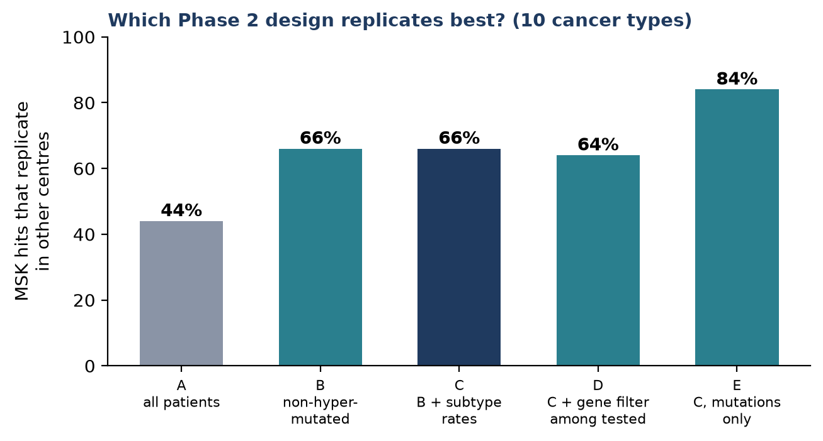
Figure 3. Replication rate by design. Design E replicates best but tests fewer pairs and cannot see copy-number biology such as CDKN2A deletion.
Why both the TMB split and the conditional test
Splitting hypermutated patients off is not enough: Fisher's test is still inflated afterwards. The conditional test alone is not enough either: on all patients it leaves 25% of colorectal pairs significant versus 5.8% in non-hypermutated patients. Ultramutated tumours (TMB ≥ 100, mostly POLE) are excluded from the hypermutated group because pooling them made 21.6% of endometrial pairs “significant”; separated, 0.3% and 0%.

7.5 How much to trust a significant pair: the deep dive
A small q-value says not chance. It does not say gene-gene interaction. Notebook 06 (06_phase2_deep_dive.ipynb, re-run on the final Phase 2 outputs on 24 Oct) re-examines all 687 significant cross-mechanism hits (313 co-occurring, 374 exclusive) for four other explanations. Its headline findings:
- Exclusivity is more robust than co-occurrence: 80% of exclusive vs 62% of co-occurring hits survive subtype stratification, and only about 1% of either direction reverses. 37% of co-occurring hits are attenuated, mostly confounded or reversed, against 19% of exclusive ones.
- Burden trims co-occurrence more than exclusivity: a median 23% of the log odds ratio is lost for co-occurring hits vs 11.5% for exclusive ones.
- *TP53*-mutant tumours carry 2x more deep copy-number changes. “Gene X amplified co-occurs with TP53 mutated” recurs in up to 8 cancer types (MYC, ERBB2), but this is one fact (p53 loss causes genomic instability), not many gene-specific interactions. Burden explains a median 26% of such hits and essentially all of four (FGF3/FGF4 in bladder, NKX2-1/TERT in lung).
- Proximity is small for cross-mechanism pairs: 2.9% (20 of 687) are genomic neighbours, mostly CDKN2A mutation against deletion of its neighbours CDKN2B and MTAP.
- 16% of subtype-robust co-occurrence hits (31 of 194) involve a copy-number gene that is an oncogene elsewhere but a likely passenger here (KIT/KDR riding the PDGFRA amplicon in glioma; FGF3/FGF4/FGF19 riding CCND1). The gene-level driver filter is blind to tissue.
- 260 of the 687 hits survive every check (107 co-occurring, 153 exclusive), for example MDM2 amplification vs TP53 mutation (8 cancer types), EGFR amplification vs IDH1 mutation in glioma, and ATRX loss with IDH1 mutation in glioma. Even this list contains a known passenger (CD79B/GATA3 in breast), so “survived” is not “is an interaction”.
Notebook 06 was brought up to date on 24 Oct
An earlier copy (last saved 13 September, before the v3 redesign) quoted “8,725 significant pairs” and recommended replacing Fisher's test. It also failed on the current Phase 2 output, which now reports fold_enrichment and direction instead of an odds ratio. The code was adapted, the notebook re-run, and its narrative rewritten with the new numbers. Several older claims no longer held (for example “15 cancer types”, “1.3% neighbours”, “333 of 918 hits”). The notebook and its output mechanism_pairs_checked.parquet are now committed.

7.6 Compared with the literature
- Agrees with DISCOVER, WeSME and WExT that Fisher's test is wrong for this data, and goes further: the DISCOVER plug-in estimate itself is biased on panel-sized gene sets.
- Puts into practice the warnings of van de Haar 2019 and MOSAIC 2026 about subtype and load. Hits that survive subtype adjustment replicate 73% of the time versus 35% for those that do not.
- Adds cross-centre replication, which most GENIE papers lack, in the spirit of Park & Lehner's re-testing.
Questions worth asking at this point
• Why is the conditional test exact rather than a permutation test? (It computes the permutation null analytically, so it is faster and has no sampling noise.)
• What does “replicated” mean precisely? (p < 0.05 in the other centres with the same direction; it is a floor on reliability, since artefacts shared by all centres also replicate.)

Source files for this part: notebooks/02_phase2_comutation_matrix.ipynb, notebooks/06_phase2_deep_dive.ipynb, README.md (Phase 2), docs/literature_review.md §7-§8.

PART 8

Phase 3: the lookup tool
Aim 1. What a clinician can ask, how each answer is computed, and why the registered similarity-matching idea lost.
Notebook: notebooks/03_phase3_lookup_tool.ipynb Inputs: Phase 1 tables (read directly), Phase 2 results (as annotation), CIViC evidence
Design principle
The tool reads the Phase 1 tables directly so that rare combinations are not filtered away, and it uses Phase 2 only to say whether a pair is also a statistically supported interaction. Statistical answers use non-hypermutated patients and subtype strata, as Phase 2 does; raw counts are shown for every TMB group.

8.1 Five questions, five functions
Clinician's question | Function | How it is answered
What else is usually altered with this? | lookup() | Panel-aware % in carriers vs non-carriers with a 95% interval, split by TMB group and optionally subtype, plus Phase 2's verdict (e.g. “candidate, replicated”)
How common is this exact combination? | combo_prevalence() | Exact counts among patients tested for every gene in the combination, with 95% intervals
Is this rare pair really over- or under-represented? | test_pair() | Phase 2's conditional test run on demand, including variants and pairs below Phase 2's filters; labelled exploratory when fewer than 5 are expected
Given the whole profile, what else is likely? | predict_partners() | One regularised logistic model per gene
What does it mean for treatment? | therapy_evidence() | CIViC evidence (3,433 accepted predictive/prognostic items), including combinations

Queries can be genes, variants (('KRAS', 'p.G12C')), copy-number changes (('MET', 'AMP')) or fusions ('ALK_fusion').

8.2 The registered aim, tested and rejected
The registered description promised to “match a new patient to genetically similar cases”. We tested four ways on held-out data, hiding one real alteration per patient and asking each method to recover it (6 cancer types).
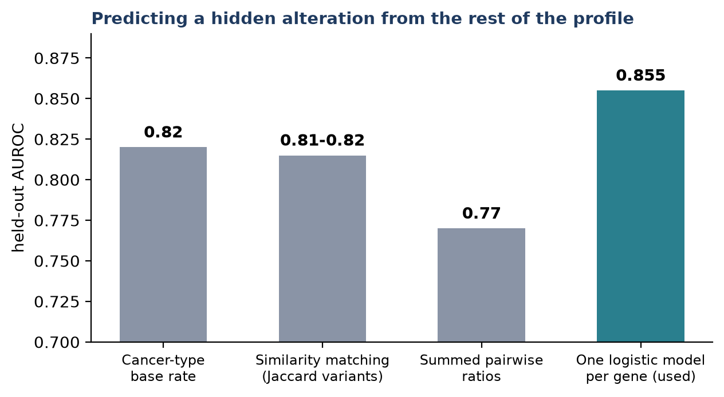
Figure 4. Held-out AUROC (axis starts at 0.70). Similarity matching does not beat simply knowing the cancer type's base rate; per-gene logistic models beat it in every cancer type and are well calibrated.
Why similarity failed: panel profiles carry only 2-4 alterations, so nearest neighbours are noisy, and raw co-occurrence ratios are inflated by heavily altered tumours (the Fisher trap again). Exact matches are still counted by combo_prevalence(), so the registered aim is met by the tool even though the method changed. Rejecting the planned method on evidence is a result worth stating in the report.

8.3 Does the tool hold up?
- It reproduces Phase 2: for KRAS/STK11 the on-demand test gives expected 460.5 vs 460.4.
- Frequencies are reproducible: MSK vs other centres correlate at 0.89-0.996, median difference under 1 percentage point.
- It matches published numbers: KRAS G12C + STK11 in lung cancer is 26% in GENIE vs about 25% in the literature.
Worked example: BRAF V600E + NRAS in melanoma
Seen in 7 of 4,144 patients, 27 times rarer than expected. CIViC holds level-B evidence that the combination confers resistance to BRAF inhibitors. One query returns the frequency, the statistical verdict and the treatment evidence together.

8.4 Compared with the literature, and limits
- The tool is variant-level, in line with Scharpf 2022, Cook 2021 and Vaeyens 2023, which show partners differ by allele.
- Similarity matching (Foote 2025; TumorComparer) works on richer profiles but did not work on panel data here.
- Limit: co-occurrence is not treatment prediction. OncoKB would add a second evidence source but needs a licence token.
- Not yet built: a simple web interface (for example Streamlit), planned once Prof. Wong agrees what it should show.
Questions worth asking at this point
• Why logistic models rather than a more powerful learner? (Profiles are short and sparse; the gain over the base rate is the question, not maximum accuracy. Worth discussing.)
• How would a new hospital's panel be handled? (The lookup is panel-aware, so genes the panel does not cover are simply not queried.)

Source files for this part: notebooks/03_phase3_lookup_tool.ipynb, README.md (Phase 3), docs/literature_review.md §10.

PART 9

Phase 4: biological insight
Aim 2. Phase 2 says which pairs interact; Phase 4 asks why, where, and how rare.
Notebook: notebooks/04_phase4_insight.ipynb Outputs: cancer_type_heterogeneity.parquet, rare_combinations.parquet, allele_*.parquet
# | Question (from the literature) | Finding
1 | Are exclusive pairs redundant hits in one pathway? (Sanchez-Vega; Mina; El Tekle) | Exclusive pairs are 3.3x enriched within one of 10 TCGA oncogenic pathways (4.5x for replicated pairs): EGFR/KRAS, BRAF/NRAS, MDM2/TP53, PIK3CA/PIK3R1. Co-occurring pairs are not enriched across pathways (OR ≈ 1). Exclusive pairs across pathways (EGFR vs STK11/KEAP1 in lung) are candidate incompatibilities
2 | Which interactions are universal, which type-specific? (Park & Lehner) | A third of the 538 pairs tested in ≥3 types differ between types; 47 reverse direction: EGFR/TP53 (together in lung, apart in glioma), KRAS/TP53 (together in pancreas, apart in lung and colorectal), CCND1/TP53. 21 are universal (ATM/TP53, CDKN2A/RB1, MDM2/RB1)
3 | Do variants of one gene have different partners? Is it smoking? (Scharpf; Cook; Vaeyens) | 10 of 201 (gene, partner) combinations differ by allele: EGFR L858R vs exon 19 for RBM10 (q = 4e-22); PIK3CA helical vs kinase for GATA3 and PTEN. Adjusting for each patient's smoking signature (C>A share) shrinks KRAS G12C/STK11 from 2.00x to 1.74x and removes G12C/RBM10; the non-smoking allele G12D is unchanged (a negative control)
4 | Which combinations are rare, and do they exist? | 351 replicated exclusive pairs; 130 seen in 1-20 patients. ALK fusion + STK11 in lung: 0 observed vs 60 expected. GNAQ + GNA11 in melanoma: 0 vs 44. H3F3A + IDH1 in glioma: 1 vs 43 (two distinct glioma classes)
5 | What differs in hypermutated tumours? (van de Haar; Campbell) | Mostly subtype structure (MSI vs MSS in colorectal cancer), not new interactions
6 | Do mutation-only and mutation-or-copy-number analyses agree? | Same direction in 98.9% of pairs significant in both
7 | Is anything here new? (novelty audit) | Of 386 robust pairs, 41 are in neither the literature nor the SelectSim atlas, and those are amplicon passengers or subtype markers; the best candidate (CTCF vs TP53, endometrial) is in SelectSim's atlas

9.1 A blind spot we found in our own method
The amplifier-burden confound (6 Oct 2026)
Looking for genuinely new signal, we found CD79B, a B-cell gene with no breast-cancer role, flagged as co-occurring with GATA3, MDM2, AURKA and GNAS in breast cancer. It is a passenger on the 17q23 amplicon; its carriers have a median of 7 other amplified genes versus 1 overall, a general “amplifier” phenotype. After adjusting for each patient's amplification burden the GATA3 link reversed sign (pure confound), while MDM2/AURKA/GNAS survived.
Systematic follow-up: of the 25 copy-number-driven candidates (at least 80% of co-altered patients carry copy-number changes in both genes), 21 survive burden adjustment and 4 are artefacts (BCL2L1/MYC colorectal, CCND1/CDKN2A bladder, CDK4/TERT and FOXA1/TERT lung).

- Building burden directly into the main test over-adjusts: known pairs like CCND1/FGFR1 are lost, because burden is partly caused by the genes being tested. So burden adjustment is kept as a sensitivity flag (burden_robust), not the default: in the final run 1,276 of 1,584 candidates pass it.
- An earlier quick check had compared amplification-only status for GATA3, which is mostly altered by mutation, so it tested a different question. The corrected, systematic script (12_burden_adjusted_retest.py) is authoritative.

9.2 An exception to the pathway rule
NF1 and PTPN11 are both RTK-RAS pathway genes, yet they co-occur in glioma, almost entirely through point mutations (so the amplicon confound does not apply). A plausible reading is cooperation rather than redundancy: losing the brake (NF1) while pressing the accelerator (PTPN11).

9.3 Is anything new? A novelty audit
The questions above come from the literature, so the answers mostly confirm known biology. To find what is not yet reported, each of the 386 most robust pairs (replicated outside MSK, burden-robust, not weak) was checked against two sources (19_novelty_screen.py): Europe PMC papers naming both genes and the cancer type in the title or abstract, and the SelectSim atlas, whose 892 validated pairs sit in a supplementary table that no title search can see.
- 343 of 386 pairs are already named together in titles or abstracts; 41 are in neither source.
- Those 41 are almost all stand-ins for known biology: passenger genes on an amplicon standing in for the real driver next to them (GLI1 beside CDK4, KDR beside PDGFRA, RARA beside ERBB2, MTAP beside CDKN2A, CD79B on 17q23), or subtype markers (CCNE1 vs CTNNB1 in endometrial cancer).
- The driver-level ones were stress-tested (20_candidate_followup.py) with logistic regression adjusted for subtype, the obvious third genes, copy-number burden and TMB, and once more in TMB < 5 tumours only. MDM2 vs SMARCA4 (lung) is explained by TP53; KRAS vs RARA (gastric) by ERBB2; BCL2L1 vs SMAD4 (colorectal) by burden; CTCF + PIK3R1 (endometrial) by residual microsatellite instability.
A candidate that turned out to be known: CTCF vs TP53 in endometrial cancer
CTCF mutations are rare in TP53-mutant endometrial cancers: 22 observed vs 121 expected. The avoidance holds after subtype, PI3K-pathway genes, copy-number burden and TMB (adjusted odds ratio 0.34, p = 3e-4), goes the same way in TCGA, and the silent-mutation route agrees.
No title or abstract reports it, so the literature screen flagged it as new. But SelectSim's supplementary atlas lists it (endometrial, breast and pan-cancer). Our analysis is an independent confirmation under stricter adjustment, not a discovery.
Lesson: a novelty claim must be checked against the supplementary tables of atlas papers, not only against abstracts.

What the audit means.
- Agreement with an independent atlas: all 79 robust pairs that SelectSim reports for the same cancer type have the same direction here (0 opposite), from a different team, method and GENIE release.
- At the level of mutation-driven driver pairs in common cancers, the landscape is close to saturated. This is a result in its own right, and it was checked rather than assumed.
- The project's distinct contribution lies elsewhere: copy-number and fusion partners (SelectSim is mutation-only: 44 of 49 copy-number pairs and 154 of 175 mixed pairs are not in it), panel-aware statistics across all centres, the artefact audits, exact rare combinations and the clinical tool.
- Where new biology is most likely: copy-number × mutation pairs, fusion partners, rare cancer types and variant-level partners. Running the same audit on those is a natural next step.

9.4 Figures
All results are drawn as publication figures in R (scripts/figures/; rebuild everything with bash scripts/figures/run_all.sh). Each is saved as a vector PDF for the thesis and a 300-dpi PNG for slides in results/figures/. Figure types follow the co-mutation literature (GENIE 2017, DISCOVER, maftools, Sanchez-Vega 2018, Park & Lehner 2015, van de Haar 2019, SelectSim 2026). Colours: green = co-occurring, purple = exclusive. Each notebook also shows its own figures in a “Publication figures” section just before its Discussion: Fig 1 in notebook 01; Fig 3 and S1 in 02; Fig 6 and S2 in 03; Figs 4, 5 and S4 in 04; Fig 2, S3, S5 and S6 in 05.
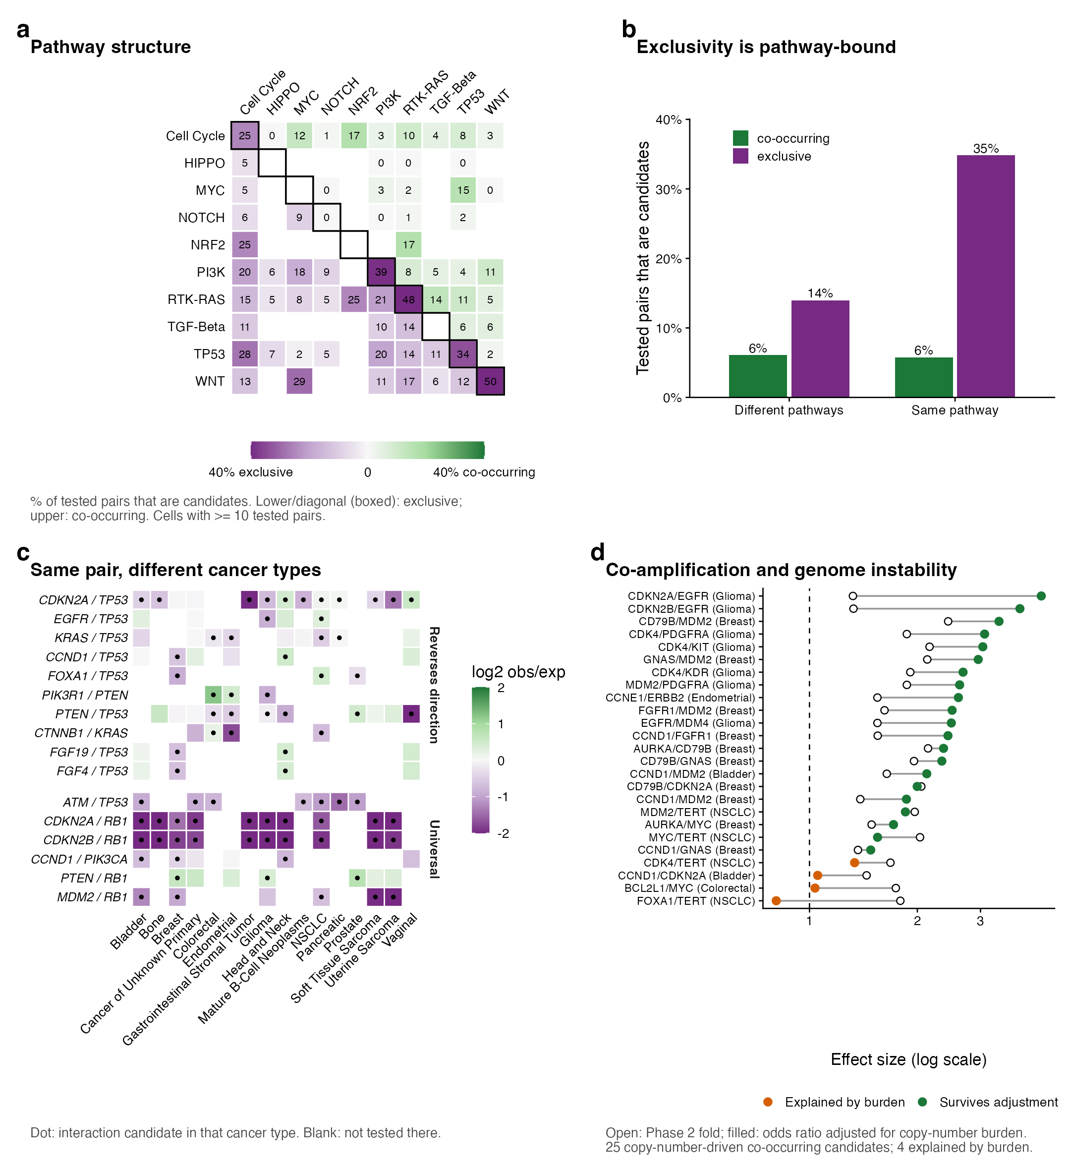
Figure 7. Biology (Figure 4 of the figure set). a, share of tested pairs that are candidates within and between the 10 Sanchez-Vega pathways; b, exclusivity is pathway-bound (35% vs 14%); c, the same pair across cancer types, reversing vs universal; d, copy-number burden check for the 25 copy-number-driven pairs.
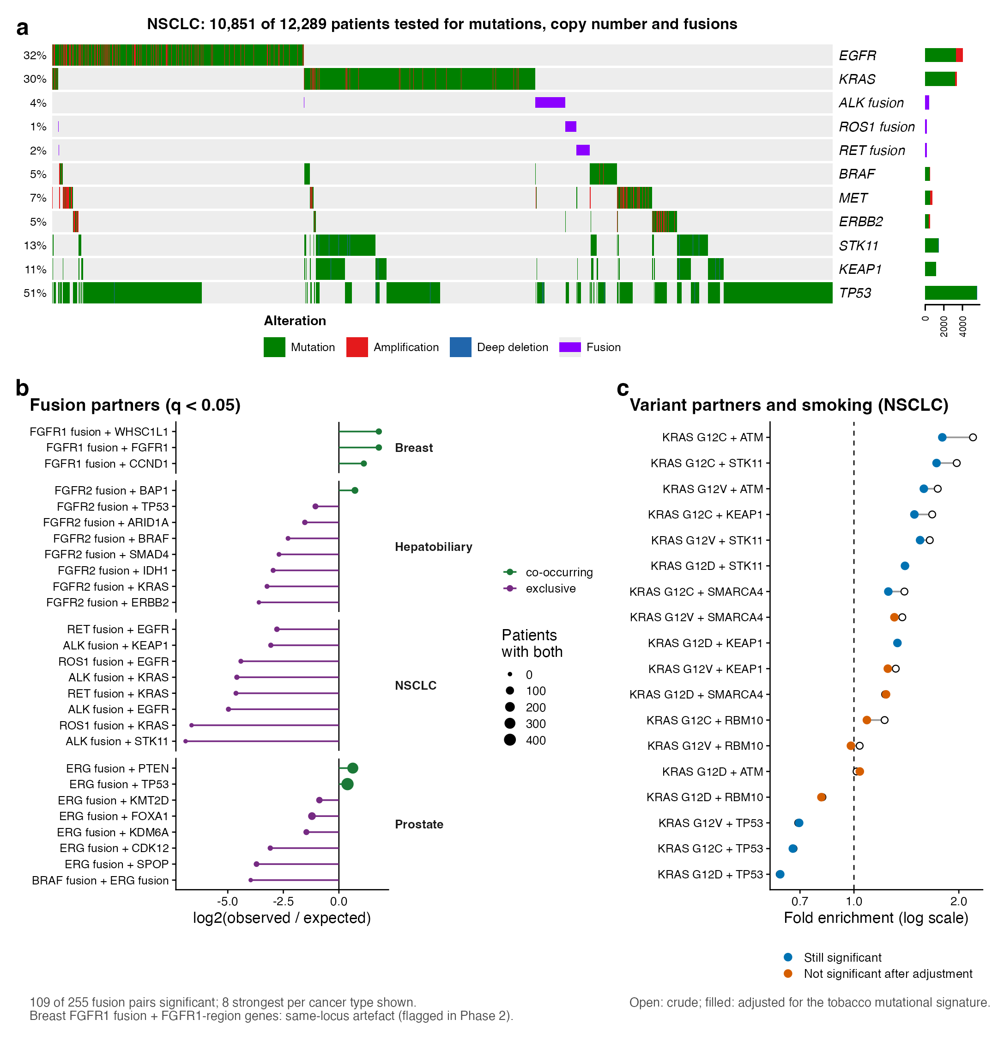
Figure 8. Fusions and variants (Figure 5 of the figure set). a, lung cancer oncoprint: EGFR, KRAS and ALK/ROS1/RET fusions form a staircase of mutual exclusivity; b, fusion partners per cancer type; c, KRAS variant partners before and after adjusting for the smoking signature.
The full set (results/figures/):
- Fig 1 Data: patient flow; cohort by centre; panel metadata vs released data; alterations per patient.
- Fig 2 Can the test be trusted? null p-value histograms; head-to-head benchmark; GENIE vs TCGA effects.
- Fig 3 Landscape: triangle heatmaps (lung, breast, colorectal); volcano of all 6,697 pairs; lung interaction network.
- Fig 4 Biology and Fig 5 Fusions and variants (shown above).
- Fig 6 The tool: KRAS G12C partners; partner prediction vs base rates; MSK vs other-centre frequencies.
- S1-S6: filter funnel; UpSet of lung drivers; KRAS/TP53 forest plot; rare combinations; dN/dS route; exclusive gene sets.

9.5 Limits stated in the notebook
- Pathway membership uses only 10 curated pathways (165 genes); pairs outside are unclassified.
- Heterogeneity variances are approximate (Poisson).
- The smoking proxy is inferred from panel mutation spectra; GENIE has no smoking history.
- Exclusivity in a cross-section cannot separate redundancy from synthetic lethality.
- The novelty audit counts papers that name both genes, not papers that claim the interaction, and covers one atlas; gene symbols that are also words (MET, ATM, KIT) err towards “known”.
Questions worth asking at this point
• Is “exclusive = same pathway” a finding or an assumption? (Finding: tested as an enrichment, 3.3x; but only for genes in the 10 curated pathways.)
• Why trust exclusive pairs more than co-occurring ones? (More robust to subtype, never reverses, strengthens under adjustment; see Part 7.5.)

Source files for this part: notebooks/04_phase4_insight.ipynb; git commits d040be9 and 507ace8; scripts/analyses/12_burden_adjusted_retest.py (script 11, the first check, is retired); scripts/analyses/19_novelty_screen.py and 20_candidate_followup.py; scripts/figures/ and results/figures/.

PART 10

Independent checks
Does the whole thing hold up in patients, centres and statistical routes it was not built on?

10.1 External validation in TCGA
All results of this part are collected in notebooks/05_validation_and_methods.ipynb. scripts/analyses/14_tcga_external_validation.py re-tests the same pairs, with the same test, in the TCGA PanCancer Atlas (independent patients, whole-exome sequencing, different centres and calling pipelines, non-hypermutated). Phase 1 rules were applied as closely as the data allow.
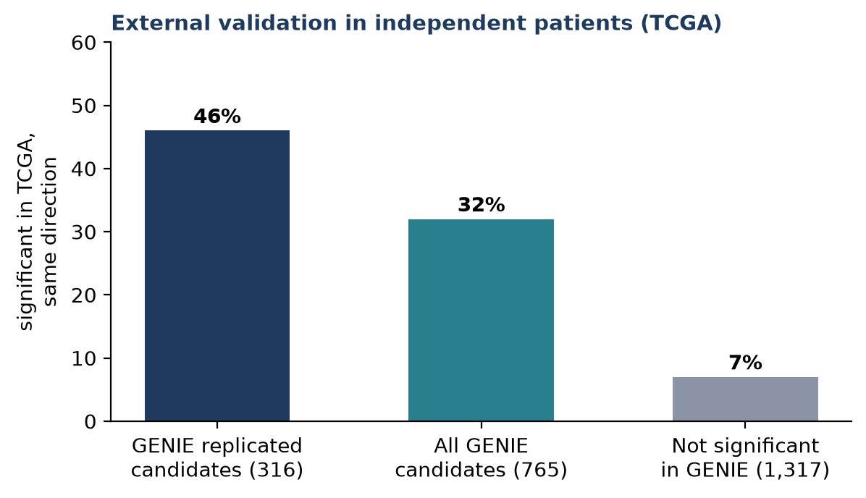
Figure 5. Share of pairs significant in TCGA in the same direction. Bracketed values are the number of pairs testable in TCGA.
GENIE result | Testable in TCGA | Same direction | TCGA p<0.05, same direction | Significant, opposite
Replicated candidates | 316 | 94% | 46% | 0
All candidates | 765 | 88% | 32% | 0
Not significant in GENIE | 1,317 | 69% | 7% (≈ chance) | 13

- Replicated candidates validate 6.5x more often than GENIE-null pairs, and none reverses. KEAP1/STK11, EGFR/KRAS, CCND1/FGFR1 and CDKN2A/EGFR are confirmed.
- TCGA is about 20x smaller, so a non-significant TCGA result mostly reflects low power.
- Agreement is lowest in lung cancer (79%), where TCGA is half squamous and smoking-related while GENIE is mostly adenocarcinoma.

10.2 An independent statistical route: conditional selection
Borrowing Coselens' idea (17_conditional_selection_dnds.py): if gene A helps gene B get selected, B's ratio of protein-changing to silent mutations should be higher in A-mutant tumours. Silent mutations measure each group's background mutation rate, so this controls mutation load by a completely different route than the conditional test.
- 219 testable directions among mutation-driven replicated candidates; direction agrees with Phase 2 in 84%, and in 100% of the 53 that are themselves significant.
- Example: IDH1-mutant gliomas carry 8x more protein-changing (relative to silent) CIC mutations than IDH1-wild-type gliomas, the biology of oligodendroglioma.
- Limit: panels report few silent mutations per gene, and subtype confounding is shared with the main analysis.

10.3 Partial pooling across cancer types
Borrowing Scharpf's idea (18_hierarchical_shrinkage.py): pull each cancer type's effect toward the pair's pooled effect, more when the estimate is noisy. Against TCGA effects over 2,152 testable pairs, correlation rises 0.691 → 0.700 and squared error falls 0.206 → 0.195; for noisy estimates (<30 co-altered patients) correlation rises 0.558 → 0.577. A modest gain that also blurs cancer-type specificity, so pooled estimates are kept as an extra column, not used for headline calls.

10.4 Head-to-head benchmark of the method families
15_method_benchmark.py ran each family on identical patients and pairs (9 cancer types, 2,553 pairs, panels covering every gene used) and scored it two ways: false positives on null data that keep every patient's alteration count and every gene's frequency but destroy gene-gene links, and replication of each method's significant calls in TCGA. SELECT (Mina 2017) was re-implemented from its published Methods S1 (weighted mutual information, 1,000 margin-preserving randomisations within subtypes, effect size and empirical FDR); a first simplified “SELECT-style” score without a null was withdrawn because it was not SELECT.
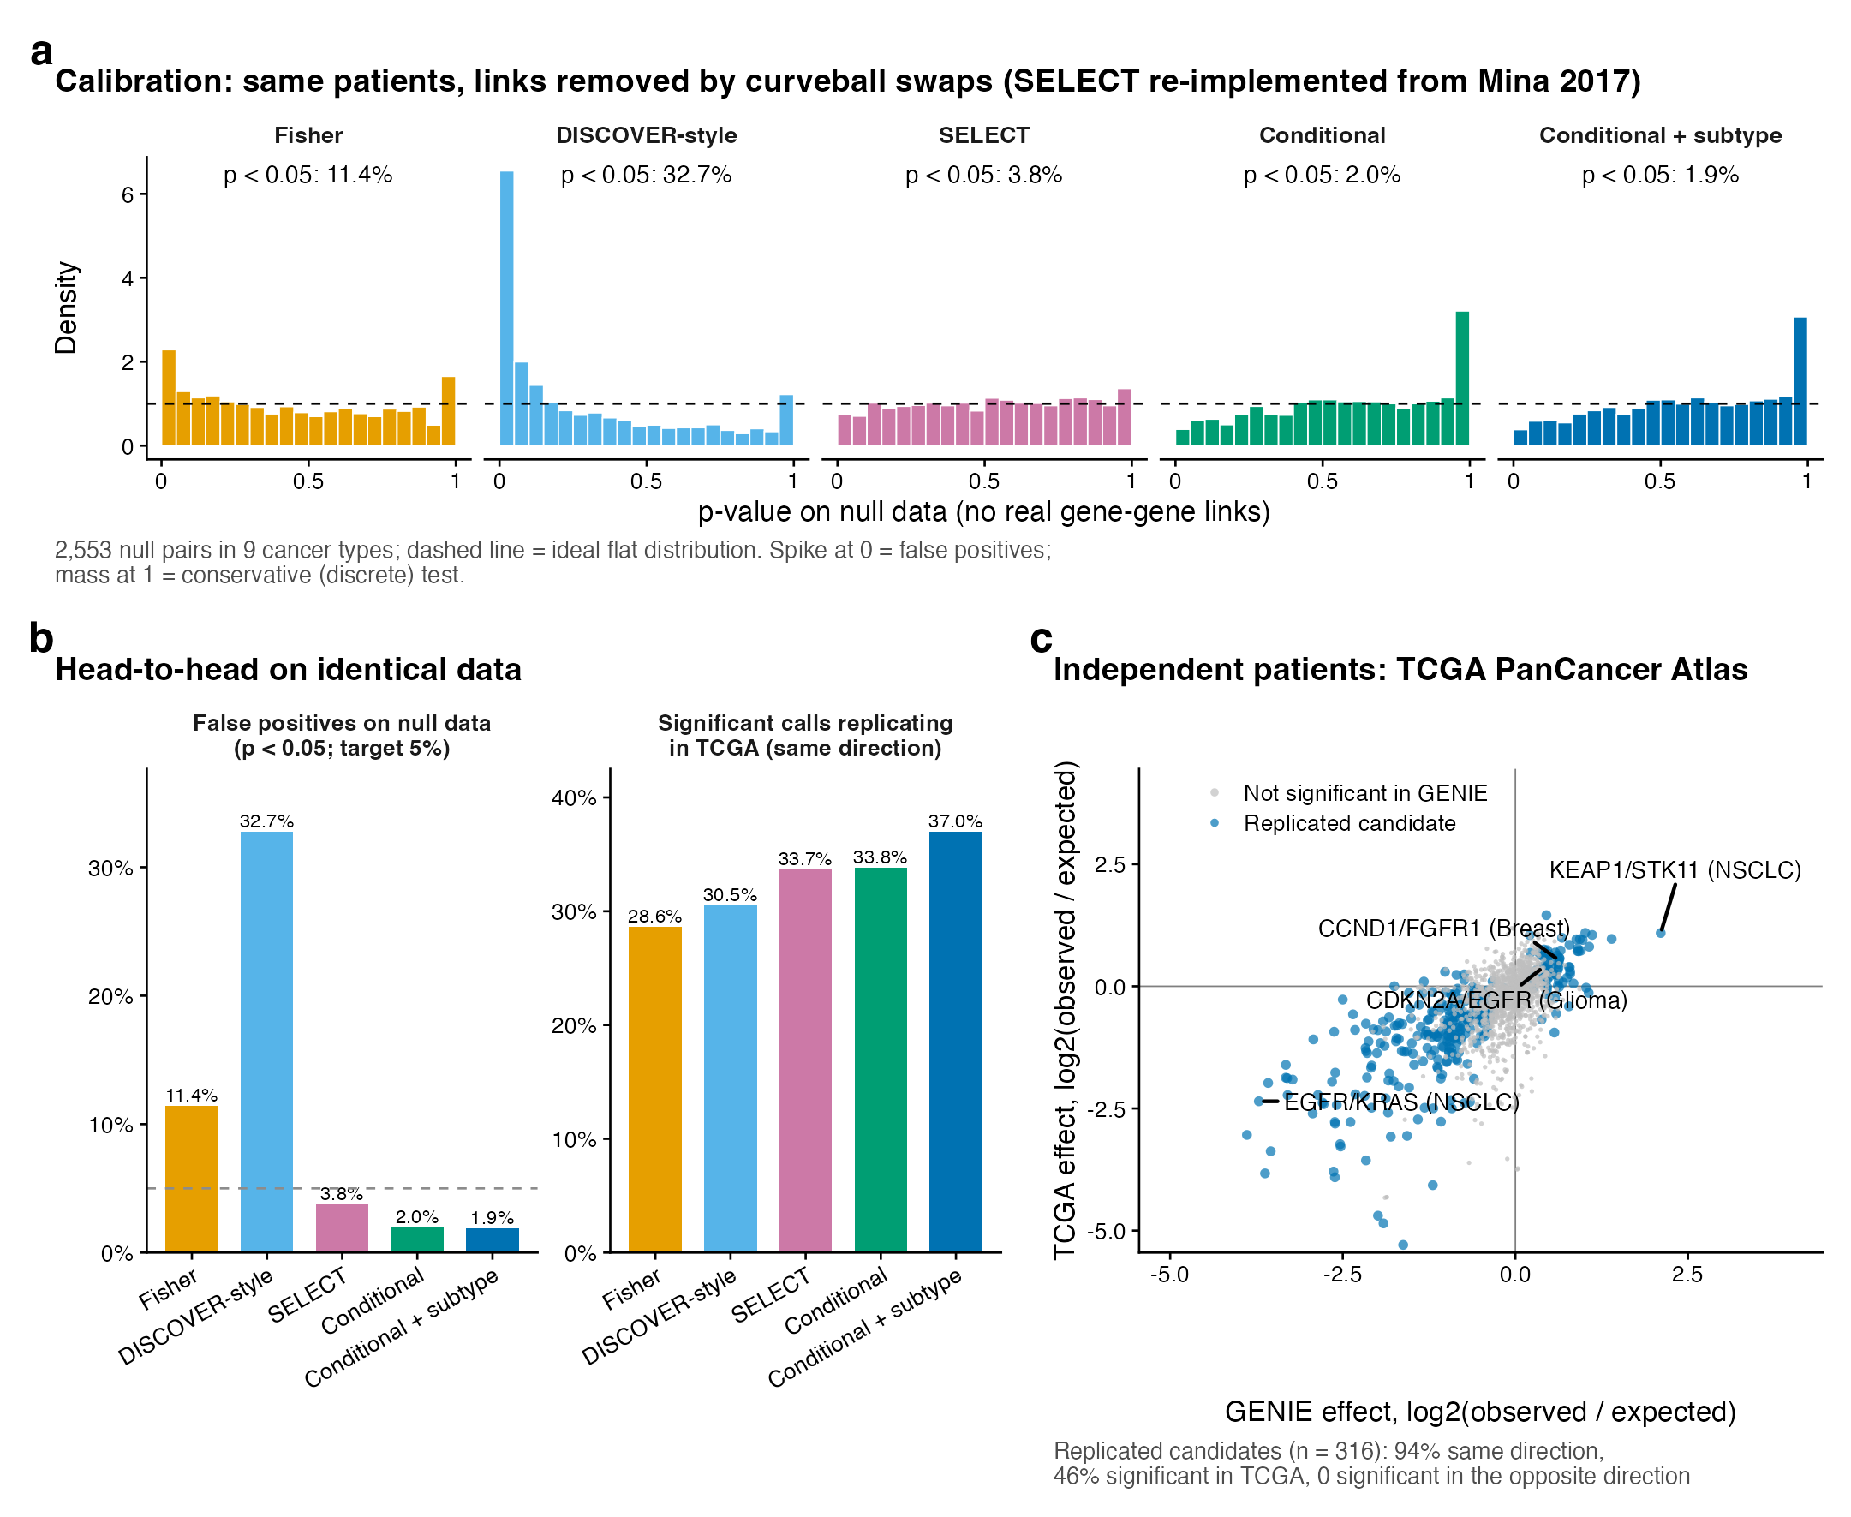
Figure 6. Figure 2 of the figure set. a, p-values on null data with no real gene-gene links (flat = calibrated); b, false positives and TCGA replication per method; c, GENIE vs TCGA effect for every testable pair.
Method | Null p<0.05 | Null after FDR | Significant (real data) | Replicate in TCGA | Opposite in TCGA
A Fisher (cBioPortal, maftools) | 11.4% | 0.6% | 990 | 28.6% | 0
B1 DISCOVER-style plug-in (Rediscover) | 32.7% | 18.1% | 1,101 | 30.5% | 0
B2 Conditional test, no strata | 2.0% | 0% | 853 | 33.8% | 0
B3 Conditional + subtype strata (Phase 2) | 1.9% | 0% | 677 | 37.0% | 0
D SELECT (Mina 2017; re-implemented) | 3.8% | 0.2% | 770 | 33.7% | 0

- Calibration needs a margin-preserving null. The conditional test (exact) and SELECT (by randomisation) are both calibrated; Fisher over-calls, and the DISCOVER-style plug-in is worst, with 18% of null pairs surviving FDR, all as false exclusivity.
- Our calls replicate best (37% vs 34% for SELECT and 29% for Fisher) with fewer calls: the extra calls of the other methods are mostly the ones that fail.
- The strongest pairs are found by every method (84-92% of each method's top 50 replicate). Methods differ on the marginal calls, which is where false positives live, and where a clinician's query usually lands.
- Honest caveat: subtype strata rank slightly lower at the top 200 pairs (56% vs 63% for the conditional test without strata), because the pairs they remove are subtype markers that TCGA reproduces too. External replication cannot penalise an artefact the two cohorts share, so the case for strata rests on the removed pairs being textbook subtype markers (CIC vs PTEN, CDH1 vs ERBB2).
- SELECT ranks the very strongest pairs best (96% of its top 50 and 84% of its top 100 replicate): its effect size is a good ranking score. Our advantage is the precision of the significant list, not the top of the ranking.

10.5 Exclusive gene sets: does the load-aware idea carry over?
16_exclusive_gene_sets.py compared Dendrix's “coverage minus overlap” score with a load-aware version that uses the conditional model's expected overlap. Both scored every gene triple among the 35 most altered genes in 6 cancer types, judged by whether the top 20 sets form one known pathway.
 | Dendrix | Load-aware
Top-20 sets with all 3 genes in one pathway | 5% | 15%
Top-20 sets with at least 2 genes sharing a pathway | 46% | 73%
Mean frequency of the genes chosen | 0.24-0.30 | 0.19-0.22

The top load-aware sets are textbook pathways: BRAF/KRAS/NRAS (colorectal), AKT1/PIK3CA/PIK3R1 (endometrial), CDK4/CDKN2A/RB1 (glioma), EGFR/ERBB2/KRAS (lung). Dendrix instead bundles TP53 with other common genes (ATM/SMAD2/TP53, KRAS/MDM2/TP53), because a coverage score that ignores mutation load rewards whatever is frequent. The load-aware null matters for sets as it does for pairs.

10.6 Mutation-load confounding: van de Haar's diagnostic
21_mutation_load_confounding.py runs the check van de Haar et al. (2019) used to show that most published mutual exclusivity is confounded by mutation load. Each gene gets a mutation load association (MLA): is it altered more in low-load or high-load tumours? On exome data, every method they tested called far more exclusive pairs for low-MLA genes (correlation r = -0.60 to -0.87).
- Not seen on GENIE panels in our design. With non-hypermutated tumours only, the correlation is slightly positive for every method (Fisher +0.16, DISCOVER-style +0.25, SELECT +0.13, ours +0.20).
- A weak version appears once hypermutated tumours are included (Fisher -0.17, ours -0.17): our test alone does not remove it.
- So the split removes it. Analysing non-hypermutated tumours separately (Prof. Wong's suggestion) is what protects against load confounding; the conditional test protects calibration. They fix different problems, which is why the design keeps both.
What trying the published methods taught us
• The main design choice is confirmed from three directions: null calibration, independent patients (TCGA) and an independent signal (silent-mutation ratios).
• The advantage is in the long tail of moderate effects, not in headline pairs.
• Copy number needs its own artefact checks (burden, neighbouring genes, shared events); no published method addresses them for panel data.
• SELECT, re-implemented faithfully, is the closest alternative: calibrated and best at ranking the strongest pairs. Shrinkage was borrowed but not adopted (small gain, blurs specificity).
• Mutation-load confounding (van de Haar) is removed by analysing non-hypermutated tumours separately, not by the choice of test.
All tables of this part are reproduced in notebooks/05_validation_and_methods.ipynb.

Source files for this part: notebooks/05_validation_and_methods.ipynb, results/logs/15-17 logs, scripts/analyses/14-18_*.py and 21_*.py, docs/literature_review.md §7 and §10.

PART 11

Where things stand
An honest status: what is done, what is moving, what needs a decision, and what to be careful about.

11.1 Progress dashboard
Component | State | Notes
Phase 1: cleaning | Done | Re-run 22 Oct with fusions; 1,945,807-row alteration table
Phase 2: pair screen | Done (v3 + fusions + burden flag) | Re-run 23 Oct; 6,697 pairs, 1,584 candidates, 486 replicated
Phase 3: lookup tool | Built and re-run | Accepts genes, variants, copy number and fusions. No web interface yet; OncoKB not integrated
Phase 4: insight | Built and re-run | Includes the burden-confound analysis and the fusion-aware rare-combination catalogue
Notebook 05: validation and methods | New, committed | Collects TCGA validation, benchmark, gene sets, dN/dS, shrinkage, burden, fusions
External validation (TCGA) | Done | 94% same direction, 0 reversed
Method benchmark (15), gene sets (16), dN/dS (17), shrinkage (18) | Done | Results in Part 10; logs in results/logs/
Literature review | Complete | Placeholders filled; 41 references
Notebook 06: deep dive | Re-run 24 Oct; committed | Updated to the final Phase 2 outputs; 260 of 687 hits survive all checks
Supervisor review | Pending | docs/supervisor_summary.md is the briefing
Figures (R) | Done | 6 main + 6 supplementary; rebuilt by scripts/figures/run_all.sh
Novelty audit (19, 20) and SelectSim comparison | Done | No new driver pair survives; full agreement in direction with SelectSim

11.2 Decisions that need Prof. Wong's view
- Main analysis = non-hypermutated patients. Agree that hypermutated tumours are reported descriptively only?
- Subtype labels. GENIE's detailed labels differ by centre (“Glioblastoma” vs “Glioblastoma Multiforme”). Harmonise via OncoTree codes?
- Weak-effect threshold for reporting (currently 1.5-fold).
- Thesis emphasis: the tool, or the biology? This decides what to polish first.
- Data access: apply for GENIE BPC (treatment and outcome) and an OncoKB academic token?

11.3 Not yet supervisor-reviewed
The conditional pair test; the germline cutoff change (1e-4 → 1e-3); one sample per patient; TMB-based hypermutation status; the expected-count gate; the shared-DNA filter; the v3 design (non-hypermutated main analysis, subtype strata, replication); gene fusions; and the burden sensitivity check.

11.4 Limitations to keep in mind
- Some panels list more genes than they report; this can only be detected statistically and is documented, not fixed.
- Panel data has no clonality, so subclonal co-occurrence is out of reach.
- GENIE has no treatment data, so the tool reports evidence, not predicted response.
- TCGA is ~20x smaller, so many pairs cannot be validated there.
- Replication is a floor on reliability: artefacts shared by all centres (hypermutation, subtype) also replicate.
- A significant pair is a statistical association, not proof of a gene-gene interaction (Parts 7.5 and 9).

11.5 Things that may confuse you
Inconsistencies found on 24 Oct, and what was done
• Notebook 06 was stale in text and code: re-run and rewritten (see Part 7.5), now committed.
• Alteration-table size: README Phase 1 step 5 and two text cells in notebook 01 said 1,936,188 rows / 230,886 samples. The data say 1,945,807 rows / 232,386 samples (1,644,226 mutations + 291,962 copy-number calls + 9,619 fusions). Fixed in all three places.
• Conditional-selection directions: the literature review said 218; the output file has 219 rows. Fixed.
• Panel count: 167 is correct (clinical file, panel coverage table and genomic_information.txt all agree). The old PLAN.md said 166, which is the number of panel files: the exome panel UHN-WGS-V1 has none. It also had 117 cancer types (true: 112) and 172,875 copy-number samples (true: 172,874).
• PLAN.md was deleted. Its lower half was the original plan (clusters, survival, Fisher's test) and no longer matched the work. The registered project description and the reason for the refocus now live in the README; the full file is in git history (commit 92e8234).
• Committed together with notebook 06, mechanism_pairs_checked.parquet and this guide.
• Notebook 07 (the Phase 2 deep dive) was renamed 06 on 25 Oct so the run order has no gap; older notes and commits call it 07.

11.6 Likely next steps
- Supervisor review of the v3 design, fusions and the Phase 3-4 results; the five decisions above.
- Simple web interface for the lookup tool once the display is agreed; OncoKB as a second evidence source if a token is obtained.
- Harmonise subtype labels via OncoTree codes if Prof. Wong agrees.
- Run the novelty audit on copy-number × mutation pairs, fusion partners and rare cancer types, where new biology is most likely; confirm CTCF vs TP53 within endometrial molecular classes if labels become available.
- Optional: external replication in MSK-MET, and GENIE BPC for outcomes.
Source files for this part: README.md (Status), docs/supervisor_summary.md, git log and status of 24 Oct 2026, results/logs/.

PART 12

Navigating the repository
Where things live, and how to reproduce them.
Path | What is there
notebooks/01 … 04 | Phase 1-4 notebooks. Each is self-contained, opens with a “data flow at a glance” diagram, shows that phase's publication figures, and ends with a Discussion
notebooks/05_validation_and_methods.ipynb | Collects TCGA validation, method benchmark, gene sets, dN/dS, shrinkage, burden and fusion results (reads saved script outputs)
notebooks/06_phase2_deep_dive.ipynb | Trust checks on Phase 2 hits (subtype, burden, proximity, passengers); re-run 24 Oct, committed
scripts/validation/ | Checks of the Phase 2 test: simulation, scipy/mpmath, Rediscover (R)
scripts/analyses/ | Numbered analyses 01-20 (script 11 retired), each labelled pipeline or design evidence; index and run order in scripts/README.md
scripts/fetch_external.py, scripts/build_notebook05.py | Downloads CIViC evidence and TCGA pathway gene lists; builds notebook 05
data/raw/, data/external/ | Original GENIE files and external resources (not in git)
data/processed/ | Cleaned outputs produced by the notebooks (tracked)
results/ | Script outputs and logs (not tracked); results/figures/ is tracked
docs/literature_review.md | Prior work, method comparison, reasons for every choice
docs/supervisor_summary.md | Short briefing for supervisor review
README.md | Aims, registered project description, headline numbers, pipeline description, GENIE data problems
scripts/figures/ | R figure scripts plus a Python export step; run_all.sh rebuilds every figure
results/figures/ | Publication figures (PDF and 300-dpi PNG); tracked in git; each is also shown in the notebook of its phase
data/README.md, scripts/README.md | Where each dataset comes from and what every processed file contains; what every script does and the run order
LICENSE | MIT licence for the code (GENIE and other data keep their own terms)

12.1 Reproducing the work
- Request GENIE v19.0 access from AACR and place the files under data/raw/.
- Run ./setup.sh in the project folder. It creates a virtual environment, installs requirements.txt and registers a Jupyter kernel named “Python (fyp-genie)”.
- Select that kernel and follow the run order in scripts/README.md: notebooks 01 → 02, the pipeline scripts in scripts/analyses/ (08, 10, 12, 14-20; the TCGA download and the literature screen need the internet), notebooks 03 → 04, then the read-only summaries 05 and 06.
- Run scripts from the repo root. For the figures and the Rediscover check, install R packages once with Rscript scripts/figures/install_r_packages.R, then bash scripts/figures/run_all.sh rebuilds every figure. scripts/validation/build_msk468_matrix.py comes first among the validation scripts.
Why the scripts load the notebook's code
The analysis scripts import the Phase 2 test functions directly from the notebook, so what is validated is exactly what the notebook runs.

Source files for this part: README.md (Repository structure, Setup, Data access, Validation scripts).

Appendix A: Glossary
Term | Meaning
alteration | A mutation, copy-number change or gene fusion in a tumour
driver / passenger | A change that helps the tumour grow / one that merely came along
gene panel | The list of genes a hospital's test reads; 167 different panels in GENIE
null model | What “chance” means in a test; the most important choice in this field
Fisher's exact test | Classic 2×2 test; assumes every tumour has the same chance of every alteration
Poisson-Binomial | Distribution of a count when each tumour has its own probability (DISCOVER, ours)
conditional (Rasch) test | Our test: each tumour's chance is computed given its own number of alterations
permutation null | Reshuffle the data keeping each tumour's and gene's totals fixed; our test computes it exactly
TMB | Tumour mutational burden, mutations per million DNA letters; ≥10 is called hypermutated here
MSI / MSS | Microsatellite-unstable (repair-deficient, hypermutated) vs stable tumours
copy-number burden / CIN | How many genes a tumour has gained or lost / ongoing chromosomal instability
amplicon | A stretch of DNA amplified as one unit, carrying several genes together
deep vs shallow call | Strong copy-number change (±2) vs one-copy gain or loss (±1)
subtype confounding | Two alterations look exclusive only because each marks a different disease subtype
dN/dS | Protein-changing vs silent mutation ratio; >1 suggests positive selection
FDR / q-value | False discovery rate; q < 0.05 means at most ~5% of called pairs expected to be false
replication | The same result in independent patients (other centres, or another cohort such as TCGA)
AUROC | Ability to rank true cases above false ones; 0.5 is a coin flip, 1.0 is perfect
shrinkage / partial pooling | Pulling a noisy estimate toward an average across related groups
over-adjustment | Adjusting for something partly caused by what you test, which hides real effects
OncoKB / CIViC | Curated knowledge bases of the clinical meaning of variants (OncoKB needs a licence; CIViC is open)
ESCAT | ESMO scale ranking the evidence for matched targeted therapy; part of the original clinical framing, not in the current plan

Appendix B: Timeline
Date | Event
6 Jul 2026 | GENIE v19.0 data inventory confirmed; original plan written
24 Sep 2026 | Project refocused with Prof. Wong: lookup tool and insight
30 Sep 2026 | Literature search begins; design-comparison tests complete
3 Oct 2026 | Phase 2 v3 implemented (non-hypermutated, subtype strata, replication)
4 Oct 2026 | Phase 3 tool v2 and Phase 4 analyses built
6 Oct 2026 | Amplifier-burden confound discovered; 24 candidates re-tested systematically
21-22 Oct 2026 | TCGA validation, conditional selection and shrinkage analyses written; fusions added; literature review expanded to 41 references
22-23 Oct 2026 | Notebooks 01-04 re-run end to end with fusions; benchmark and gene-set scripts finish; commit 10a5c99 (fusions, burden sensitivity, TCGA validation, benchmark)
23 Oct 2026 | Notebook 05 added to collect all validation results (commit 92e8234)
24 Oct 2026 | Notebook 07 (renamed 06 on 25 Oct) re-run and rewritten; count fixes in README, notebook 01 and literature review; obsolete PLAN.md deleted; all committed
25 Oct 2026 | R publication figures (6 main, 6 supplementary); novelty audit of 386 robust pairs and comparison with the SelectSim atlas; repository organised (data/ and scripts/ READMEs, notebook 07 renamed 06, MIT licence); allele screen and partner models re-run on the final data (KRAS G12C/STK11 2.00x → 1.74x after smoking adjustment; partner prediction unchanged); script 11 retired; this guide updated
26 Oct 2026 | SELECT re-implemented from its published methods and benchmarked (calibrated; best at ranking the strongest pairs); review statements about van de Haar 2019 and Scharpf 2022 checked against their full texts and corrected; mutation-load confounding check added (script 21); Mina 2020 citations made precise

Appendix C: Key references
Full list of 42 references with DOIs is in docs/literature_review.md. The ones used most in this guide:
- Canisius S, Martens JWM, Wessels LFA. DISCOVER. Genome Biol 2016;17:261. doi:10.1186/s13059-016-1114-x
- Ferrer-Bonsoms JA et al. Rediscover. Bioinformatics 2022;38:844-5. doi:10.1093/bioinformatics/btab709
- Kim YA et al. WeSME. Bioinformatics 2017;33:814-21. doi:10.1093/bioinformatics/btw242
- Leiserson MDM et al. WExT. Bioinformatics 2016;32:i736-45. doi:10.1093/bioinformatics/btw462
- van de Haar J et al. Identifying epistasis in cancer genomes: a delicate affair. Cell 2019;177:1375-83. doi:10.1016/j.cell.2019.05.005
- Park S, Lehner B. Cancer type-dependent genetic interactions. Mol Syst Biol 2015;11:824. doi:10.15252/msb.20156102
- Mina M et al. Conditional selection of genomic alterations. Cancer Cell 2017;32:155-68. doi:10.1016/j.ccell.2017.06.010
- Mina M et al. Discovering functional evolutionary dependencies. Nat Genet 2020;52:1198-207. doi:10.1038/s41588-020-0703-5
- Iranzo J et al. Pervasive conditional selection of driver mutations. Cell Rep 2022;40:111272. doi:10.1016/j.celrep.2022.111272
- Sanchez-Vega F et al. Oncogenic signaling pathways in TCGA. Cell 2018;173:321-37. doi:10.1016/j.cell.2018.03.035
- Scharpf RB et al. Genomic landscapes and hallmarks of mutant RAS. Cancer Res 2022;82:4058-78. doi:10.1158/0008-5472.CAN-22-1731
- Cook JH et al. KRAS mutations are allele- and tissue-specific. Nat Commun 2021;12:1808. doi:10.1038/s41467-021-22125-z
- Skoulidis F, Heymach JV. Co-occurring genomic alterations in NSCLC. Nat Rev Cancer 2019;19:495-509. doi:10.1038/s41568-019-0179-8
- AACR Project GENIE Consortium. Cancer Discov 2017;7:818-31. doi:10.1158/2159-8290.CD-17-0151
- Hoadley KA et al. Cell-of-origin patterns dominate the molecular classification of 10,000 tumors. Cell 2018;173:291-304. doi:10.1016/j.cell.2018.03.022
- Griffith M et al. CIViC. Nat Genet 2017;49:170-4. doi:10.1038/ng.3774
- Chakravarty D et al. OncoKB. JCO Precis Oncol 2017. doi:10.1200/PO.17.00011
- Campbell K, Reyna MA. MOSAIC. bioRxiv 2026. doi:10.64898/2026.04.29.721672
- Iyer A, Petrovic M, Sesia D, Nanni L, Mina M, Ciriello G. Evolving patterns of co-mutations from tumor initiation to metastatic progression (SelectSim). Nat Genet 2026. doi:10.1038/s41588-026-02661-4

