420-541-VA Game Programming 2
Lab 9 and 10 : Testing a game and TRC ( 2%)
Today we will be looking into testing our game.

In order to download the project you will have to clone this git repository :
https://github.com/amcnabbbaltar/420-541-Week12_Lab2

Then :
Task 1) Open the game project, then go in to Build and run in the options and build the game. You can put the build in a Build folder.
The scene are in \Assets\Karting\Scenes
Task 2) Fill out the little TRC in the next page ( Page 2)
Task 3) Find a major bugs and fill out a bug report on it.
Hint : The expected behavior is that the pickups should speed you up.
Task 4 ) Fill a play test report.

How to submit your project.

- Fill out this form and send it back through LEA.
Task 2 :

1. Basic Functionality
- Launching & Exiting
  - Task: Launch the game and observe any initial loading screens.
  - Question: Did the game start up without errors? How long did the initial load take?
Yes the build started with a few errors in the console. It took about 2 minutes before the build completed _______________________________________________________________________________________________________________________________________________
  - Observation: Is there a clear way to exit or quit from the game?
There is no clear way to exit the game there is only a pause button
- Main Menu Navigation
  - Task: Use the game’s main menu to start a single race or level.
  - Question: Are menu items clearly labeled and easy to understand?
Yes menu items are easy to understand one play button to start the game and one control button to see the controls ________________________________________________________________________________________________________________________________________________
  - Observation: Is there a “Back” or “Exit” option at every menu level?
There is no exit in the actual game and no back button when you press play________________________________________________________________________________________________________________________________________________

2. Performance Check
- Frame Rate & Stability
  - Task: Play a race or level for at least 5 minutes.
  - Question: Do you notice any severe lag, frame drops, or freezing?
  - I had a few freezes on the first run but nothing after that ________________________________________________________________________
  - Observation: Note any spots where performance drops noticeably (e.g., too many objects on screen).
  - Performance didn’t drop at all when running the game _______________________________________________________________________

- Loading Times
  - Task: Return to the main menu or restart a race multiple times.
  - Question: Is loading time consistent, or does it get slower over repeated loads?
The loading time has been consistent whenever I load the game ______________________________________________________________________________________________________________________________________________________
  - Observation: Record approximate load times (e.g., 2s, 5s).
  - I think about 2-3 seconds ________________________________________________________________________________________________________________________________________________

4. Audio & Visual Clarity
- Audio Levels
  - Task: Listen to background music, sound effects, and any voiceovers.
  - Question: Can you hear everything clearly, or are some sounds too loud/quiet?
  - Everything sounds clear nothing is too loud or too low ________________________________________________________________________________________________________________________________________________

  - Observation: Do volume sliders or audio options work if available?

  - No volume sliders are available ________________________________________________________________________________________________________________________________________________

- Graphics & HUD
  - Task: Observe the Heads-Up Display (HUD) during gameplay (lap count, speedometer, items, etc.).
  - Question: Is the information easy to read and not overlapping? Everything is easy to read nothing is overlapping. The timer is in the middle and information is spread out in a easy to view way ________________________________________________________________________________________________________________________________________________

  - Observation: Check for any visual glitches (flickering, texture pop-in).
    - I didn’t notice any visual glitches when playing ________________________________________________________________________________________________________________________________________________

6. Bugs & Crashes
- Stress Test
  - Task: Try to trigger intense moments (lots of items on screen, speed boosts, collisions, etc.).
  - Question: Does the game stay stable, or does it crash or show major glitches?

  - The game stayed stable for me No frame rate glitches I had a constant 700 fps ___________________________________________________________________________________________________________________________________________

- Reporting Mechanism
  - Task: If there’s an in-game bug reporting or feedback system, test it.
  - Question: Does it successfully send feedback or create an error log?
  - There is a error log created when the player goes through a boost but its not in game its in the unity console ________________________________________________________________________________________________________________________________________________
  - Observation: Is there a crash log or a simple error message you can review?
  - There is a error message in the unity console. It says game object is missing ________________________________________________________________________________________________________________________________________________

7. Overall User Experience
- First Impressions
  - Task: Ask a classmate who hasn’t played the game to try it for 5 minutes.
  - Question: How easy was it to understand and start playing?
  - It was easy to start playing its a normal kart game there is also the controls in the menu as well. ________________________________________________________________________________________________________________________________________________
  - Observation: Note any confusion points or areas where the user needed extra help.
  - ______None__________________________________________________________________________________________________________________________________________

- Fun Factor & Engagement
  - Task: Reflect after the test session.
  - Question: Were the controls, UI, and performance good enough to enjoy the game?
  - Yes everything was good enough to enjoy the game there were no lag spikes or glitches that affected the experience ________________________________________________________________________________________________________________________________________________

  - Observation: Note suggestions for improvement (e.g., better tutorials, more feedback, clearer instructions).

  - A suggestion would be maybe a pop up at the start of the run to show controls or show them one by one as the game is going for those who could not understand the game right away. Also a exit button in the game so the user can exit when wanted ________________________________________________________________________________________________________________________________________________

Task 3 : Bug repport
Now you will need to fill out this bug report.
Go through a power up block and notice the behaviour then fill out the bug repport that has been partially filled.

Bug repport to complete :
BUG Report
Bug Description :
Pickup blocks have no effect. When the kart drives through one, it gets no speed boost and the block stays visible.

Reproduction Steps:
- Launch the build and press Play from the intro menu.
- Drive the kart into any power-up block on the track.
- Watch the kart’s speed and the block.

Expected Behavior: : When the player goes over a power up block it should speed the player up.
Actual Behavior:
The kart’s speed doesn’t change, and the block doesn’t disappear or respawn.

Platform and Environment:
- Windows 11
- Unity 6.5.9f1
- GPU: Rx 9060 XT 16 GB / CPU: Ryzen 5 9600X
- 32 GB Ram
Screenshot/Video:

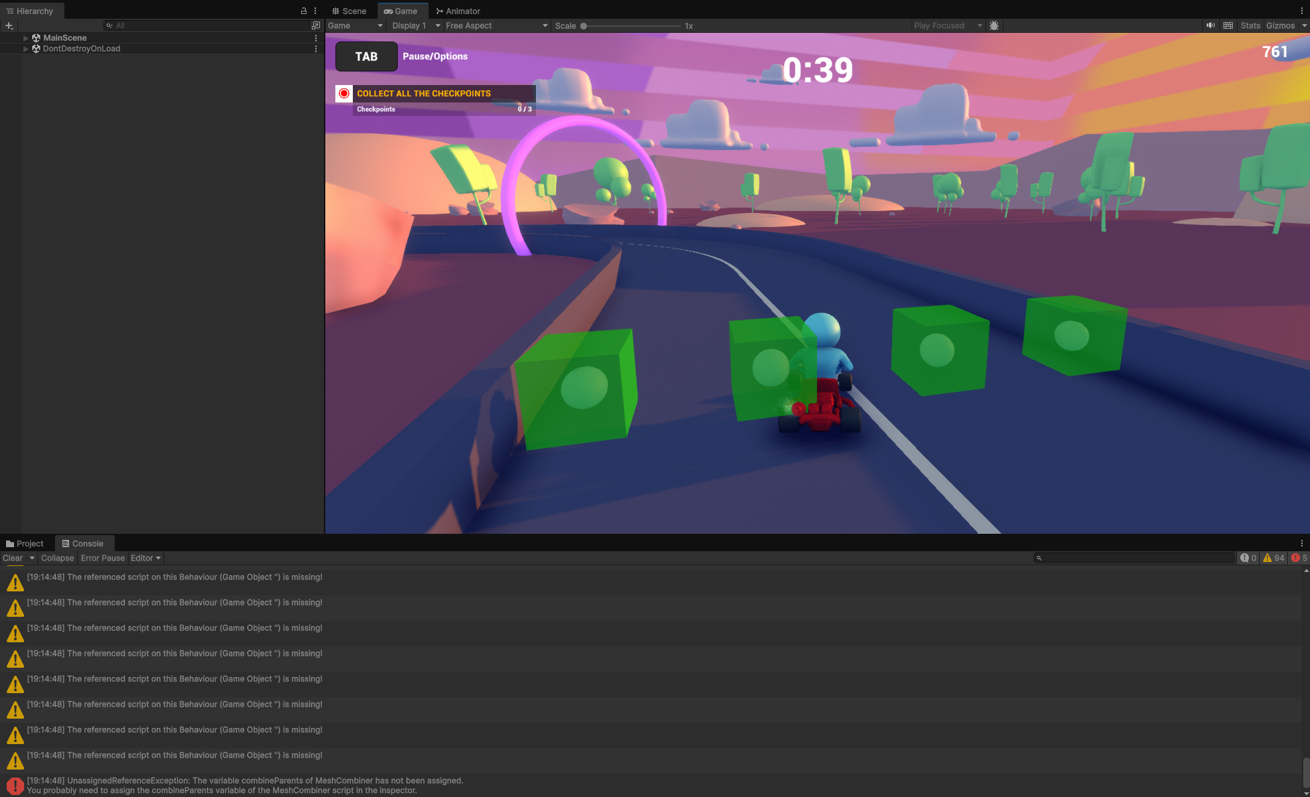

Task 4 : Fill in a play test report;

In the file PickupComponent uncomment the code in Assets\Addtional Assets\Prefabs\PickupComponent:

/*gameObject.SetActive(false);
Invoke("Reset",3.0f);

ArcadeKart ak = other.transform.parent.GetComponent<ArcadeKart>();
if (ak != null)
{
ak.AddPowerup(powerup);
}*/
Then fill out
General Questions
- How would you rate your overall experience with the game?
  - Excellent
  - Good
  - Fair
  - Poor

Gameplay Experience
- Did you find the game enjoyable?
Yes the game is enjoyable it is a very simple game but well made so that the user doesn’t run into issues to frustrate them. It is a good game
- Which aspects of the game did you like the most?
I liked the racing part of the game the most I like trackmania so its like a very simple version of that.
- Which aspects did you like the least or found frustrating?
Pickup boost weren’t working so that was the most frustrating before the fix
- Did you find the game intuitive and easy to understand?
  - Yes
  - Somewhat
  - No
Please explain your answer.

Controls and Mechanics
- How responsive did you find the controls?
  - Very responsive
  - Somewhat responsive
  - Not responsive
- Were the controls easy to learn and use?
  - Yes
  - Somewhat
  - No
- Did you encounter any issues with the steering, acceleration, or braking mechanics?
No issues at all. Maybe that you can turn without moving forward or backward is an issue but for a small and short game like this it isn’t anything major
- Do you have any suggestions for improving the controls or mechanics?
Not allowing the player to turn in circles when forward is not pressed

Graphics and Sound
- How would you rate the overall graphics of the game?
  - Excellent
  - Good
  - Fair
  - Poor
- Did the visual style appeal to you?
Visual style was pretty good its very colorful and has a nice background besides the race element its something I would want in a good game.

Bugs and Technical Issues
- Did you encounter any bugs or crashes during your playtime?
My game didn’t crash or have any bugs besides the initial lag spike on the first run
- Did you experience any performance issues (e.g., lag, frame rate drops)?
No lag spikes besides the first one I kept a solid 700 fps or more during the entire time I tested the game out

