GAME DESIGN & METHODOLOGIES — LAB 2
Lab 2: Designing Your Level
Turn the maze you built in Lab 1 into a real level — one that teaches, escalates, and lets the player choose.

Before You Start
This lab continues directly from Lab 1. You will need to download the following repo from github
https://github.com/amcnabbbaltar/420_541_Lab2-Level-Design
Once downloaded open the scene in the folder called Asset/Scenes called MainScene

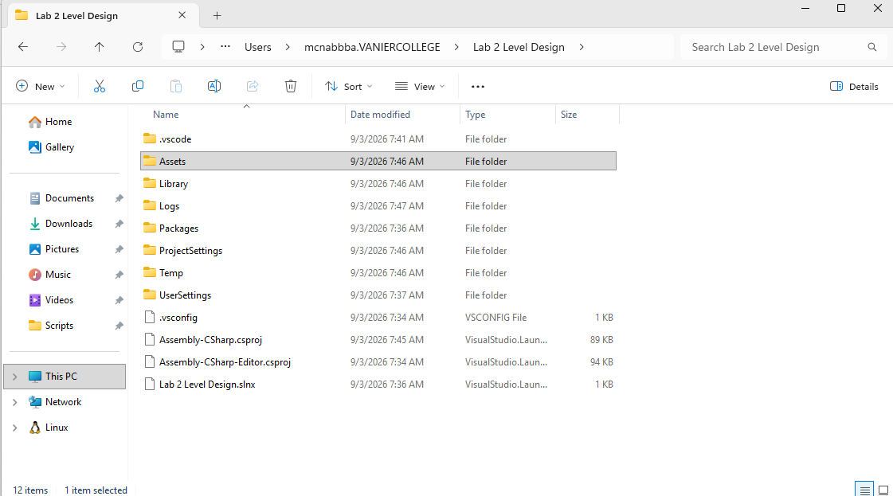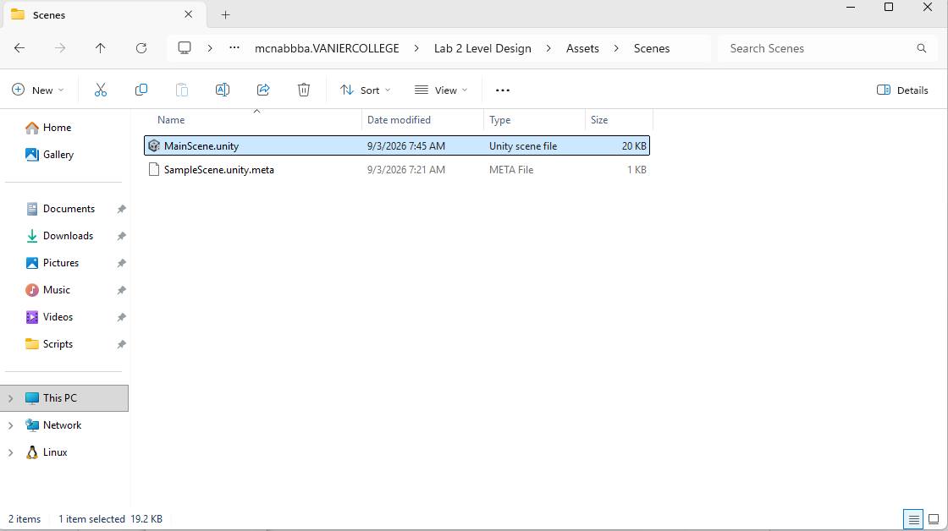

Task 1: Sketch Your Level on Paper
Before touching Unity, spend five minutes sketching a simple top-down map of your level on paper or in a drawing app. Mark on it:
- Start point (where the Player spawns).
- Tutorial Zone — a short, safe opening area.
- 2–3 Challenge Zones of increasing difficulty.
- One Choice Point where the path forks into two routes.
- Finish point.
Keep this sketch — you will take a photo or screenshot of it for your submission.

Task 2: Build Faster With Grid and Snap (Unity 6.5)
Unity 6.5 carries forward a redesigned Grid and Snap workflow that makes it much easier to butt Wall and Trap cubes together edge-to-edge with no gaps or overlaps — exactly what you need for corridors, forks, and tightly-fitted level geometry. Set it up now, before you start placing anything.
- In the Scene view, press ` (backtick) to open the Overlay menu, and enable Grid and Snap if it isn't already visible.
- 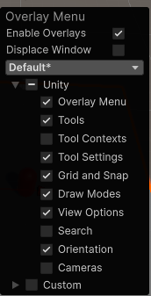
- In the Grid and Snap overlay, select Open Grid and Snap Settings to see every grid and snapping option in one place.
- 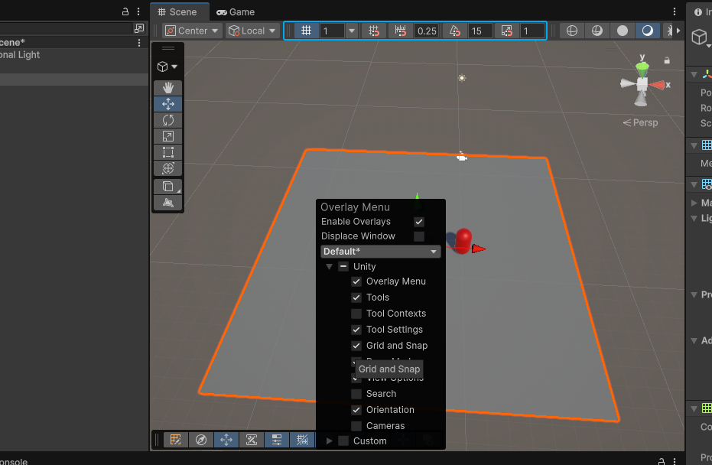
- Set Grid Size to match the size of your Wall and Trap cubes (1 unit by default) so objects snap flush against each other with no gaps.
- 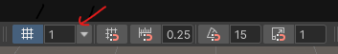
- 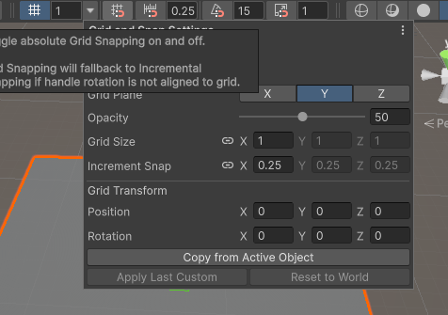
- Note that Incremental Snap Size is now a separate setting from Grid Size — leave it matching your Grid Size for now, or lower it if you want finer control while placing objects.
- Enable Snapping (the magnet icon in the overlay, or hold Ctrl while dragging) and drag a Wall cube next to another — it should lock into place edge-to-edge automatically.
- 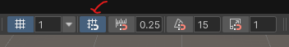
- For an angled section (useful for Task 10's choice point fork), select a reference GameObject and choose Copy from Active Object under Grid Transform in the settings window — this rotates and repositions the whole grid to match that object, so angled walls snap just as cleanly as straight ones. Usefull if you want to rotate the grid to wich your snapping to
- 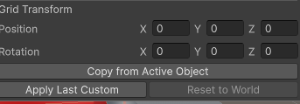
- Right-click anywhere in the Scene view to open the Grid submenu for quick fixes: Move to Handle Position snaps the grid to your current selection, and Reset to World returns it to the origin.
- 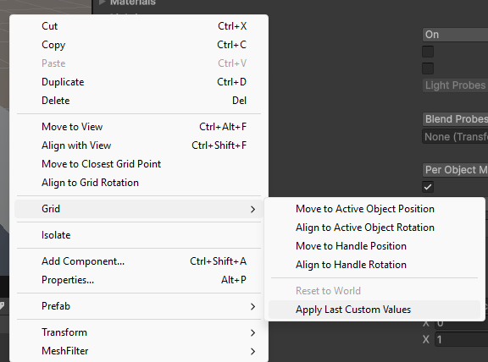

Checkpoint: With Snapping on, drag a new Wall cube toward an existing one — it should lock into place with no visible gap or overlap, saving you from typing exact Transform values by hand.

Task 3: Organize Your Scene Hierarchy
You have a hierarchy left you with a flat list of Cube, Cube (1), Cube (2)... objects. That's fine for a handful of objects, but once you add Challenge Zones, hazards, and lights in later tasks, an unorganized Hierarchy gets hard to navigate fast. Set up a folder structure now, before your scene grows.
- In the Hierarchy panel, right-click empty space and select Create Empty. Rename it Level.
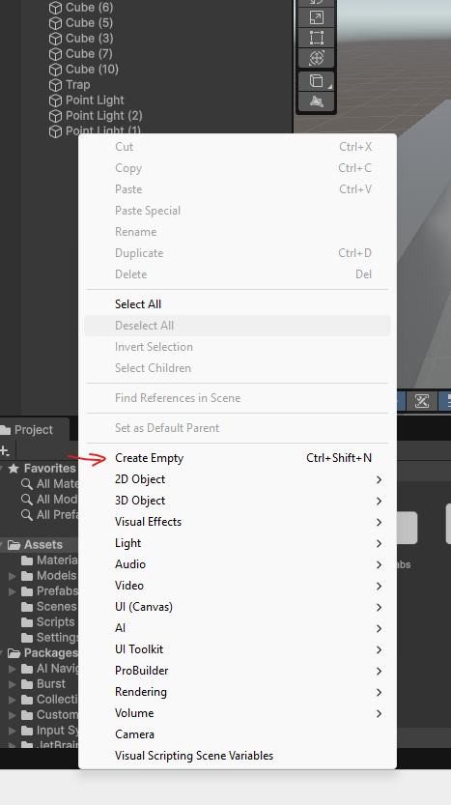
- With Level selected, right-click it and select Create Empty Four more times to add five group objects nested inside it. Name them Walls,Floors, Traps, Lighting, and Triggers.
- 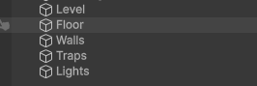
- Select all four group objects at once, and in the Inspector click the ⋮ menu next to Transform and choose Reset, so each group sits at Position (0, 0, 0) — this keeps every child's Transform values meaningful on their own.
- 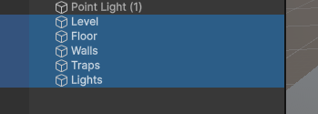
- 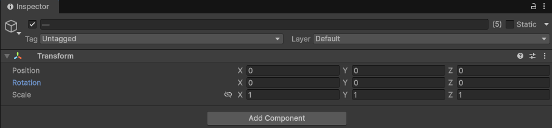
- Drag your existing Wall cubes from into the Walls group, and your Trap cubes into the Traps group. Drag your Directional Light, Spot Light, and Point Light objects into the Lighting group.
- 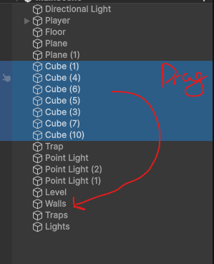
- 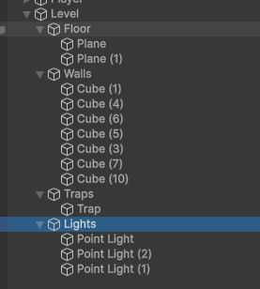
- Keep your Player and the floor at the top level of the Hierarchy (outside Level) — only group the objects that make up the level layout itself.
- Rename objects with clear, specific names as you build — Wall_Corridor1, Trap_Moving_A — instead of leaving the Unity default Cube (7), Cube (8)....
- Test your organization using the search bar at the top of the Hierarchy window: type Trap and confirm only your Trap objects are highlighted.
- 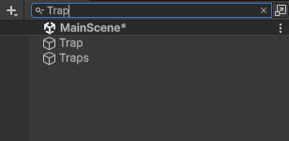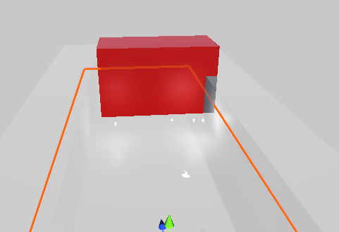
Checkpoint: A well-organized Hierarchy should let you collapse Walls, Traps, and Lighting down to single rows so you can see your whole level's structure at a glance. As you add FinishZone, RespawnPoint, and hazard triggers in the next tasks, drop them into the Triggers group to keep this habit going.

Task 4: Build the Tutorial Zone
Using the Wall and Trap cubes from Lab 1 Task 1, build a short opening corridor right after the Player's spawn point.
- In the Hierarchy panel, arrange 2–4 Wall cubes so they form a simple, obvious corridor with no branches yet.
- Place exactly one Trap cube in this corridor, clearly visible and easy to walk around — this is the very first thing the player will notice.
Checkpoint: Play your scene. If a first-time player would walk straight into that Trap without ever seeing it coming, widen the corridor or move the Trap so it's in clear view before the player reaches it.

Task 5: Add a Finish Trigger (the Win State)
Right now nothing in your level tells the player they've succeeded. Add a Finish Zone that reacts when the Player reaches it.
- In the Hierarchy panel, select your Player object (the renamed Main Camera from Lab 1) and, in the Inspector, set its Tag to Player. If "Player" isn't in the Tag list yet, use Add Tag... to create it first.
- Right-click in the Hierarchy and select 3D Object > Cube to mark the end of your level. Name it FinishZone and drop it in your Triggers group from Task 4.
- In the Inspector, select the FinishZone's Box Collider and check Is Trigger.
- Uncheck the Mesh Renderer component on FinishZone (or shrink/hide it) so it doesn't look like a solid wall — it should be invisible to the player.
- In the Project panel, open your Scripts folder from Lab 1 and create a new C# Script named FinishTrigger.
- Double-click it to open your code editor and replace the contents with the script below.
using UnityEngine;

public class FinishTrigger : MonoBehaviour
{
void OnTriggerEnter(Collider other)
{
if (other.CompareTag("Player"))
{
Debug.Log("Level Complete!");
}
}
}
- Save the script, then drag FinishTrigger from the Project panel onto the FinishZone object in the Hierarchy.
- Press Play, walk your Player into the FinishZone, and confirm "Level Complete!" appears in the Console.

Task 7: Add a Hazard Trigger (the Fail State)
A win state alone isn't enough — the player also needs to know clearly when they've failed. Turn one of your existing Traps into a hazard that sends the player back to the start.
- In the Hierarchy panel, create an empty GameObject (right-click > Create Empty) and name it RespawnPoint — drop it in your Triggers group from Task 4. Move it to your Player's starting position.
- Pick one Trap in your Tutorial Zone (from Task 5) to act as your first hazard. Select it, and in the Inspector check Is Trigger on its Box Collider.
- Because it's now a trigger, the Player will pass through it instead of bumping into it — that's expected, the script below handles the consequence.
- In the Project panel, create a new C# Script named TrapTrigger in your Scripts folder and open it.
- Replace its contents with the script below.
using UnityEngine;

public class TrapTrigger : MonoBehaviour
{
public Transform respawnPoint;

void OnTriggerEnter(Collider other)
{
if (other.CompareTag("Player"))
{
other.transform.position = respawnPoint.position;
Debug.Log("You hit a trap! Back to start.");
}
}
}
- Drag TrapTrigger onto your chosen Trap object in the Hierarchy.
- With the Trap selected, drag your RespawnPoint object from the Hierarchy into the Respawn Point slot in the script's Inspector fields.
- Press Play, walk into the Trap, and confirm the Player snaps back to the start and the Console logs the message.
Checkpoint: Repeat Task 7 for one or two more Traps as you build the rest of the level in Task 8, so every hazard the player can reach gives the same clear feedback.

Task 8: Build Up the Rest of the Level
With teaching (Task 5), winning (Task 6), and failing (Task 7) all working, extend the level past the Tutorial Zone using the "build up the level" method: design one challenge at a time, then combine them.
- Design Challenge Zone 1: a section with one hazard Trap the player must dodge in a straight corridor (repeat Task 7's steps to make it react on contact).
- Design Challenge Zone 2: add a moving hazard. Select a Trap, drag on the ObjectMover script from Lab 1 Task 5, and set its Movement value (e.g., 0, 1, 0) so it patrols back and forth across the path.
- Design Challenge Zone 3 (optional, for extra challenge): combine a moving Trap with a narrower Wall corridor so the player has less room to react.
- Connect the Tutorial Zone → Challenge Zone 1 → Challenge Zone 2 → (optional Challenge Zone 3) → FinishZone into one continuous path using Wall cubes.
Checkpoint: Difficulty should climb gently. If Challenge Zone 1 already feels as hard as your hardest zone, spread the difficulty out more evenly.

Task 9: Add a Meaningful Choice
Pick one point in your level — ideally between two Challenge Zones — and split the path into two routes the player must choose between. The two routes should feel different, not just easier or harder versions of the same thing.
- Build a fork in the corridor: two separate paths that both lead toward the FinishZone.
Path A — Risky Shortcut: shorter, but passes close to a moving Trap (from Task 8).
Path B — Safe Detour: built from Wall cubes, longer and walled off from any hazard, but takes more time to walk.
- Make sure a player standing at the fork can see both paths (and, ideally, glimpse the moving Trap on Path A) before choosing — a choice the player can't see isn't a real choice.
- Do not place any text or sign at the fork. The layout itself should make each path's trade-off readable.

Task 10: Guide the Player With Light and Color
Reuse your Lab 1 materials and lighting skills to give the player a wordless visual hint at the choice point, instead of any on-screen instruction.
- In your Materials folder, create a new Material (e.g., WarmMaterial) and set its Albedo color to a warm red/orange tone.
- Right-click in the Hierarchy near the entrance of Path B and select Light > Point Light to softly light the Safe Detour, similar to Lab 1 Task 3.
- Play the scene and stand at the fork — the two paths should visually read as different in tone before the player commits to either one.

Task 11: Playtest and Reflect
Have a classmate play your finished level with no explanation from you (or replay it yourself after a short break). Watch where they hesitate, where they get hit by a hazard, and which path they pick at the fork.
- Did they understand what the first Trap in the Tutorial Zone was without being told? Yes / No — describe what happened.

Yes they understood what the trap was they went around it pretty easily without dying.

- Did they always know whether they were succeeding or failing while playing? Give one example from the playtest.

They knew they were succeeding because going straight brings you closer to the finish and going back brings you back to the tutorial starter zone. I also had a yellow block indicating where the finish was so it was pretty easy to realize where to go.

- Which path did they choose at the fork, and why do you think they chose it?
My player chose the harder path since the finish was clearly there after passing the harder section. Indication from the yellow block.

- What is the one change you would make to this level if you had more time?
One thing I would change would be the color of the meshes in the map everything is grey color which can be a bit confusing but its not hard to find your way around the map.
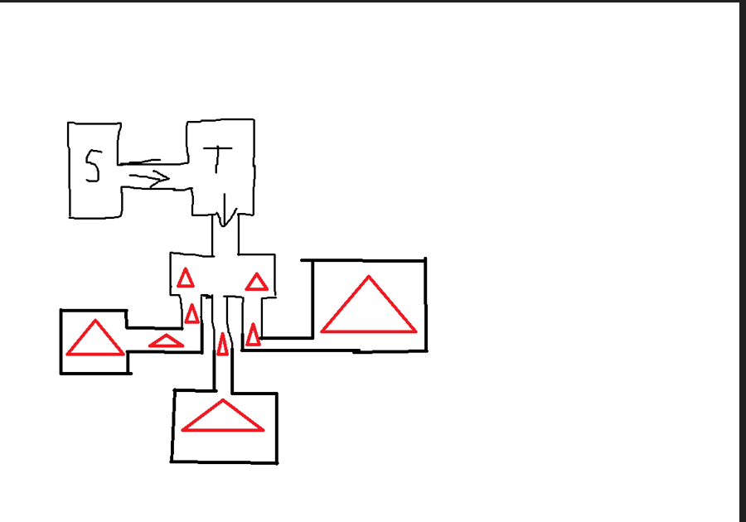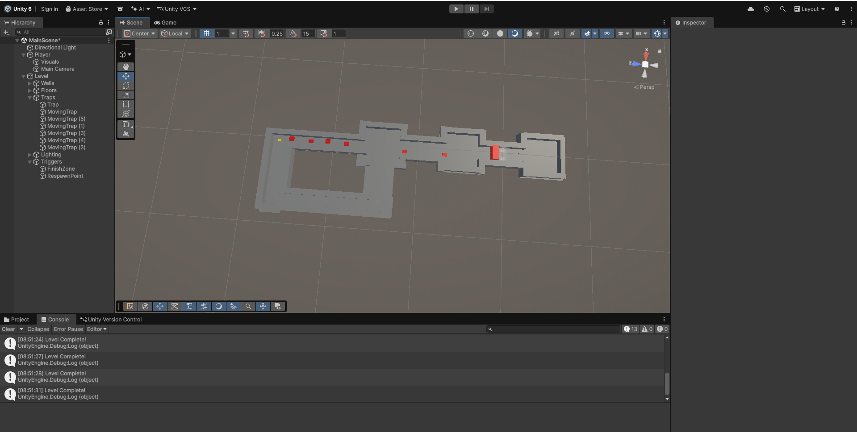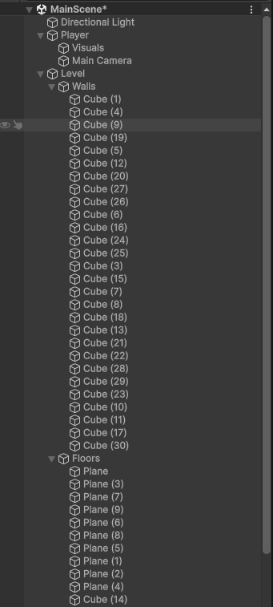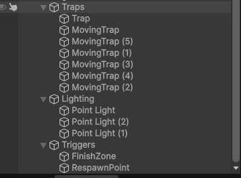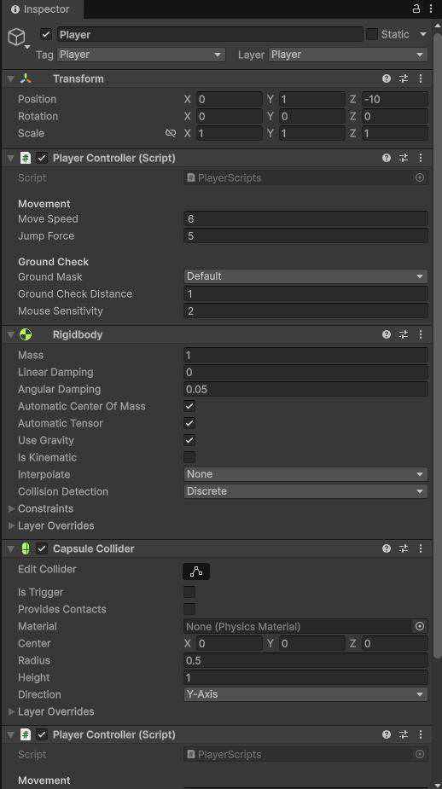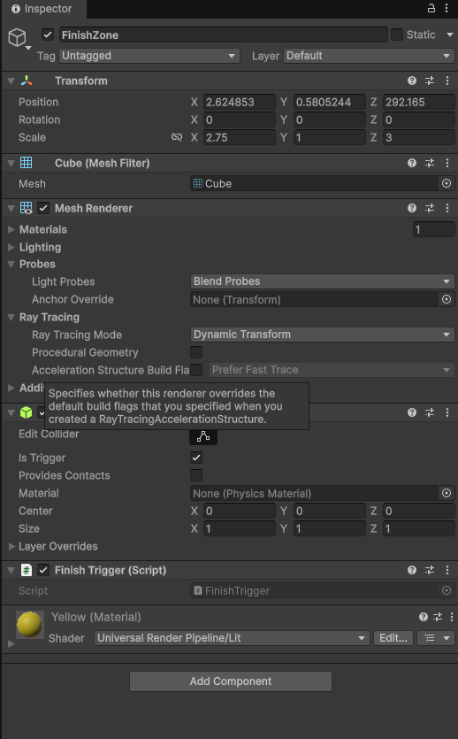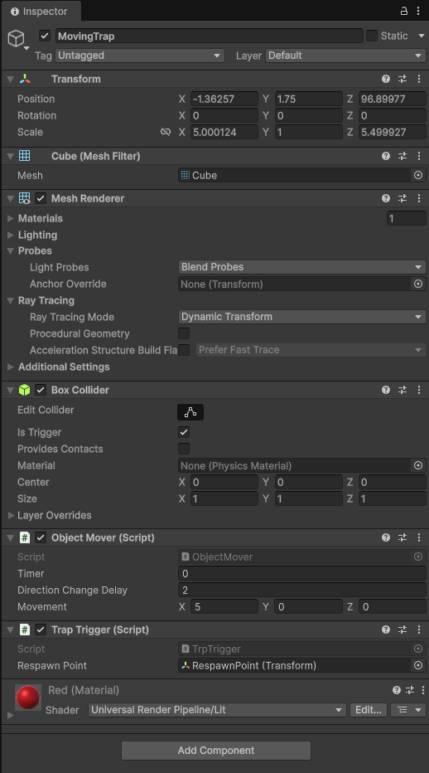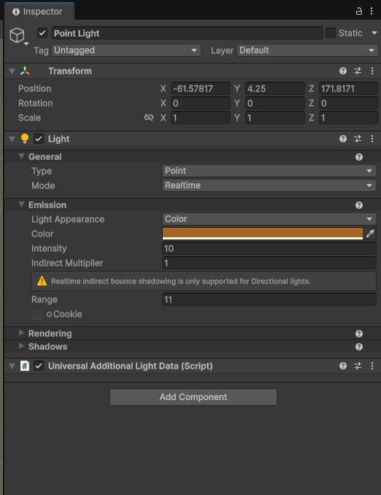

Submission
- Save your scene and make sure Task 1's paper sketch, Task 11's written answers, and all screenshots below are included.
- Take and include the following screenshots:
- A photo or scan of your Task 1 paper sketch.
- Screenshot of your full Scene view, showing the whole level from above.
- Screenshot of your Scene Hierarchy, showing the Task 4 Walls / Traps / Lighting / Triggers grouping.
- Inspector view of your Player object, showing the upgraded PlayerController script and its Move Speed / Mouse Sensitivity values.
- Inspector view of your FinishZone object, showing the FinishTrigger script attached.
- Inspector view of one hazard Trap, showing the TrapTrigger script and its assigned Respawn Point.
- Inspector view of the Choice Point materials/light from Task 10 .
- Close your project, then right-click your project's root folder and select Compress or Send to > Compressed (zipped) folder.
- Log in to LÉA, go to the submission section for Lab 2, and upload the compressed project folder along with this document.
Builds on Lab 1 — Getting to Know the Editor. Concepts from Intro to Level Design and Lecture 2 — Game Design & Methodologies.

