Lab 5 : Moving and Animating a Character

Lab Overview:
In this lab you will bring a character to life in two stages. First, you will write a physics-based PlayerMovement script from scratch so the player can walk, jump and collide with the world using a Rigidbody. Then you will use Unity's Animator system to configure an animation state machine, build a blend tree, create transitions between animations, and write a second script that drives those animations from the character's real movement. Finally, you will create your own animation clip for a spinning coin that adds to the player's score when collected.
By the end of the lab you should be able to explain why input is read in Update() but physics is applied in FixedUpdate(), how a raycast ground check works, and how gameplay code passes information to an Animator through parameters.

Step-by-Step Solution:

Task 1: Setup the Animator and Avatar for Both the Character and Animations
- Open the github classroom assignment and download the repo :
https://github.com/amcnabbbaltar/420_541_Lab5_2026
2. Once the repo is clone , Open the Sample Scene
  - In the scene folder, Open the sample scene . You should see something like this
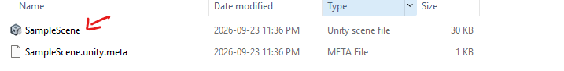
- Select Your Character:
  - In Unity, go to the Hierarchy window and locate your Player prefab.
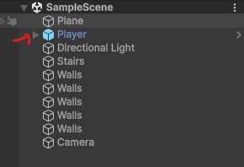

- Create an Animator Controller:
  - In the Assets window (Project tab),open the Character Folder, then the Animation Folder
  - Then right-click and choose Create > Animator Controller.
  - Name the new Animator Controller, for example, PlayerAnimator.
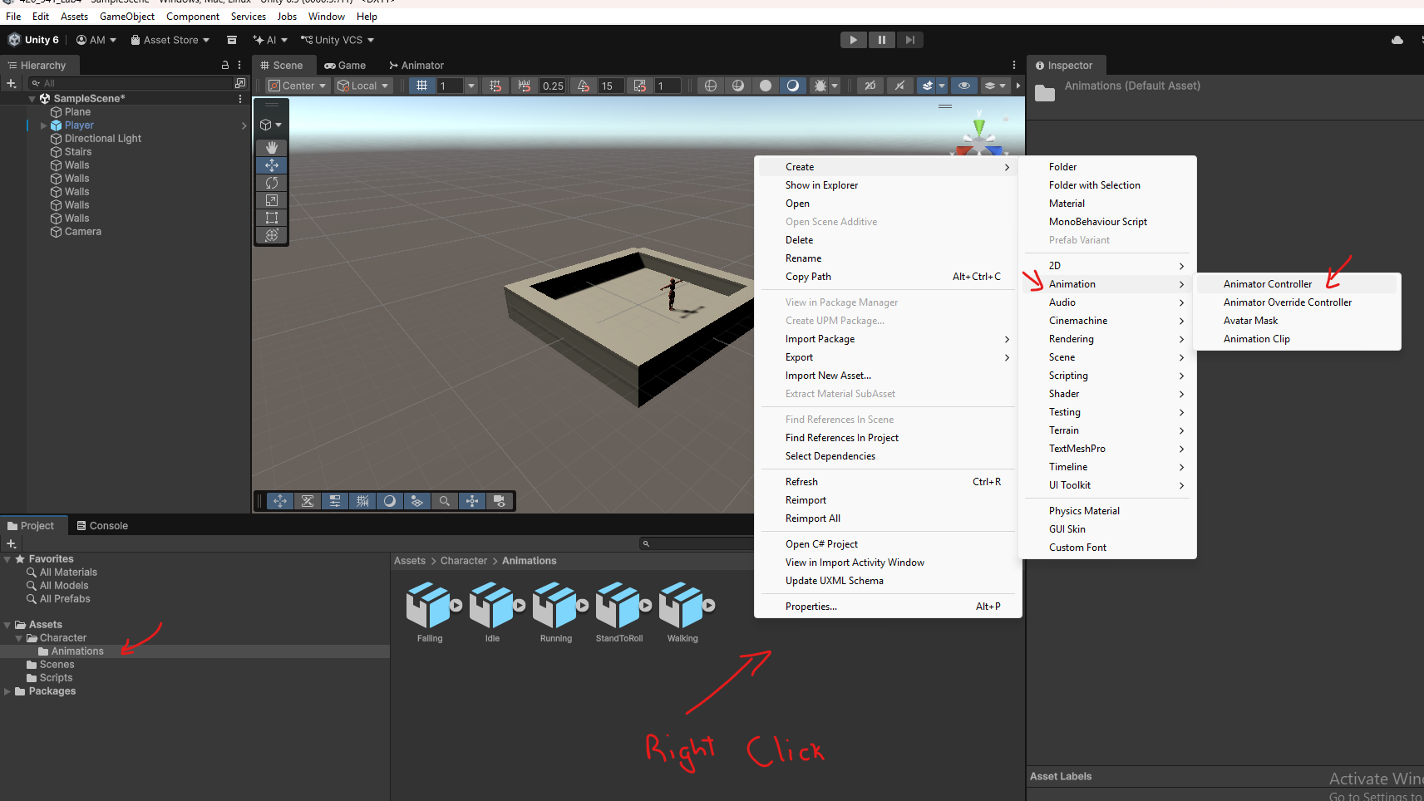

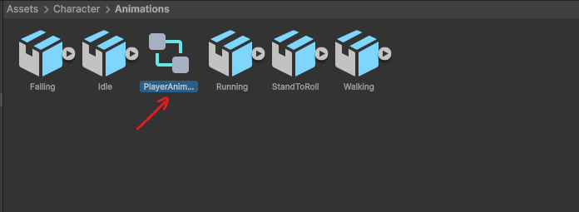

- Assign the Animator Controller to the Character:
  - Select your character in the Hierarchy and look in the Inspector window.
  - Under the Animator component, assign the newly created CharacterAnimator controller by dragging it from the Assets window to the Controller slot in the Animator component.
  - 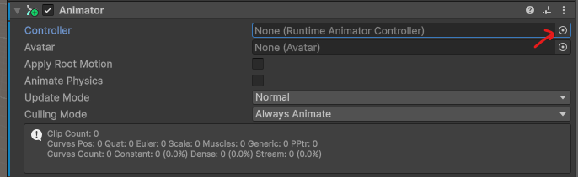
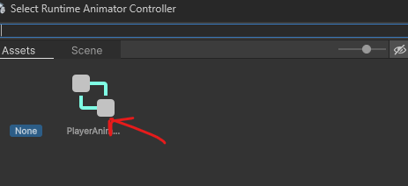
- Ensure the Avatar is Assigned:
  - In the Animator component, there is a field for Avatar. Ensure that the Avatar (skeleton) for your character is properly assigned here. Unity should auto-assign it when importing the character, but if it is missing, you can manually select the Avatar file associated with your character model.
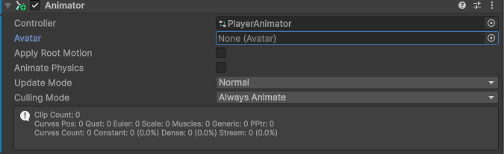
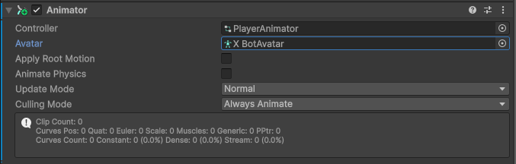

- Open the Animator Controller:
  - You should already have animations (Idle, Walking, Running, Rolling, Falling) in your Animation folder( Assets/Character/Animation).
  - Open the Animator window by going to Window > Animation > Animator or by double clicking on the CharacterAnimator in the assets view .
    - You should see a window like this that pop up
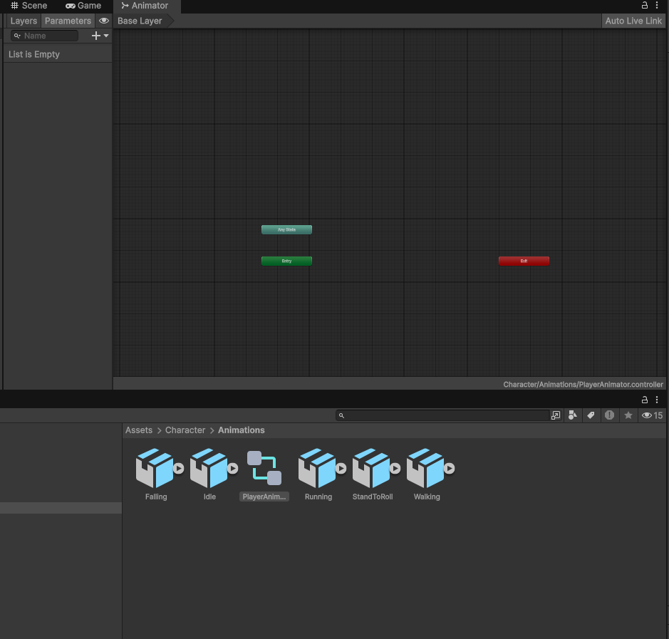

Task 2: Build the Player Movement Script
Before we animate anything, the character needs to actually move. In this task you will write a PlayerMovement script that uses Unity's physics engine (a Rigidbody) to move the player with WASD / arrow keys and jump with Space. You will build it one piece at a time so you understand what every line does.

- Prepare the Player for physics:
  - Select your Player in the Hierarchy.
  - If the Player already has an older movement script attached (for example CharacterMovement), remove that component (right-click the component header > Remove Component) so two scripts don't fight over the same Rigidbody.
  - Click Add Component and add a Capsule Collider. Adjust its Center and Height until the green capsule wraps the character in the Scene view. For a typical humanoid, try Center Y = 0.9, Height = 1.8, Radius = 0.3.
  - In the Animator component, uncheck Apply Root Motion. Our script, not the animation clips, will decide where the character goes. (In Task 4 the roll behaviour turns root motion on only while rolling.)
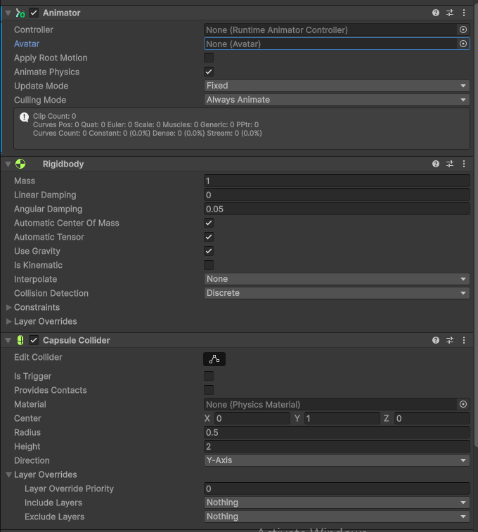

Why a Rigidbody? A Rigidbody hands the character over to Unity's physics engine, which gives us gravity, collisions and forces for free. You don't need to add it yourself: the [RequireComponent] line in our script adds it automatically.
- Create a Ground layer:
  - Select the floor/ground object(s) in your scene.
  - At the top of the Inspector, open the Layer dropdown and choose Add Layer…. Type Ground into an empty User Layer slot.
  - Select the floor again and set its Layer to Ground. Make sure the floor has a collider (a Box Collider or Mesh Collider).
  - Do not put the Player on the Ground layer, otherwise the player could detect itself as ground.
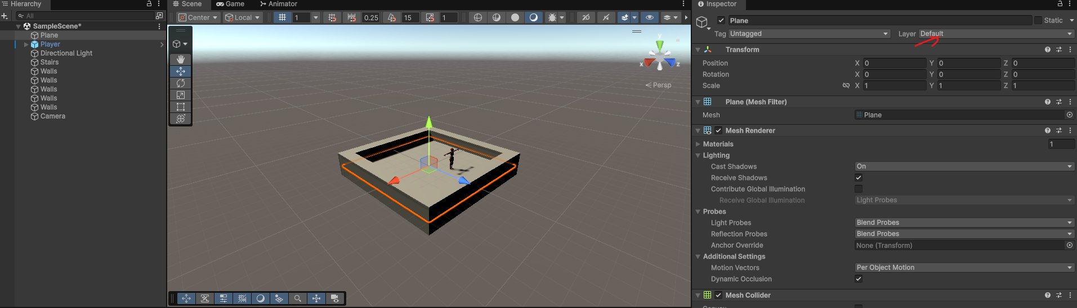
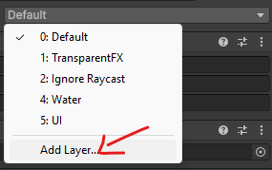
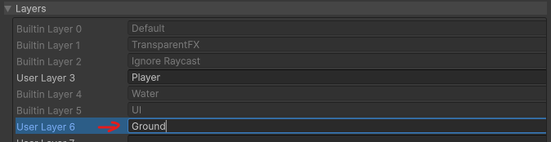

- Create the script:
  - With the Player selected, click Add Component, type PlayerMovement, choose New Script, then Create and Add.
  - Double-click the script to open it in your code editor and delete the default contents. The file name and class name must both be exactly PlayerMovement, or Unity won't be able to attach it.
- Declare the class and its variables:
Start with the class, its settings and the private variables it will use:
using UnityEngine;

// Moves the player with a Rigidbody:
// A/D or Left/Right arrows to ROTATE, W/S or Up/Down to move Forward/Backward, Space to jump.
[RequireComponent(typeof(Rigidbody))]
public class PlayerMovement : MonoBehaviour
{
[Header("Movement Settings")]
[SerializeField] private float moveSpeed = 7f; // units per second
[SerializeField] private float turnSpeed = 150f; // degrees per second
[SerializeField] private float jumpForce = 5f; // strength of the jump

[Header("Ground Check Settings")]
[SerializeField] private float groundDistance = 0.5f; // ray length
[SerializeField] private LayerMask groundMask; // ground layers

private Rigidbody rb; // the physics body we move
private Vector3 moveDirection; // worked out from input in Update()
private float turnInput; // horizontal input for rotation
private bool isGrounded; // true when standing on the ground
private bool jumpRequested = false; // set in Update(), used later
// The methods from the next steps go here, inside the class
}
  - [RequireComponent(typeof(Rigidbody))] guarantees the GameObject has a Rigidbody, adding one if it is missing.
  - [SerializeField] private keeps the variable private to this script but still shows it in the Inspector so you can tune it without editing code. [Header] just groups the fields under a label.
  - groundMask is a LayerMask: it tells the ground check which layers count as ground.
  - moveDirection, isGrounded and jumpRequested store information that Update() collects and FixedUpdate() uses.
- Get the Rigidbody in Start():
Replace the comment inside the class with the Start() method:
// Start runs once, just before the first frame
private void Start()
{
// Find the Rigidbody on this GameObject so we can move it
rb = GetComponent<Rigidbody>();

// Freeze rotation so the player doesn't fall over when colliding
rb.constraints = RigidbodyConstraints.FreezeRotation;
}
  - GetComponent<Rigidbody>() finds the Rigidbody on this GameObject and stores it in rb so we don't search for it every frame.
  - Freezing rotation stops physics from tipping the capsule over when it bumps into walls.
- Read input and check the ground in Update():
Add the Update() method below Start():
private void Update()
{
// 1. Ground Check
isGrounded = Physics.Raycast(transform.position + transform.up*groundDistance/2, -transform.up, groundDistance, groundMask);

// 2. Read Inputs
turnInput = Input.GetAxisRaw("Horizontal"); // A/D or Left/Right turn input
float moveZ = Input.GetAxisRaw("Vertical"); // W/S or Up/Down forward/backward

// Rotate the player transform in Update for responsive turning visuals
transform.Rotate(0f, turnInput * turnSpeed * Time.deltaTime, 0f);

// Calculate forward movement relative to current facing direction
moveDirection = transform.forward * moveZ;

// 3. Handle Jump Input
if (Input.GetButtonDown("Jump") && isGrounded)
{
jumpRequested = true;
}
}

  - Ground check: Physics.Raycast fires an invisible ray from the character's position straight down (-Vector3.up) for groundDistance units, and only hits objects on the layers in groundMask. If it hits, isGrounded is true.
  - Movement input: GetAxisRaw returns -1, 0 or 1 for the Horizontal (A/D, ←/→) and Vertical (W/S, ↑/↓) axes. Multiplying by transform.right and transform.forward makes movement relative to the way the player is facing.
  - .normalized gives the direction a length of 1, so moving diagonally isn't faster than moving straight.
  - Jump input: GetButtonDown is only true on the single frame the key is pressed. We only accept it when isGrounded is true, so the player can't jump again in mid-air, and we set a flag instead of jumping right away.
- Apply physics in FixedUpdate():
Add the FixedUpdate() method below Update():
private void FixedUpdate()
{
MovePlayer();

if (jumpRequested)
{
Jump();
jumpRequested = false;
}
}

Why two update methods? Update() runs once per rendered frame, which is the only reliable place to catch a key press. FixedUpdate() runs on the physics engine's fixed timestep, which is the correct place to change a Rigidbody. The jumpRequested flag carries the key press from one to the other, so no jump is ever missed and physics stays smooth.
- Write the MovePlayer() and Jump() helper methods:
Finally, add these two methods below FixedUpdate():
private void MovePlayer()
{
// Calculate velocity based on current forward vector
Vector3 targetVelocity = moveDirection * moveSpeed;

// Apply movement while preserving vertical velocity (gravity/jumping)
rb.linearVelocity = new Vector3(targetVelocity.x, rb.linearVelocity.y, targetVelocity.z);
}

private void Jump()
{
rb.linearVelocity = new Vector3(rb.linearVelocity.x, 0f, rb.linearVelocity.z);
rb.AddForce(Vector3.up * jumpForce, ForceMode.VelocityChange);
}

  - MovePlayer() sets the horizontal (X and Z) velocity directly for snappy, responsive movement, but keeps the current Y velocity so gravity and jumping still work.
  - Jump() first zeroes the vertical velocity so every jump reaches the same height, even if the player was falling, then pushes the Rigidbody upward. ForceMode.VelocityChange applies the push instantly and ignores the Rigidbody's mass.
Unity 6 note: This lab is written for Unity 6, where the Rigidbody's velocity is called linearVelocity. If you are using Unity 2022 or older, write velocity instead of linearVelocity in both scripts.
- Checkpoint: compare with the complete script
Save the file. Your finished PlayerMovement script should look exactly like this:
using UnityEngine;

// Moves the player with a Rigidbody:
// A/D or Left/Right arrows to ROTATE, W/S or Up/Down to move Forward/Backward, Space to jump.
[RequireComponent(typeof(Rigidbody))]
public class PlayerMovement : MonoBehaviour
{
[Header("Movement Settings")]
[SerializeField] private float moveSpeed = 7f; // units per second
[SerializeField] private float turnSpeed = 150f; // degrees per second
[SerializeField] private float jumpForce = 5f; // strength of the jump

[Header("Ground Check Settings")]
[SerializeField] private float groundDistance = 0.5f; // ray length
[SerializeField] private LayerMask groundMask; // ground layers

private Rigidbody rb; // the physics body we move
private Vector3 moveDirection; // worked out from input in Update()
private float turnInput; // horizontal input for rotation
private bool isGrounded; // true when standing on the ground
private bool jumpRequested = false; // set in Update(), used later

public bool IsGrounded => isGrounded;

private void Start()
{
rb = GetComponent<Rigidbody>();
rb.constraints = RigidbodyConstraints.FreezeRotation;
}

private void Update()
{
// 1. Ground Check
isGrounded = Physics.Raycast(transform.position + transform.up*groundDistance/2, -transform.up, groundDistance, groundMask);

// 2. Read Inputs
turnInput = Input.GetAxisRaw("Horizontal"); // A/D or Left/Right turn input
float moveZ = Input.GetAxisRaw("Vertical"); // W/S or Up/Down forward/backward

// Rotate the player transform in Update for responsive turning visuals
transform.Rotate(0f, turnInput * turnSpeed * Time.deltaTime, 0f);

// Calculate forward movement relative to current facing direction
moveDirection = transform.forward * moveZ;

// 3. Handle Jump Input
if (Input.GetButtonDown("Jump") && isGrounded)
{
jumpRequested = true;
}
}

private void FixedUpdate()
{
MovePlayer();

if (jumpRequested)
{
Jump();
jumpRequested = false;
}
}

private void MovePlayer()
{
// Calculate velocity based on current forward vector
Vector3 targetVelocity = moveDirection * moveSpeed;

// Apply movement while preserving vertical velocity (gravity/jumping)
rb.linearVelocity = new Vector3(targetVelocity.x, rb.linearVelocity.y, targetVelocity.z);
}

private void Jump()
{
rb.linearVelocity = new Vector3(rb.linearVelocity.x, 0f, rb.linearVelocity.z);
rb.AddForce(Vector3.up * jumpForce, ForceMode.VelocityChange);
}
}
- Configure the script in the Inspector:
  - Return to Unity and wait for the script to compile. Select the Player and find the Player Movement component.
  - Set Ground Mask to Ground and Default. If you skip this, the raycast will never hit anything and the player won't be able to jump.
  - Leave Move Speed at 7, Jump Force at 5 and Ground Distance at 0.5 for now. You can tune these later.
  - Notice that a Rigidbody component has appeared automatically thanks to [RequireComponent].

- Test the movement:
  - Press Play. Move with WASD or the arrow keys and jump with Space.
  - The character will slide around in a single pose. That is expected: nothing is telling the Animator what to play yet. Fixing that is what the rest of this lab is about.
  - Can't jump? Check that the floor is on the Ground layer, Ground Mask is set to Ground, and the floor has a collider. If your character's pivot is at its centre rather than its feet, the ray may be too short: increase Ground Distance (about 1.1).
  - Falling through the floor? The floor or the Player is missing a collider.
  - Character tips over? Make sure the Rigidbody's rotation constraints are frozen (the script does this in Start()).
- Check your understanding:
  - Why do we store the jump in jumpRequested instead of calling Jump() directly inside Update()? :
We store jump in the jumpRequested instead of directly calling it because Jump modifies the Rigidbodys velocity and also applies force since Update runs once per rendered frame it can create irregular jumps since fps can stutter or lag but fixedupdate runs on a fixed timestamp that the phsics engine expects.

  - What would happen to gravity if MovePlayer() set the velocity to new Vector3(targetVelocity.x, 0f, targetVelocity.z)?
The gravity applied by the physics engine gets cancelled out because we are manually setting the y axis every frame the y axis gets set to 0 instead of going down slowly like it would normally with the engine___________________________________________________________

  - What happens to diagonal movement speed if you remove .normalized? Try it and see.
If you remove normalized when moving diagnolly you would go faster than in a straight line because of how the movement is calculated both inputs would get added together and instead of being 1 it would be a double input also doubling the speed ________________________________________________________________

Task 3: Create a Blend Tree for Movement (Idle/Walking/Running)
- Create a Blend Tree State:
  - In the Animator window, right-click in an empty space and choose Create State > From New Blend Tree.

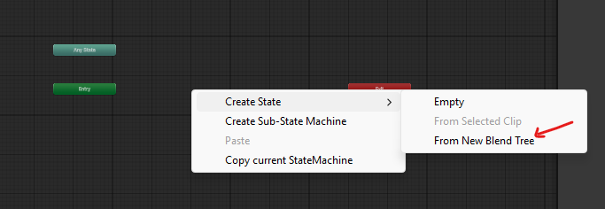

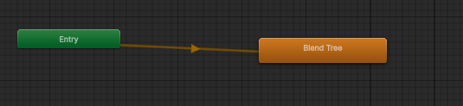

    - In order to rename it. Right click on the Orange box and details of that stat should show up in the inspector
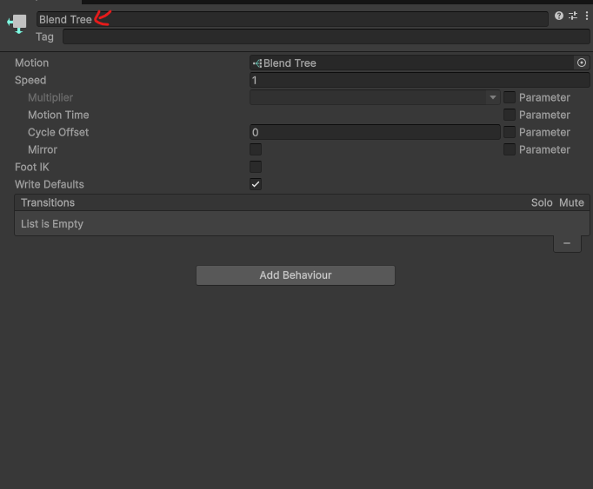

[ Screenshot ]
Inspector showing the selected state's name field
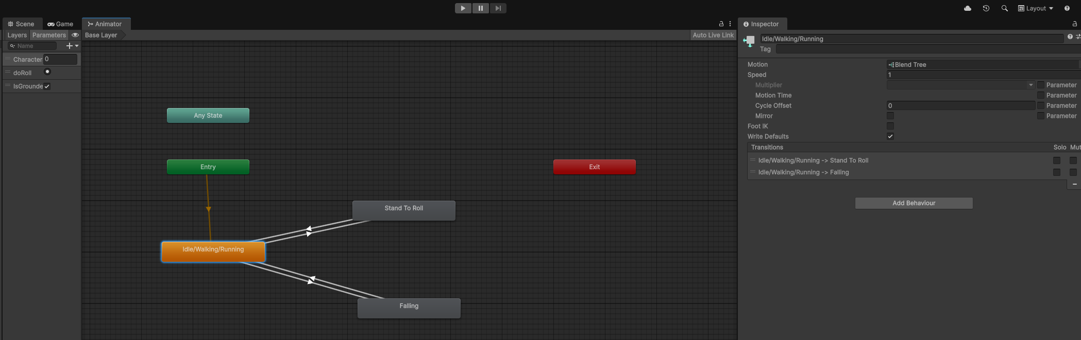

    - You can now rename the State at the top of the Inpsector
    - Rename this blend tree Idle/Walking/Running to represent the different movement states.
  - By default, this state should appear in orange, meaning it is the entry state (the default state when the game starts).

- Open the Blend Tree:
  - Double-click on the Idle/Walking/Running state to open the blend tree editor.
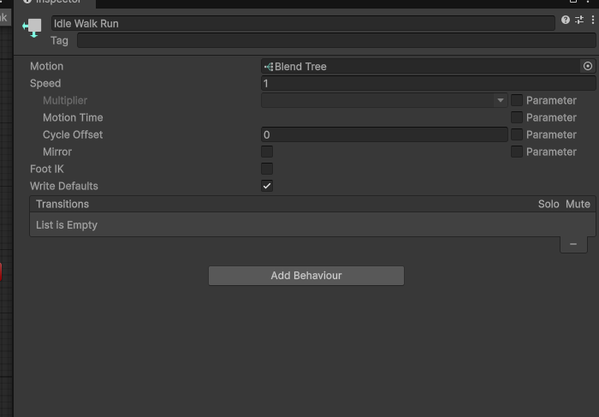

- Set the Blend Parameter:
  - In the Inspector panel (while the blend tree is selected), you will see a Blend section.
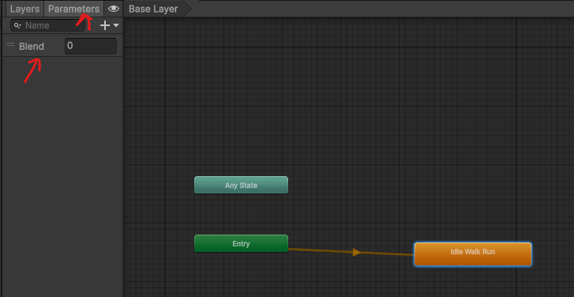

  - Set the Blend Parameter to a new parameter called CharacterSpeed. By double clicking on the Blend parameter This parameter will control which animation (Idle, Walking, or Running) plays based on the character’s speed.
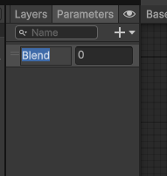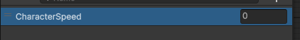

- Add Animations to the Blend Tree:
  - Double click on the Blend Tree State
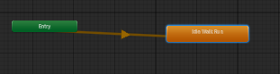
  - 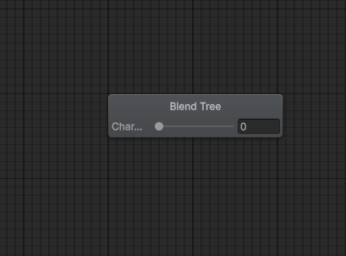
  - In the Inspector panel, click + Add Motion Field to add animation slots to the blend tree.
  - 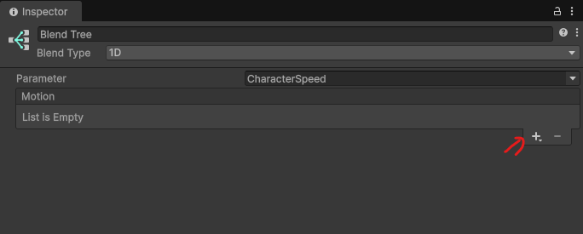
  - 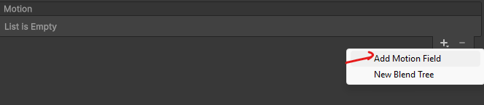
  - 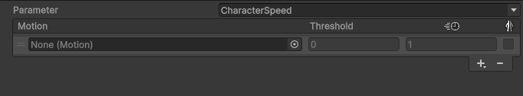
  - Do that 3 times
  - 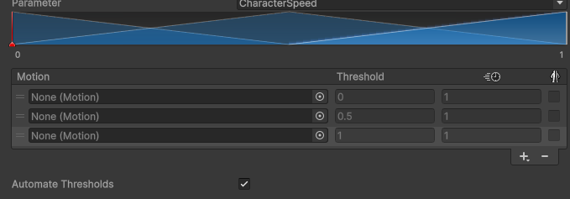

  - Click the little dot in the entry of the List of Motion,then select
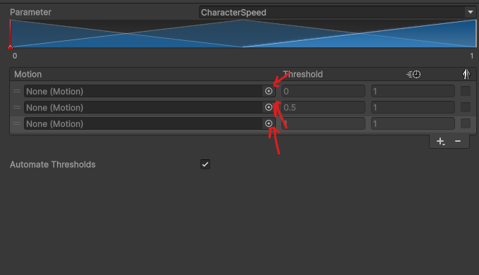
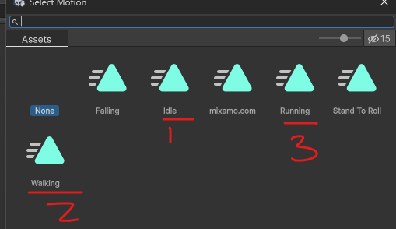

  - Idle to the first slot , Walking to the second, and Running to the third slot.
  - Uncheck the Compute threshold checkbox.
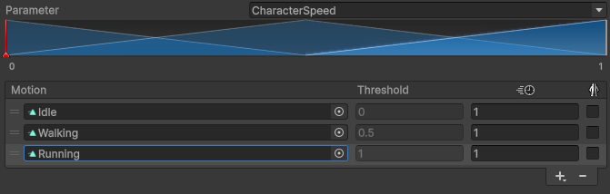

  - Your blend tree all setup should look like the picture above
- Configure Speed Thresholds:
  - 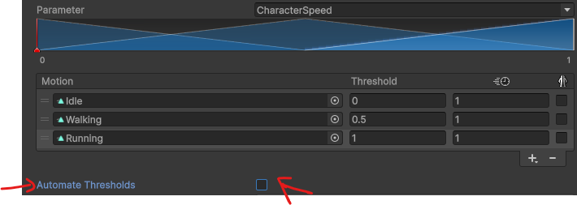
  - Set the speed values for each animation to correspond with different character speeds:
    - Idle: Speed = 0
    - Walking: Speed = 5
    - Running: Speed = 7
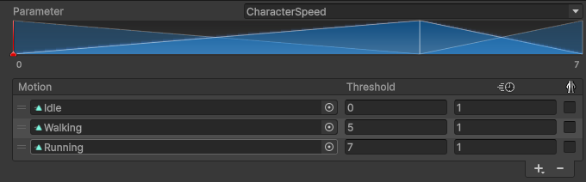
  - As the CharacterSpeed parameter increases from 0 to 7, the blend tree will interpolate between these animations based on the speed of the character. These thresholds line up with the moveSpeed of 7 you set in PlayerMovement in Task 2, so the character reaches the full Running animation at top speed.

Go back to the base layer in the Animator by clicking on the Base Layer Button :
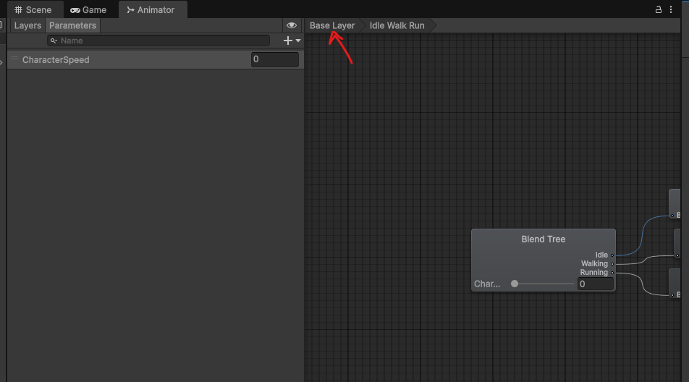

Task 4: Create Transitions for the "Stand to Roll" Animation
- Add the Rolling Animation:
  - Drag the Stand to Roll animation from your Assets folder into the Animator window, creating a new state.
  - 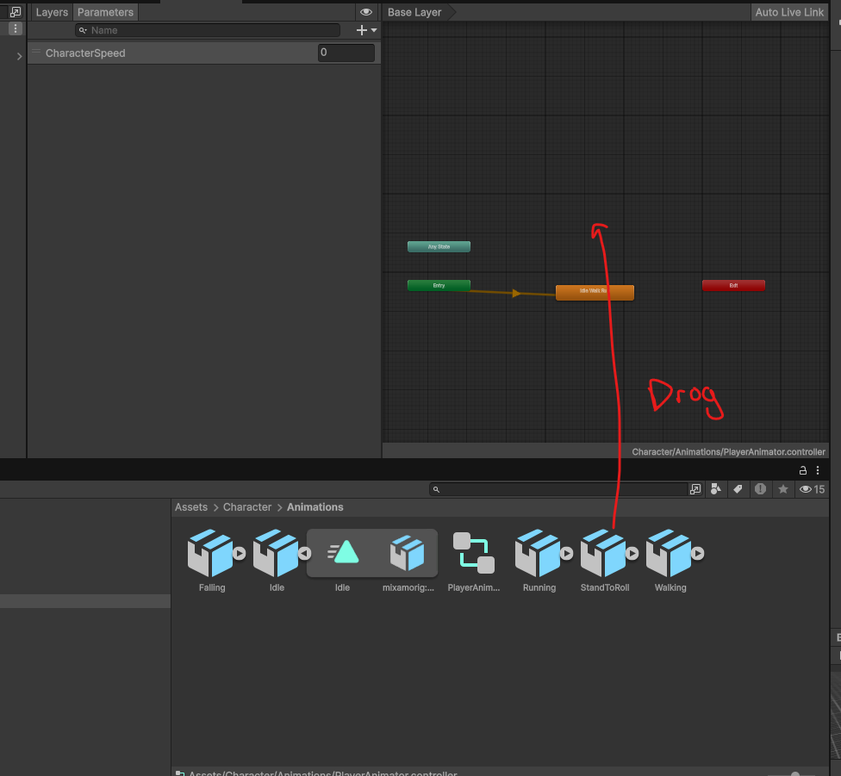

- Create a Transition from Idle/Walking/Running to Rolling:
  - Right-click on the Idle/Walking/Running blend tree and select Make Transition.
  - 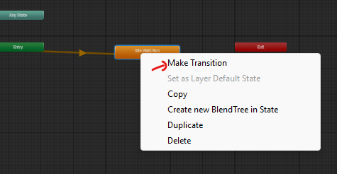
  - Drag the arrow to the Stand to Roll state.

- Create a Transition from Rolling back to Idle/Walking/Running:
  - Right-click on the Stand to Roll state, choose Make Transition, and drag the arrow back to the Idle/Walking/Running blend tree.

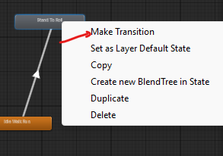

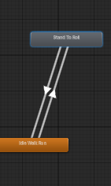

- Setup the "IsRolling" Parameter:
  - In the Animator window, click the Parameters tab (next to Layers).
  - 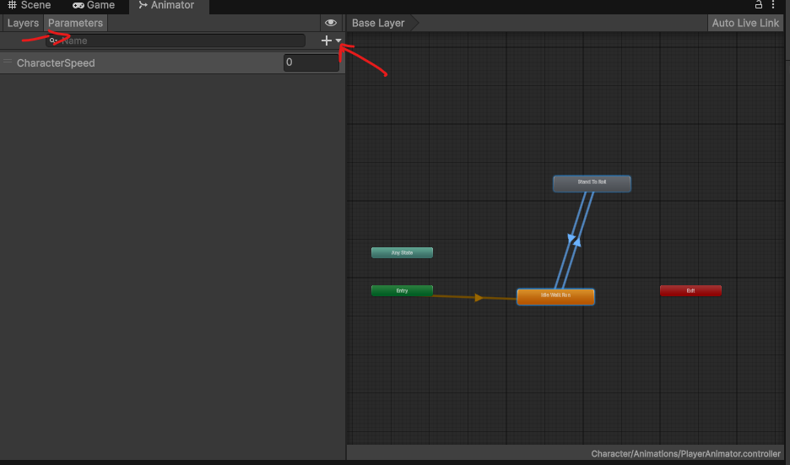

  - Add a new Trigger parameter called doRoll.

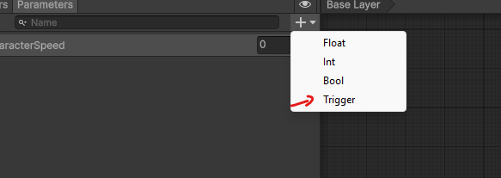

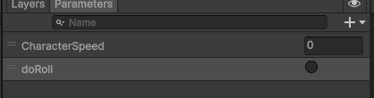

  - By the end your stand to roll should be connected like the previous picture

- Configure Transition Conditions:
  - Select the transition from Idle/Walking/Running to Stand to Roll.
    - Add the parameter doRoll in the condition
    - Uncheck Has Exit time

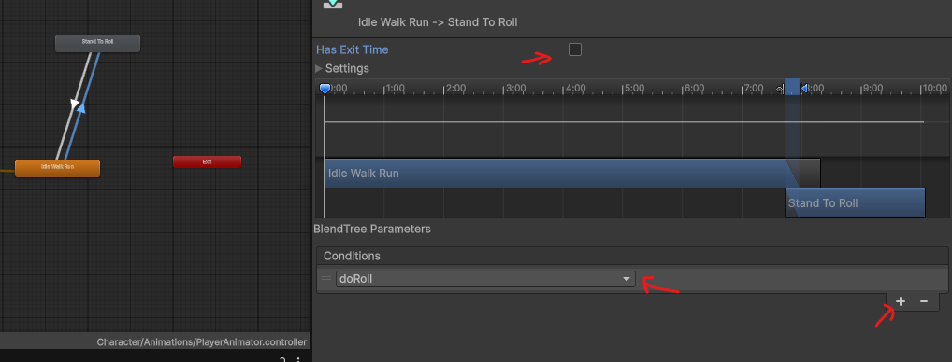

  - Select the transition back to Idle/Walking/Running make sure the HasExitTime is still checked to make sure the roll animation plays fully before going back to the Idle/Walk/Run state

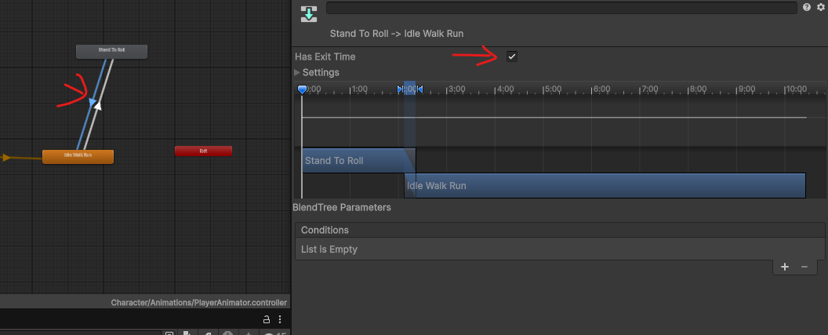

Adding a behaviour to the roll.
Click on the state Stand to roll
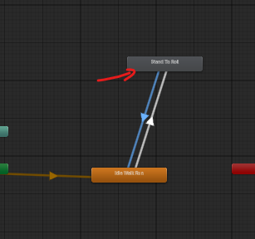

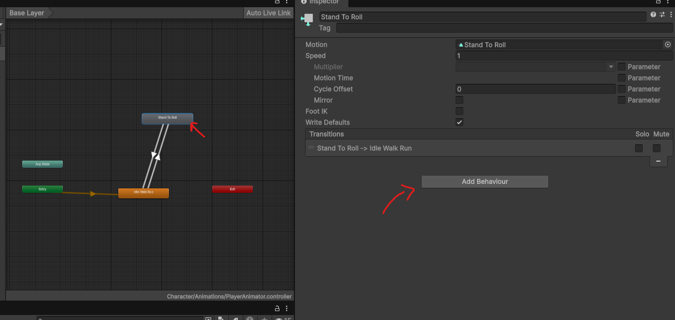

On the left panel you should see this window click on the Add behaviour button.

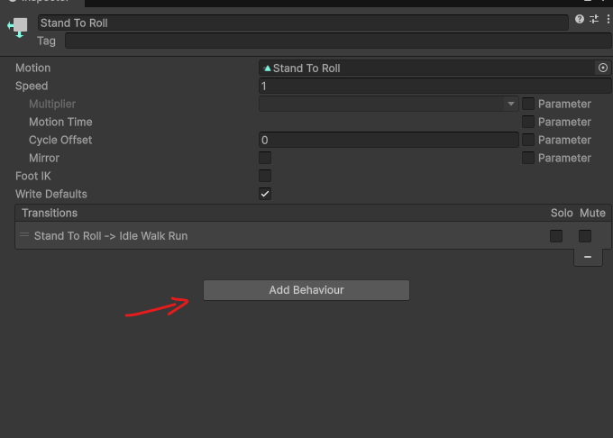

Click new Script

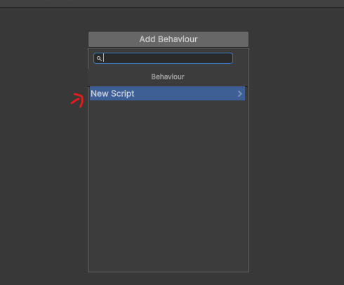

Call it Roll Behaviour
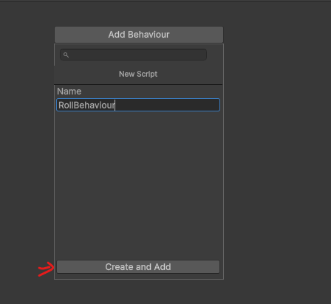

Update the script you just created this script. This will enable and disable rootmotion at the begining and end of the roll animation so that only the roll is affected by root motion.
using UnityEngine;

// A StateMachineBehaviour runs on an Animator state,
// not on a GameObject.
// This one is attached to the Stand to Roll state.
public class RollBehaviour : StateMachineBehaviour
{
// Called when the Animator starts playing this state
public override void OnStateEnter(Animator animator,
AnimatorStateInfo stateInfo, int layerIndex)
{
// Let the roll animation itself move the character forward
animator.applyRootMotion = true;
}

// Called when the Animator finishes this state
public override void OnStateExit(Animator animator,
AnimatorStateInfo stateInfo, int layerIndex)
{
// Hand movement back to the PlayerMovement script
animator.applyRootMotion = false;
}
}

Task 5: Create Transitions for Falling Animation
- Add the Falling Idle Animation:
  - Drag the Falling animation from your Assets folder into the Animator window, creating a new state.
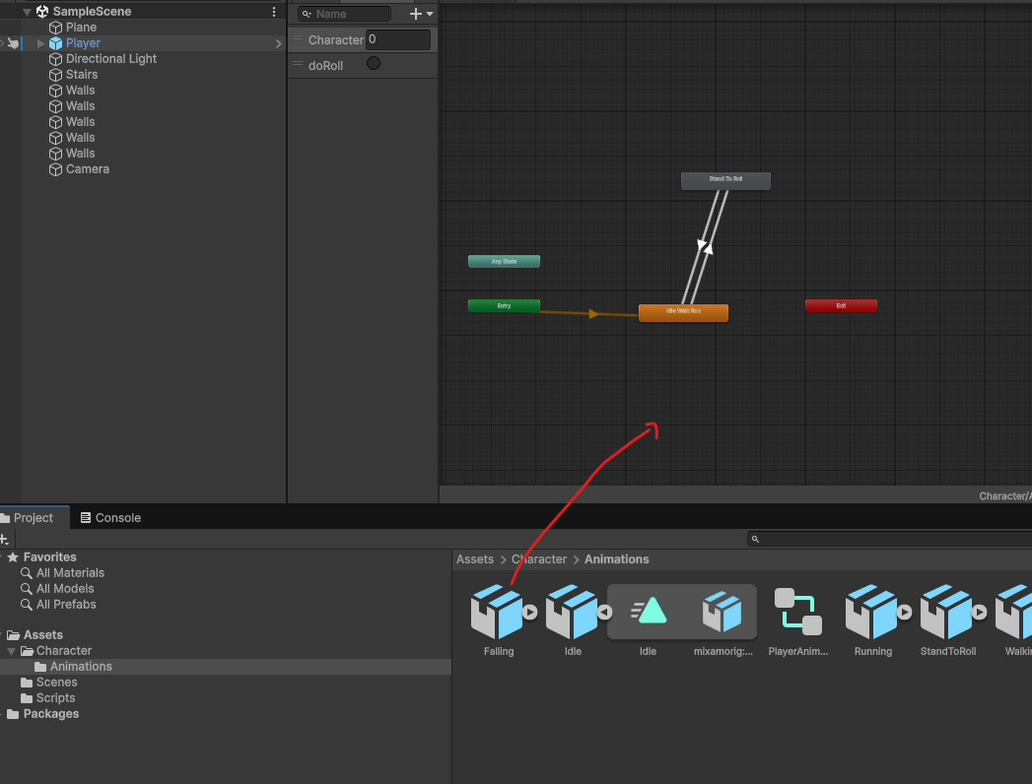

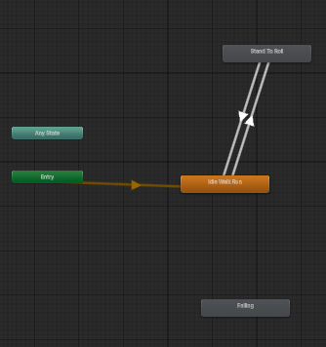

- Create a Transition from Idle/Walking/Running to Falling:
  - Right-click on the Idle/Walking/Running state, select Make Transition, and drag the arrow to the Falling state.

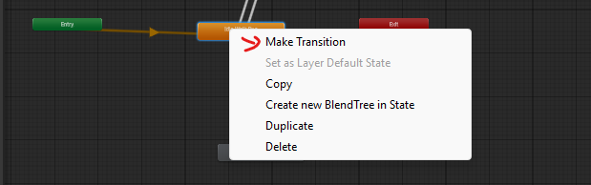

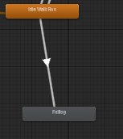

- Create a Transition from Falling back to Idle/Walking/Running:
  - Right-click on the Falling state, select Make Transition, and drag the arrow back to Idle/Walking/Running.

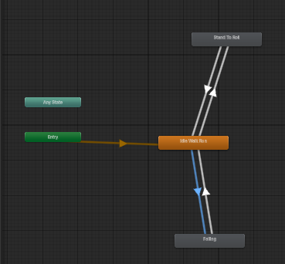

- Setup the "IsGrounded" Parameter:
  - In the Parameters tab, add a new Bool parameter called IsGrounded.
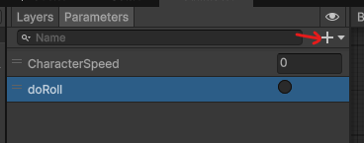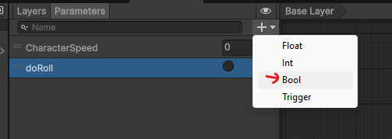
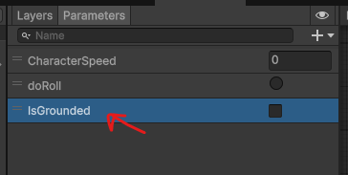

- Configure Transition Conditions:
  - Select the transition from Idle/Walking/Running to Falling.
  - In the Inspector, set the condition to IsGrounded== false and make sure HasExitTime is checked off. ( We want to transition as soon as IsFalling Becomes true
  - 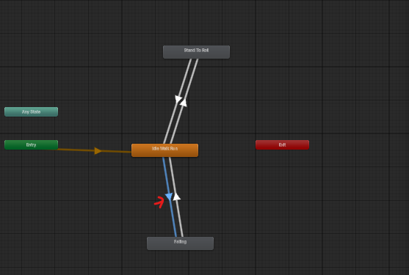

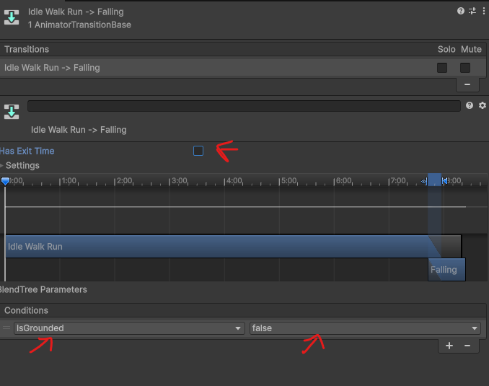

  - Select the transition from Falling Idle back to Idle/Walking/Running and set the condition to IsGrounded== true and we also want to make sure HasExitTime is checked off.

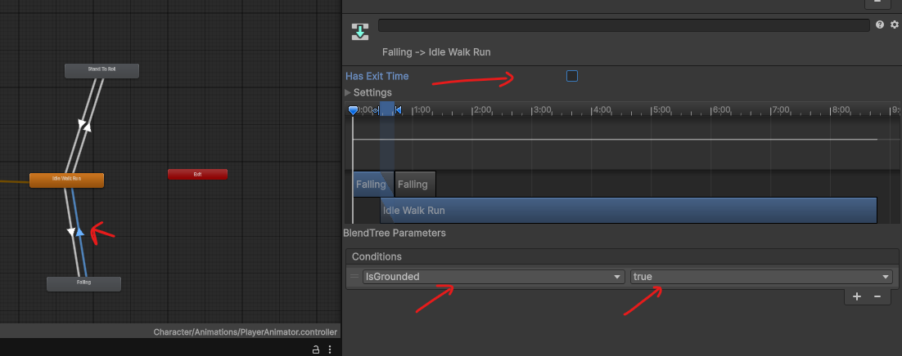

- Make sure the parameter IsGrounded is set to true by default

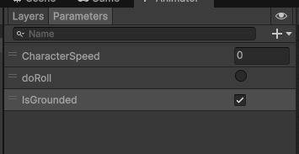

Task 6: Connect Movement to Animation with a PlayerAnimatorController Script
Now we connect the two halves of the lab. The Animator parameters you created (CharacterSpeed, IsGrounded and doRoll) need to be updated every frame from the character's actual movement.
- Expose the grounded state from PlayerMovement:
  - The animation script needs to know whether the player is on the ground, but isGrounded is private inside PlayerMovement, so other scripts can't see it.
  - Open PlayerMovement and add this read-only property just below the private variables:
// Lets other scripts READ isGrounded, but not change it.
// "=> isGrounded" means "when asked, return isGrounded".
public bool IsGrounded => isGrounded;
Why a property instead of making the field public? => isGrounded means other scripts can read the value but can't overwrite it. Only PlayerMovement is allowed to decide whether the player is grounded.
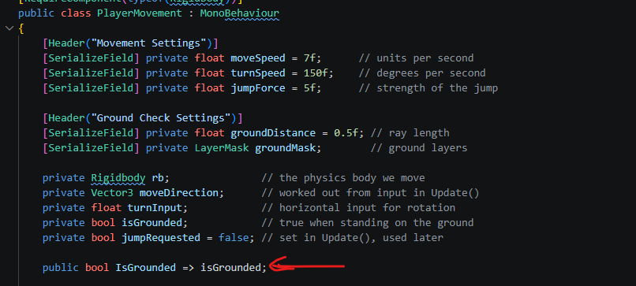
- Create the PlayerAnimatorController script:
Select the Player, click Add Component and create a new script called PlayerAnimatorController (the file name must match the class name exactly). Replace its contents with this code:
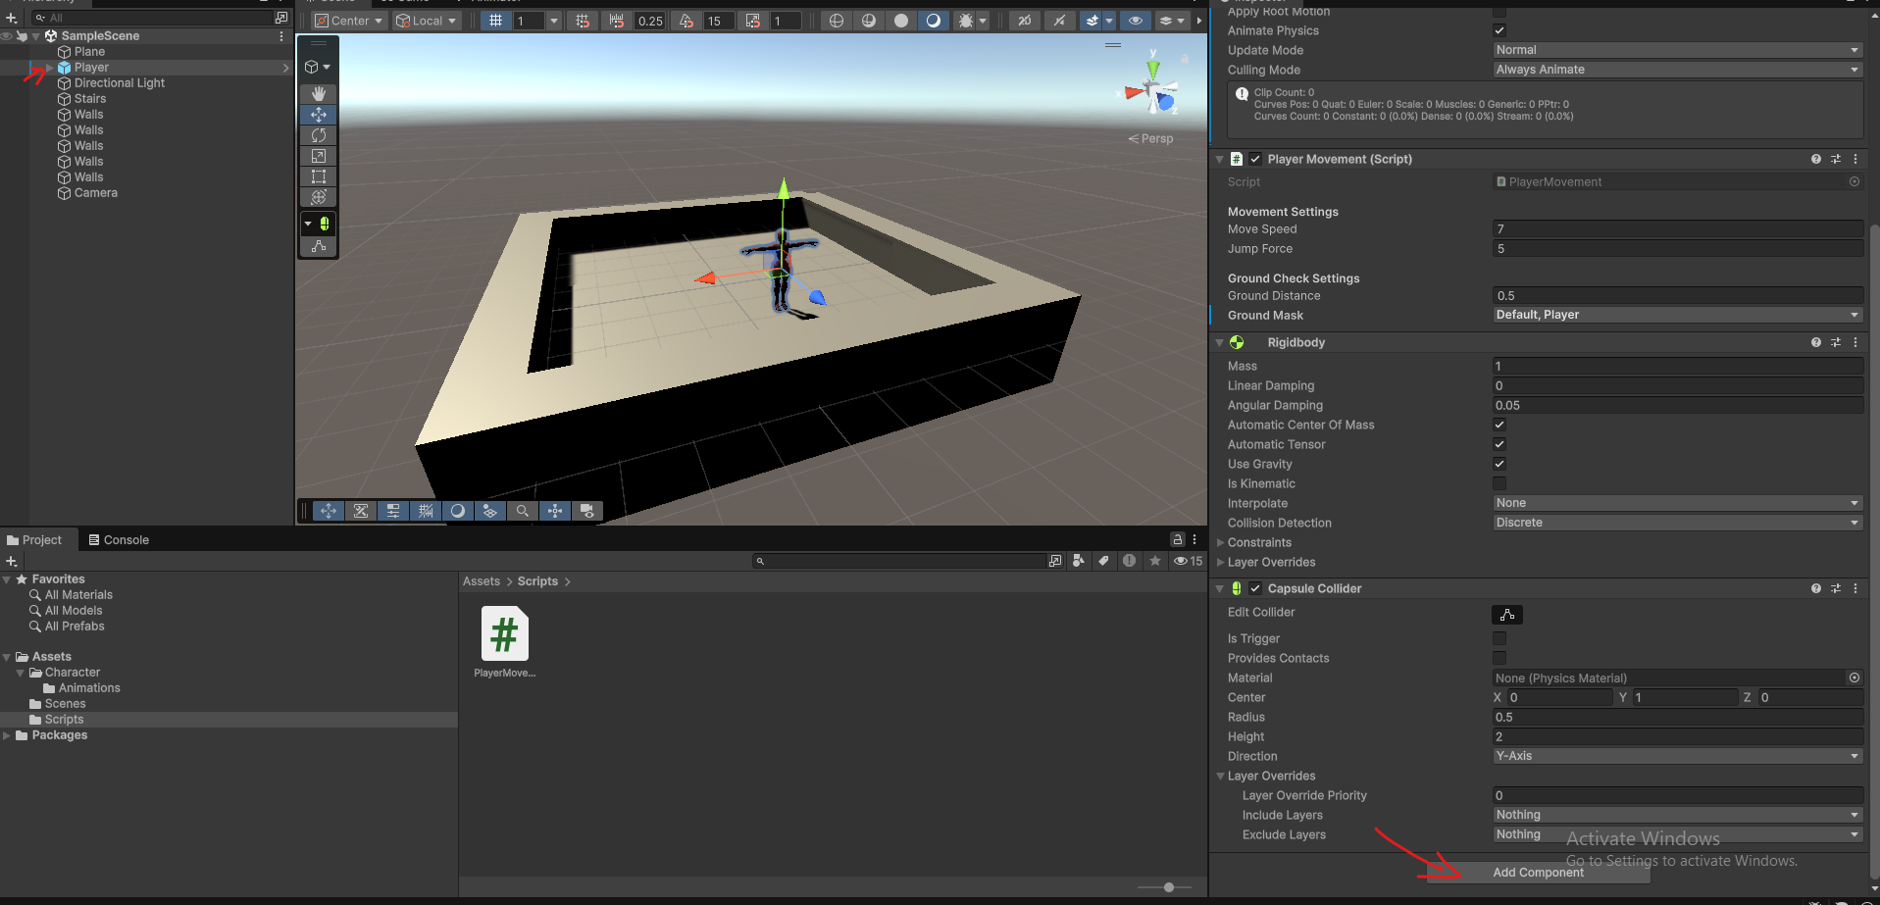
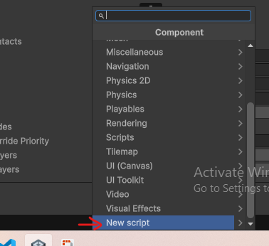

using UnityEngine;

// Sends the player's movement to the Animator every frame
// so the right animation plays at the right time.
public class PlayerAnimatorController : MonoBehaviour
{
private Animator animator; // plays the animations
private PlayerMovement movement; // our movement script (for IsGrounded)
private Rigidbody rb; // used to read how fast the player moves

private void Start()
{
// Find the components on this same GameObject
animator = GetComponent<Animator>();
movement = GetComponent<PlayerMovement>();
rb = GetComponent<Rigidbody>();
}

private void Update()
{
// Send the current speed to the blend tree (Idle/Walking/Running).
// Unity 6 calls the Rigidbody's velocity linearVelocity.
animator.SetFloat("CharacterSpeed", rb.linearVelocity.magnitude);

// Tell the Animator if we're on the ground (controls Falling)
animator.SetBool("IsGrounded", movement.IsGrounded);

// When Fire1 (left mouse button / left Ctrl) is released, roll
if (Input.GetButtonUp("Fire1"))
{
animator.SetTrigger("doRoll");
}
}
}
How it works:
  - GetComponent<PlayerMovement>() finds the script you wrote in Task 2 on the same GameObject.
  - SetFloat("CharacterSpeed", …) sends the Rigidbody's speed to the blend tree every frame, so Idle, Walking and Running blend automatically as the character speeds up and slows down.
  - SetBool("IsGrounded", movement.IsGrounded) passes the raycast result to the Animator, which triggers the Falling transitions from Task 5.
  - SetTrigger("doRoll") fires the roll when you release Fire1 (left mouse button or left Ctrl).
  - The parameter names in the strings must match the Animator parameters exactly, including capital letters.

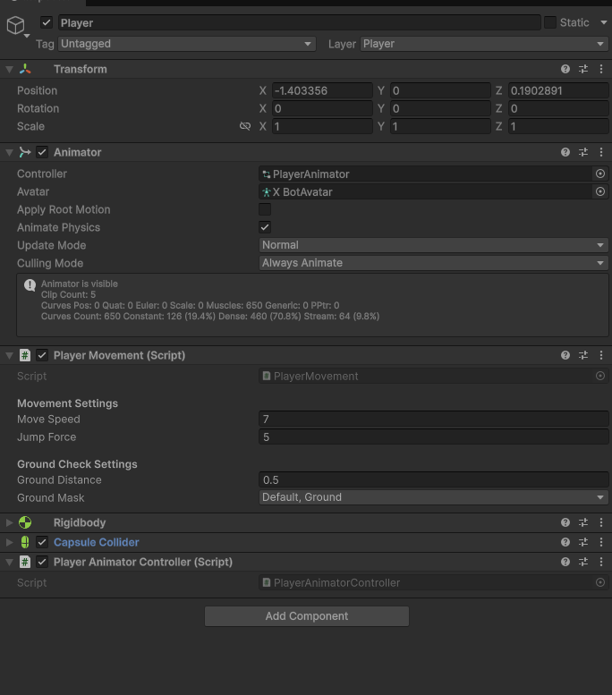

Your Inspector should now show a Player Movement component (from Task 2), a Player Animator Controller component, a Rigidbody and a Capsule Collider, with Apply Root Motion unchecked.

Task 7: Animate a Score Pickup with an Animation Clip
So far every animation has come from imported clips. In this task you will make your own animation clip in Unity's Animation window: a coin that spins and bobs up and down. When the player runs over it, it adds points to the player's score and disappears.
- Build the coin from a parent and a child:
  - In the Hierarchy, right-click and choose Create Empty. Rename it ScorePickup and set its Position Y to 0.5, somewhere the player can reach.
  - Right-click ScorePickup and choose 3D Object > Cylinder, so the cylinder is a child of ScorePickup. Rename it Visuals.
  - On Visuals, set Position to 0, 0, 0, Rotation to 90, 0, 0 and Scale to 0.5, 0.05, 0.5 so it looks like a coin standing on its edge.
  - On Visuals, remove the Capsule Collider (right-click the component header > Remove Component). The parent will have the collider.
  - Optional: create a gold-coloured material and drag it onto Visuals.
  - 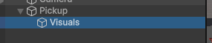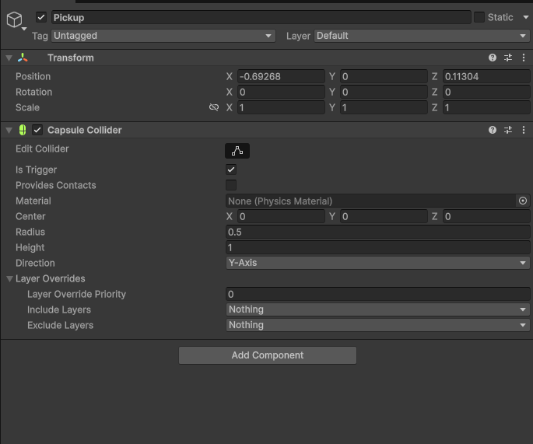

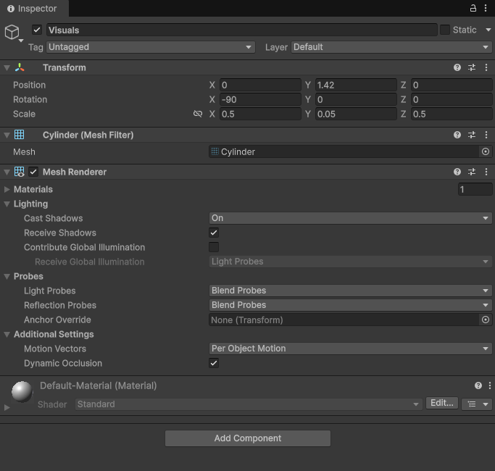

Why a parent and a child? An animation clip stores exact position values. If we animated the object we place in the scene, every copy would snap to the same spot the moment the clip played. Instead we animate the child's local position, which is relative to its parent. The parent can then sit anywhere in the level and the coin bobs around that point.
- Make the coin a trigger:
  - Select ScorePickup (the parent) and click Add Component > Sphere Collider.
  - Check Is Trigger and set Radius to 0.5.
  - 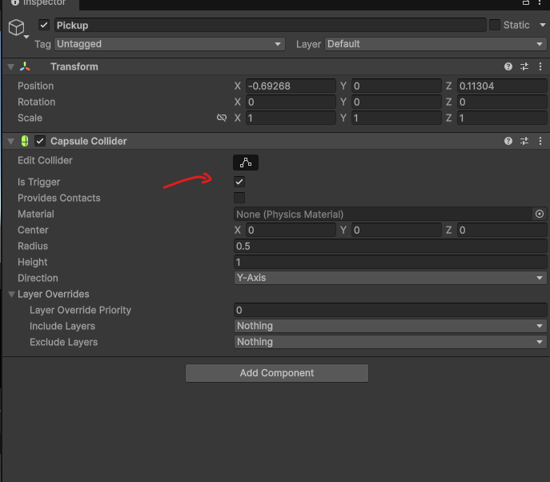
Trigger vs. collider: A normal collider is solid, so the player would bump into the coin and stop. A trigger is not solid: things pass through it, but Unity still tells our script the moment something enters it by calling OnTriggerEnter. Triggers only fire if one of the two objects has a Rigidbody. Our player already does.
- Create the animation clip:
  - Select ScorePickup (the parent) and open Window > Animation > Animation (not the Animator window).
  - 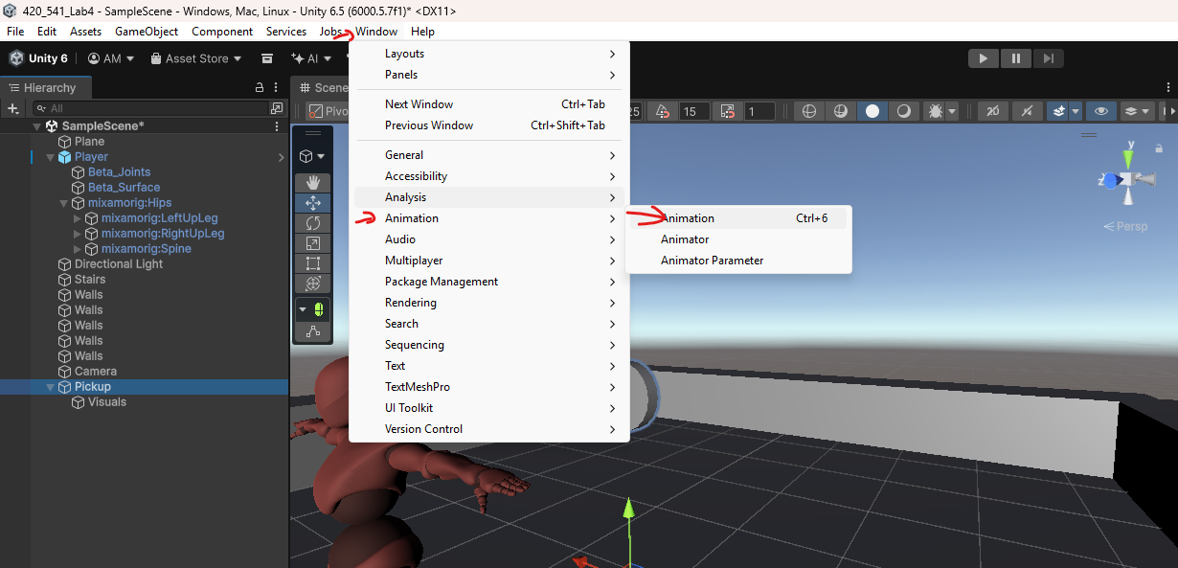
  - Click Create. Save the clip as CoinSpin in your Animation folder.
  - Unity automatically adds an Animator component to ScorePickup and creates an Animator Controller with CoinSpin as its default state. You don't need to set up any states or transitions yourself.

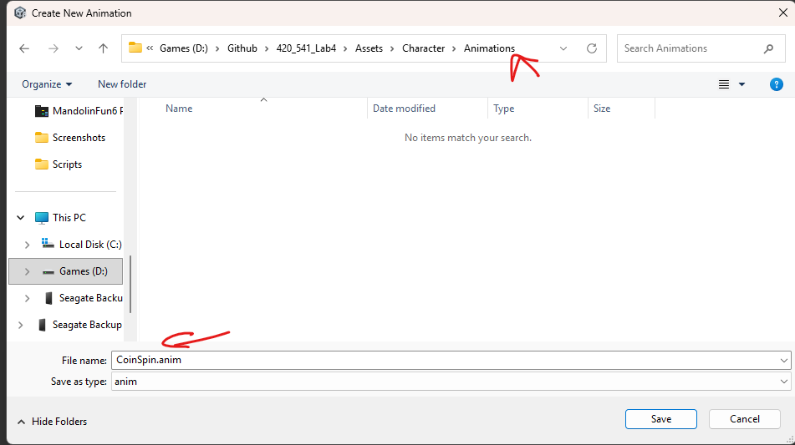

- Choose which properties to animate:
  - In the Animation window, click Add Property, expand Visuals > Transform and click + next to Position. Do the same for Rotation.
  - Unity adds keyframes (the diamonds) at the start (0:00) and end (1:00) of the timeline, using the current values.

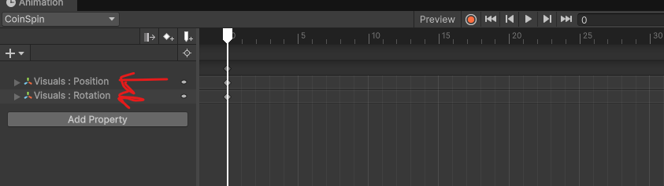

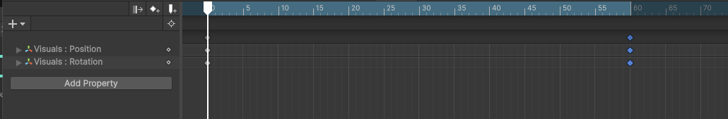
- Record the spin and the bob:
  - Click the red Record button. While it's on, any change you make to a property becomes a keyframe.
  - Bob up: click the timeline at 0:30 to move the playhead there, select Visualsin the Hierarchy and set its Position Y to 0.25.
  - Spin: move the playhead to 1:00 and set Visuals Rotation Y to 360.
  - Click Record again to stop recording, then press the Play button in the Animation window to preview. The coin should rise, fall back and make one full turn every second.
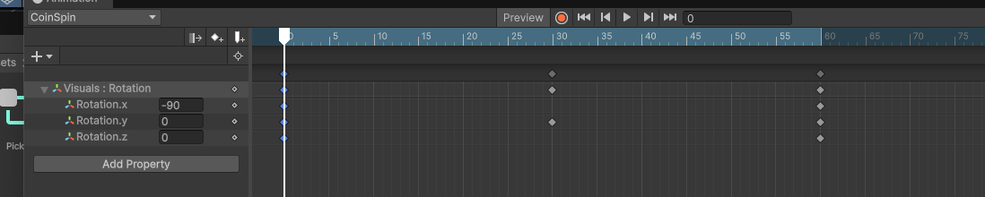

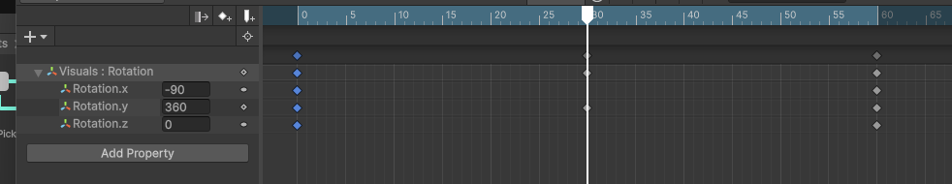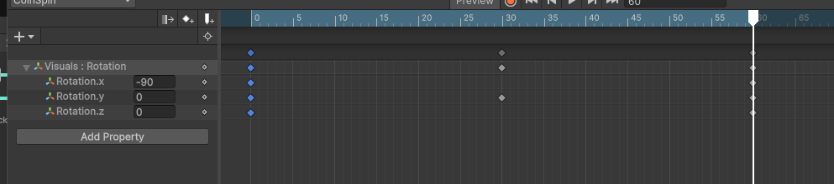

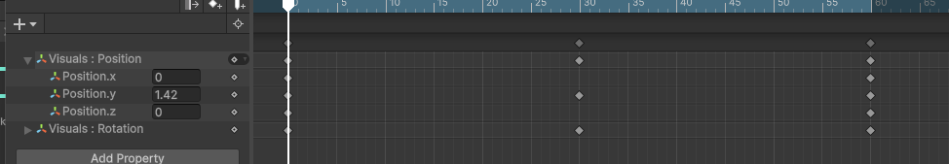
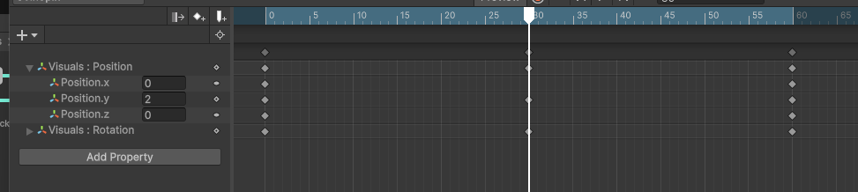
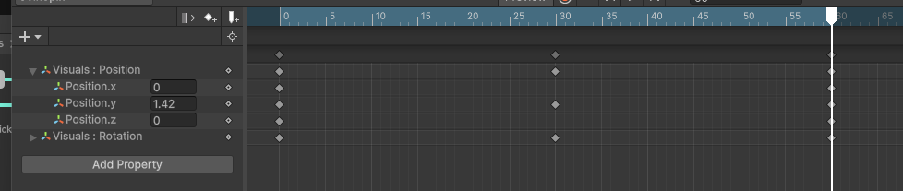
How keyframes work: You only set the important moments (the keyframes). Unity fills in every frame in between by smoothly blending the values. This blending is called interpolation. Three keyframes are enough for a full second of animation.
- Make the clip loop:
  - Select the CoinSpin clip in the Project window and make sure Loop Time is checked in the Inspector, so the coin keeps spinning forever.
  - 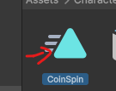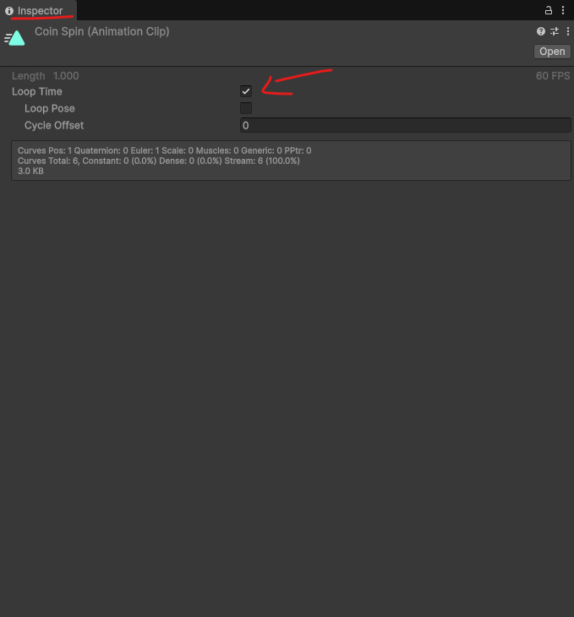
- Create the ScoreManager script:
  - Select the Player. At the top of the Inspector, set its Tag to Player (a built-in tag). The coins use this tag to recognise the player.
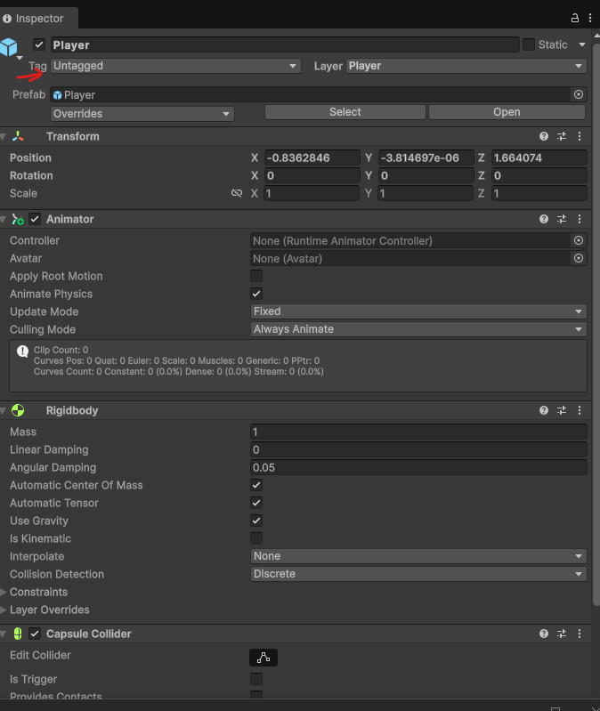

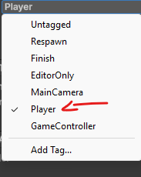
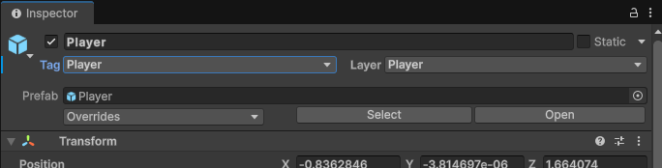
  - Create an empty game object , click Add Component, create a new script called ScoreManager and replace its contents with:
using UnityEngine;

// Keeps track of the player's score.
// It's a singleton: there is only ever one, reachable from any script
// through ScoreManager.Instance.
public class ScoreManager : MonoBehaviour
{
// The single shared instance that any script can reach.
// "static" means it belongs to the class, not to one object.
public static ScoreManager Instance { get; private set; }

// Anyone can read the score, only ScoreManager can change it
public int Score { get; private set; }

// Awake runs before any Start(), so Instance is ready before coins need it
private void Awake()
{
// If a ScoreManager already exists, remove this extra component
// (only the script, not the whole Player)
if (Instance != null && Instance != this)
{
Destroy(this);
return;
}

// Otherwise, this is the one and only ScoreManager
Instance = this;
}

// Called by coins when they're collected
public void AddScore(int amount)
{
Score += amount;

// Print the new total to the Console window
Debug.Log("Score: " + Score);
}
}
How it works:
  - Instance is a static property, which means it belongs to the ScoreManager class itself rather than to one object. Any script can write ScoreManager.Instance to reach the manager. private set means only this class can assign it.
  - Awake() runs before any Start() method. It stores this manager in Instance. If one already exists, it destroys this extra component with Destroy(this), not the whole Player, so there is only ever one manager.
  - public int Score { get; private set; } lets any script read the score (for a UI later) but only ScoreManager can change it.
  - AddScore() adds the points and prints the new total to the Console window.
What is a singleton? A singleton is a class that only ever has one instance, which everyone can reach through a single global access point (Instance). It's useful for managers that there should only be one of, like a game, audio or score manager. The trade-off is that any script can call it from anywhere, so use singletons for true one-of-a-kind managers, not for everything.
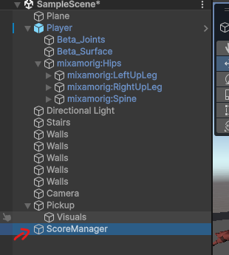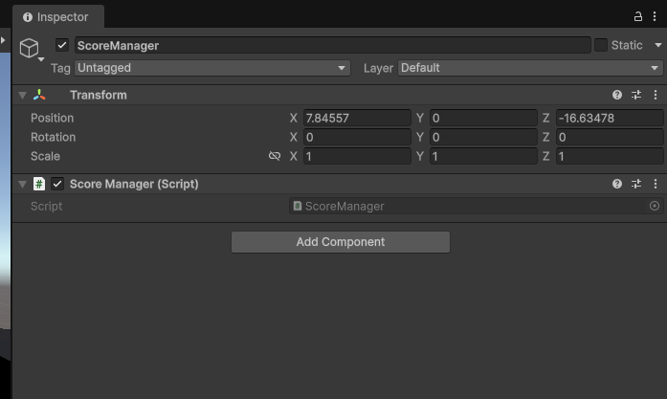

- Create the ScorePickup script:
  - Select ScorePickup (the parent), click Add Component, create a new script called ScorePickup and replace its contents with:
using UnityEngine;

// A coin that adds points to the score when the player touches it.
// Needs a collider with Is Trigger ticked on the same GameObject.
public class ScorePickup : MonoBehaviour
{
// How many points this coin is worth (change it in the Inspector)
[SerializeField] private int points = 10;

// Called automatically when something enters this trigger
private void OnTriggerEnter(Collider other)
{
// Only react to the player, ignore everything else
if (other.CompareTag("Player"))
{
// Add our points through the ScoreManager singleton
ScoreManager.Instance.AddScore(points);

// Remove the coin from the scene: it's collected once and gone
Destroy(gameObject);
}
}
}
  - When the player touches the coin, it adds points to the score and then destroys itself.
  - Thanks to the singleton, the coin doesn't need a reference to the player or a GetComponent call to find the ScoreManager.
- Turn the coin into a prefab and place a few:
  - Drag ScorePickup into your Assets folder to make a prefab, then drag several copies around the level.
  - 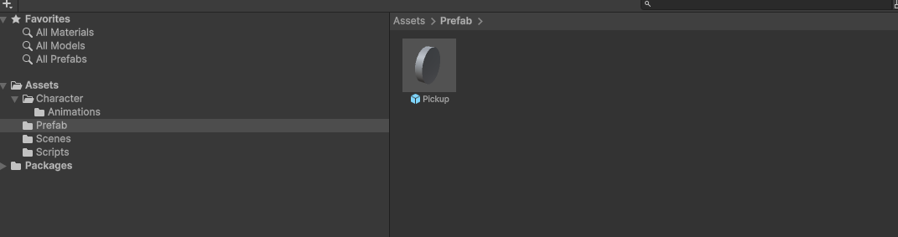
  - Each copy bobs around its own position because only the child is animated.

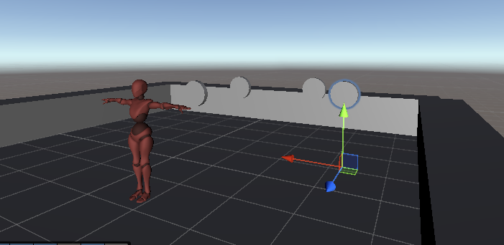

- Test the coins:
  - Open the Console window (Window > General > Console) and press Play.
  - The coins should spin and bob. Run through one: it should disappear and the Console should show Score: 10, then 20, 30…
  - All the coins jump to the same spot? You animated ScorePickup instead of Visuals. The clip's properties should read Visuals: Position and Visuals: Rotation.
  - The coin doesn't animate? Check that ScorePickup has an Animator with the CoinSpin controller, and that Loop Time is on.
  - Nothing happens when you touch it? Check that the Sphere Collider on the parent has Is Trigger ticked and the Player's tag is Player.
- Check your understanding:
  - What would go wrong if the animation clip changed the position of ScorePickup itself instead of its Visuals child?
If the animation clip changed the position of ScorePickup itself whenever adding a coin to the game they would just snap to that location on the scene. The visual makes so it spins around that coins base or spins around itself.________________________________________________________________________________________________________________________________________________________________________________________________________________________________________________________________________________________________________________

Final Steps:
- Test Your Project:
  - Press Play in Unity. Move with WASD / arrow keys and check that the character blends from Idle to Running, jumps with Space, plays Falling while in the air and lands back into Idle/Walking/Running, and rolls when you click Fire1.
  - Run through a coin and check that it spins and bobs, disappears when collected, and the Console shows the score going up.
  - Select the Player while the game is running and open the Animator window to watch the parameters and active state change live. This is the fastest way to debug a transition that doesn't fire.
- Submission:
  - Save your fork of the repo.
Submit your Assets folder zipped with this filled in and saved document in the assets folder.

