
Faculty of Science and Technology
420-411-VA E-Commerce Section 00001

Project Proposal

Team Leader
Willkerdy Elveus (6236388)

Team Members
Mohamed Amine Hamidouch (2379855)
Luis Angelo Primero (2272888)
Samuel Wilson (2216511)

Repository URL
https://github.com/Wlszn/Mix-Max.git

Mix & Max

Domain Names:
- mixandmax.com
- mixmaxevents.com
- mixmaxtickets.com

Description:
Mix & Max is a full-stack web application that allows users to discover, reserve, and purchase tickets for concerts and live events that they want to attend. The platform aims to simplify the ticket buying process by offering a clear event catalog, flexible seat selection, and a secure checkout process. The application focuses on providing a seamless ticket purchasing experience.
The system targets live eventgoers who want a fast and reliable way to book tickets online, as well as administrators who manage event listings and ticket inventory. On the administrative side there is a secure back-end interface that allows authorized users to create and manage events, venues, and ticket availability using role-based access and two-factor authentication for security.

Target Users:
- General Users
  - People looking to discover and purchase tickets for concerts and events
- Administrators
  - Event organizers or staff managing events and ticket inventory

Repository URL
https://github.com/Wlszn/Mix-Max.git

Feature Suite

Event search & AJAX filtering
Users can search for events by artist, venue, city, date range, or genre. Results update dynamically using AJAX filters like price range, availability, date.

List-based seat selection
For a chosen event, available seats are displayed in a list grouped by row. The users will be able to select specific seats in each row. They can even buy multiple seats if those seats are available. The system prevents double-booking by checking availability in real time.

Session based cart
Selected seats are stored in a session-based cart. Users can add tickets for multiple events, adjust quantities, and remove selections before proceeding to check out. They’ll be able to log out and log in back and it will still be in their cart.

Booking confirmation
After checkout the system creates a unique booking reference and generates a PDF e-ticket containing event details, and seat numbers for entry. A confirmation page and email will also be displayed after paying.

Admin Dashboard
Administrators log in using two-factor authentication. From the dashboard they can perform CRUD operations on events, venues, and ticket inventory. They’ll also be able to view reports and cancel bookings. Role based access makes sure only admins can see that page and have the privileges to modify anything.

Internationalization
The platform supports multiple languages, allowing users to switch languages dynamically and improving accessibility for a wider audience.

ERD Diagram
- User
  - Id
  - Username
  - Email
  - Password_hash
  - 2fa_secret
  - Role
  - Created_at
- Venue
  - Id
  - Name
  - Address
  - City
  - Capacity
- Event
  - Id
  - Title
  - Artist
  - Description
  - Venue_id
  - Event_date
  - Start_time
  - End_time
  - Image_path
  - Status
- Ticket
  - Id
  - Event_id
  - Section
  - Row_number
  - Seat_number
  - Price
  - Status
  - Held_until

- Booking
  - Id
  - user_id
  - booking_reference
  - booking_date
  - total_price
  - status
- Booking_Ticket
  - Id
  - Booking_id
  - Ticket_id
  - Price_paid
A venue can have many Events (1:N)
An event belongs to one Venue and can have many tickets (1:N)
A User can have many Bookings (1:N)
A Booking can have many Tickets, and a ticket belongs to exactly one Booking (N: 1)
Booking_Ticket is a many to many table for the booking and tickets relationship
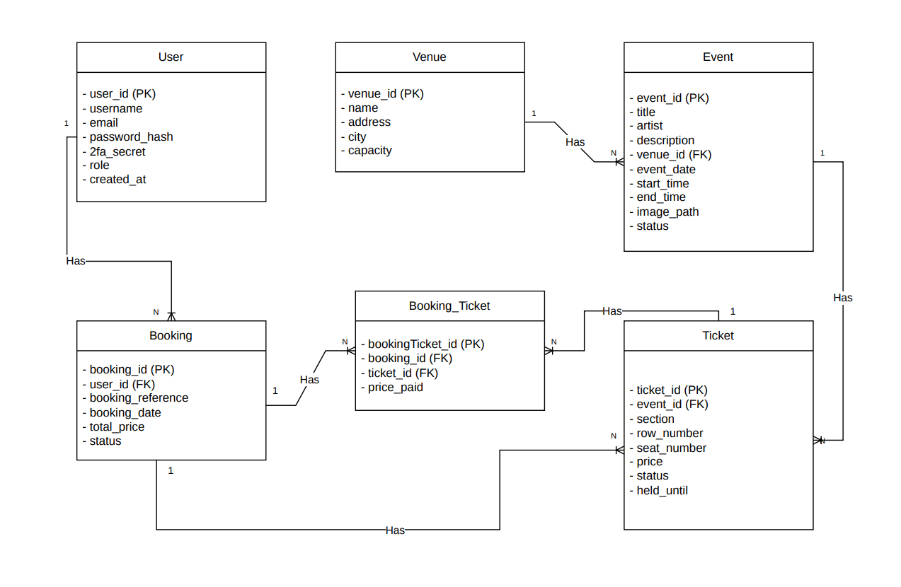

Deployment Plan
Development:
The application will be developed and tested locally using XAMPP/WAMP on each member’s machine.
Version control:
Version control will be managed using GitHub. Each team member will contribute through commits with clear and descriptive messages
Database:
The application will use a MariaDB / MySQL relational database for storing all application data
Hosting:
The application will be deployed on a cloud based private server like Digital Ocean or other.

