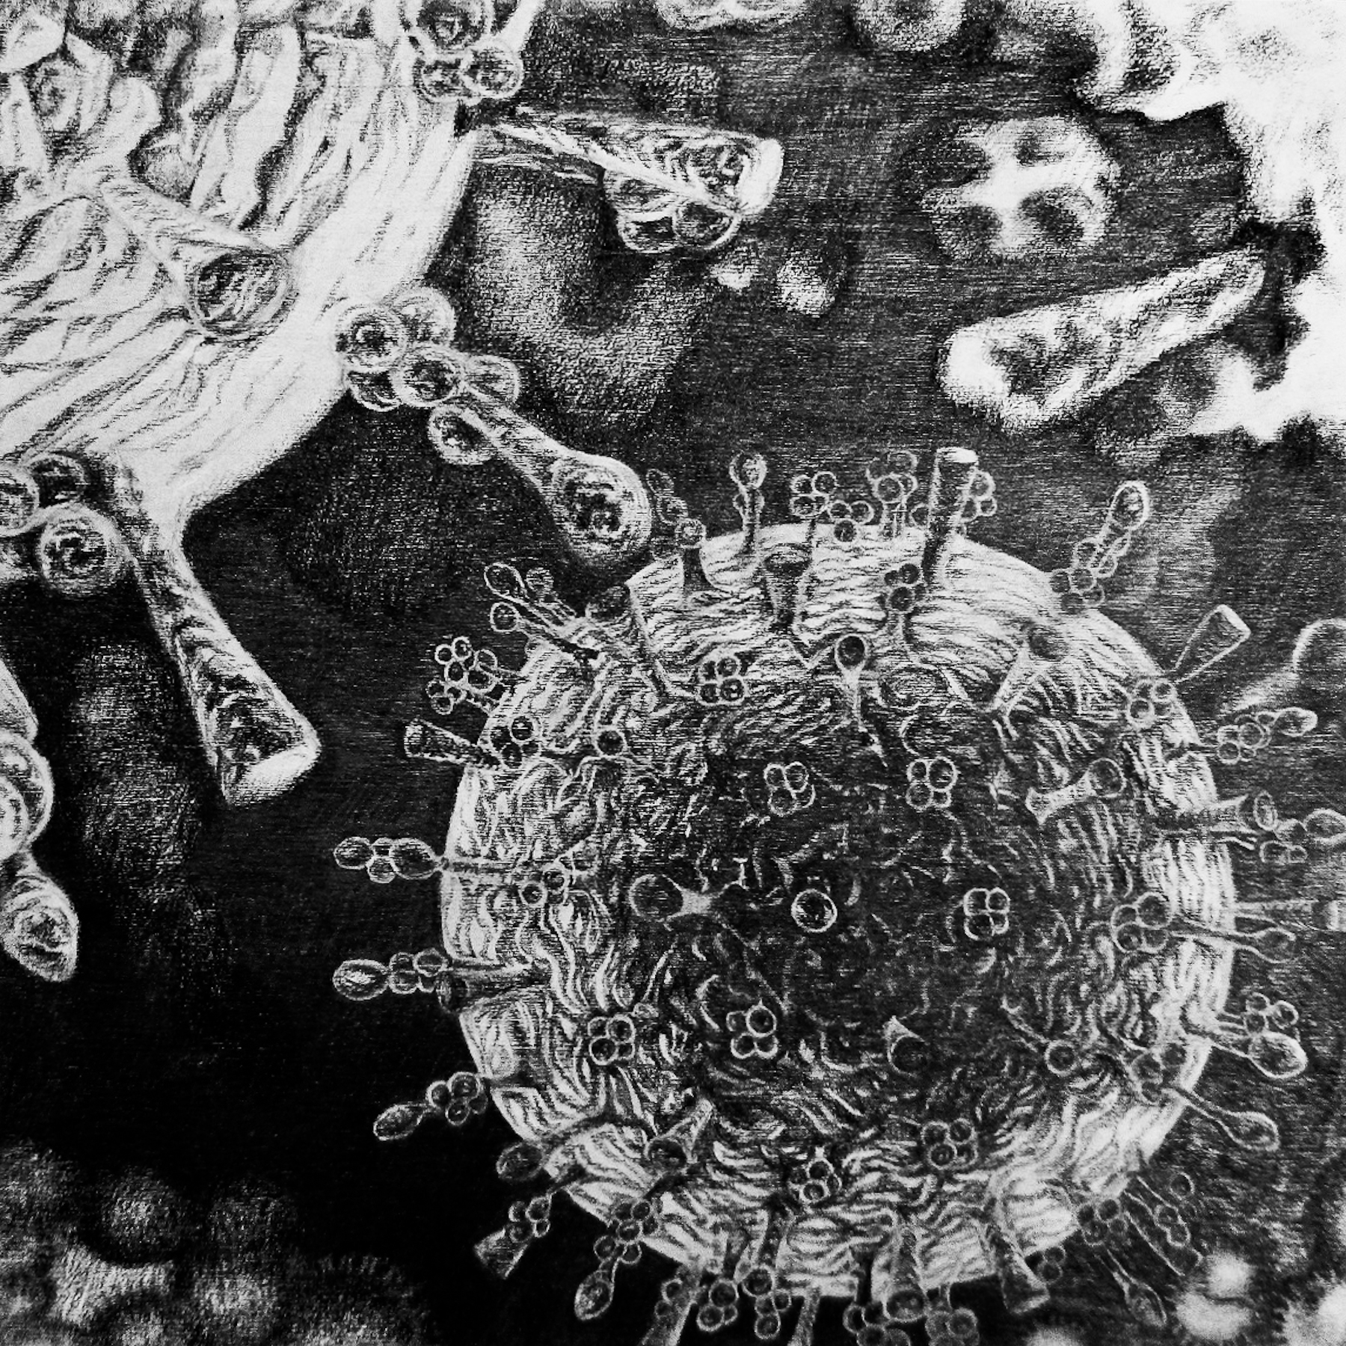

## New work AT THE Cedar Hill Arts Centre Gallery

## **3220 Cedar Hill Road**

450 Hillside Avenue

**August 3rd – August 17th, 2016**

## This is a series of graphite drawings on wood panels that explores intercellular and intimate interior spaces

## Visit [**www.deborah-mccoll.com**](http://www.deborah-mccoll.com) for more of deborah’s work

✹

Deborah McColl

## Atlas Project – Intercellular series

✹

# THE COMMUNITY ARTS COUNCIL OF GREATER VICTORIA

# New Graphite Work by